**Results**

**Index** is a main file where it opens login window as shown below.

It is connected with another file that is **Menu** which pops up after logging in

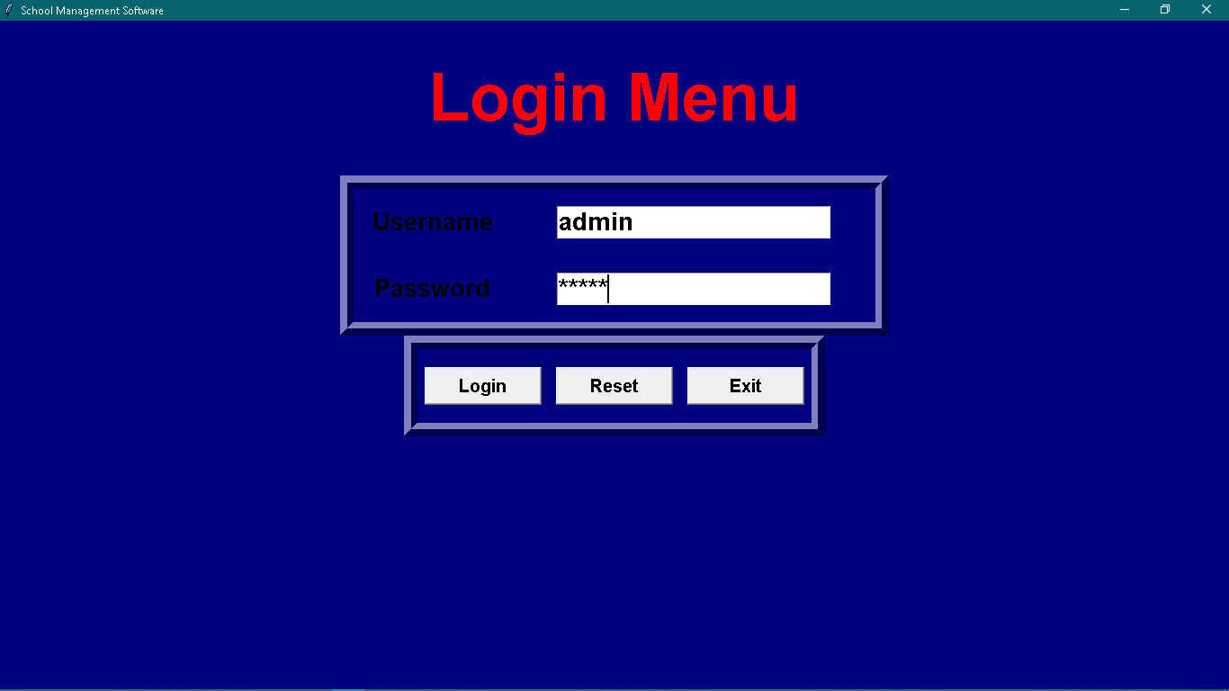

After entering username and password click login.

Exit is used for direct close of window which pops up a notification for confirmation to close window.

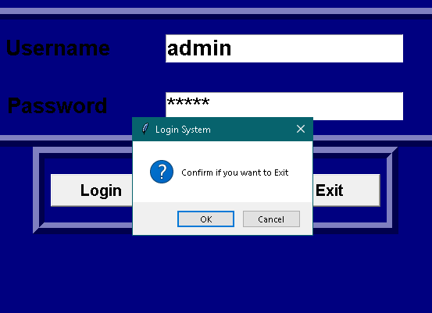

After entering the data click on save button so that it can save data of a particular person, this data can be identified by name of a student

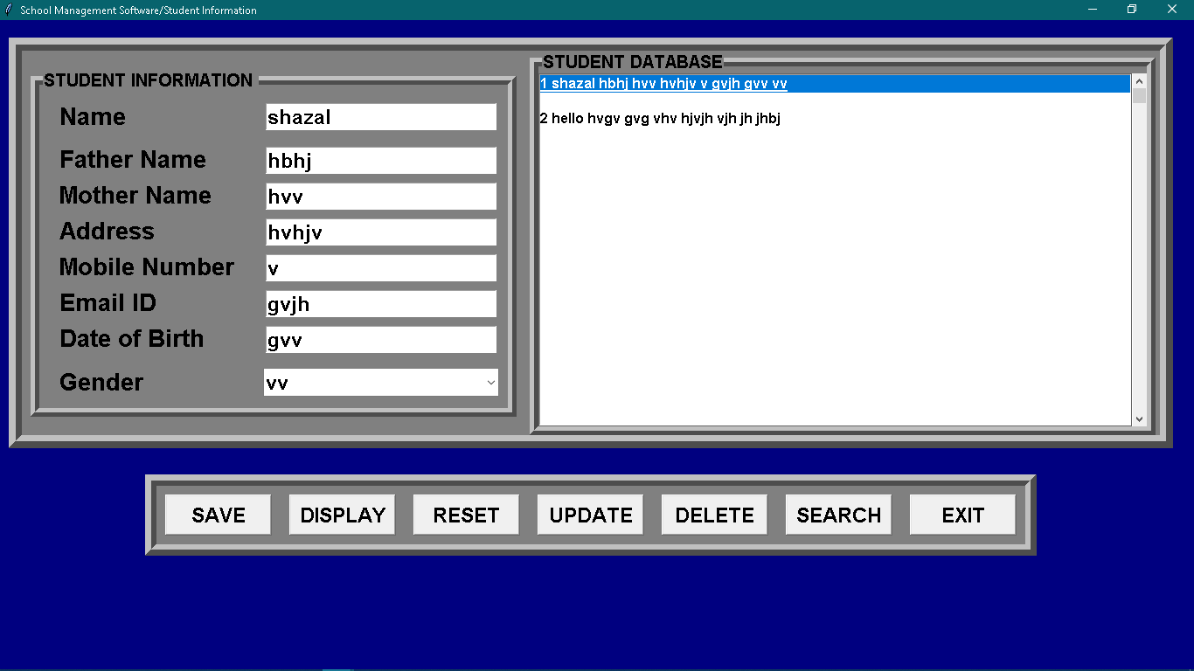

By selecting data in right hand side block of student’s database we can fetch information.

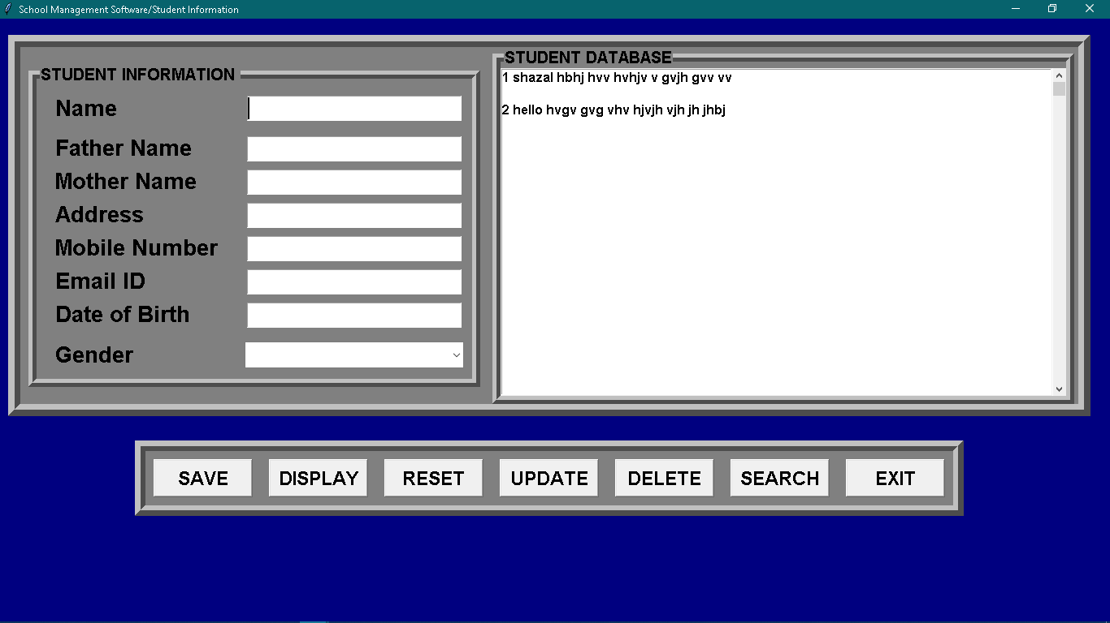

Display button is used to display all the data on right hand side, as shown below.

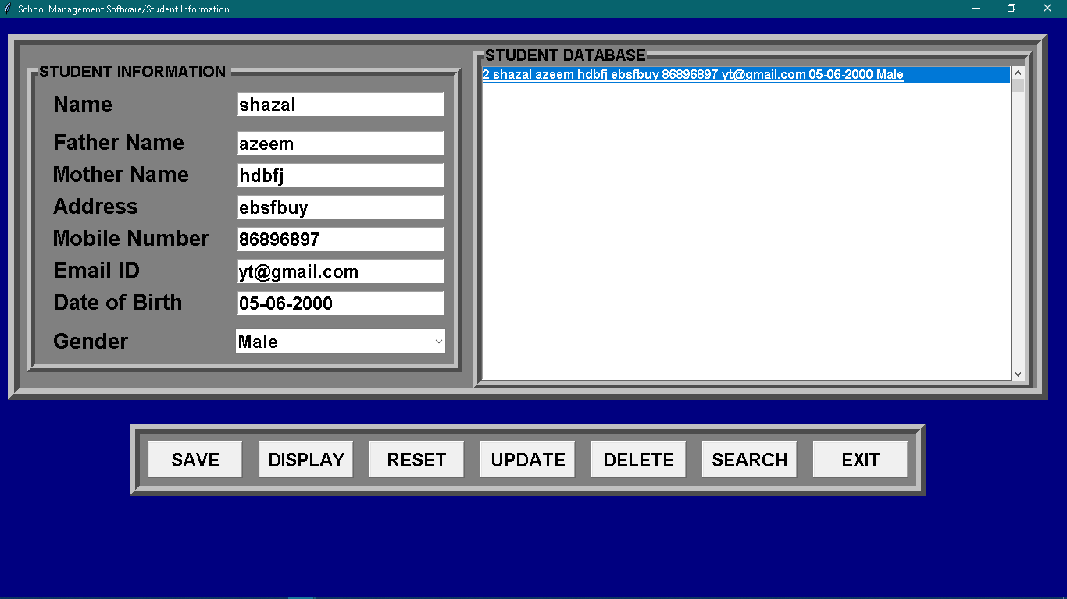

**Fee report window**

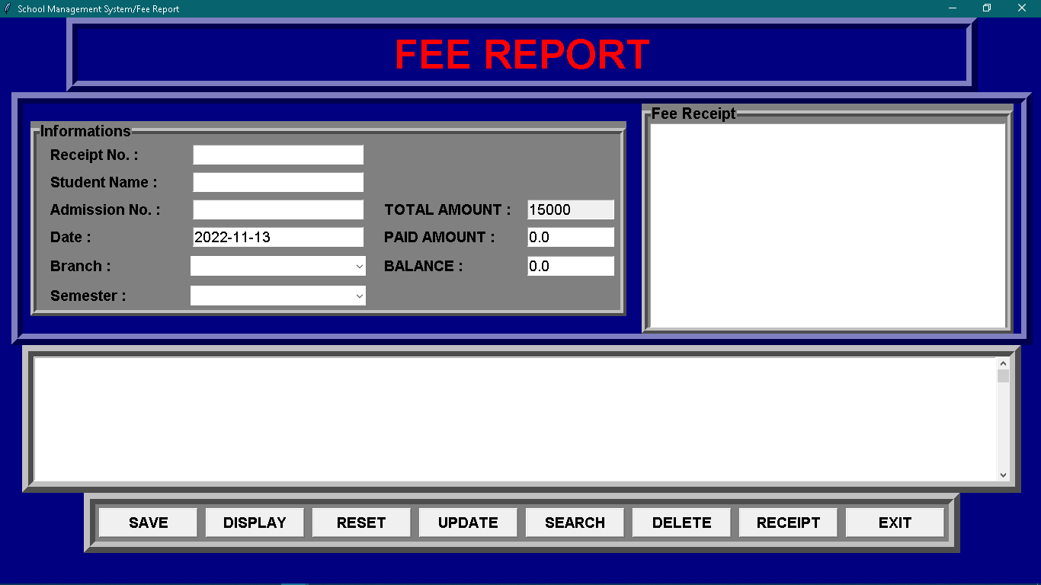

Enter the details and click on save button

By selecting data on right hand side, we can update data by using **update button**

By selecting data on right hand side, we can delete data by using **delete button**

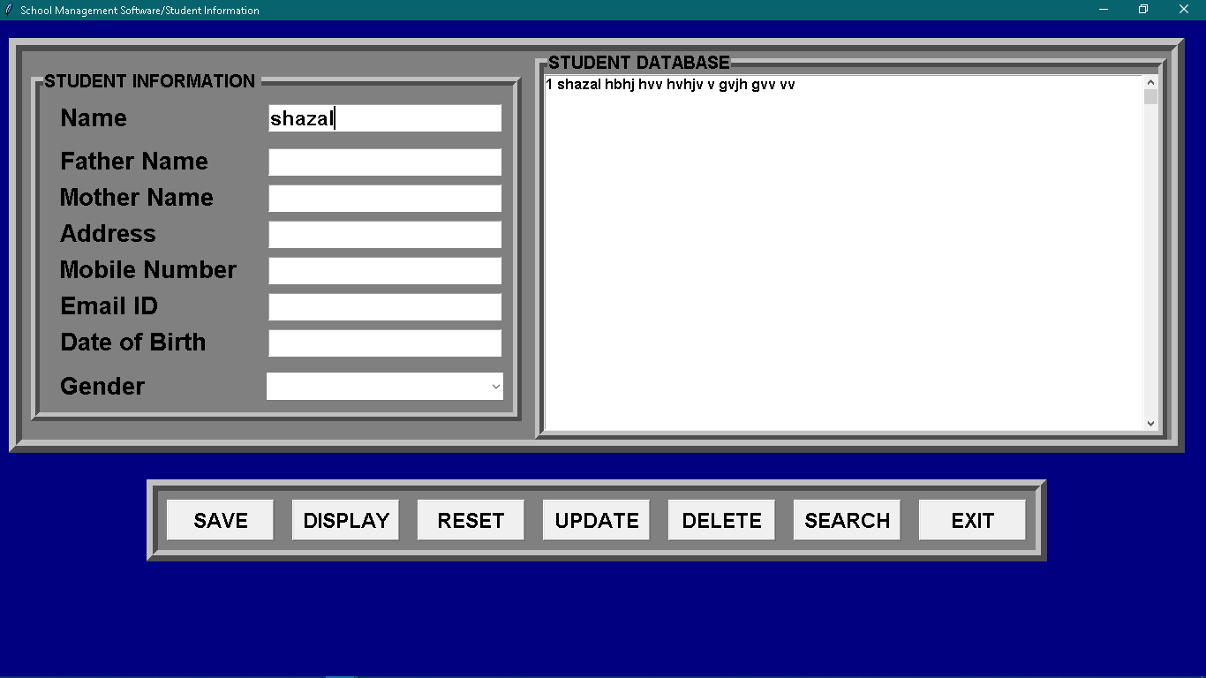

If data is excessive, we can use search button as it helps to find data by just entering students name and then click on search, as shown below.

Click on receipt to display at the right-hand side, as shown below

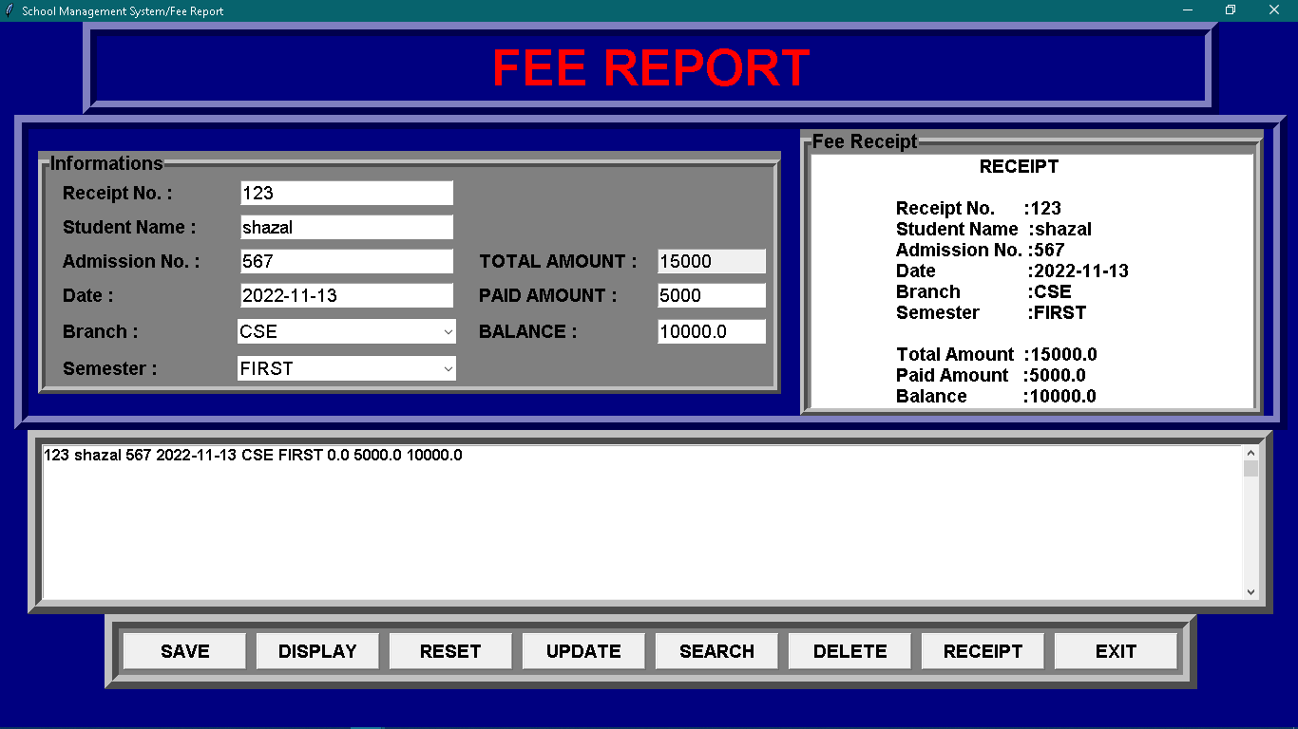

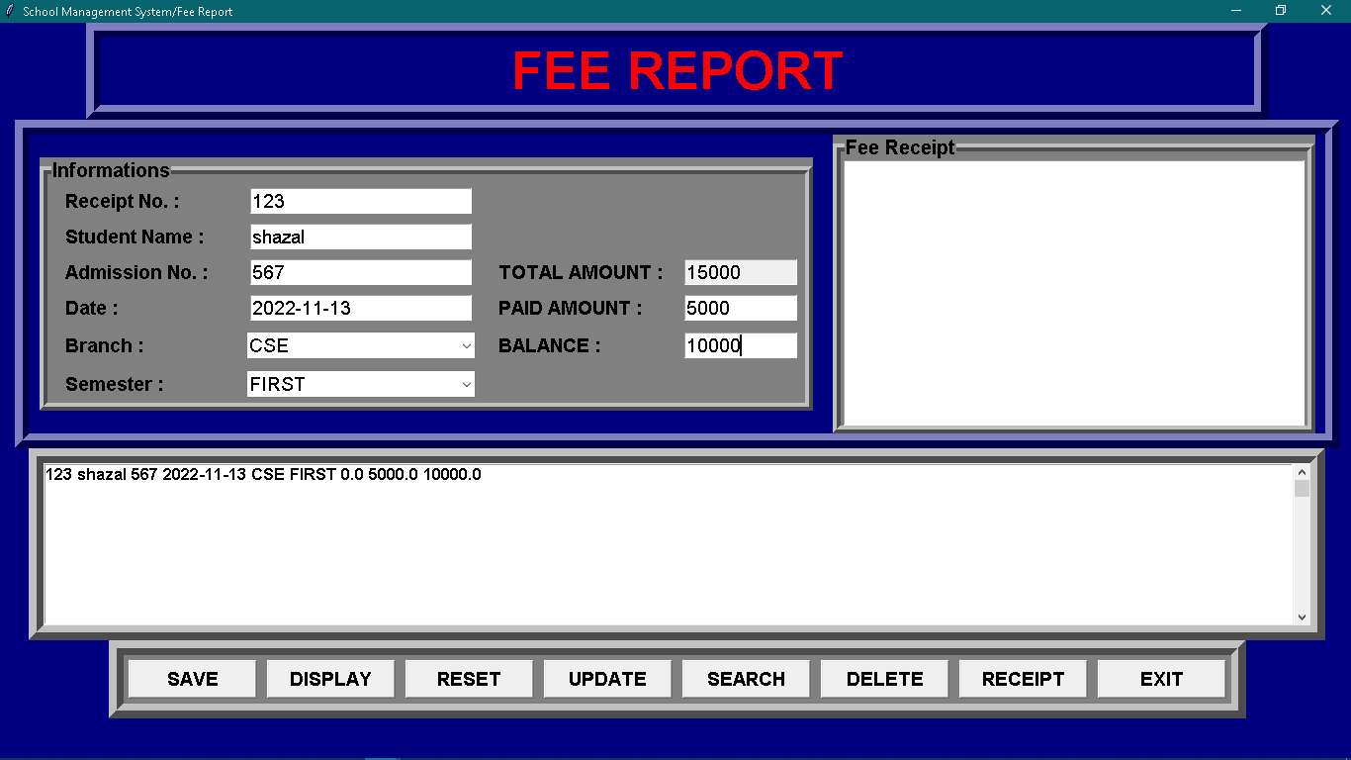

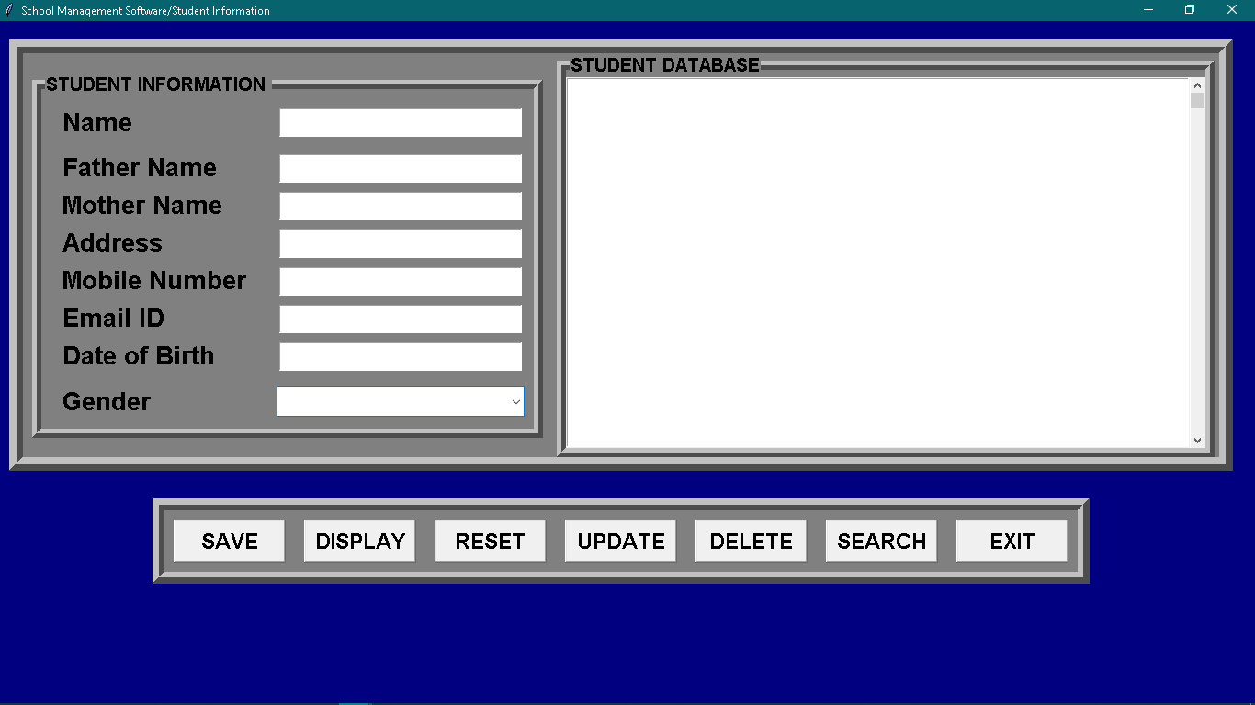

Select the appropriate option as per the use

Selecting student profile:

It opens student information window.

File name: Std_info_FrontEnd

Selecting Fee Report:

It opens fee report window.

File name: Fee_Frontend

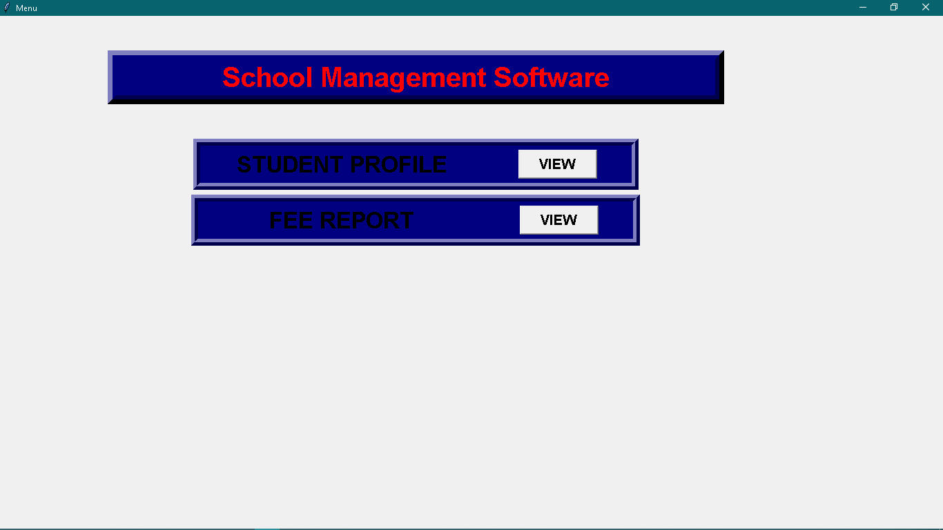

**Menu** window provides two options

* Student profile
* Fee Report