Assignment :: PHP: Object oriented programming

Name : Mohd Usama

1:- Explain OOPS concept with an example.

Ans : Object Oriented is an approach to software development that models application around real world objects such as employees, cars, bank accounts.

Object: An object consists of :
- State : It is represented by attributes of an object. It also reflects the properties of an object.
- Behavior : It is represented by methods of an object. It also reflects the response of an object with other objects.
- Identity : It gives a unique name to an object and enables one object to interact with other objects.
Class -- A class is a user defined blueprint or prototype from which objects are created. It represents the set of properties or methods that are common to all objects of one type.

Encapsulation – this is concerned with hiding the implementation details and only exposing the methods. The main purpose of encapsulation is to;
- Reduce software development complexity – by hiding the implementation details and only exposing the operations, using a class becomes easy.
Inheritance – this is concerned with the relationship between classes. The relationship takes the form of a parent and child. The child uses the methods defined in the parent class. The main purpose of inheritance is; Re-usability– a number of children.

Polymorphism – this is concerned with having a single form but many different implementation ways. The main purpose of polymorphism is;
  - Simplify maintaining applications and making them more extendable.

Class a
{
Int a , b // these are class level veriable
Function abc()
{
//this part is under scope
}
}
//Creation of the object

Object_name = new class_name

Here new is a keyword that tell to compiler about memory intilization of object

2:- Explain Classes & Objects with an example.

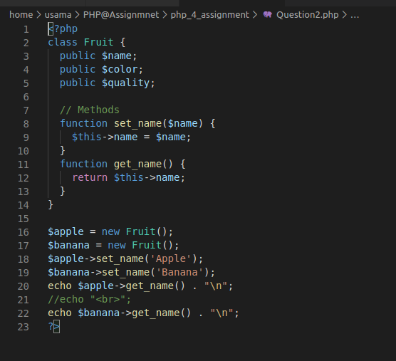


3:- What is a Namespace?

Ans :: In the broadest definition namespaces are a way of encapsulating items. This can be seen as an abstract concept in many places. For example, in any operating system directories serve to group related files, and act as a namespace for the files within them.
1: It allows redeclaring the same functions/classes/interfaces/constant functions in the separate namespace without getting the fatal error.

4:- Explain constructor and destructor with an example. And Q 5:: Write a program that initialize class property using constructor.

Constructor : Constructors are special member functions for initial settings of newly created object instances from a class, which is the key part of the object-oriented concept in PHP5.Once the object is initialized, the constructor is automatically called

Deconstructor: Destructors are for destroying objects and automatically called at the end of execution.

Both are special member functions of any class with different concepts but the same name except destructors are preceded by a ~ Tilda operator.

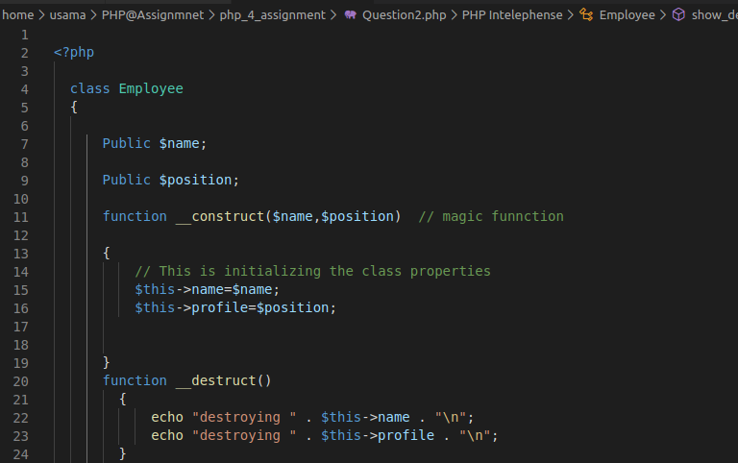
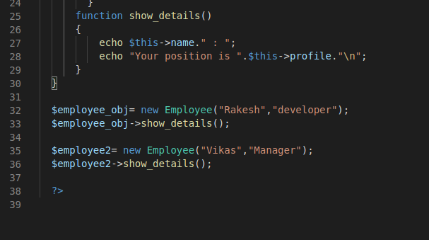

Ques: 6:- Write a PHP program to return Factorial value of number in a Object oriented way. Factorial logic should be in separate function.

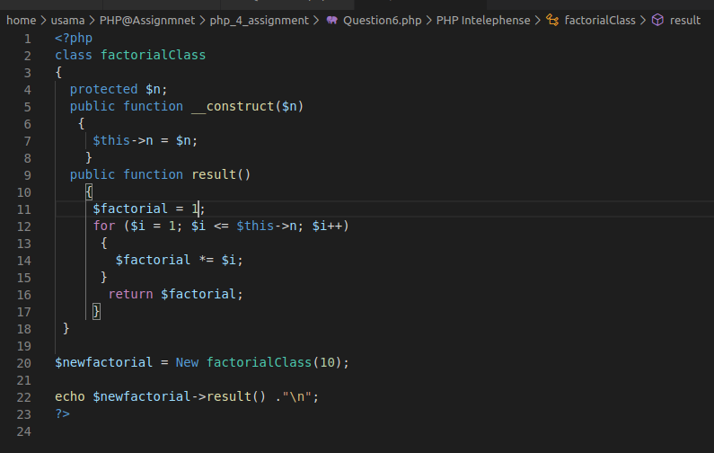


6:- Write a class that extends Abstract class.

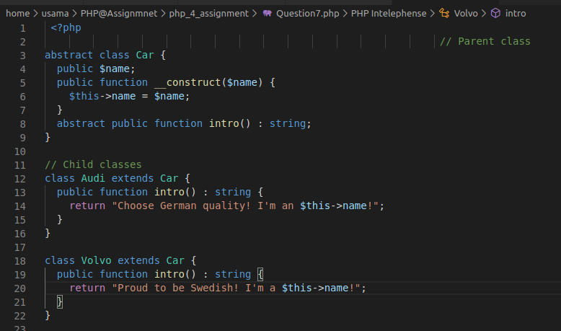
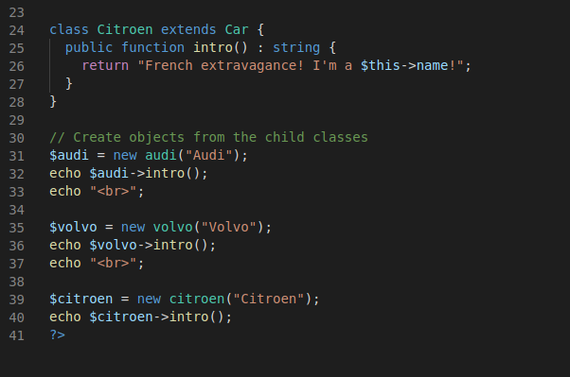

8:- Implement Inheritance in PHP program to display the Message when Parent class method is called and when the Child method is called.
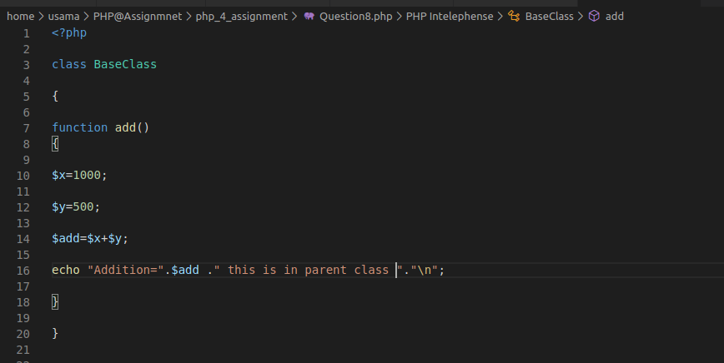
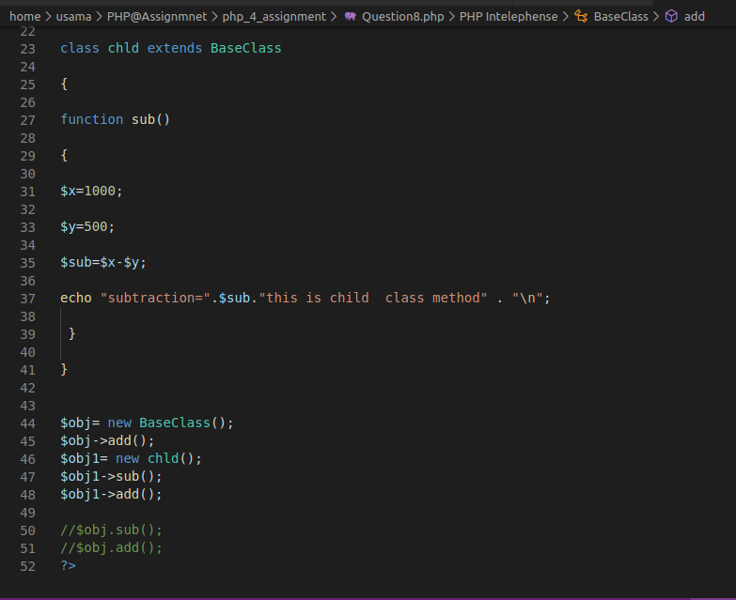
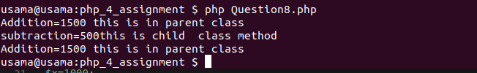

9:- What is method chaining explain with an example.
Ans:Method Chaining would allow you to write the above statements in a more compact way .
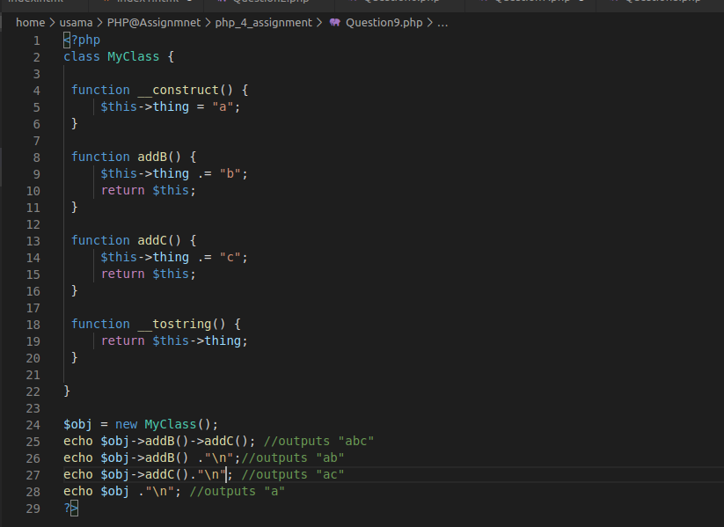


10:- What is $this keyword
Ans :
$this is mainly used to refer properties of a class. It is the way to reference an instance of a class from within itself, the same as many other object oriented languages. From the PHP docs: The pseudo-variable $this is available when a method is called from within an object context.
Example ::

11:- Write program to explain Multi Level Inheritance

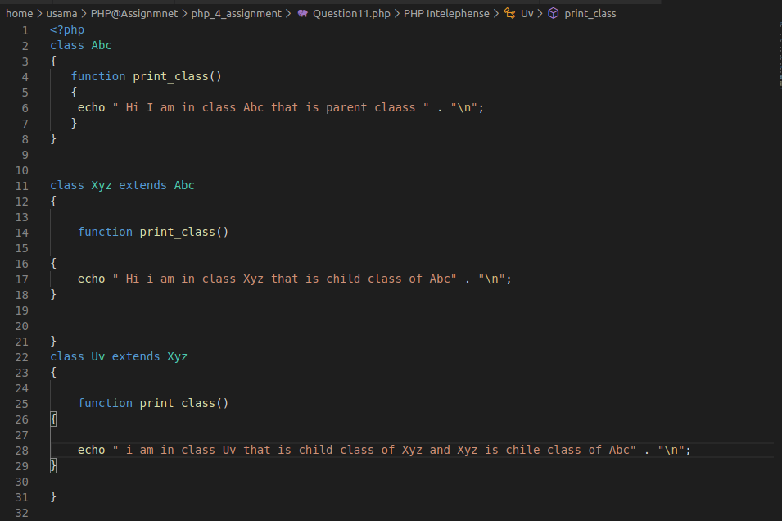
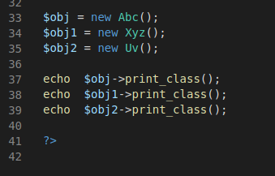

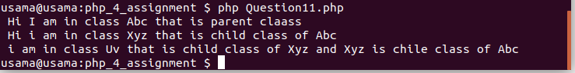

12.- Develop prototype for flight-booking service. Here, we don't own any flights. we are just a service provider mediator.
Define two methods :
a. checkFlightsAvailability() - to check available flights from two vendors like "Air India", "IndiGO".
b. bookFlights() - to book a seat from respective vendor.

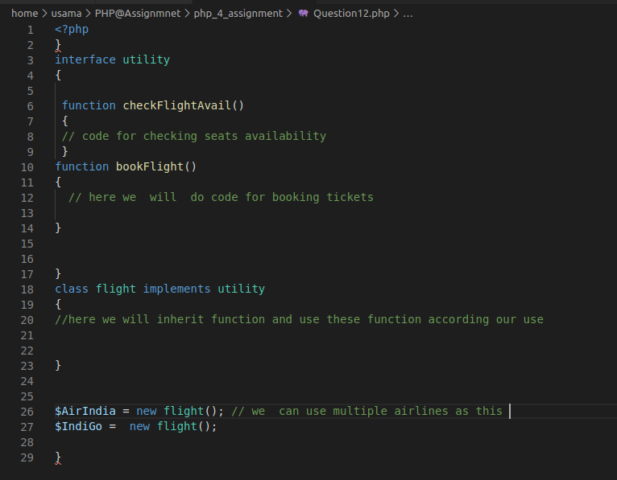

13:- Define three traits and use it in class and override it's function.
Ans :
