1:: Steps(with command and screenshots) for installing apache.
Ans :
Cammand : Sudo apt-get install apache2

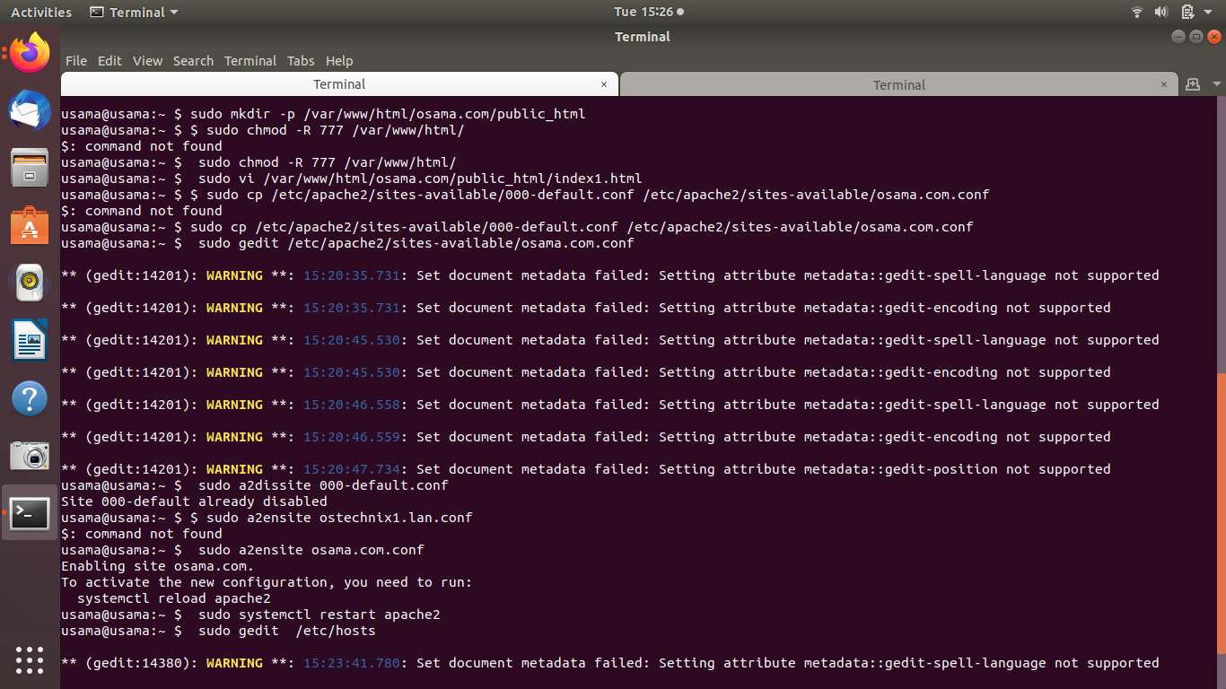

After runing fisrt osama.com on host:

File :: osama .com
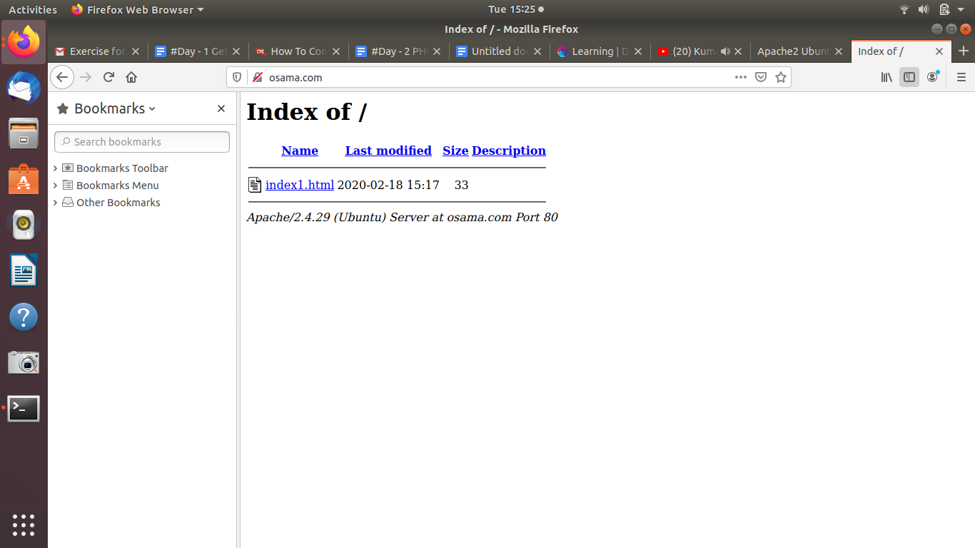

2:: Installation steps(with command and screenshots) PHP and print current version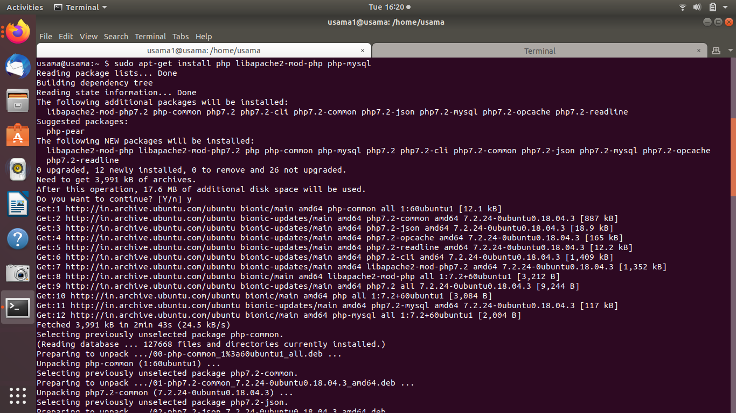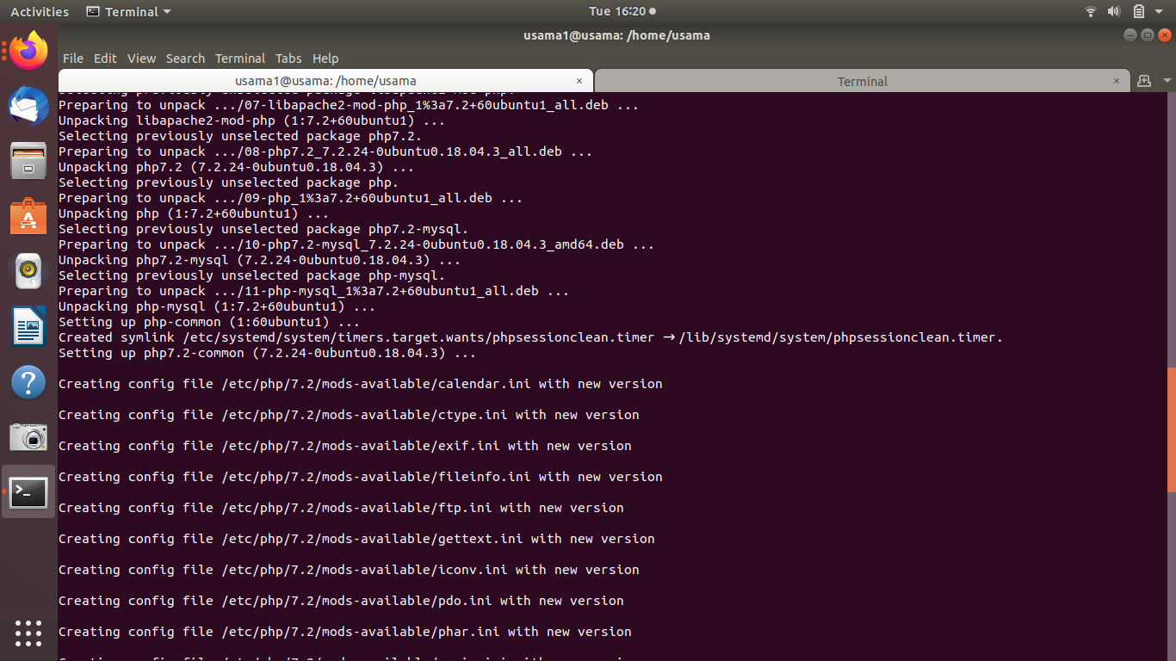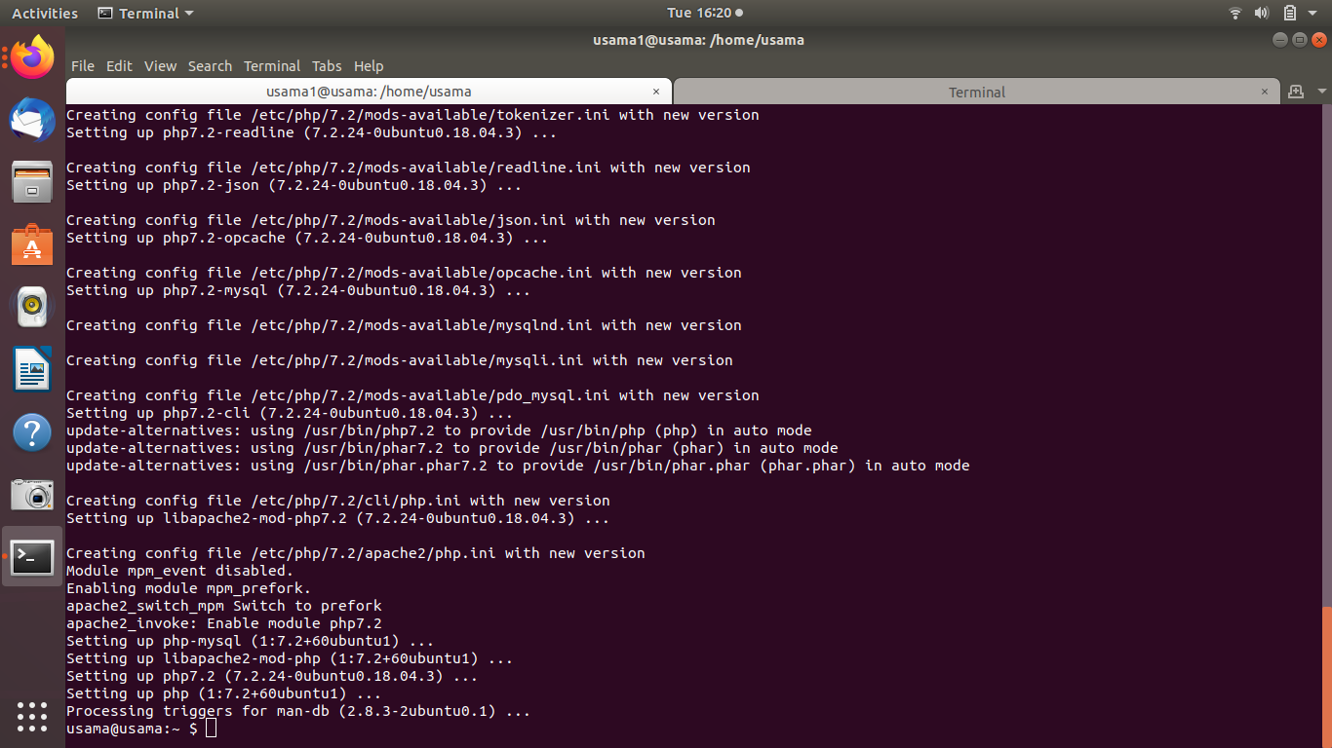

3: Installation steps(with command and screenshots) MySQL and print the current version

Ans : first we will use sudo apt-get update command and after that we will use that below commands 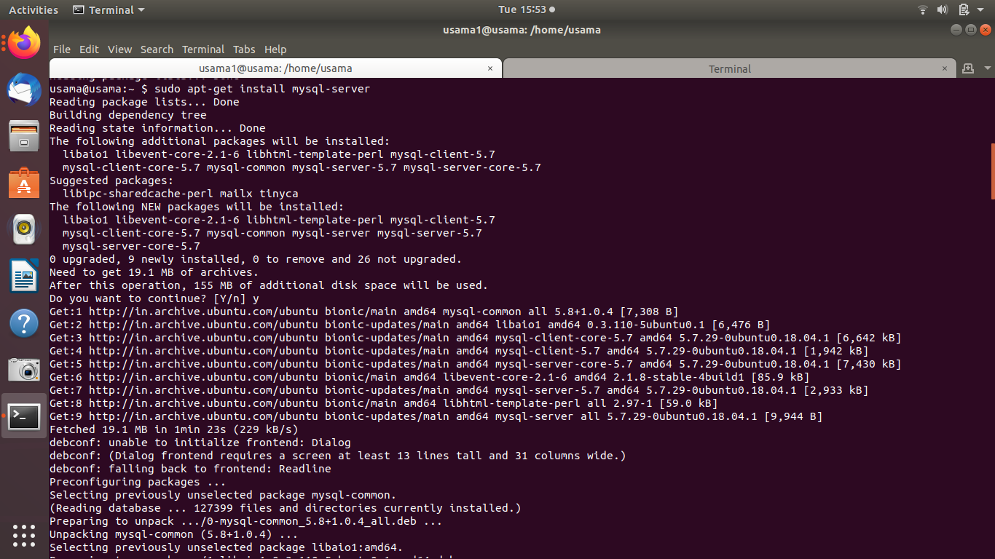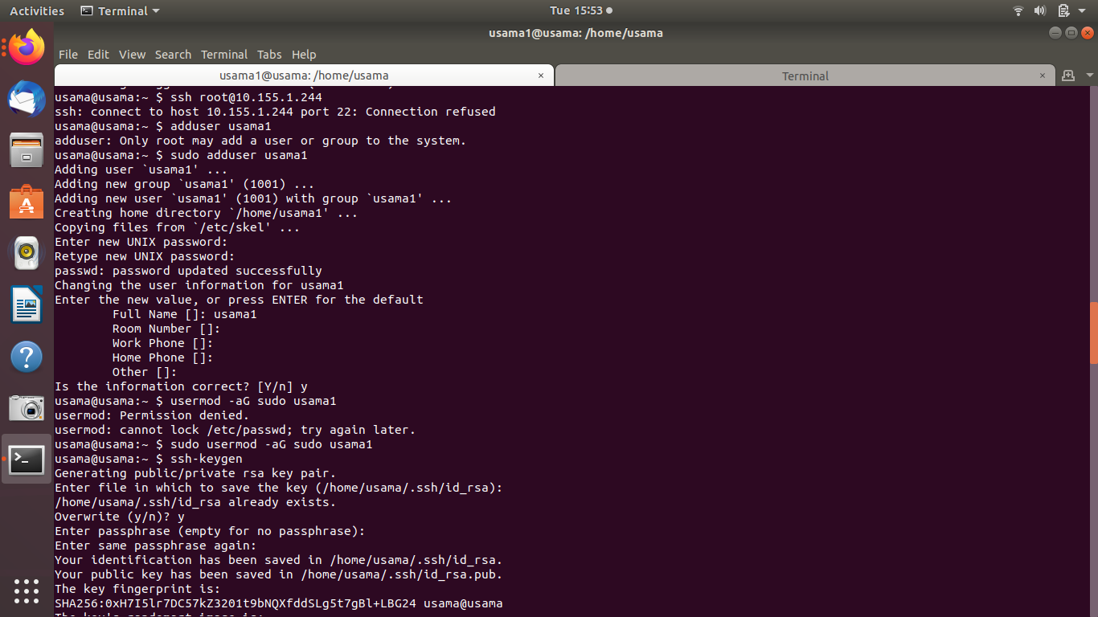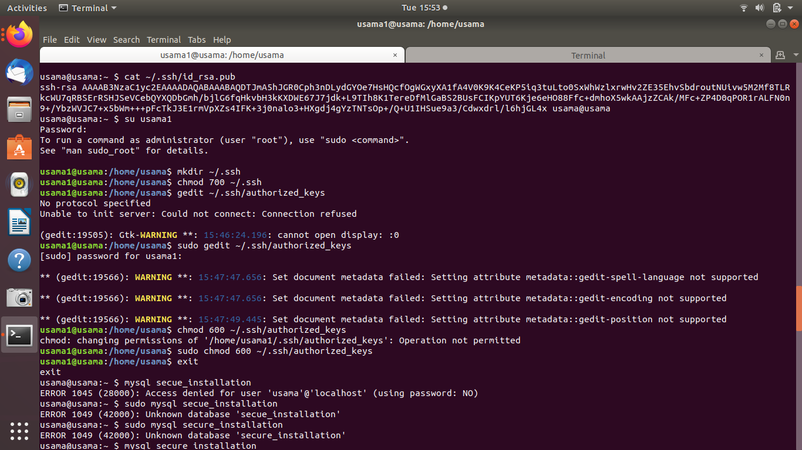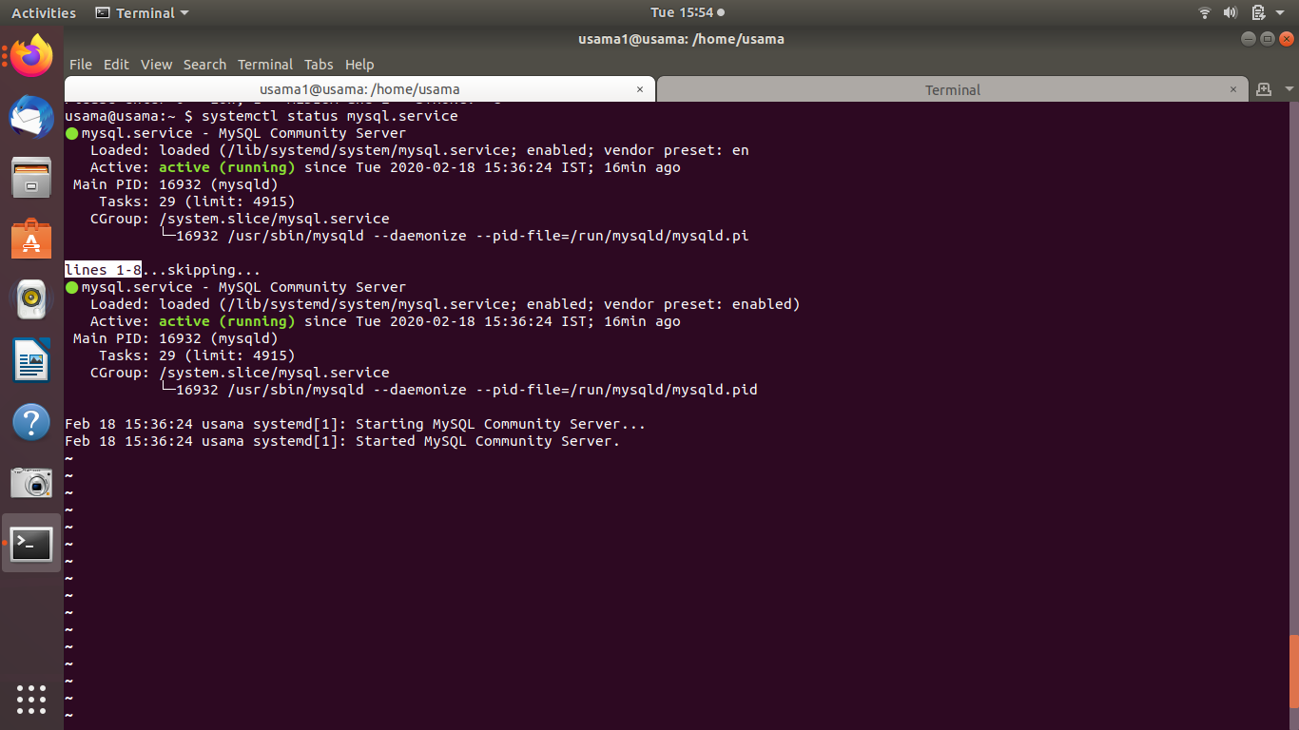

4: What is HTTP?
Ans :
HTTP stands for hypertext transfer protocol . It’s a protocol that allows communication between different systems. Most commonly, it is used for transferring data from a web server to a browser to view web pages.

5.What domain name will have the following address – 127.0.0.1
Ans:

127.0.0.1 is the loopback Internet protocol (IP) address also referred to as the localhost. The address is used to establish an IP connection to the same machine or computer being used by the end-user.

6.What language should you use for writing queries for the database?
Ans -

SQL is the most mainstream language that is used to access databases because it can work with any database. The databases, with which you interface, are programs that enable clients to store and manage information in a logical manner.

7.Which command is used for restart apache
Ans:
sudo systemctl restart apache2

8: Print fibonacci series
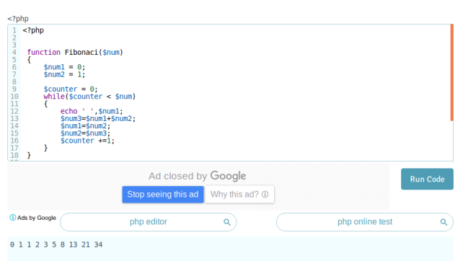

8.1 : Print 1 & 6 using foreach in array( 1, 2, 3, 4, 5, 6, 7 )
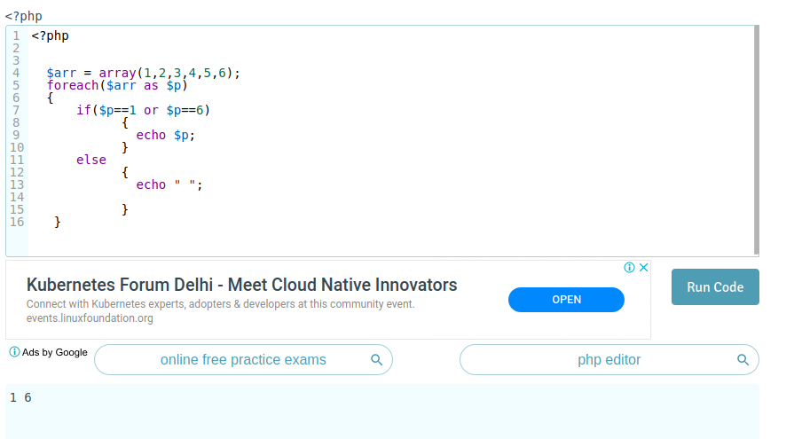

8.3:: Print 1 2 3 4 using break and foreach in array( 1, 2, 3, 4, 5, 6, 7 )

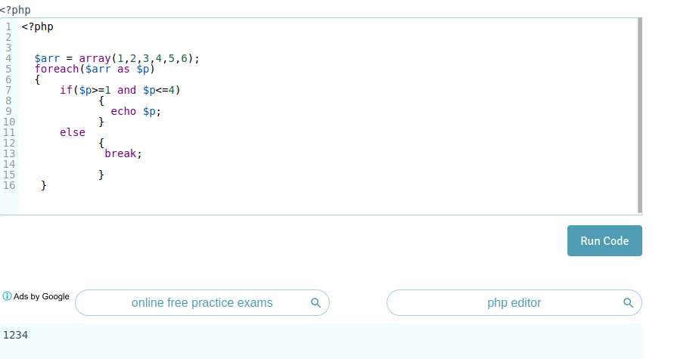

8.4: Using switch case, check if value ($value = 4) is greater than 5 or not. Case should be 1, 2, 3, 4, 5, 6.
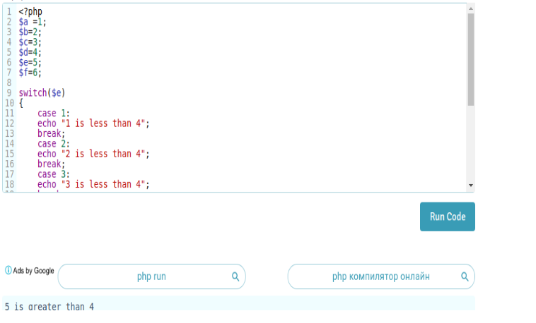

8.5 Create and print an infinite loop.
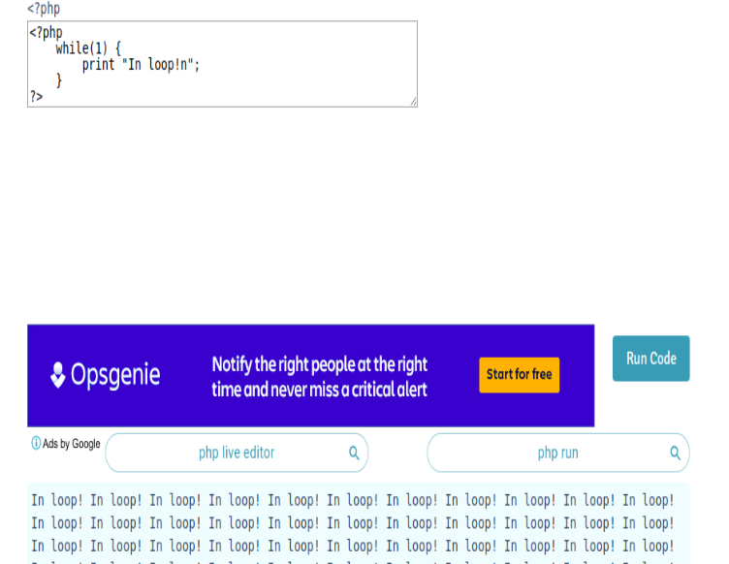

8.6: Create a script that displays 1-2-3-4-5-6-7-8-9-10 on one line. There will be no hyphen(-) at the starting and ending position.

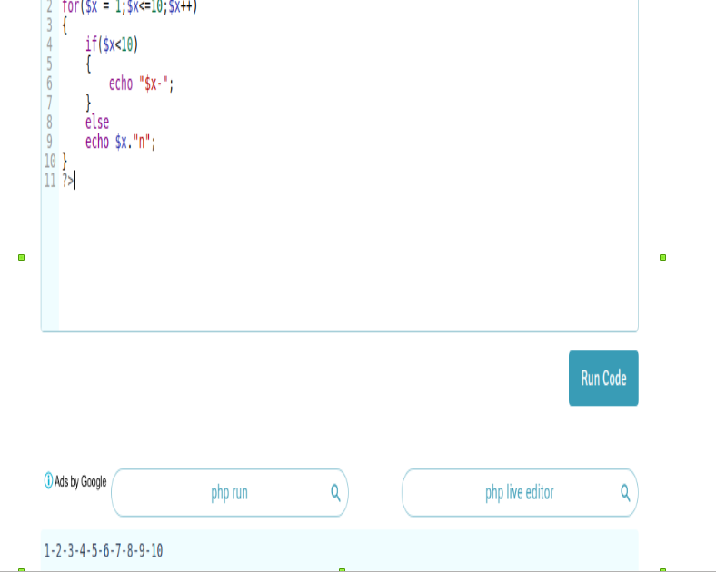

8.7:
Using Alternative syntax print values of array( 1, 2, 3, 4, 5, 6, 7 )

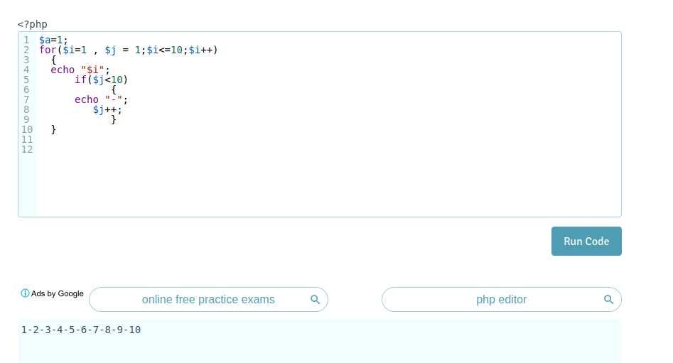

8.8 Print 1,2,3,6,7 from array( 1, 2, 3, 4, 5, 6, 7 )
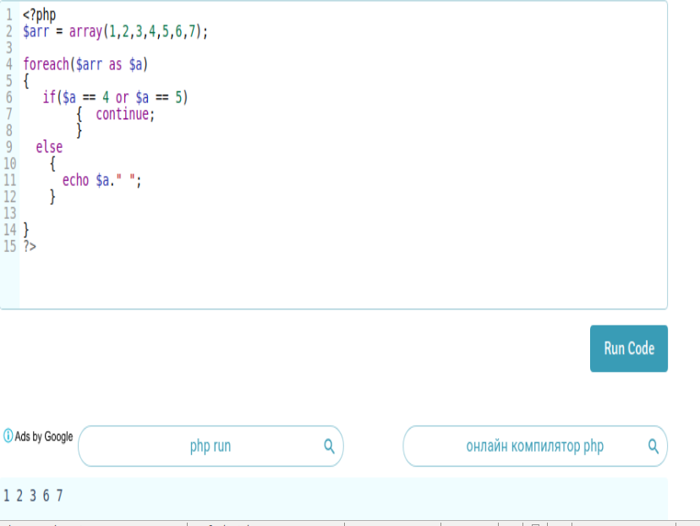

8.9: Create a function to calculate factorial value of a number. Use this function to get factorial of 5.’
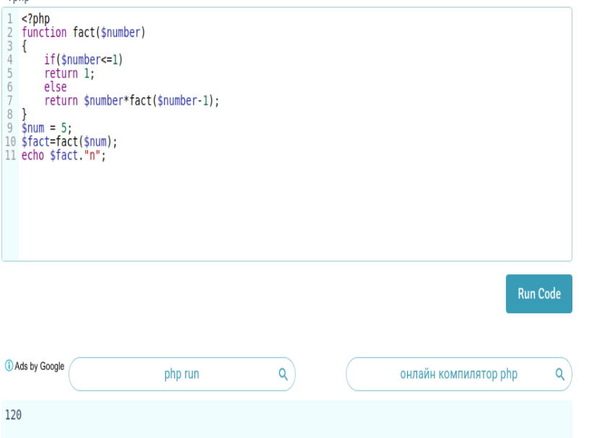

8.10 :
Include a PHP file (abc.php) in another file (xyz.php) and use variables from abc.php in xyz.php

8.11:
Using loop find the sum of numbers from 1 to 15.
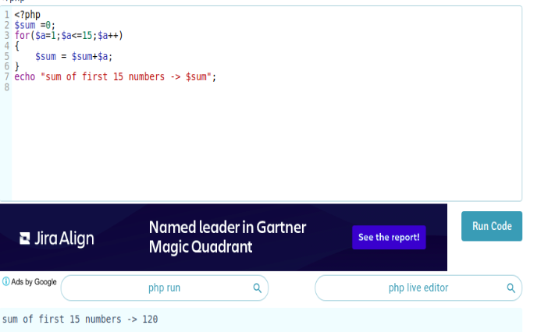

8.12 :
Give examples of Print, printf, sprintf.

Ans :
1:
printf will output a formatted string using placeholders

2:
sprintf will return the formatted string

3:
1: print can doesn't pass multiple argument .print always return 1 .it is slower than echo
