**Online Shopping**



**GROUP MEMBERS**

**“MUHAMMAD HUZAIFA”**

**Student1429963**

**“SALMAN KHAN”**

**Student1407193**

**“HUZAIFA IMRAN”**

**Student1430197**

**“KASHAN”**

**Student1429957**

**“JAMILA MUGHAL”**

**Student1385547**

**CURRICULUM**

***7062***

**BATCH**

***2211C2***

**FACULTY**

***“MS. NEELAM MALIK”***

**CO-ORDINATOR**

***“MS. MUNAZZAH KHAN*”**

**CERTIFICATE**

THIS IS TO CERTIFY THAT THE DISSERTATION ENTITLED

**“ONLINE SHOPPING”**

IS SUBMITTED BY

**MUHAMMAD HUZAIFA**

**STUDENT: 1429963**,

**SALMAN KHAN**

**STUDENT: 1407193,**

**HUZAIFA IMRAN**

**STUDENT:1430197**,

**KASHAN**

**STUDENT: 1429957**,

**JAMILA MUGHAL**

**STUDENT: 1385547**

IN THEIR PARTIAL FULFILMENT OF THE REQUIREMENT OF THE AWARD OF THE

APTECH COMPUTER CERTIFIED.



# 

**ACKNOWLEDGEMENT**

The success and final outcome of this project required a lot of guidance and assistance from many people and I am extremely privileged to have got this all along the completion of my project. All that I have done is only due to such supervision and assistance and I would not forget to thank them.

I respect and thank Aptech for providing me an opportunity to do the project work in ACE and giving us all support and guidance, which made me complete the project duly. I am extremely thankful to Aptech for providing such a nice support and guidance.

I owe my deep gratitude to our project guide MS. Neelam Malik, who took keen interest on our project work and guided us all along, till the completion of our project work by providing all the necessary information for developing a good system.

**ABSTRACT**

Welcome to our **Online Shopping website**, The "**Online Shopping**" website is a dynamic e-commerce platform designed to provide users with a convenient and seamless shopping experience. With an extensive catalog of products and services, this website offers a wide range of options for consumers to explore and purchase, all from the comfort of their own homes. The website prioritizes user-friendly design, efficient navigation, and a secure payment system to ensure a trustworthy and satisfying shopping experience. It incorporates modern web technologies and responsive design to make it accessible from various devices. "Online Shopping" aims to revolutionize the way customers shop, making it easier than ever to find, compare, and buy products and services online.

Key features of our website includes:

1. **User-Friendly Product Search and Filtering:** The "Online Shopping" website offers an intuitive and efficient product search and filtering system. Users can easily find the products they are looking for by using search keywords, categories, price ranges, and other filters. This feature enhances the user experience by helping customers quickly locate the items they desire, saving them time and frustration.
2. **Secure Payment Processing:** Security is a top priority for "Online Shopping." The website incorporates robust encryption and secure payment processing methods, ensuring the safety of customer financial information during transactions. Customers can confidently make purchases, knowing that their payment details are protected, which builds trust and encourages repeat business.

**Contents**

ACKNOWLEDGEMENT 4

ABSTRACT 5

CHAPTER NO 1 7

CHAPTER NO 2 8

CHAPTER NO 3 9

CHAPTER NO 4 11

CHAPTER NO 5 12

CHAPTER NO 6 17

CHAPTER NO 7 18

CHAPTER NO 8 19

**CHAPTER NO 1**

**INTRODUCTION**

Welcome to the future of shopping with the "Online Shopping" website! In a world where convenience and choice are paramount, we've crafted an exceptional e-commerce platform designed to redefine your shopping experience. Our website is not just a marketplace; it's a digital gateway to a world of endless possibilities.

Imagine a place where you can explore a vast catalog of products and services from the comfort of your home, office, or anywhere you choose. Whether you're looking for the latest fashion trends, cutting-edge electronics, or everyday essentials, we've got you covered. "Online Shopping" is your one-stop destination for all your shopping needs.

What sets us apart? It's not just our expansive selection but also the commitment to making your journey as smooth and secure as possible. We understand that your time is valuable, and your security is paramount. That's why we've implemented a user-friendly product search and filtering system to help you find what you need with ease, along with robust security measures to ensure your transactions are protected.

As you embark on this digital shopping adventure, you'll discover an ecosystem that's not only visually appealing but also highly functional. Our responsive design ensures that you can access our website from your desktop, tablet, or smartphone, making it effortless to shop on your terms.

"Online Shopping" is more than just a website; it's a promise of convenience, variety, and security. Join us on this journey to redefine the way you shop. Your future purchases are just a click away!

Top of Form

**CHAPTER NO 2**

***FUNCTION***

***REQUIREMENT***

1. **User Registration and Login:**
   * Users should be able to create accounts and log in securely.
2. **Product Catalog:**
   * Display a comprehensive catalog of products and services.
   * Organize products into categories and subcategories for easy navigation.
   * Include high-quality images, detailed descriptions, prices, and availability status.
3. **Responsive Design:**
   * Ensure the website is accessible and user-friendly on various devices (desktop, tablet, mobile).
4. **Admin Panel:**
   * Provide an admin panel for website administrators to manage products, users, and orders.
   * Enable content management, including the addition of new products, categories, and promotions.
5. **Performance Optimization:**
   * Ensure fast page loading times and minimal downtime.
6. **User Reviews and Ratings:**
   * Enable customers to leave reviews and ratings for products.
   * Display average product ratings and individual reviews.

**CHAPTER NO 3**

***REQUIREMENT***

***SPECIFICATION***

**INTRODUCTION:**

To be used efficiently, all computer software needs certain hardware components or the other software resources to be present on a computer. These pre-requisites are known as (computer) system requirements and are often used as a guideline as opposed to an absolute rule. Most software defines two sets of system requirements: minimum and recommended. With increasing demand for higher processing power and resources in newer versions of software, system requirements tend to increase over time. Industry analysts suggest that this trend plays a bigger part in driving upgrades to existing computer systems than technological advancements.

**HARDWARE REQUIREMENTS:**

The most common set of requirements defined by any operating system or software application is the physical computer resources, also known as hardware. A hardware requirements list is often accompanied by a hardware compatibility list (HCL), especially in case of operating systems. An HCL lists tested, compatibility and sometimes incompatible hardware devices for a particular operating system or application. The following sub-sections discuss the various aspects of hardware requirements.

**HARDWARE REQUIREMENTS FOR PRESENT PROJECT:**

PROCESSOR: Intel dual Core, i3

RAM: 4 GB

HARD DISK: 250 GB

**SOFTWARE REQUIREMENTS:**

Software Requirements deal with defining software resource requirements and pre-requisites that need to be installed on a computer to provide optimal functioning of an application. These requirements or pre-requisites are generally not included in the software installation package and need to be installed separately before the software is installed.

**SOFTWARE REQUIREMENTS FOR PRESENT PROJECT:**

OPERATING SYSTEM: Windows 7/ XP/8/10

SOFTWARE: Visual Studio Code

FRONT END: PHP

DATABASE: My SQL

**CHAPTER NO 4**

**LANGUAGE SPECIFICATION:**

**PHP:**

PHP started out as a small open source project that evolved as more and more people found out how useful it was. Rasmus Leadoff unleashed the first version of PHP way back in 1994.

* PHP is a recursive acronym for "PHP: Hypertext Preprocessor".
* PHP is a server-side scripting language that is embedded in HTML. It is used to manage dynamic content, databases, session tracking, even build entire e-commerce sites.
* It is integrated with a number of popular databases, including MySQL, PostgreSQL, Oracle, Sybase, Informix, and Microsoft SQL Server.
* PHP is pleasingly zippy in its execution, especially when compiled as an Apache module on the Unix side. The MySQL server, once started, executes even very complex queries with huge result sets in record-setting time.
* PHP supports a large number of major protocols such as POP3, IMAP, and LDAP. PHP4 added support for Java and distributed object architectures (COM and CORBA), making n-tier development a possibility for the first time.
* PHP is forgiving: PHP language tries to be as forgiving as possible.
* PHP Syntax is C-Like.

**MY SQL:**

MySQL is an open source relational database management system that was originally released in 1995. MySQL is popular among all databases, and is ranked as the 2nd most popular database, only slightly trailing Oracle Database. Among open source databases, MySQL is the most popular database in use today.

**CHAPTER NO 5**

**SCREEN SHOTS**

**HOME**



**REGISTER**

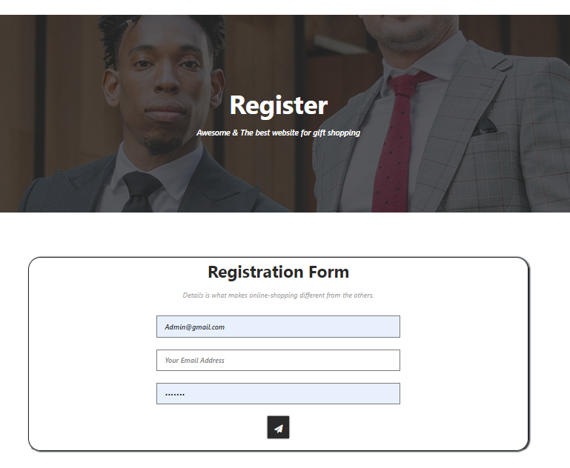

**LOGIN**

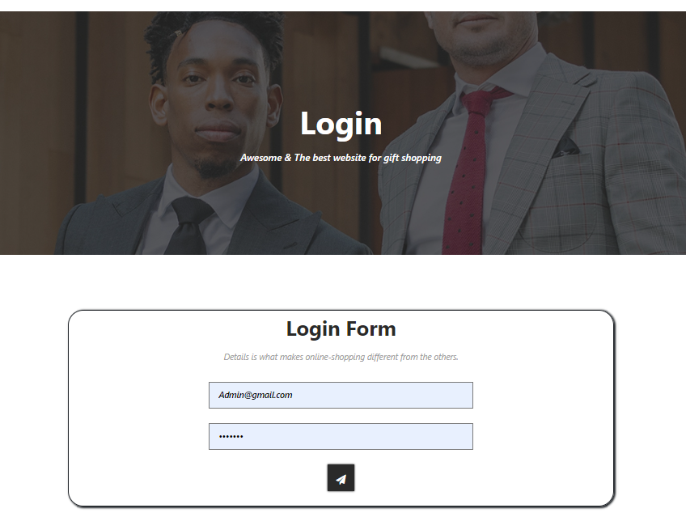

**ABOUT**

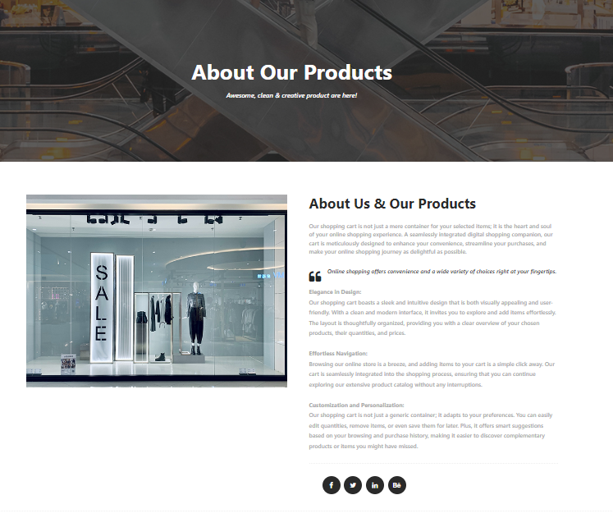

**CONTACT US**

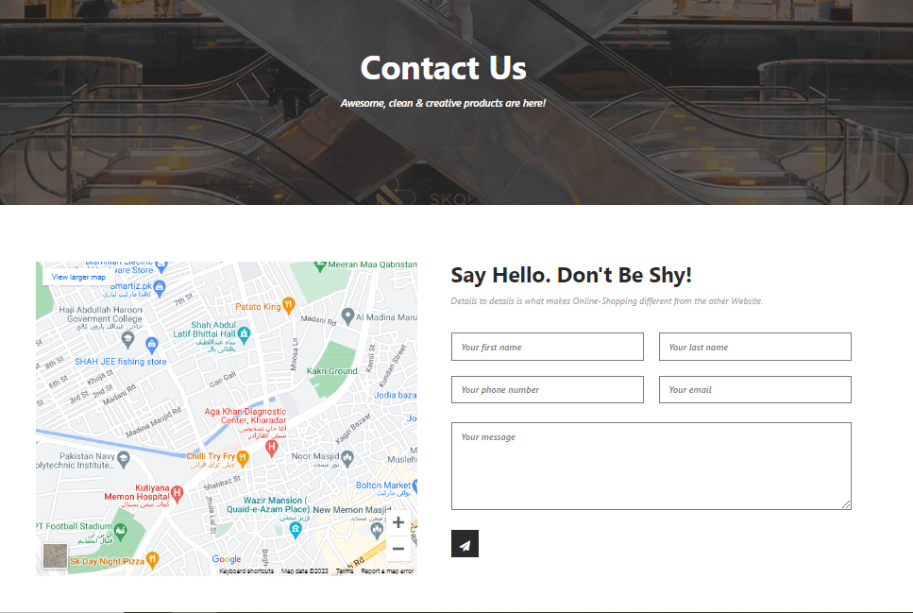

**CHAPTER NO 6**

**TASK SHEET**

|  |  |  |  |
| --- | --- | --- | --- |
| **S#** | TASK | **TEAM MEMBER NAMES** | **STATUS** |
| **1.** | Database | SALMAN KHAN, JAMILA MUGHAL | ✓ |
| **2.** | CRUD Operations | MUHAMMAD HUZAIFA, KASHAN | ✓ |
| **3.** | Development | MUHAMMAD HUZAIFA, JAMILA MUGHAL,  HUZAIFA IMRAN, KASHAN | ✓ |
| **4.** | Documentation | HUZAIFA IMRAN, SALMAN KHAN | ✓ |
| **5.** | Finalization | HUZAIFA IMRAN, SALMAN KHAN, KASHAN,  MUHAMMAD HUZAIFA, JAMILA MUGHAL | ✓ |

**CHAPTER NO 7**

**Submission List**

|  |  |  |  |
| --- | --- | --- | --- |
| **S#** | **LIST OF ITEMS** | **REMARKS** | **COMMENTS** |
| **1.** | Do All Pages link together? | **YES** | ✓ |
| **2.** | Authorization | **YES** | ✓ |
| **3.** | CRUD Operations | **YES** | ✓ |
| **4.** | Database Connection | **YES** | ✓ |
| **5.** | Feedback form included | **YES** | ✓ |
| **6.** | Project ZIP file | **YES** | ✓ |

**CHAPTER NO 8**

**CONCLUSION**

This is an automated project designed to facilitate the management of legal services and appointments. The website caters to users and administrators who utilize its features involve extending access to lawyer to accept or reject appointment if they want within the legal industry.