Experiment 6
Aim: To apply Agile methodologies and use Jira for sprint planning, task tracking, and integrating with DevOps workflows.
LO : Mapped LO1
LO: Apply Agile methodologies and use Jira for sprint planning, task tracking, and integrating with DevOps workflows.
Theory:
Agile is an iterative approach to software development in which work is delivered in small increments and continuously reviewed and improved. Scrum is an Agile framework that organizes development into time-boxed iterations called sprints. Jira provides a digital environment for implementing these practices by organizing requirements, planning sprint work, tracking progress and visualizing dependencies.
In Jira, a project can be organized using a hierarchy consisting of high-level goals, epics, user stories and tasks/sub-tasks. An epic represents a larger initiative that can be divided into smaller deliverables.
User stories describe functional requirements that provide customer value, while tasks represent specific pieces of implementation work. The project used in this experiment is “Sheify Website Development”, with the epics “Improve Customer Service” and “Increase Product Page Conversions”.
The Backlog is used to refine and prioritize work before or during sprint planning. Selected work items are moved into a sprint, where the team works toward a defined sprint goal. The Scrum Board provides a visual workflow in which issues move through statuses such as To Do, In Progress, In Review and Done. This makes the current state of each work item visible to the team.
Jira also supports issue linking to represent dependencies between work items. A dependency can indicate that one task blocks another task or story. The Timeline view provides a Gantt-style representation of epics and their child work items over time and can display dependency relationships. These views help the team understand scheduling, workload and progress while applying Agile project-management practices.

Procedure:
1. Open the Jira project “Sheify Website Development” and select the Scrum project views.
2. Open Backlog and verify Scrum Sprint 1, the sprint goal, the issues included in the sprint and the remaining backlog items.
3. Observe the work breakdown under the parent epics “Improve Customer Service” and “Increase Product Page Conversions”.
4. Verify the current status and assignment of sprint issues in the Backlog.
5. Open the Board and observe the workflow columns To Do, In Progress, In Review and Done and the issues placed in each column.
6. Open the Timeline and observe the sprint schedule, epic/issue bars, assignees and dependency links between work items.
7. Capture the Backlog, Board and Timeline views as the final experimental output.
Project Details:
• Project: Sheify Website Development
• Framework: Scrum
• Sprint: SCRUM Sprint 1 — 3 Sep to 30 Sep
• Sprint Goal: Improve our customer's experience on our website
• Epic 1: SCRUM-5 — improve customer service
• Epic 2: SCRUM-6 — increase product page conversions
• Sprint Work Items: SCRUM-7 — provide live chat as a feature; SCRUM-3 — Add WhatsApp chat to our website; SCRUM-10 — Add Facebook messenger chat to our website
• Remaining Backlog: SCRUM-8 — create a video based knowledge base; SCRUM-9 — create a review based system for collecting and showing reviews
• Observed Statuses: SCRUM-7: In Progress; SCRUM-3: In Review; SCRUM-10: To Do; SCRUM-8: To Do; SCRUM-9: To Do

Output:

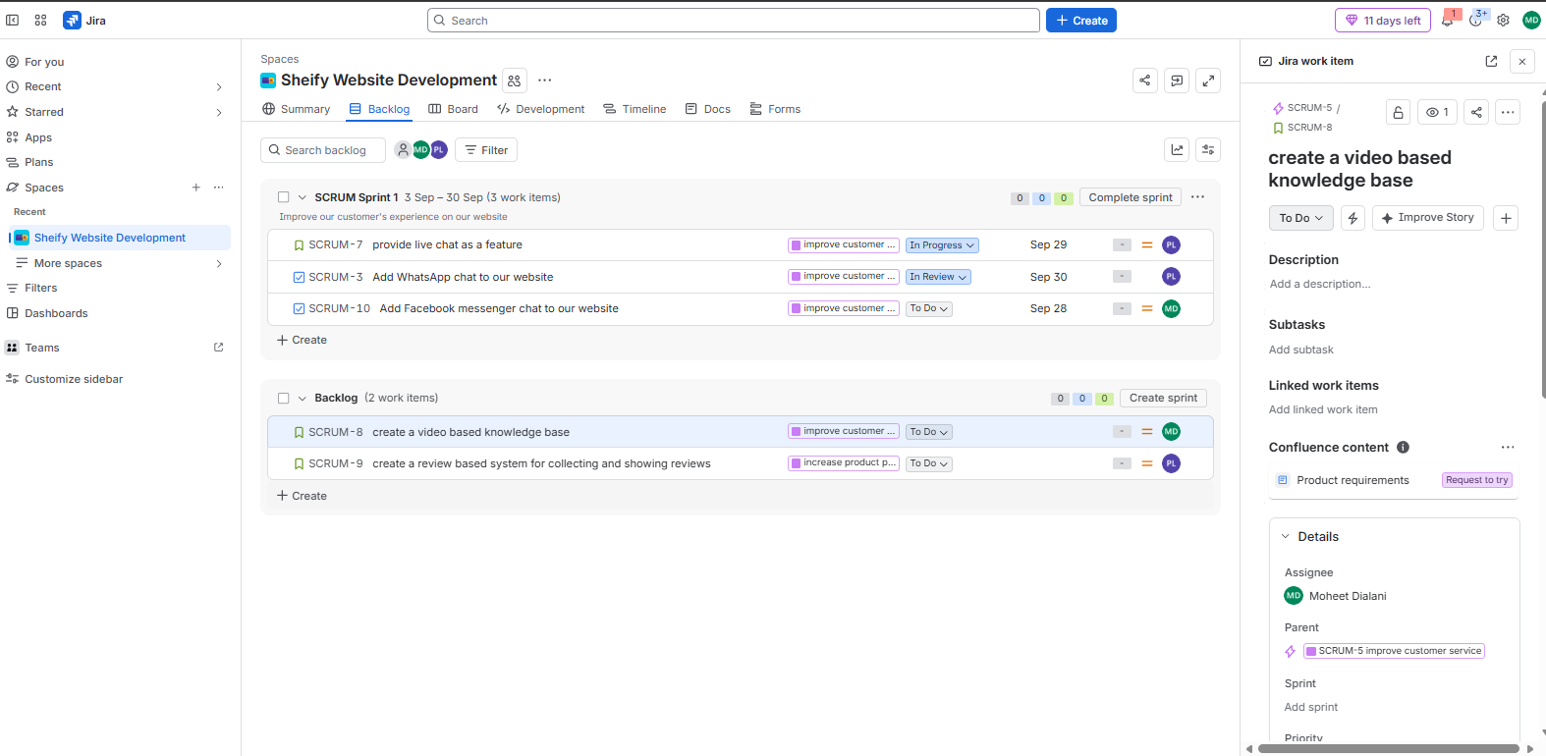
d
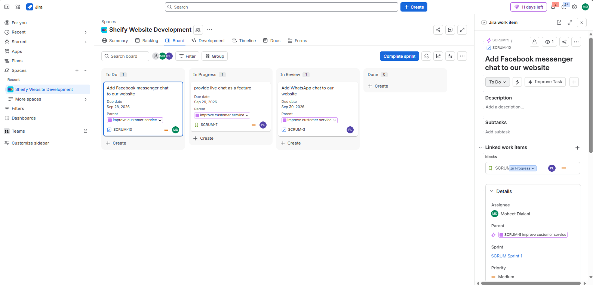

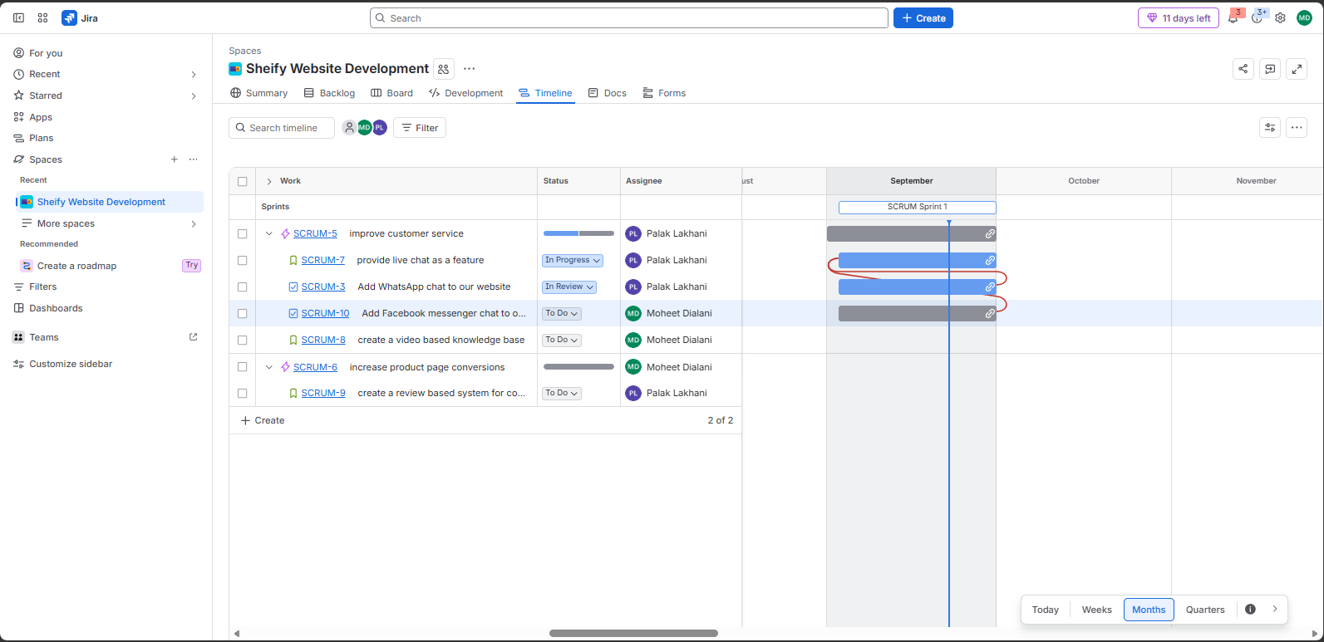

Conclusion:
The experiment demonstrated how Jira can be used to apply Agile/Scrum practices in a software project. Backlog refinement and sprint planning organize the work, the Scrum Board enables continuous status tracking, and the Timeline provides a visual understanding of schedules and dependencies. Together, these features support transparent planning, collaboration and progress monitoring in an Agile development workflow.

