University of St Andrews
University Library

Research Data Officer – AD1671AS

Further Particulars for Applicants

University Library

The University Library was founded in 1612 by a royal gift of books from King James VI of Scotland, and our collection development policy has always reflected the teaching and research profile of the institution. We are responsible for delivering high-quality information in digital and print form along with user-centric services to support students, academic and research staff who work within the University as well as the wider academic and local communities. The University Library has a staff of over 100 and is organised into four divisions:
- Collections, Liaison and Resources
- Digital Research
- Public Services and Communications
- Special Collections
Staff across the divisions work together to support the University in its mission to deliver excellence in learning, teaching and research. We aim to provide excellent customer service and remain at the forefront of service delivery.

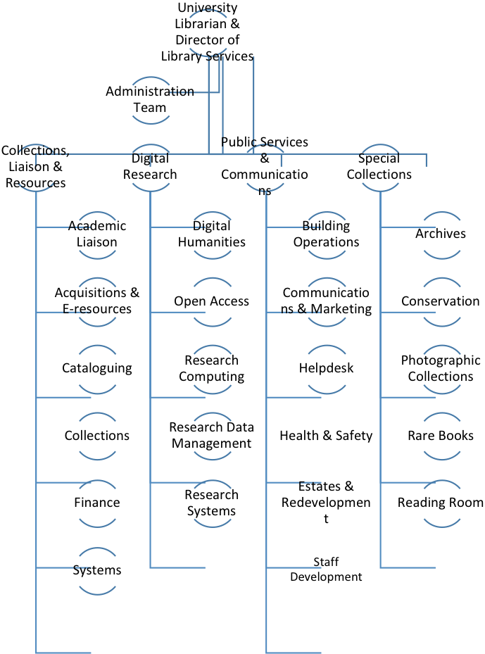

The job description for this role is attached below.

Job Description

Job Title: Research Data Officer

School/Unit: University Library

Reporting to: Data Scientist

Job Family: Managerial, Specialist & Administrative

Duration of Post: 6 months/may be extended
Secondment Opportunity

Working Hours: Full-time/ 36.25 hours per week

Grade/Salary Range: Grade 5/£26,495 – £31,604 per annum, pro rata

Reference No: AD1671AS

Start Date: 12 Nov 2018, or as soon as possible thereafter

Interview date: 27 September 2018

Main Purpose of Role

To support the day-to-day running of the Research Data Management service and to assist the Data Scientist in ensuring that the University meets funders’ evolving requirements for open research data. To this end the post holder will advise academic staff on policy compliance, assist researchers to deposit research data to the University’s current research information system (PURE) and promote good practice in research data management throughout the research life cycle.

The post holder will also support the Data Scientist on the Jisc Research Data Shared Service project.

Key Duties and Responsibilities

Research Data Management (RDM) support and advocacy
- Provide first and second line support to researchers (staff and students) across the University in order to make University research data publicly available.
- Answer research data management enquiries; i.e.: data publication workflows and deposit in Pure.
- Support researchers with mediated deposit of research data when requested.
- Work on the Research Information System PURE to create, edit, check and validate research data records. This will include quality control of data files, metadata creation, metadata quality control for research data and issuing of DOIs (Digital Objects Identifiers).
- Develop and maintain an understanding of different licensing options for datasets; i.e. Creative Commons licences.
- Build and maintain effective relationships with colleagues in the library, research policy office and administrative and technical staff in academic schools.
- Contribute to the refinement of existing workflows and the development of new ones.
- Co-ordinate and develop discipline-specific guidance and workflows.
- Create documentation, factsheets and information for web pages and the RDM blog.
- Co-ordinate updates of funders’ policies information on the RDM website.
- Support the organisation and presentation of advocacy and training events for research data management services, including covering for the Data Scientist as required.

RDM policy and compliance
- Acquire and maintain expert knowledge of funder mandates on research data and compliance criteria, and provide advice to researchers on data management and sharing requirements.
- Monitor RDM policy compliance using the Research Information System PURE with specific responsibility for some Schools. Contact researchers to deposit research data if they have not already done so.
- Quantitative reporting on research data compliance. Support and assist with the preparation of figures and reports for compliance monitoring.
- Manage the recording of statistics from Pure on datasets deposits, datasets downloads, file sizes and other relevant figures.

Jisc Research Data Shared Service project
- Assist with the organisation of regular project meetings.
- Take and distribute project meetings minutes.
- Assist with maintaining the project documentation library.

Please note that this job description is not exhaustive, and the role holder may be required to undertake other relevant duties commensurate with the grading of the post. Activities may be subject to amendment over time as the role develops and/or priorities and requirements evolve.

Person Specification

This section details the attributes e.g. skills, knowledge/qualifications and competencies which are required in order to undertake the full remit of this post.

Attributes
Essential
Desirable
Means of Assessment
(i.e. application form, interview, test, presentation etc.)

Education & Qualifications

(technical, professional, academic qualifications and training required)

Degree / equivalent professional qualification
OR
Equivalent work experience

Application

Experience & Knowledge

(examples of specific experience and knowledge sought)

Knowledge of the academic research process

Awareness of the open research environment

Experience of preparing reports for a variety of audiences

Experience of team working
Knowledge of external (funder, publisher) policies affecting research data management within UK HEI.

Experience of working in support service role at HEI or experience of working in a research environment

Knowledge and experience of research methodologies, and particularly creating/managing or publishing research data

Working knowledge of the research publication process

Experience of using PURE CRIS as an end user or in an administrative role

Application
Interview

Competencies & Skills

(e.g. effective communication skills, initiative, flexibility, leadership etc.)

Able to manipulate data in Excel

High degree of attention to detail, accuracy

Ability to work alone and as part of a team

Ability to work under pressure to targets and deadlines

Ability to plan and organize work and prioritise conflicting demands

Ability to demonstrate problem solving skills

Excellent interpersonal and communication skills both written and oral

Customer service skills

Webpage creation, desktop publishing experience, knowledge of digital formats
Application
Interview
Test

Essential Criteria – requirements without which a candidate would not be able to undertake the full remit of the role. Applicants who have not clearly demonstrated in their application that they possess the essential requirements will normally be rejected at the short listing stage.

Desirable Criteria – requirements which would be useful for the candidate to hold. When short listing, these criteria will be considered when more than one applicant meets the essential requirements.

Other Information

Interviews will be held on Thursday 27 September 2018

We encourage applicants to apply online at www.vacancies.st-andrews.ac.uk/welcome.aspx, however if you are unable to do this, please call +44 (0)1334 462571 for a paper application form.

For all applications, please quote ref: AD1671AS

This role does not meet the minimum requirements set by the UKVI to enable sponsorship of migrant workers. Further information can be found at https://www.st-andrews.ac.uk/staff/policy/immigration/.

The University of St Andrews is committed to promoting equality of opportunity for all, which is further demonstrated through its working on the Gender and Race Equality Charters and being awarded the Athena SWAN award for women in science, HR Excellence in Research Award and the LGBT Charter; http://www.st-andrews.ac.uk/hr/edi/diversityawards/.

The University is committed to equality of opportunity.

The University of St Andrews is a charity registered in Scotland (No SC013532).

Obligations as an Employee

You have a duty to carry out your work in a safe manner in order not to endanger yourself or anyone else by your acts or omissions.

You are required to comply with the University health and safety policy as it relates to your work activities, and to take appropriate action in case of an emergency.

You are required to undertake the Information Security Essentials computer-based training course and adhere to its principles alongside related University Policy and Regulations.

You are responsible for applying the University’s equality and diversity policies and principles in your own area of responsibility and in your general conduct.

You have a responsibility to promote high levels of customer care within your own area of work/activities.

You should be adaptable to change, and be willing to acquire new skills and knowledge as applicable to the needs of the role.

You may, with reasonable notice, be required to work within other Schools/Units within the University of St Andrews.

You have the responsibility to engage with the University’s commitment to Environmental Sustainability in order to reduce its waste, energy consumption and carbon footprint.

The University & Town

Founded in the early 15th century, St Andrews is Scotland’s first university and the third oldest in the English speaking world.

Situated on the east coast of Scotland and framed by countryside, beaches and cliffs, the town of St Andrews was once the centre of the nation’s political and religious life.

Today it is known around the world as the ‘Home of Golf’ and a vibrant academic town with a distinctively cosmopolitan feel where students and university staff account for more than 40% of the local population.

The University of St Andrews is a diverse and international community of over 11,000, comprising students and staff of over 120 nationalities. It has 8,800 students, just over 7,000 of them undergraduates, and employs approximately 2,540 staff - made up of c. 1,190 in the academic job families and c 1,350 in the non-academic job families.

St Andrews has approximately 50,000 living graduates, among them former Scottish First Minister Alex Salmond and the novelist Fay Weldon. In the last 90 years, the University has conferred around 1000 honorary degrees; notable recipients include Benjamin Franklin, Rudyard Kipling, Alexander Fleming, Iris Murdoch, James Black, Elizabeth Blackadder, Tim Berners-Lee and Hillary Clinton.

The University is one of Europe’s most research intensive seats of learning. It is the top rated university in Scotland for teaching quality and student satisfaction. In the Research Excellence Framework (REF) 2014 the University was ranked top in Scotland for quality of research output and one of the UK’s top 20 research universities.

St Andrews is consistently held to be one of the United Kingdom’s top ten universities in university league tables compiled by The Times and The Sunday Times, The Guardian and The Complete University Guide. The University has eight times been named the top multi-faculty university in the UK in the National Student Survey – a direct reflection of the quality of teaching, assessment and facilities. In international and world rankings St Andrews scores highly for teaching quality, research, international outlook and citations. It is established as a World Top 100 institution in annual rankings produced by QS and Times Higher Education.

Its international reputation for delivering high quality teaching and research and student satisfaction make it one of the most sought after destinations for prospective students from the UK, Europe and overseas. In 2015 the University received on average 12 applications per place. St Andrews has highly challenging academic entry requirements to attract only the most academically potent students in the Arts, Sciences, Medicine and Divinity.

The University is closely integrated with the town. The Main Library, many academic Schools and Service Units are located centrally, while the growth in research-active sciences and medicine has been accommodated at the North Haugh on the western edge of St Andrews.

As the University enters its seventh century, it is delivering a varied programme of strategic investment, including the refurbishment of its Main Library and a major investment in its collections, the opening of a research library, the development of a major arts centre and a Music Centre, the refurbishment of the Students’ Union, the provision of 900 additional students beds, the relocation of professional services to purpose built accommodation and the development of a wind-farm and green energy centre to offset energy costs.

