

American International University-Bangladesh (AIUB)  
**Department of Computer Science and Engineering   
Faculty of Science &Technology (FST)  
SUMMER-2021  
CSC 00191- Object Oriented Analysis And Design (OOAD)**

**Section: I**

**Project Title: Online Shopping Management System**

**Submitted by:**

|  |  |
| --- | --- |
| **Name** | **ID** |
| 1. **Rijon Fardous** | **20-41943-1** |
| 1. **Sabiha Khair Ohi** | **20-41905-1** |
| 1. **Samihatul Bari** | **20-42018-1** |
| 1. **Mohi Uddin Anando** | **20-43585-1** |

**Submitted to:**

**MD. ANWARUL KABIR**

**Sr. Assistant Professor**

**Department of Computer Science**

# 1. Project Title: Online Shopping Management System

# 2. Project Overview:

In this project, people can easily buy products online. Online shopping is a platform where people can just open an app and select the needy goods for placing an order and delivery men will deliver the goods in front of their house. The novel coronavirus disease (COVID-19) has impacted the daily life of many people. Grocery Shopping plays an important role in our life. People are using public transport for grocery shopping various type of people travel in public transport which is very unhygienic. For traveling in public transport and visiting crowded grocery shops they can be affected by covid 19 even they are family can be affected also. Online grocery is far better than offline grocery shopping. It is hygienic also. They don’t have to give much effort in online shopping. They just have to place an order by using an app and the delivery boy will deliver the parcel outside of their house. Registered users/customers can easily order products from here. They can manage carts from this system. Either, they can pay online which really benefits them. On the other hand, administrators can easily see what customers order and confirm them so the delivery man can deliver them.

**Actor:**

1.User

2.Administrator

3.Registered User

4.Payment Service Provider

3. Justification:

The Internet has revolutionized the way we shop. Because of the numerous advantages and benefits, more and more people these days prefer buying things online over the conventional method of going into stores. There are a lot of benefits of our proposed system. They are

1.**No crowds:** During holidays, festivals, or on weekends, they can be such a huge headache. Also, being crushed in the crowds of shoppers sometimes makes us feel rushed or hurried. You don't have to battle for a parking place. All of these problems can be avoided when you shop online.

2.**Easy price comparisons:** If you're shopping for appliances, for example, you can find consumer reviews and product comparisons for all the options on the market, with links to the best prices. We can research firsthand experience, ratings, and reviews for most products and retailers.

3.**No pressure:** Oftentimes when we're out shopping, we end up buying things that we don't really need, all because shopkeepers pressure us or use their selling skills to compel us to make these purchases.

4. **Easy to find:** Finding a product on the Internet is much easier than running through your local store to find the right product or size. You can order your shopping online and have it delivered to a convenient pickup point (Click and Collect) or to a Collect in Store counter.

5.**Privacy:** When you shop in-store everybody sees what you buy. In some cases, this might be problematic or even embarrassing. With online shopping, you always get the desired privacy and anonymity.

4. Overall Use Case of the project:

In an Online Shopping management system, there are several types of users. In this system, user can view products and search products. User can also get registered and create an account. A registered customer need to login to the system before they use this system. But to login customer have to go through password verification. System Administrator deals with the account of the customers. In this System, An Administrator manage inventory and confirm delivery. After login System customer can Manage their shopping chart by add products to chart and delete products from chart if he/she needed. A customer can pay his bills in online. System Customer can pay bills by credit cards or debit cards. The payment service provider deals with the payment of the customer.

**Use Diagram**:

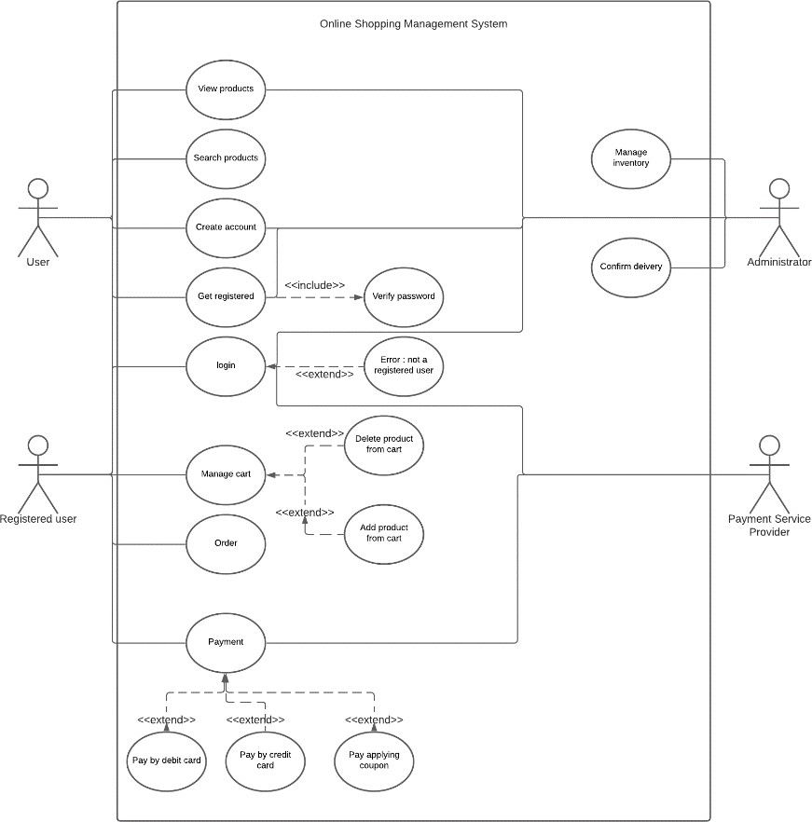

5. Class diagram of the project:

In a online shopping system a customer has six attributes customerName, customerID, address, email, customerMobile, customerAccountNo. All attributes are private and all the attributes are string type. there are five methods in customer class. A customer may have one account and a customer has one shopping cart. A customer has many products in shopping cart. Customer can make payment through credit and debit card. In the Order class there are five attributes:orderId, orderDate, orderItems, totalAmount, deliveryAddress. Except totalAmount all the attributes are string. totalAmount is double. there are five methods in order class. an order has one payment. in the Product class there are fourattributes:productName, productId, productDescription, productPrice. except productPrice all of them are String type. productPrice is double. there are six Methods in product class. Administrator manage many inventories and maintain many customers.

**Design (name, attributes, operation) of 3 classes**

|  |  |  |  |  |
| --- | --- | --- | --- | --- |
|  | **Customer** | | |  |
| -customerName: string  -customerid: string  -address; string  -email: string  -customerMobile: string  -customerAccountNo; string | | |
| +setCustomerName (name: String)  +getCustomerId (): String  +getCustomerAddress (): String  +getMobileNo : Integer  +getAccountNo (): String | | |
| **Order** | |  | **Product** | |
| -orderId: string | |  | |
| -orderDate: string  -orderitems: string  -totalAmount: double  -deliveryAddress: string | |
| -productName: string  -productID: string  -productDescrition: string  -productPrice: double | |
|  | | +setProductName (name: String) | |
|  | | +getProductId (): String | |
|  | |
| +setDeliveryAddress (): String | | +setProductDescription | |
| +setOrderItems (): String | | (description: String) | |
| +getOrderId (): string | | +getProductDescription (): | |
| +getOrderDate (): String | | String | |
| +getTotalAmount: Double | | +setProductPrice(price: Double) | |
|  | | +getProductPrice(): Double | |
|  | |  | |

**Class Diagram**



may have

1

1

**Registered customer**

may plans

maintain

0 .. *

**account**

1

1

**Administrator**

1

manage

*

has

**order**

**inventory**

1

*

1

makes

1

**Payment**

**Credit**

**Debit**

**Product**

**Shopping cart**

6. Activity Diagram of the project:

In an online shopping system, a customer login in their account by entering their pin. Then the system verifies the pin. If the pin is correct then a customer can access their account. And they can view item. Then the system will show the customer item description and price. Then a customer can order products. If the password is incorrect then the system will show login error and the system will end. In shopping cart, a customer, a search for items. If the item is found then they can view item. They can add products to their shopping cart. They can get the price of products. They can confirm order. If the price is paid then system will case order. If not, system will cancel order. If the item is not found system will take the back to search item.

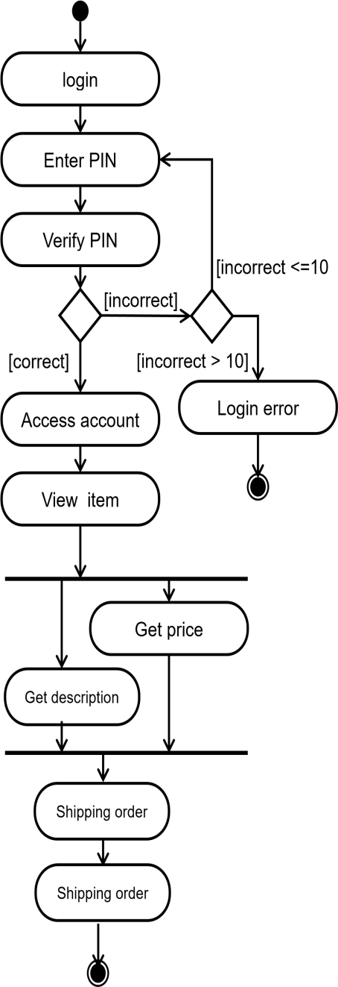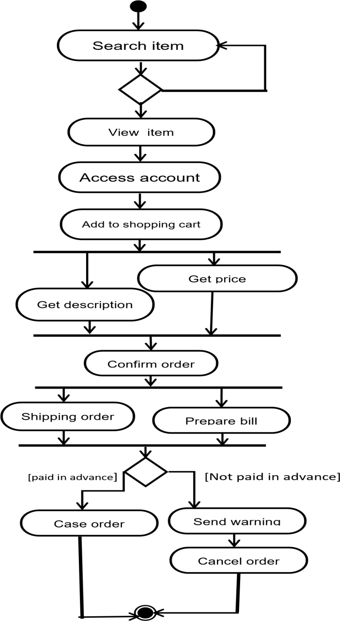

7. Sequence Diagram of the project

In an Online shopping Management system user can create new customer account. For access in the account customer need to login to the system before they use this system. But to Login customer have to go through password verification. If the password is error, then it displays login error. The system verifies the customer authentication using the information provided in customer account. In case of unsuccessful verification customer authentication, the customer request is denied. After access in account, System user can search and view items. When customer view items they can get description and get price of the items at the same time. Customer can Add item to shopping cart in the system. The customer can place order in the system. The customer can update in the cart and get the update cart list.

If the shopping cart is not updated then the customer get notification. The system can check availability of the items. If the items are available the system allow to order that item. If the item is not available Customer get notification. Then the customer can confirm the order and pay bill for the items. After paying bill payment Information is written in the database and the customer get the confirmation at the same time. If the Payment bill process is not done then Customer get notification again. An unprocessed order can get accepted or rejected by the system. If the order accepted by the system but some items are not available then the order pending on the system. But if all items are available then it can be considered as fulfilled order by the system. After successfully place first order the Customer considered as active Customer. If the customer does not place his first order, then back to initial state which is Prospective. If the customer missed the payment, Then the customer gets Warning by the system. If the customer not paid the payment even after warning, then the customer gets suspendered. If Customer paid the payment for the items, then the customer considered as Preferred customer.

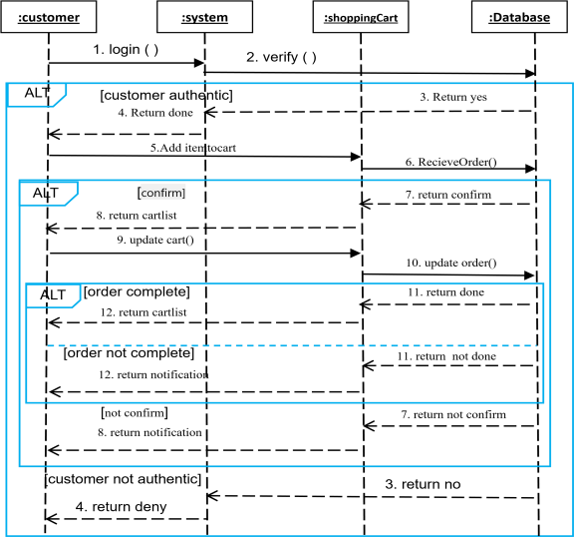**FOR PAYMENT FOR SHOPPING CART**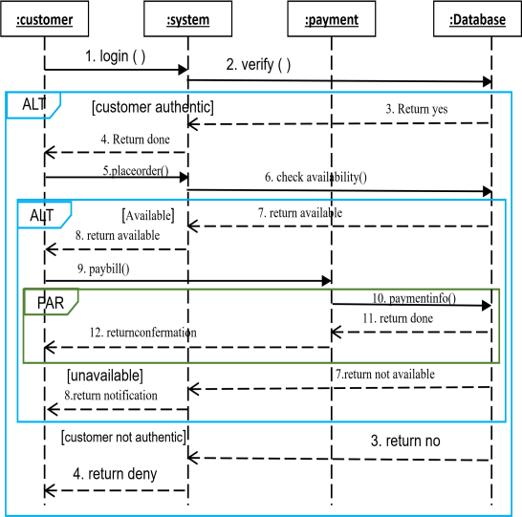

8. Statechart Diagram

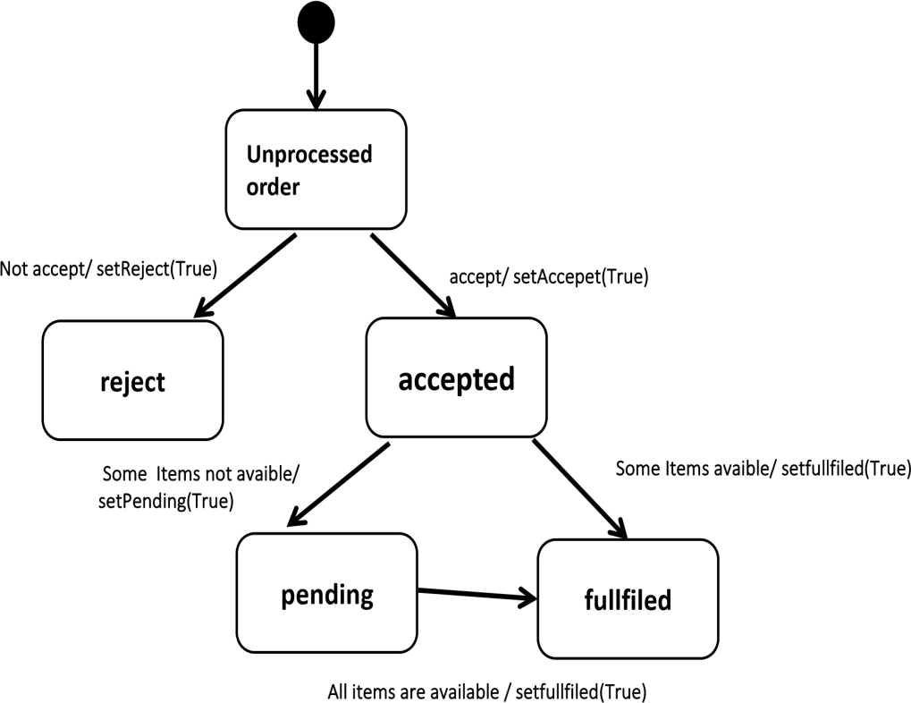

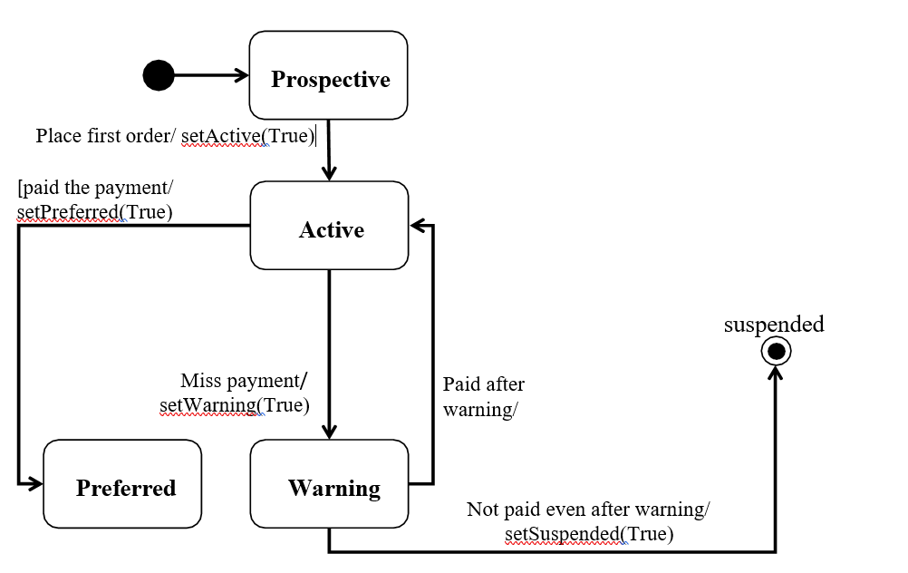

9. Conclusion: