There are several functionalities on our website. To demonstrate, some of the code implementations are given below :

**Login-Logout Functionalities**

Login and Logout are restricted to the particular user

* **Admin Login-Logout**

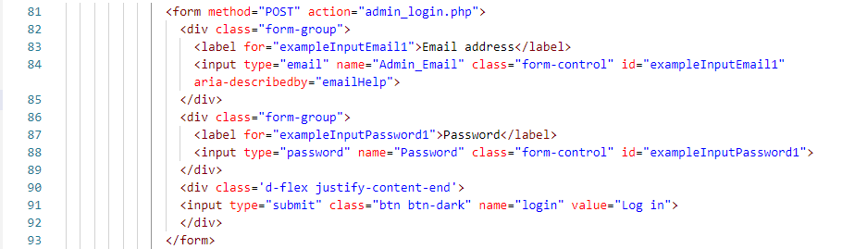

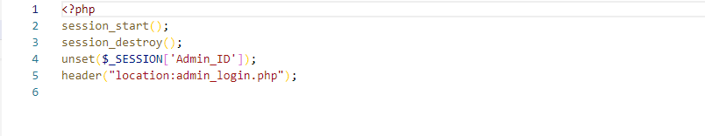

* **Teacher Login-Logout**

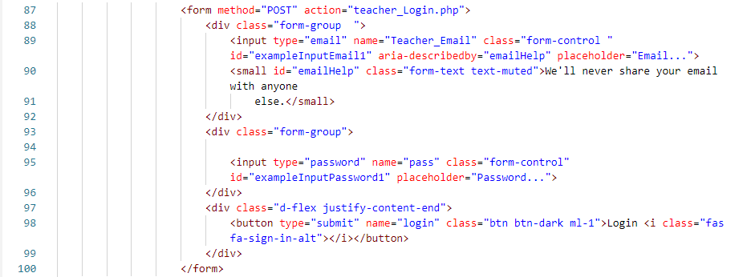

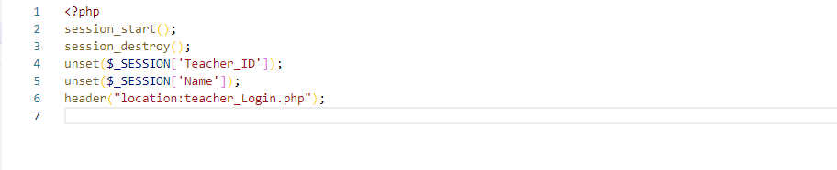

* **Student Login-Logout**

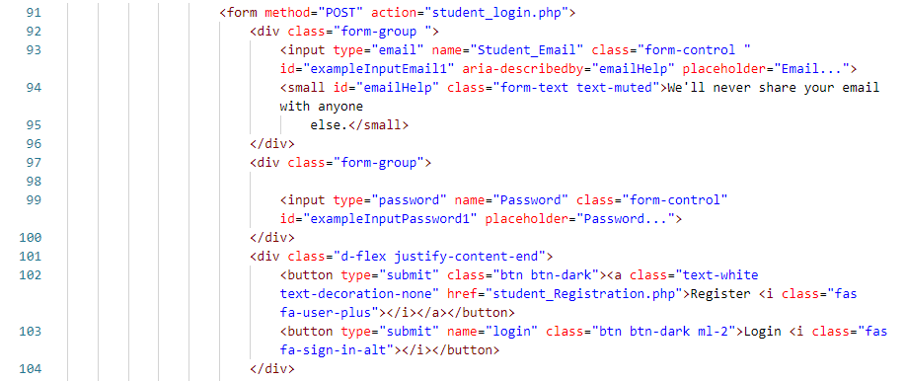

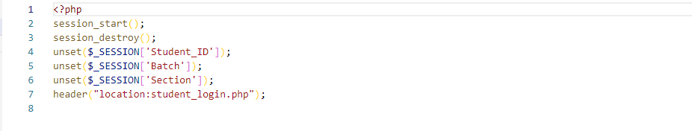

**Student Registration Functionalities**

* **Student Registration**

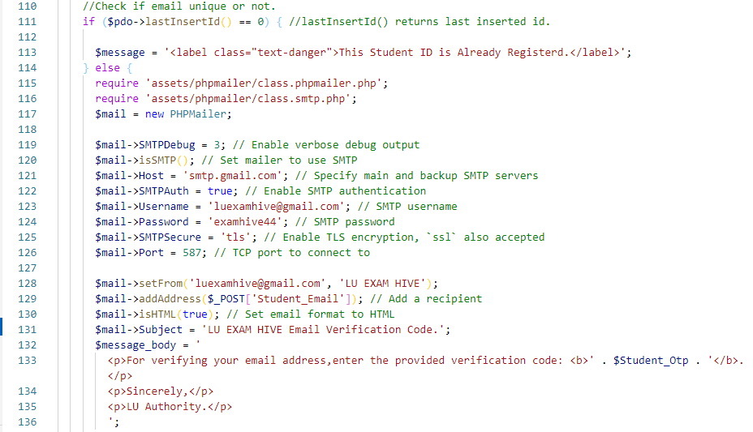

* **OTP**

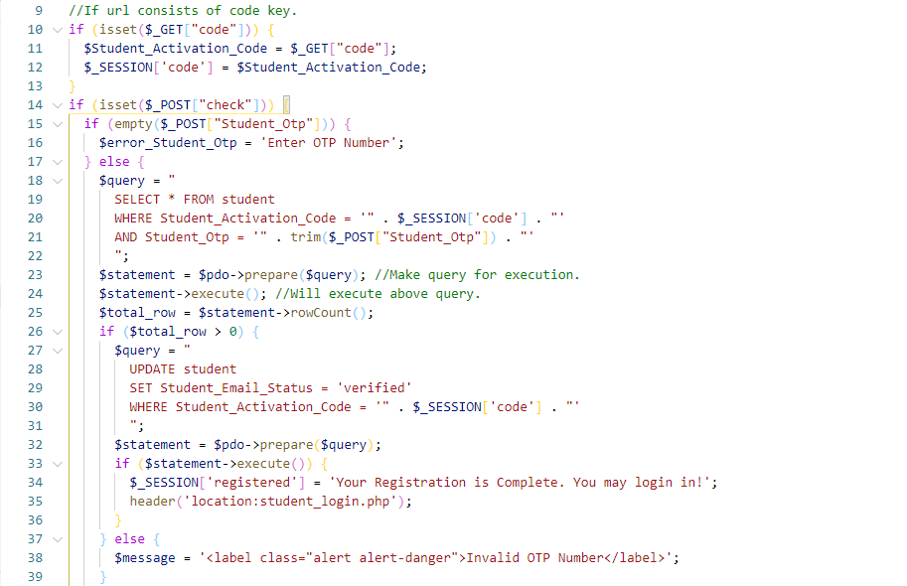

* **Reset password**

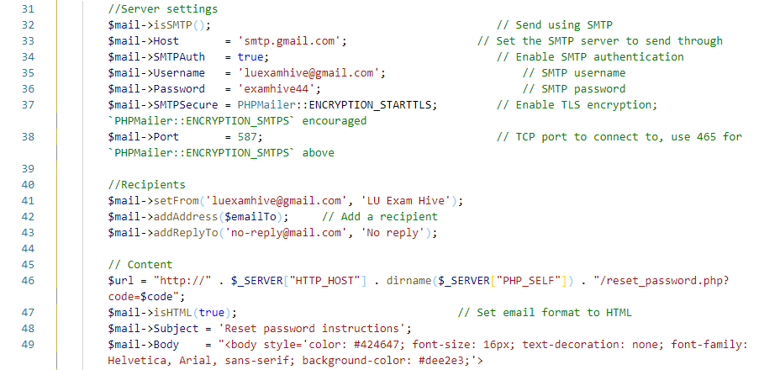

* **Request Reset Password**

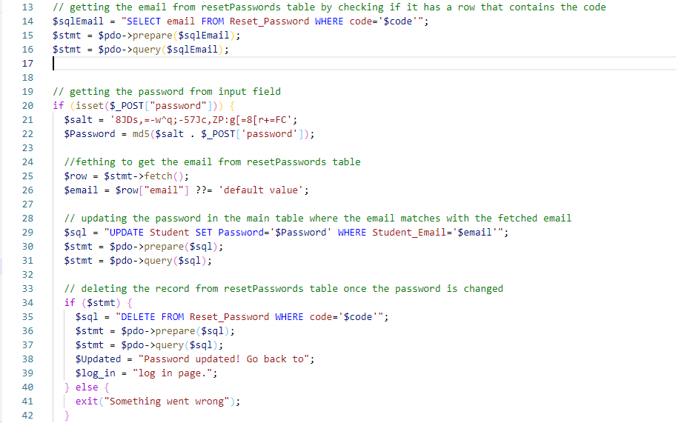

**Teacher Dashboard**

* **Create Question**

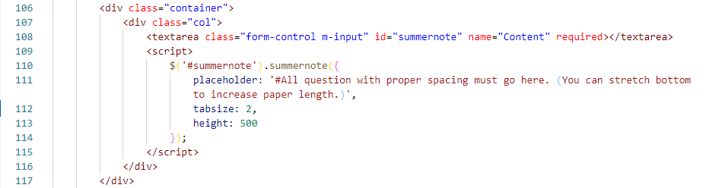

* **Create Meeting**

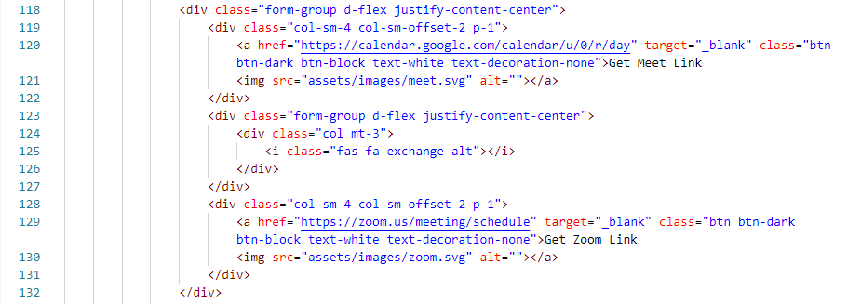

* **Posted Question**

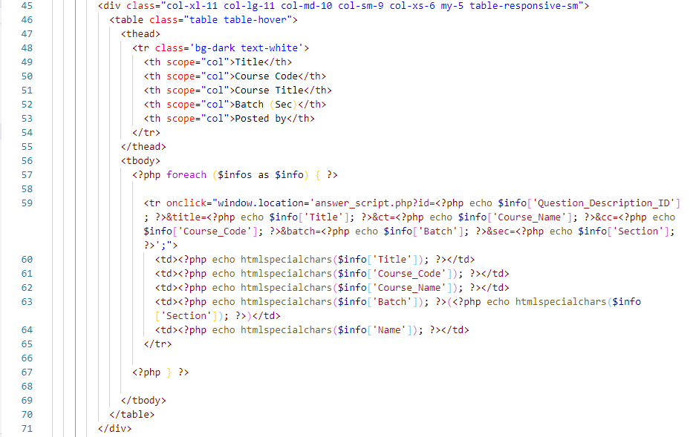

* **Question View**

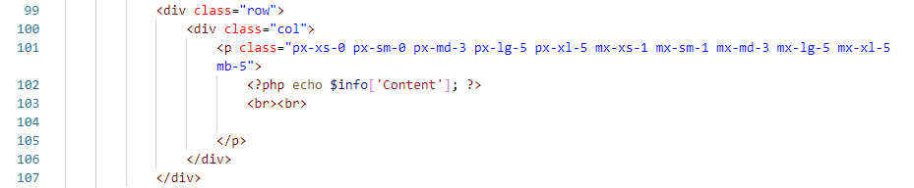

* **Question Submission**

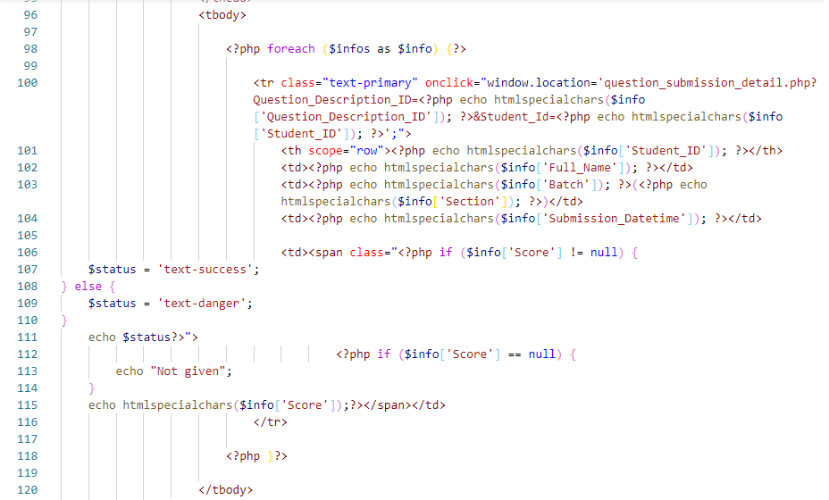

* **Generate Result**

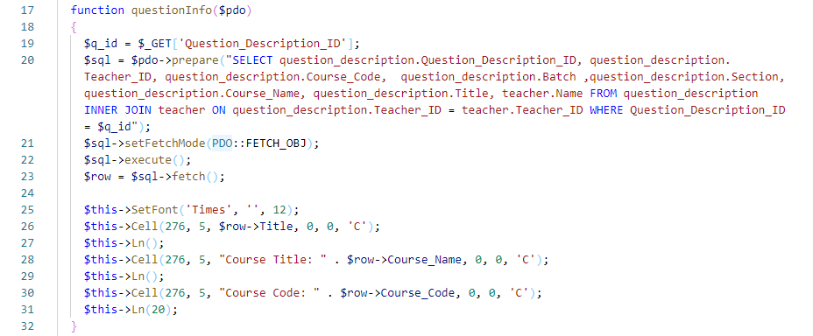

* **Submission Details**

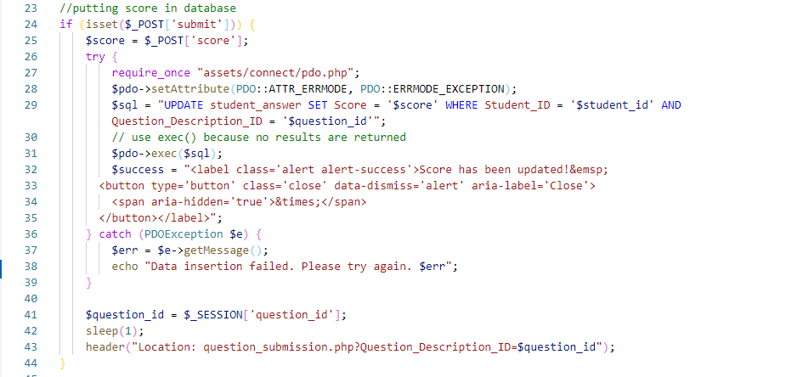

* **Edit question**

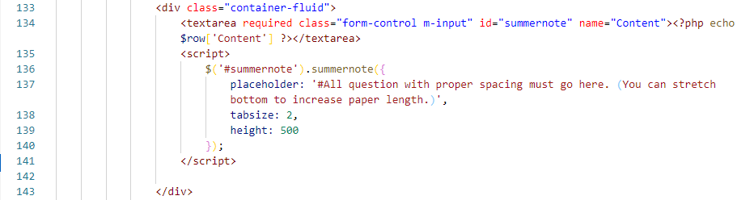

* **Delete Question**

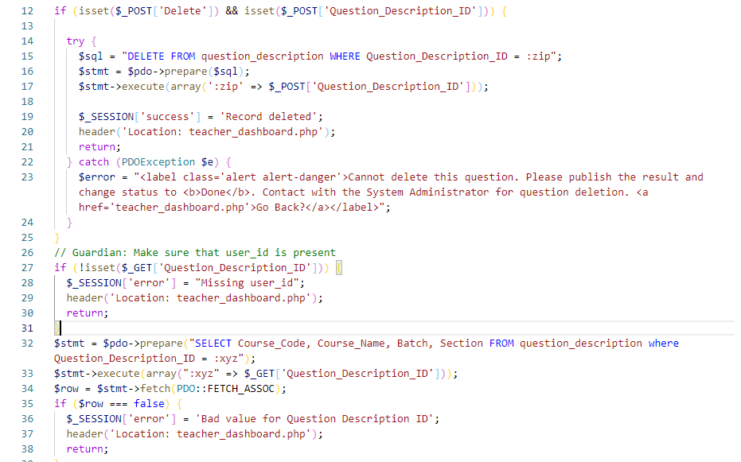

**Student Dashboard**

* **Dashboard**

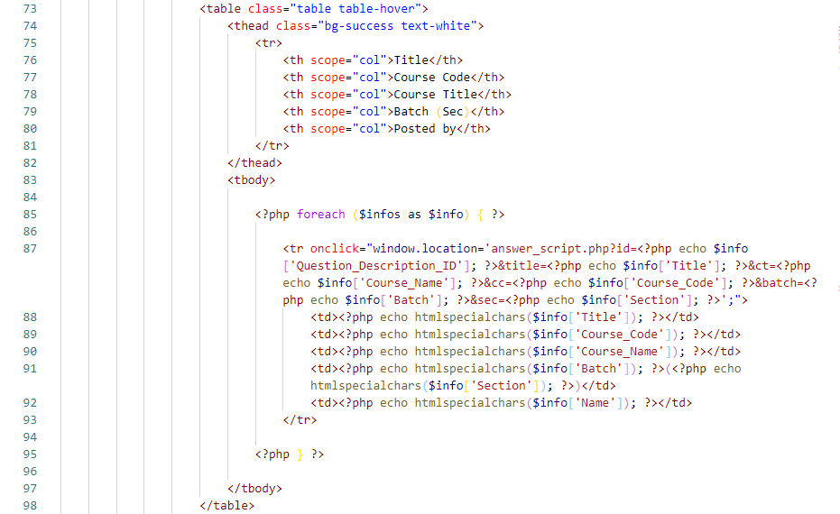

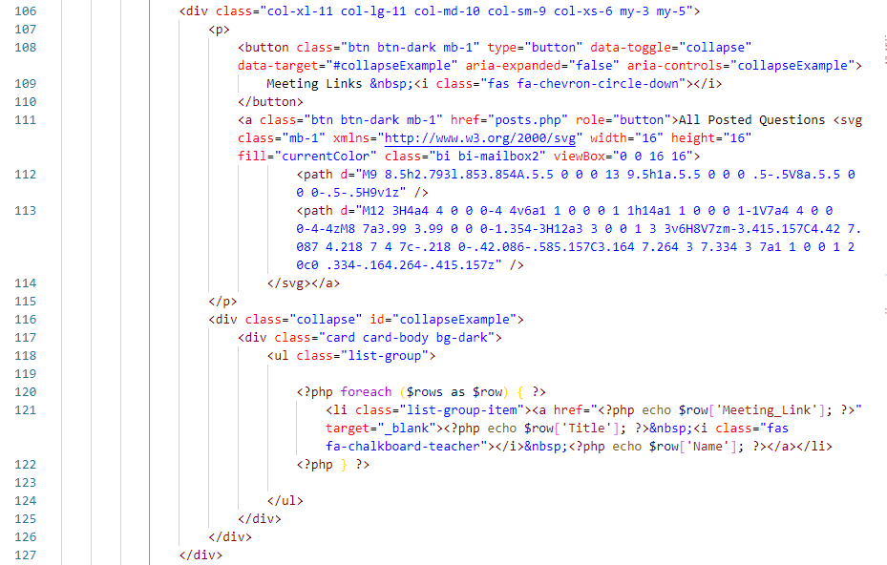

* **Answer Script**

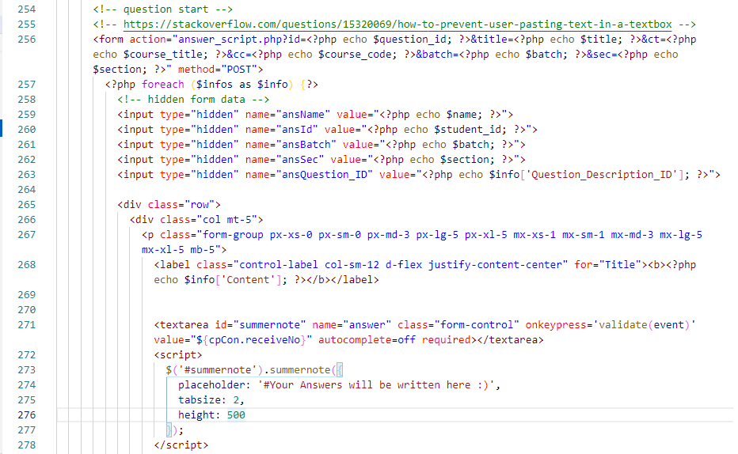

**Admin Dashboard**

* **Contact Info**

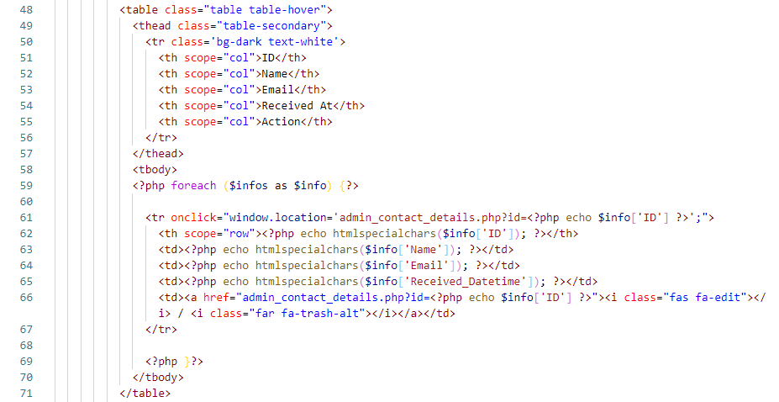

* **Contact Details**

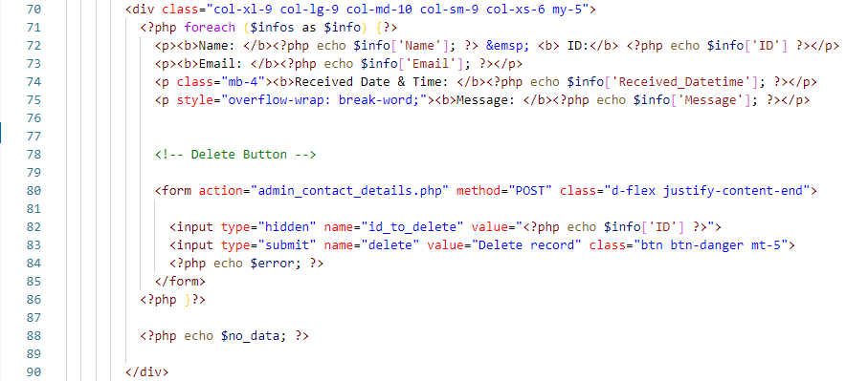

* **Contact Delete**

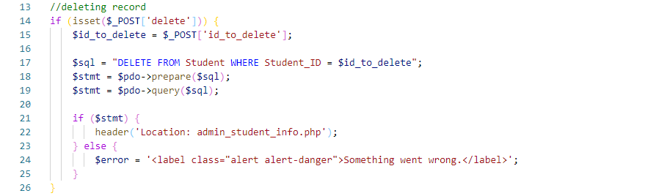

* **Teacher Info**

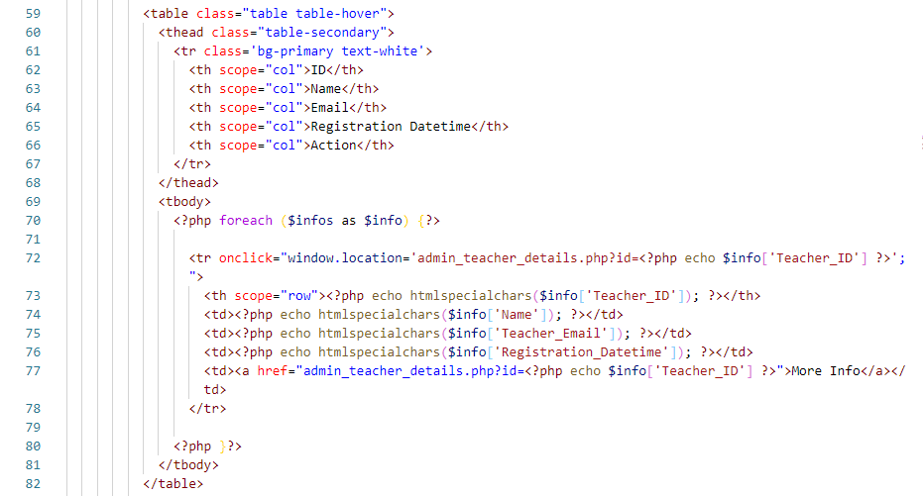

* **Teacher Details**

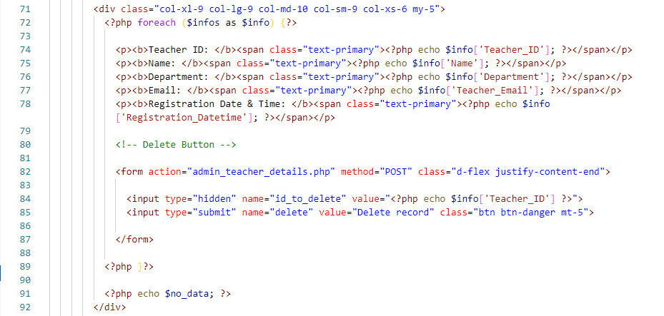

* **Insert Teacher Info**

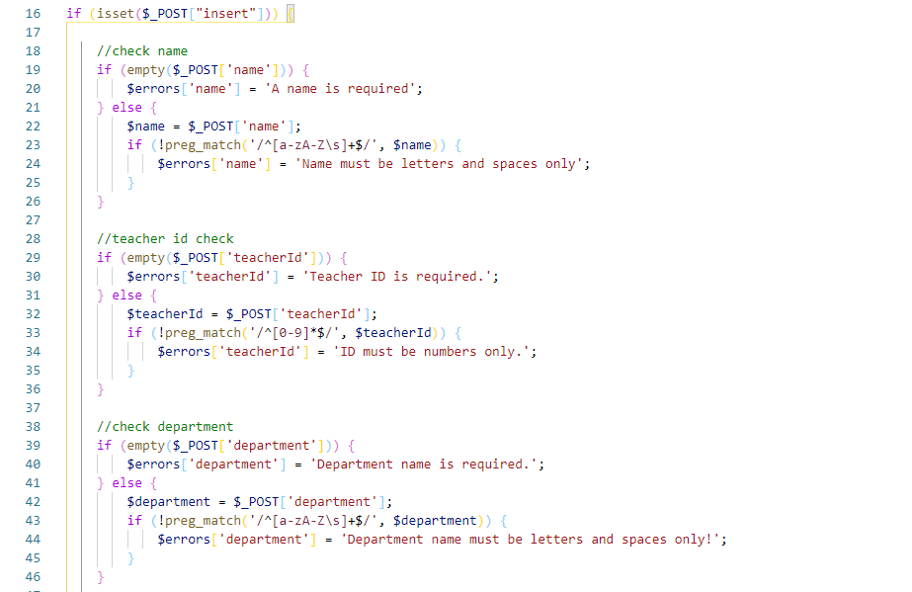

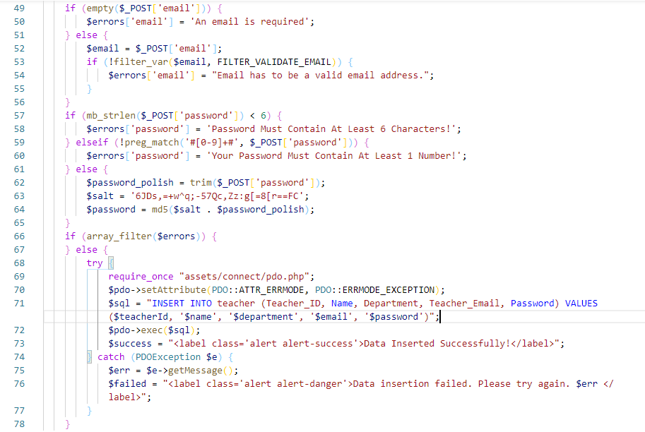

* **Student Info**

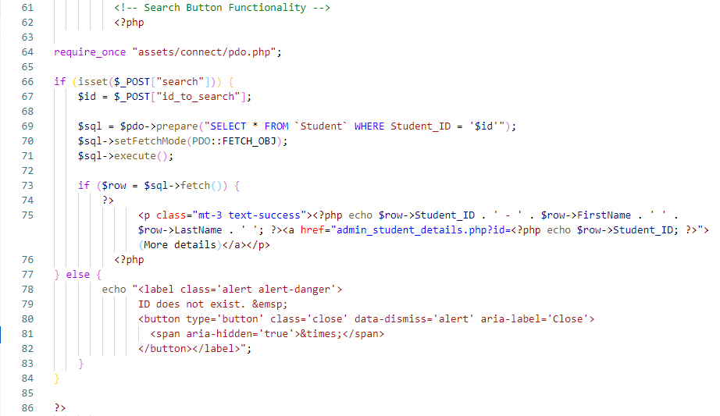

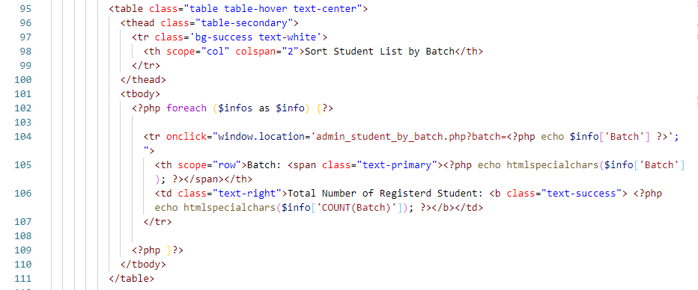

* **Student Details**

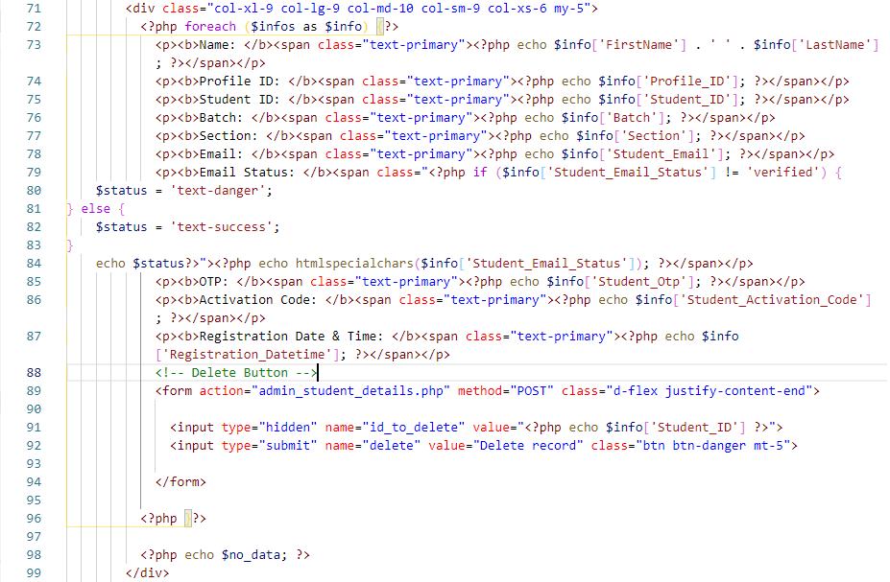

* **Student Info By Batch**

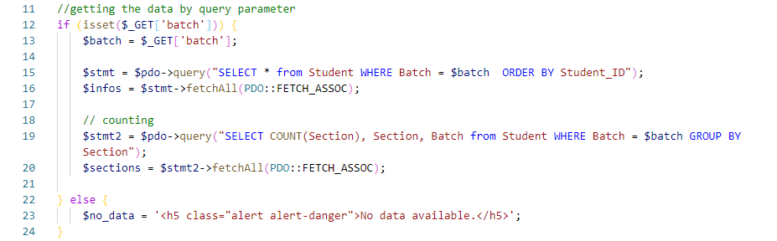

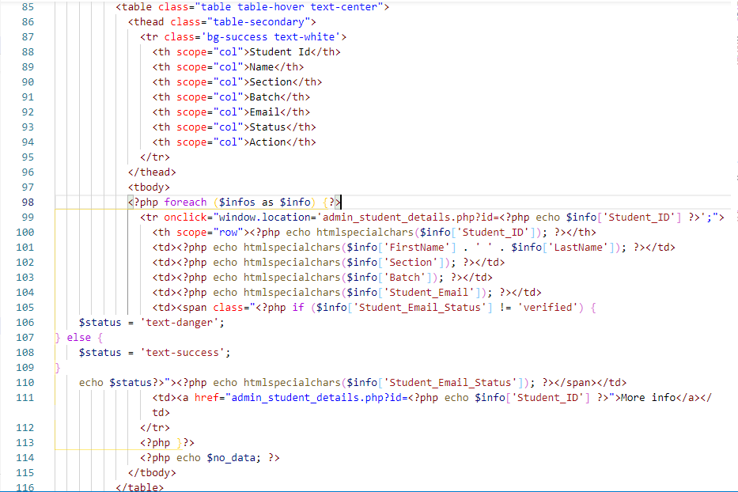

* **Student Info By Section**

