Digital Image Processing

Project2

Task2: classify the pore images

Team Characters | Name | Student ID | Task
Leader | 李四林 | 17S053255 | Image Pre-Processing  &Model Training
Member | 苏鹏鹏 | 18S053236 | Feature Engineering
Member | 帅俊 | 18S153746 | Image Pre-Processing

- Introduction

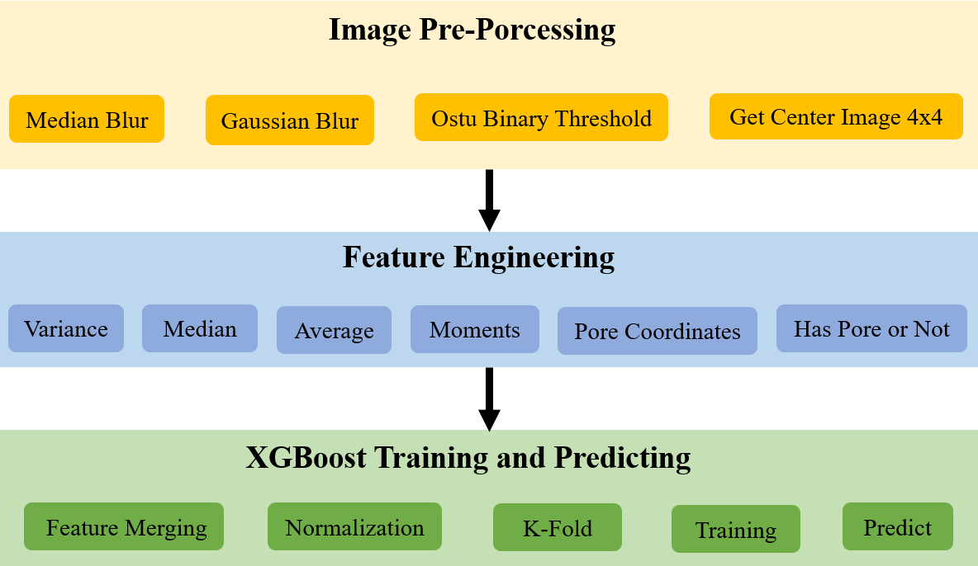
Fig 1. algorithm main steps

For the entire project flow, we use the flow chart of the above figure for a brief introduction. The details of the three main steps divided will be briefly introduced in the following three points.
  - Image Pre-Processing
Considering that the image may contain noise, it will affect the subsequent feature engineering. Therefore, we first use the various filters including but not limited to Gaussian filtering, mean filtering, and median filtering to preprocess the image.
Because the images of the course are separate from the background and the image with sweaty holes in the center. In order to ensure the rationality of the training, we randomly select 20% of the images as the test set and 80% of the images as the training set.
  - Feature Engineering
For the extraction of features of images, we consider various aspects such as texture, pixel values, and histograms. After trying a variety of features, we only took some of the better-performing features as a training feature.
This includes the mean value of the pixel values, the variance, the standard deviation, the presence or absence of sweat in the central region, and the coordinate distribution of the sweat holes.
  - XGBoost Training and Predicting
Based on the extracted features, we perform a purposeful combination and normalization, and then train. And use the remaining 20% of the data to evaluate the model. According to the evaluation results, we analyze the contribution degree of the feature, and carry out a new feature combination, and finally select a better feature combination as a sample of the final training model.

- Image preprocessing
In order to eliminate the influence of the noise of the sample itself on the image, we have filtered all the images. And analyze the gray histogram of different images. According to the distribution of the histogram, we specifically combine the filtering algorithms such as Gaussian filtering, mean filtering and median filtering to eliminate the influence of noise on the results as much as possible.
At the same time, because the middle 4*4 area is used as the sample of feature acquisition, we extract the middle area of all images and perform secondary analysis and feature extraction on the middle area.

- Feature extraction
The extraction and selection of image features is an important part of the image processing process and has an important impact on subsequent image classification. And the original data of the image has the characteristics of high dimensionality and inconspicuous features. To extract useful information from the image, the image features must be reduced in dimension. Therefore, feature extraction and feature selection are the most effective dimension reduction methods. The purpose is to obtain a feature subspace that reflects the nature of the data and has a higher recognition rate.
  - Sweat pore center
What we ultimately need to judge is whether there is sweat in the center of the image. Therefore, in the first step of feature extraction, we choose to determine whether there is sweat pore in the center area.
The size of the known image is 20*20. In the final stage of image preprocessing, we get a picture after binarization. We will first process the four connected domains in one step. We choose the 4*4 area in the middle, first determine whether there are 4 connected domains with less than 20 connected domains in this small area. If so, we think this is the center of the sweat hole.
In the data of the training set of 80% randomly selected in the background data set and the sweat data set, according to the above method, the image of the qualified image is recorded as 1, and the image of the unqualified image is recorded as 0.
  - Sweat pore center coordinate
Based on the extraction of sweat holes, we further add coordinate judgment. For images that have been judged to contain sweat holes in the center, we obtain the coordinates of the pixels of all the sweat holes to obtain the center position of the sweat holes. In this way, we are able to obtain the xy coordinates of the sweat hole.
For the coordinate processing of images, we will extract the following features:

- The coordinate value of the x direction.
We count all images containing sweat holes and characterize their x coordinates. For images without perforations, set the x value to 0.
- The coordinate value of the y direction.
We count all images containing sweat holes and characterize their y coordinates. For images without perforations, set the y value to 0.
- Norm between x, y coordinates
We count all the images containing the sweat holes, we calculate the two norms of the x and y coordinates sqrt(x^2+y^2). An image judged to have no sweat holes is replaced with 0.
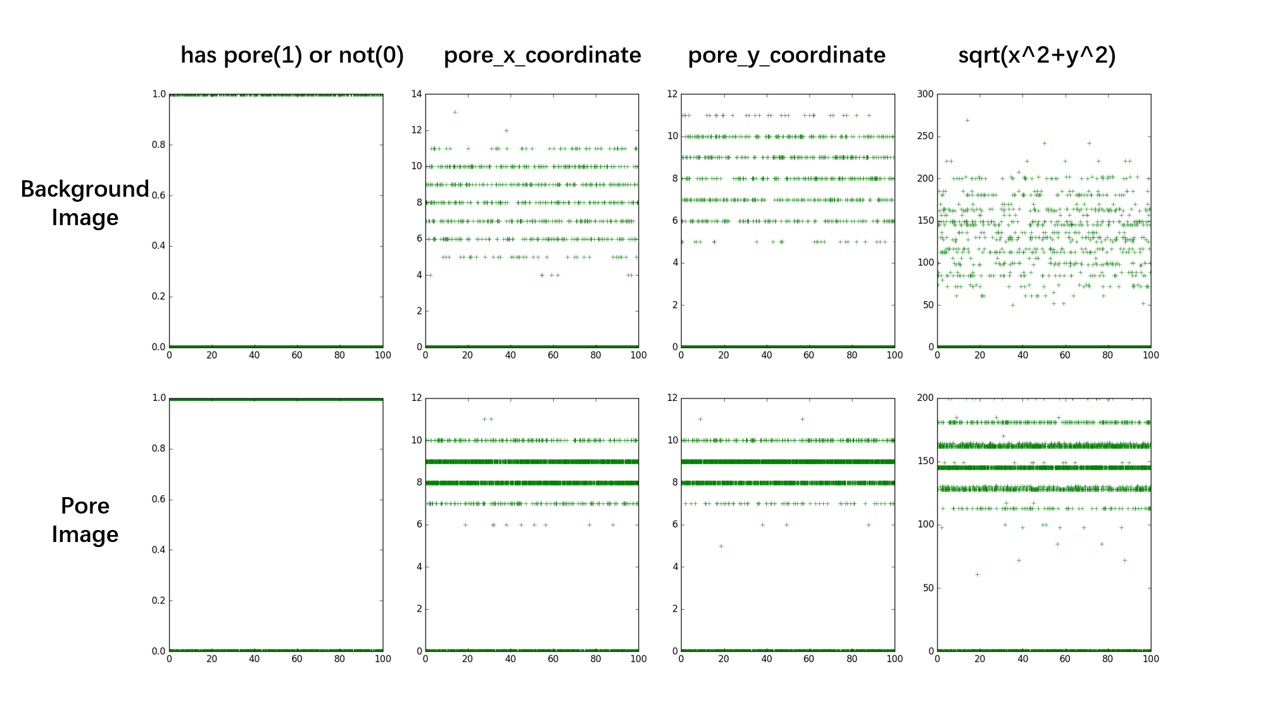
Fig2. Judge pore and calculate xy coordainate data distributions

  - Center region pixel value
We consider that the pixel value of the middle area of the image with sweaty holes becomes higher, and the pixel value of the middle area of the image without sweaty is grayish black, and the pixel value is lower, so the pixel value of the middle area is also considered by us. The pixel values we consider include standard deviation, variance, mean, maximum, and so on.
- standard deviation
We count the standard deviation of all pixel values in the middle region and plot the distribution.
- mean value
We count the mean of all pixel values in the middle region and plot the distribution of these values.
- median value
We count the median of all pixel values in the middle region and plot the distribution of these values.
- argmax
We count the maximum values of all pixel values in the middle region and plot the distribution of these values.
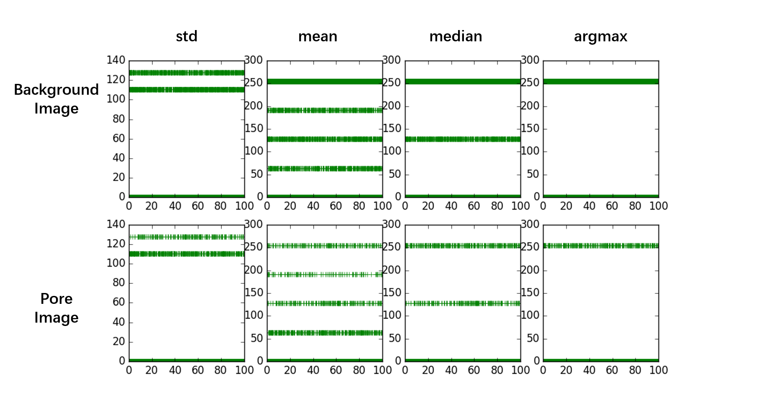
Fig3. Std, mean, median, argmax data distributions

  - black and white pixels count
We also counted the black and white pixel distribution of the entire image. The distribution of pixel values is also considered to be one of the features. It turns out that this is indeed possible. The statistics of the specific distribution are shown in the figure below.
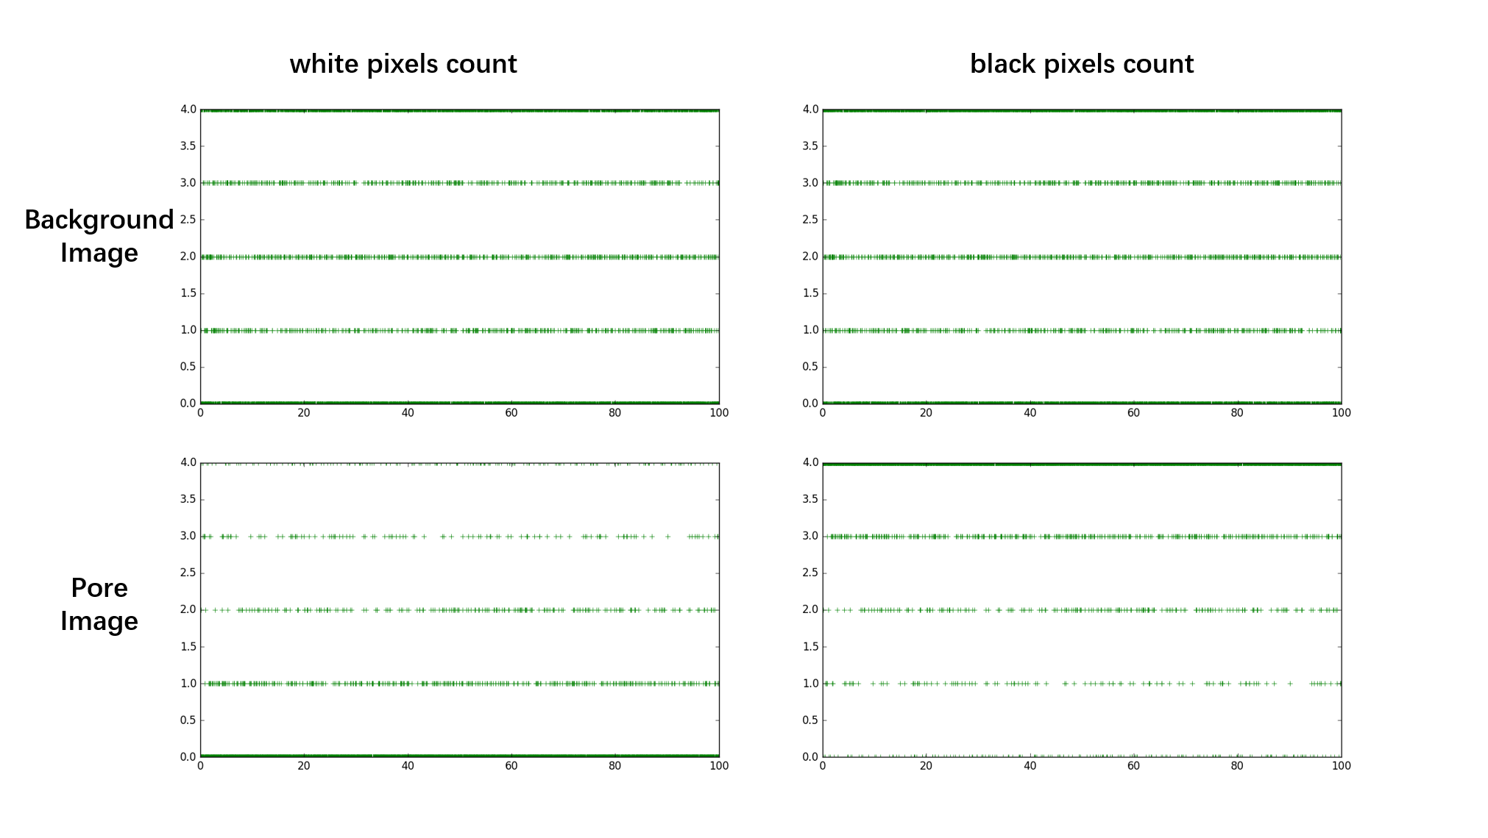
Fig 4. White and black pixel count data distributions

  - Moment of image
A core problem of image recognition is the feature extraction of images. A simple description is to describe the whole image with a simple set of data (image description quantity). The simpler the representative data, the better. Good features are not disturbed by light, noise, or geometric distortion. Image recognition has been developed for decades, and new features have been proposed, and image invariant moments are one of them.
First, the moments of the image are common and commonly used.
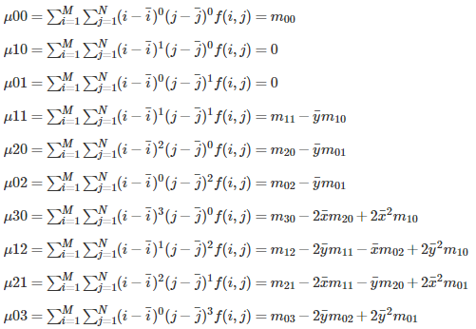
For these moments, we apply the calculation statistics in the image separately. According to the statistical distribution of the moments of the image, a better image moment is selected and combined as one of the characteristics of the training.

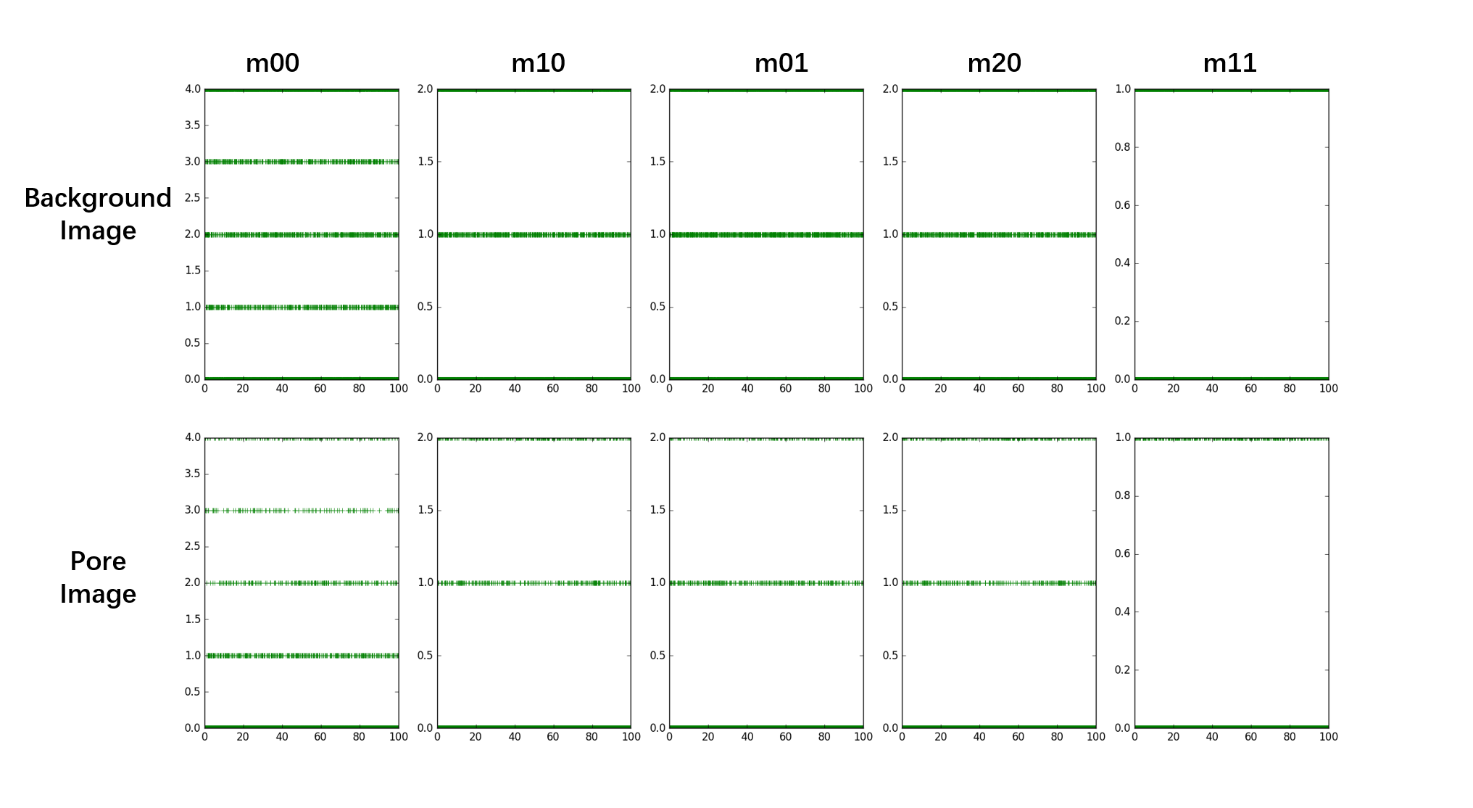
Fig 5. moments data distributions
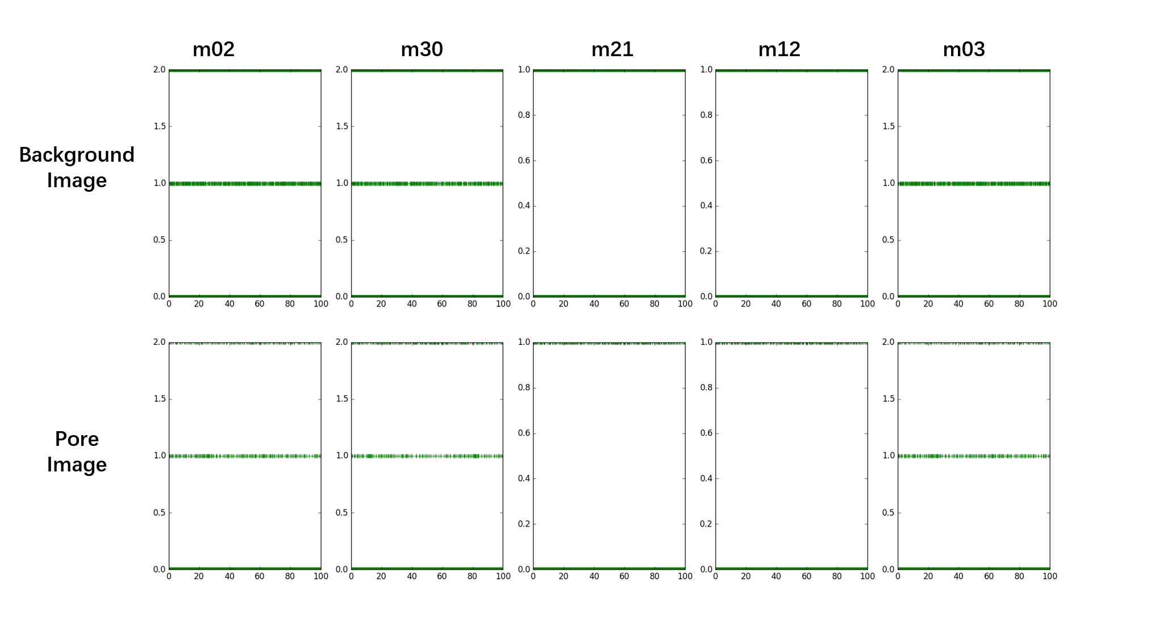
Fig 6. moments data distributions
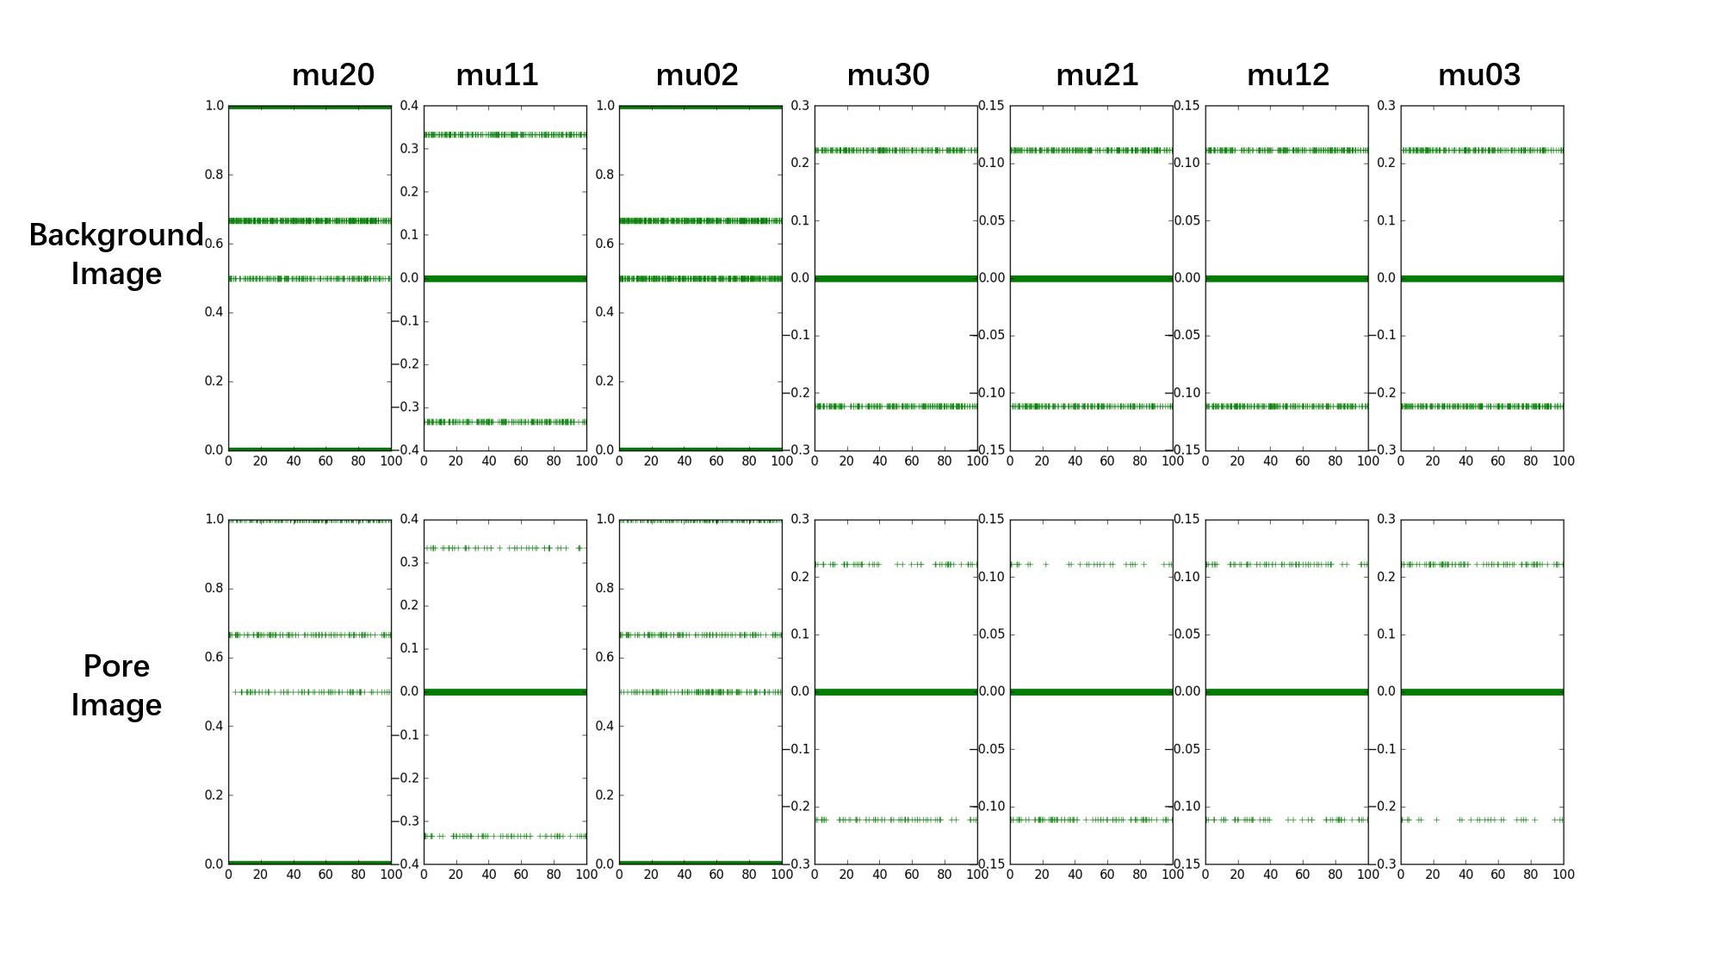
Fig 7. moments `data distributions
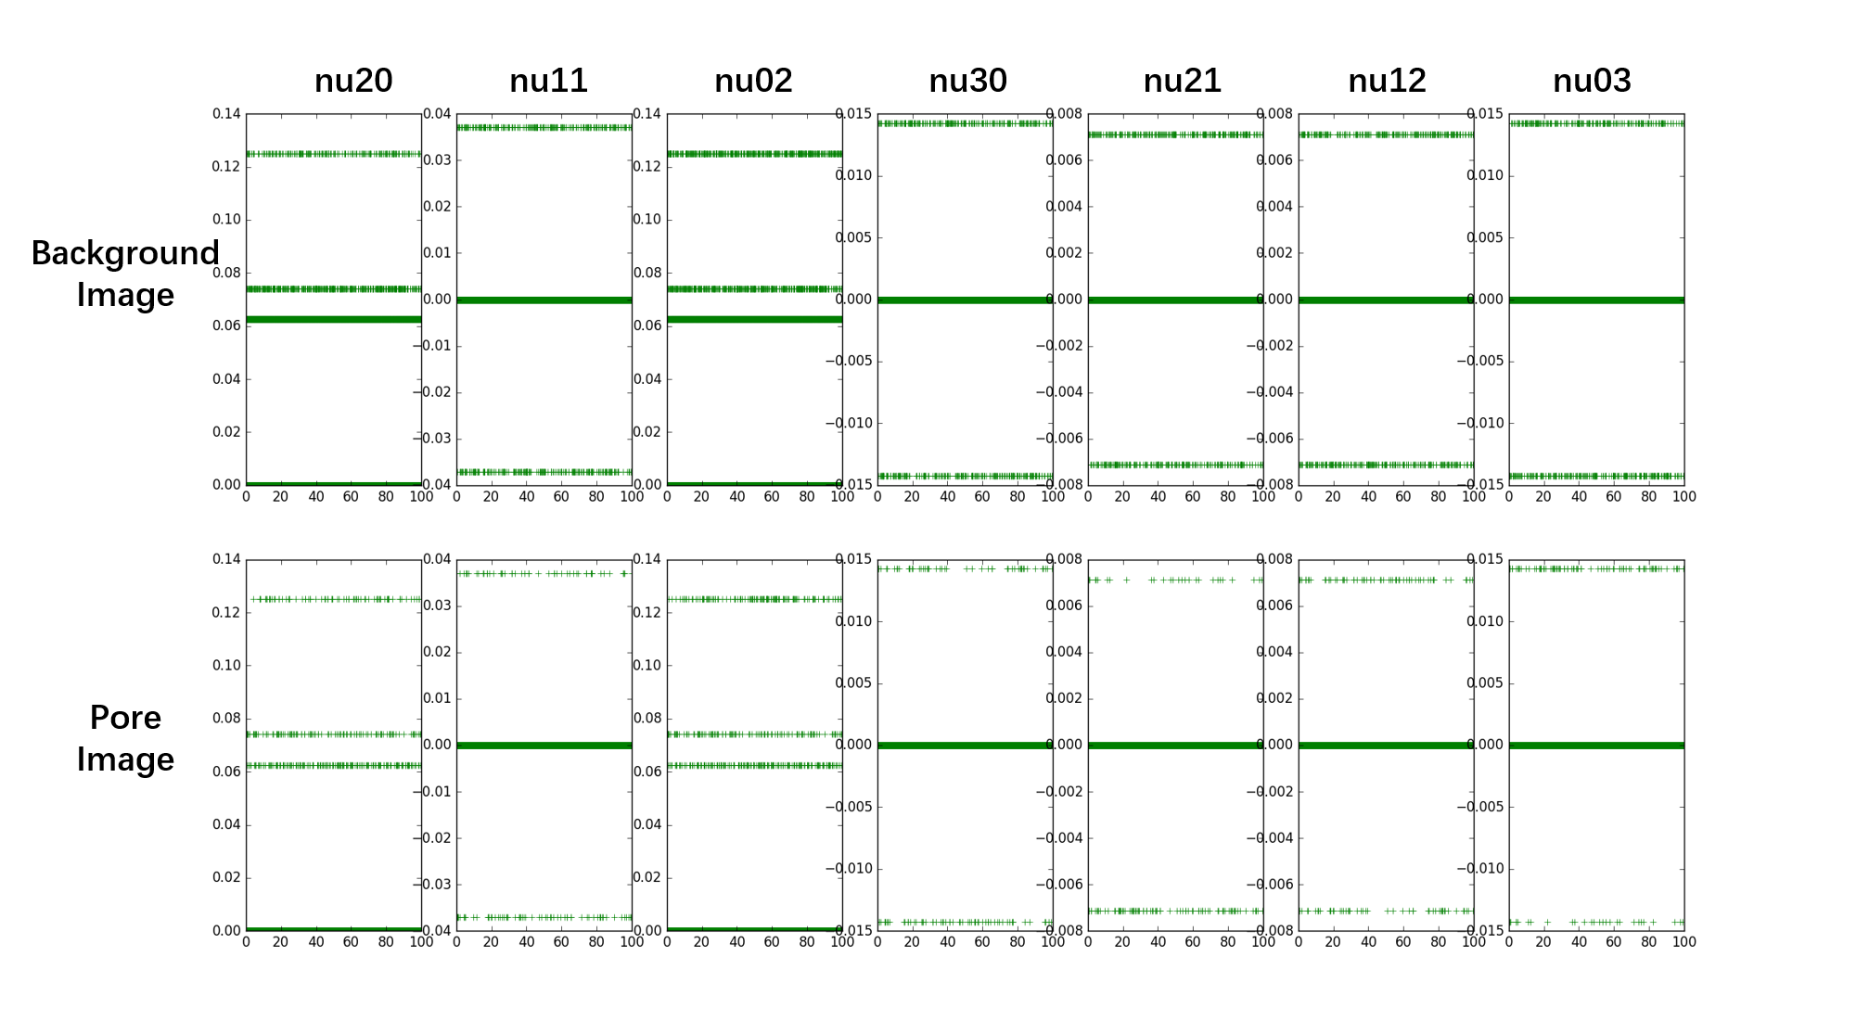
Fig 8. moments data distributions

- Model training
The reason we choose xgboost as our classifier is that it implements machine learning algorithms under the Gradient Boosting framework. XGBoost provides a parallel tree boosting (also known as GBDT, GBM) that solve many data science problems in a fast and accurate way.
We choose 80% images of dataset as training set, 20% as test set randomly. In training set, we use k-fold cross-validate, where k is 5.
The parameters we set in xgboost classifier are listed as follows:

Parameters | Values
booster | gbtree
objective | multi:softmax
num_class | 2
gamma | 0.05
max_depth | 12
subsample` | 0.4
colsample_bytree | 0.7
eta | 0.005
seed | 710
nthread | 4

Tab 1. parameters we set in xgboost classifier

After training, we plot the features importance in xgboost classifier as the following figure.
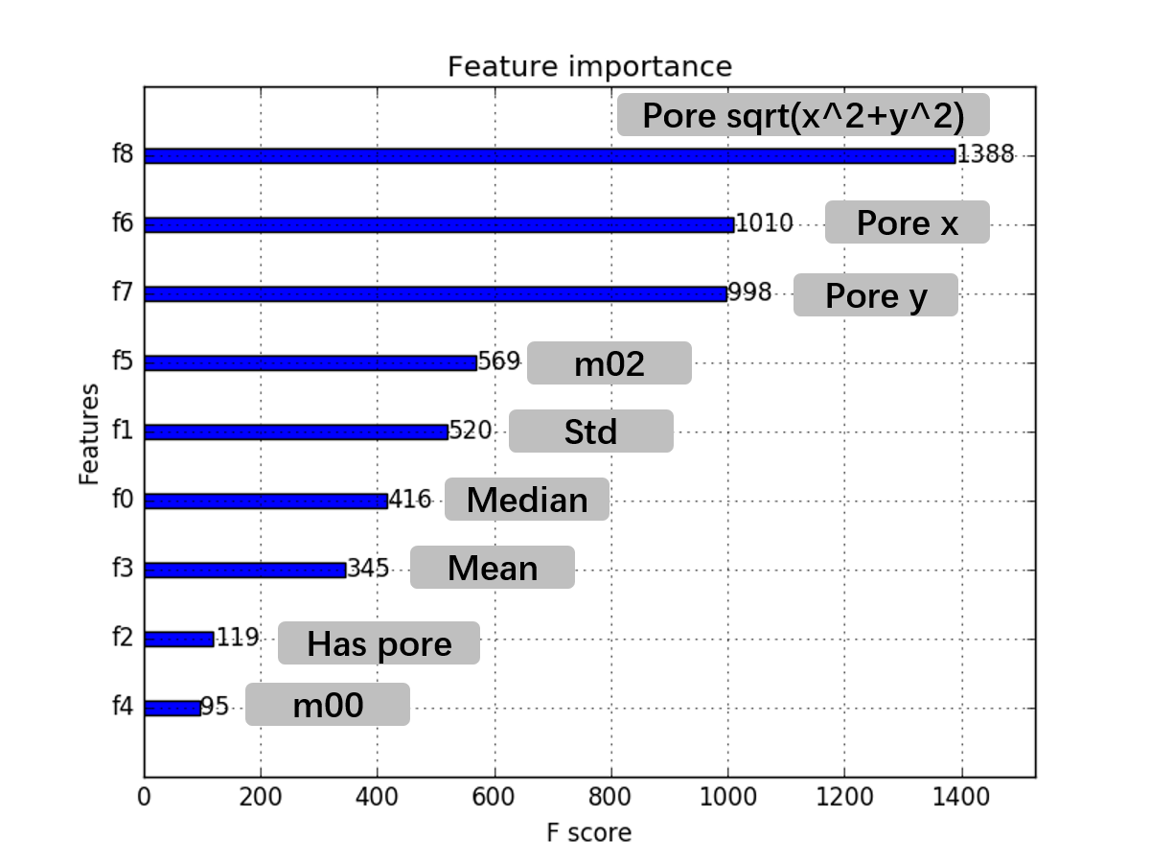
Fig 9. features importance in xgboost classifier

Finally, the best result we got is listed as followed:

Scores | Values
accuracy_score | 0.8507
recall_score | 0.6858
precision_score | 0.8209
confusion_matrix | [[1382 130] [ 273 596]]

Tab 2. best result

- Conclusion
Before we do this project, we think the most import work for task2 is how to extract useful features. And then we select some different features for our project, but how to evaluate the importance of different features is very significant. After our team’s brain storm, we think the features’ data distribution is the most powerful reason to verify whether the feature we extracted is useful or not. If the feature can make contribution to our classification, then the feature data distribution figure will be different between background images and pore images.
After solve the feature engineering problem, we began to think how to select a good classification method to classify this two different kind of image. Through researching, we decide to choose xgboost classifier to solve the problem. As a matter of fact, we achieved 85% accuracy, 68% recall, and 82% precision. Even if the result is worse than the result did by deep learning, we still learned many many interesting knowledge when we do this project.
Finally, thanks my teacher for teaching us knowledge, thanks my teammates for working together to solve our common problems. Thank you all.

