**Features:**

* Helps in reducing Boiler Plate Codes Such as Getter, Setters Method, toString, hashCode, equals Methods and Logger Methods and so on..
* Project Lombok provides classes and interfaces which are present in multiple packages comprises of .jar file.

**Useful Annotations:**

1. **@ToString:**



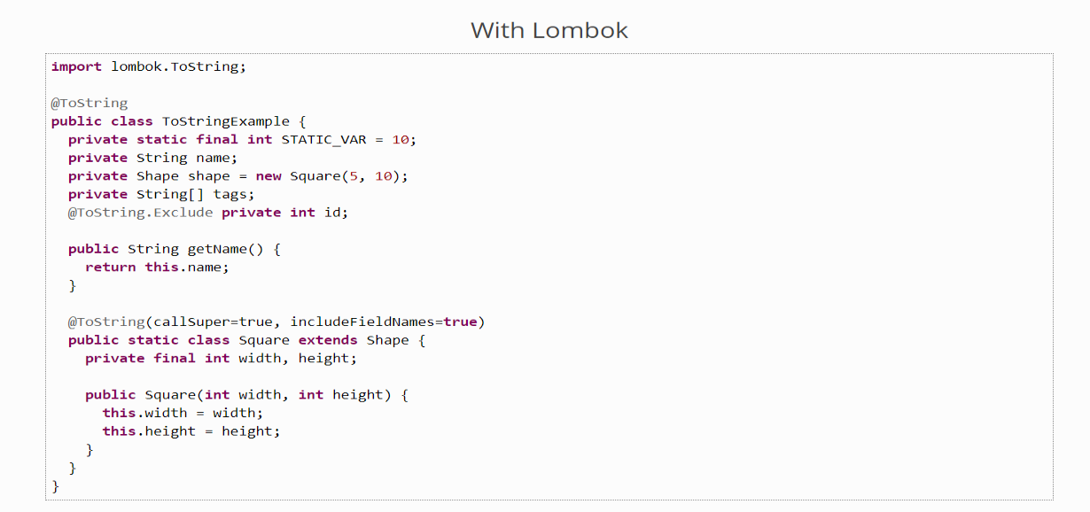

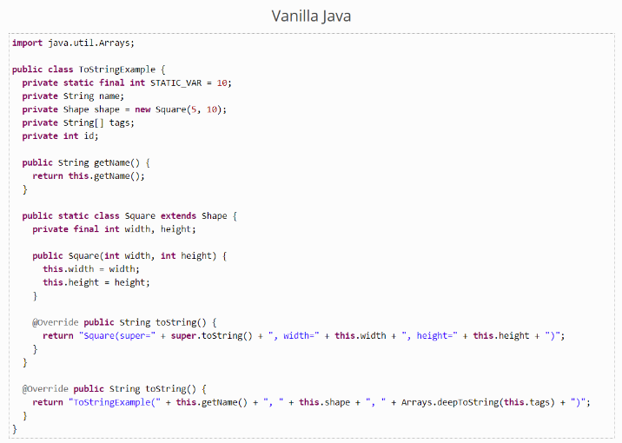**without Lombok Annotations:**

1. **@HashCode & Equals**

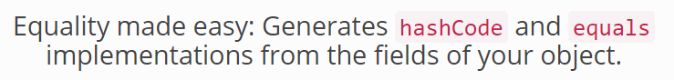

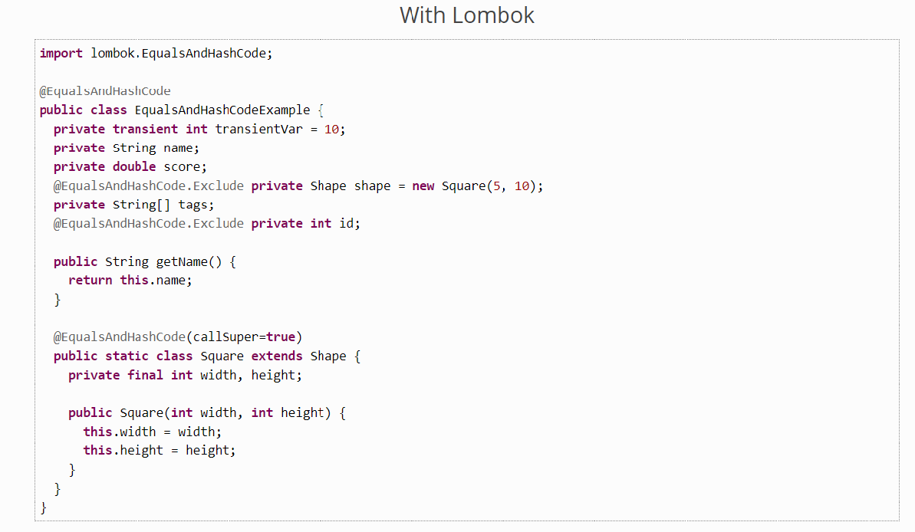

**Without Lombok Annotation :**

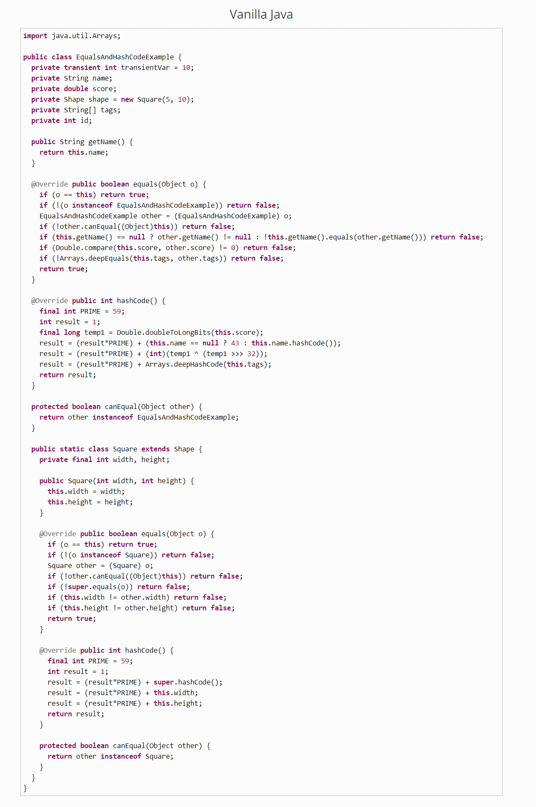

1. **@Getters and @Setters:**

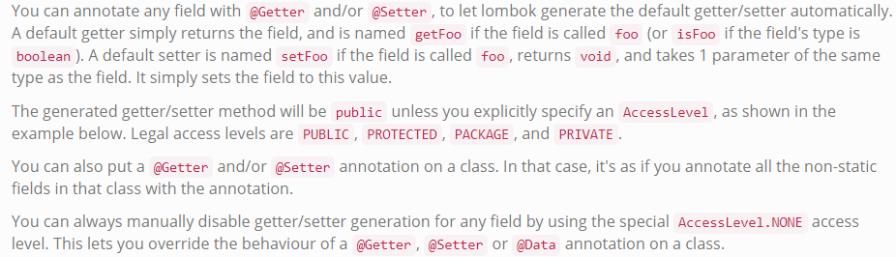

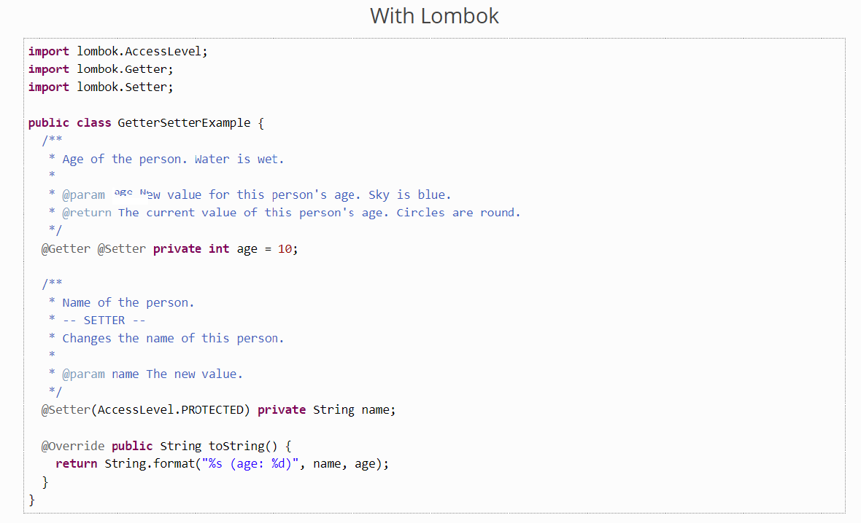

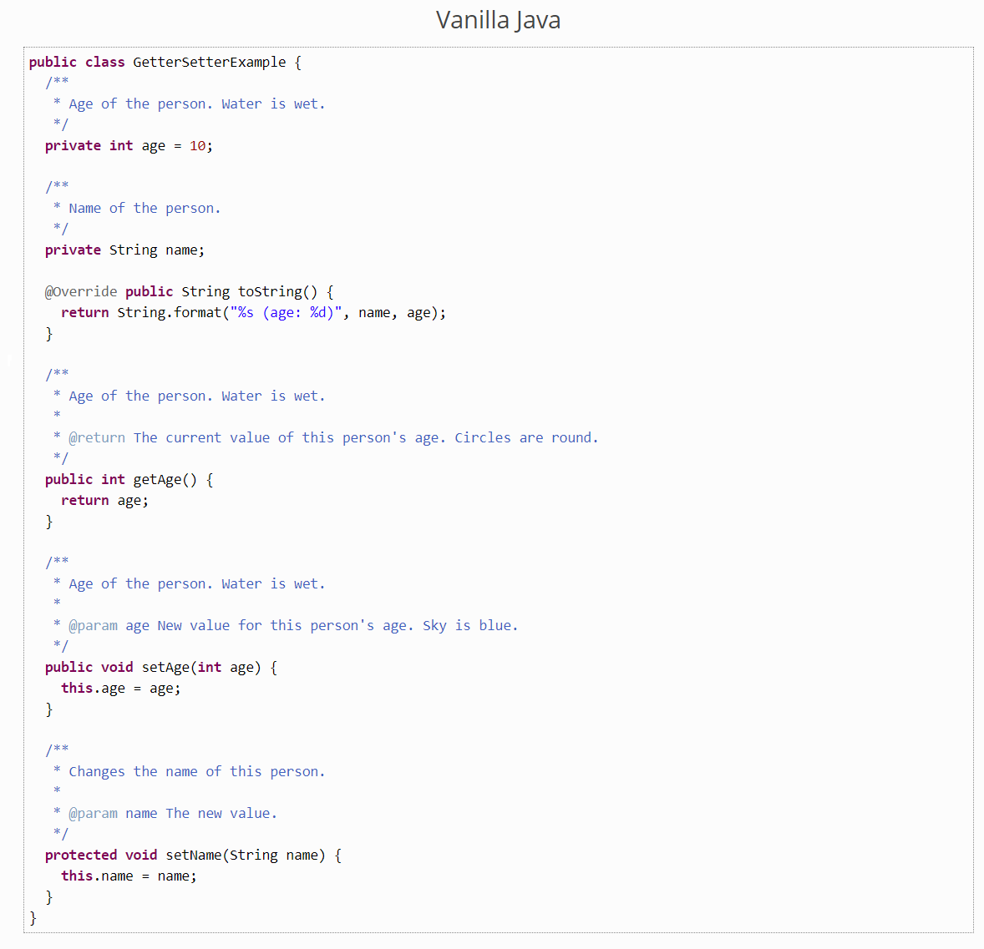

1. **NoArgsConstructor, RequiredArgsConstructor, AllArgsConstructor:**

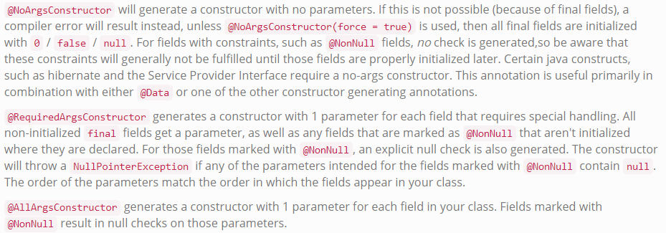

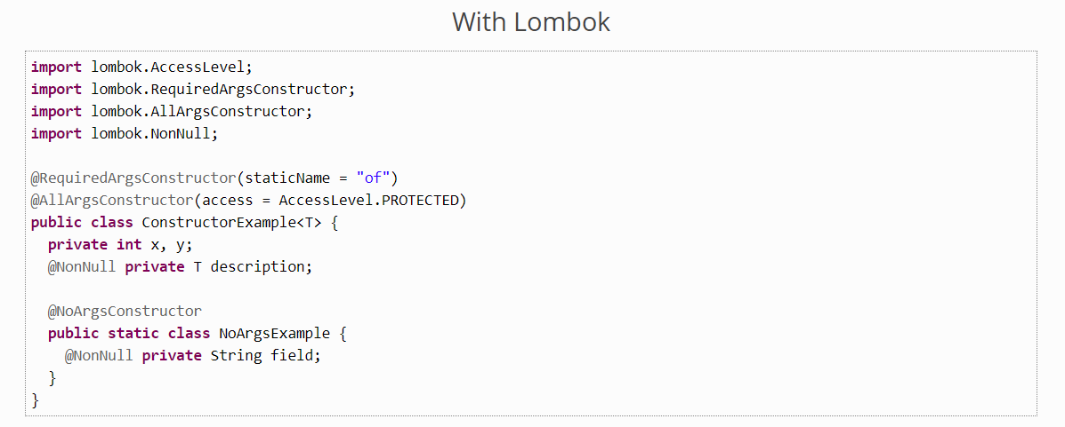

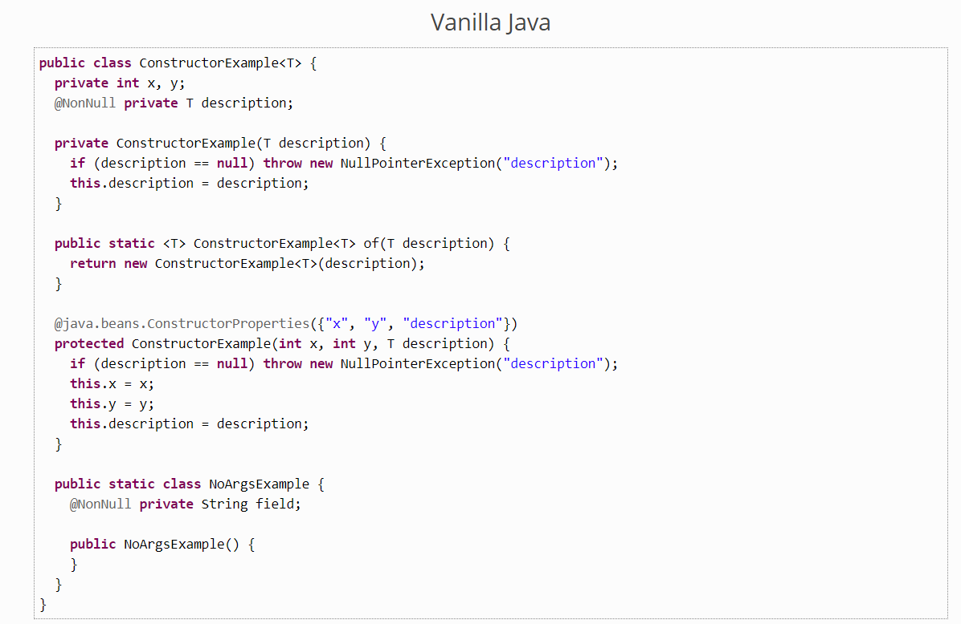

1. **@Data:**

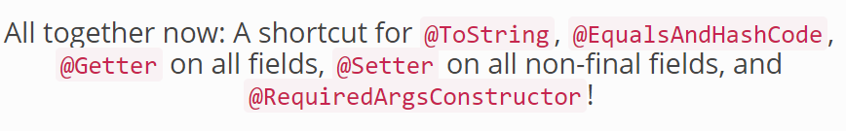

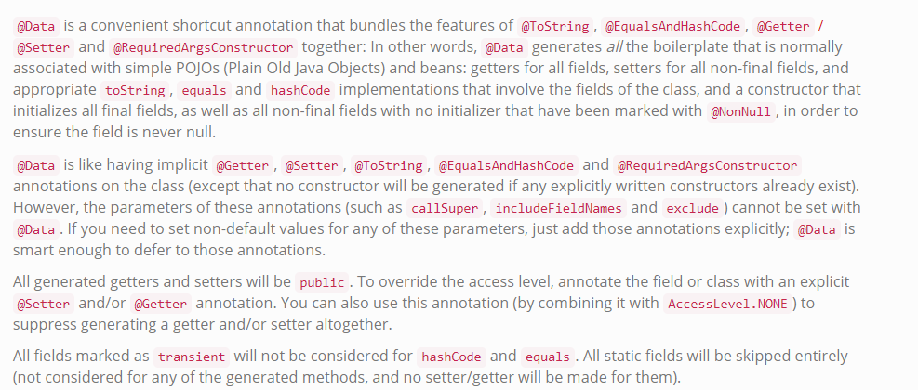

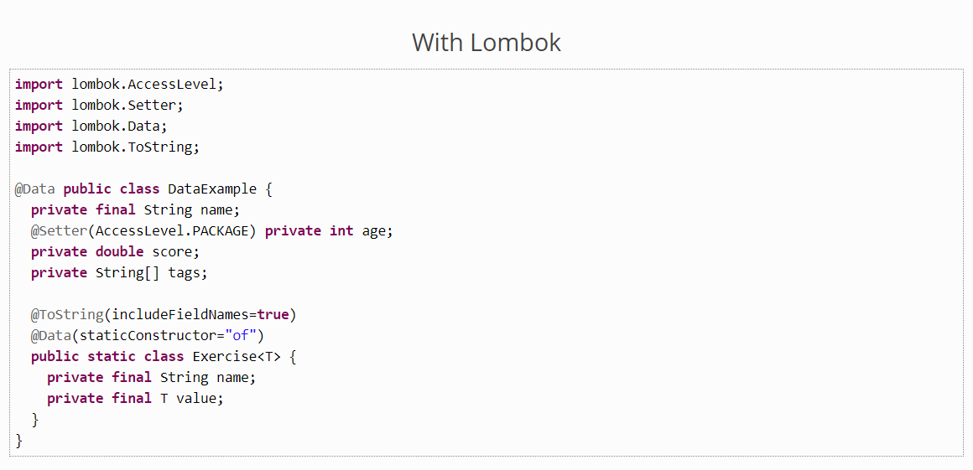

1. **@Value:**

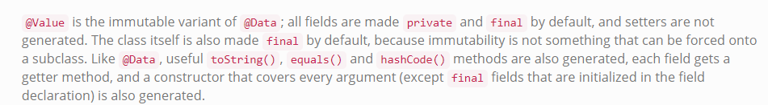

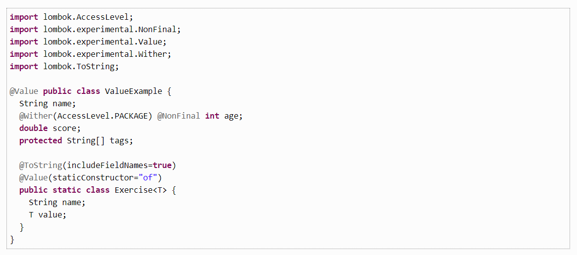

1. **@Synchronized:**

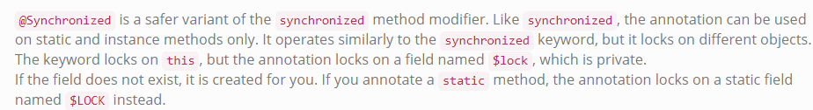

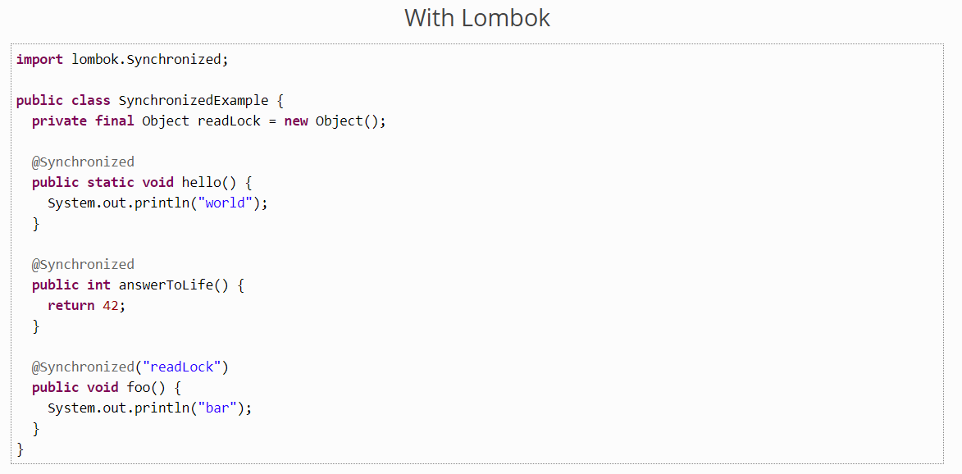

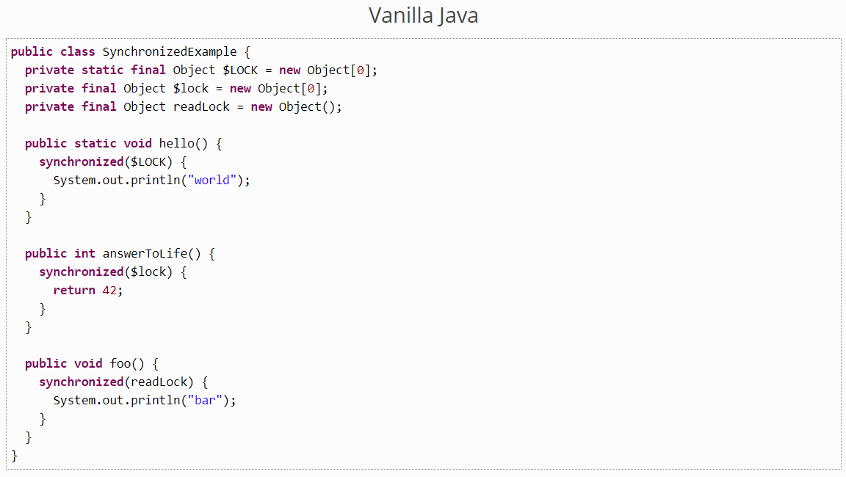

1. **@Cleanup:**

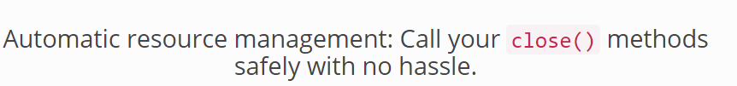

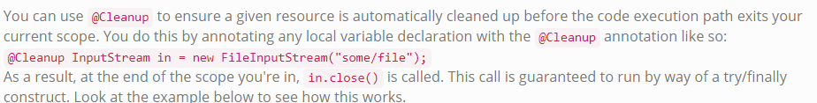

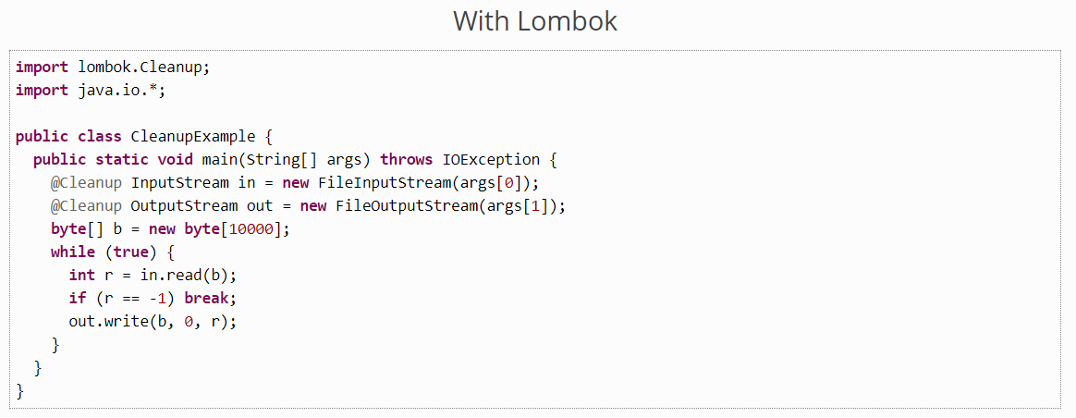

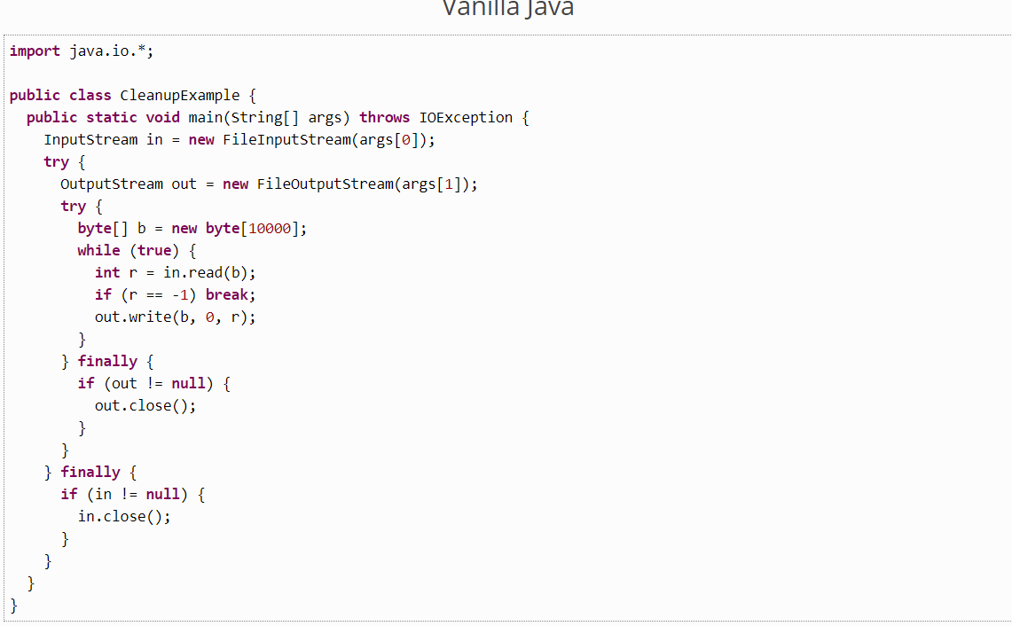

1. **@Log:**



