Mohid Anwar

2023

Contents

**Employees Route** 2

1. GET / employees 2

2. GET /employees/:employeeId 2

3. PUT /employees/:employeeId 3

**Teams Route** 3

1. GET /teams 3

2. Delete /teams/:teamId 4

Output Screenshots

# Employees Route

### GET / employees

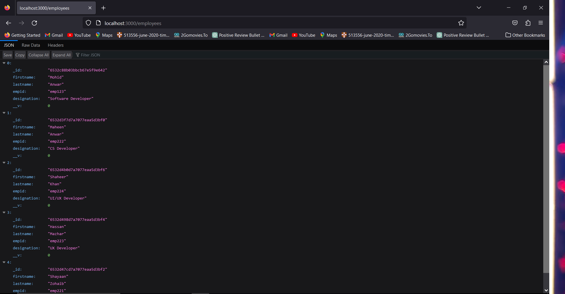

### GET /employees/:employeeId

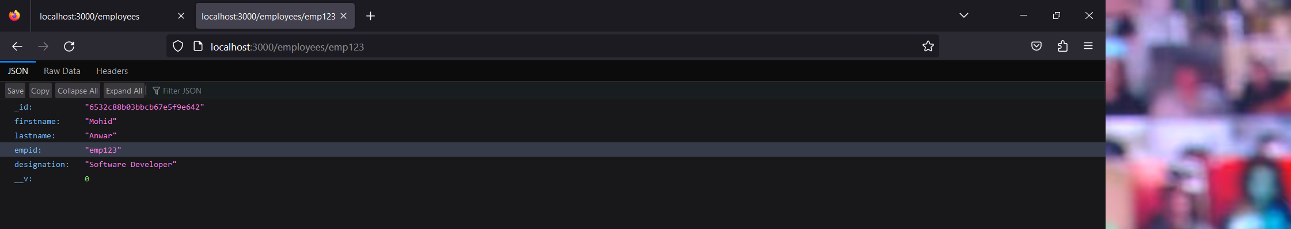

### PUT /employees/:employeeId

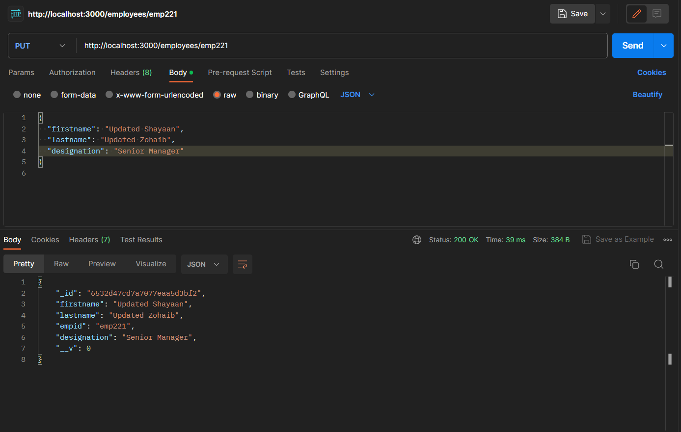

# Teams Route

### GET /teams

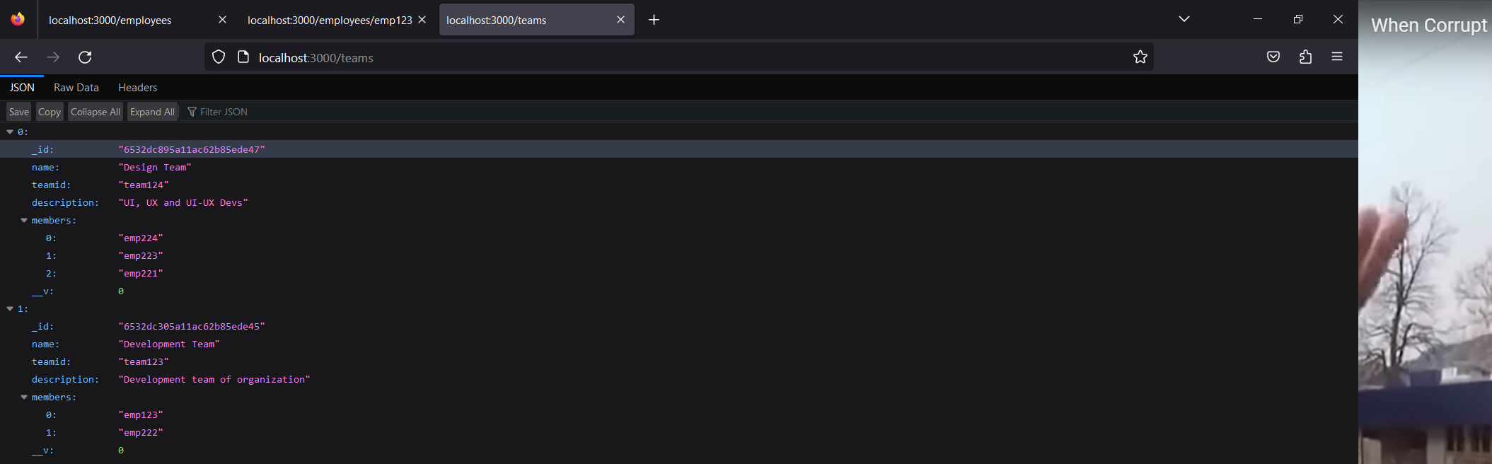

### Delete /teams/:teamId

Displays deleted team

