**ParaView crash course**

Version 5.7.0 – February 2025

File -> Open -> C:/MOHID-Lagrangian-master/RUN_Cases/PCOMS_test_case/PCOMS_test_case_out/PCOMS_test_case.pvd

Or

File -> Open -> C:/MOHID-Lagrangian-master/RUN_Cases/PCOMS_test_case/PCOMS_test_case_out/PCOMS_test_case_..vtu (Group of all *.vtu’s instances)

Inside the “Pipeline Browser” you will see the file you just opened. Click on the eyelid on the left side of the file name to make the layer visible (or right click on name and select “show all”).

In the second toolbar line, there are two drop-down menus. Change from “Surface” to “Points” in the second menu and from “Solid Color” to any of the other options, e.g., “velocity”.

By selecting “velocity”, the middle drop-down menu becomes active, because there are additional options to visualize that parameter: you may also select X, Y, Z to see zonal, meridional and vertical velocity components, respectively.

You can zoom in to a particular region by selecting the magnifying glass button on the highlighted toolbar and dragging a box over the “RederView” window. Additional *camera* visualization options are available here in this toolbar, with the “reset view” button being the left-most one.



Within the “Properties” window, if you scroll down or resize the window, you can see a section names “Styling”. You can enlarge and change the opacity of the points / particles rendered (the effects are most obvious when zooming in on the particles if you have many in a particular domain).



You can explore additional settings to control the coloring of the particles and the colorbar by clicking the “Edit” button on the “Coloring” section of the “Properties” window (right above the “Styling” section). This opens another window named “Color Map Editor”.

There are some presets for colormaps in the drop-down menu “Color Space”, but you can also change the colors individually in the “Mapping Data”.

To reset the changes, scroll down in this window and click the blue circular arrows button , in the bottom left corner.



Spread Sheet View – To check actual numerical values inside *.vtus

You can open a new sheet by clicking the “+” of the layouts which will show you several options to visualize data. 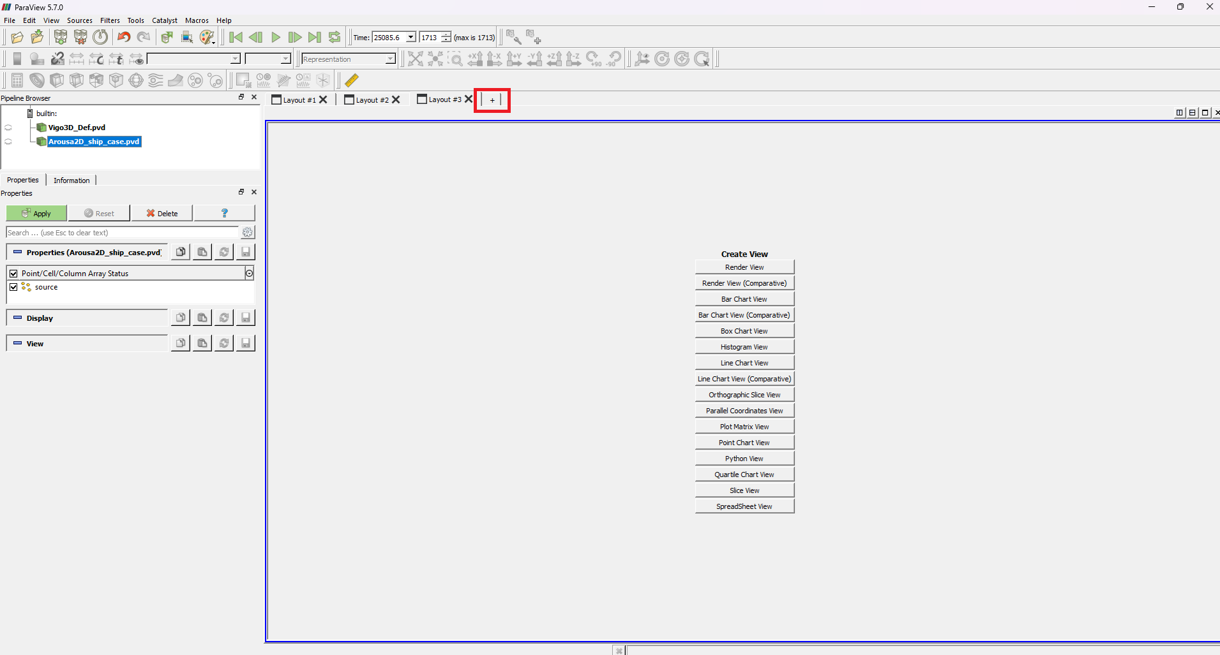

By selecting “Spreadsheet View”, you will see a table similar to and *.odt or *.xlsx spreadsheet where you can check the actual numerical values of the results. This gives you a better measure of what is happening to your particles.

