MOHID-LAGRANGIAN
INSTALLATION-GUIDE

PROLOGUE
This installation guide is done with the purpose of help for Windows and Linux users. The installation guide for Windows is more user friendly than the Linux one. The Linux one install makes some assumptions based on the user are a more experienced user.
Without plattaform dependence, the user should take into account that some links maybe are unavailable or outdated at the time you are reading this file. We will try to update this links but if you found some mistake, please notify us.

WINDOWS Installation guide

- INTRODUCTION
On the installation step we will distinguish two types of installation.
- End users: people who just want to run the code and obtain results.
- Developers: people who wants to write and modify code and to make tests (a guide for this kind of installation will be done in a future).
This installation guide is intended for Windows 10 64 bit system for simplicity. If you have another windows version or 32 system version, select the right architecture when you download the additional software required. Linux installation guide will be added later
In the case of the End users the list of the list of the software require is:
  - Software required for end users:
- Python 3.7 with the following packages:
  - xarray, numba, h5py netcdf4 vtk
- Paraview
  - Software required for developers:
- The previous software for end users and:
- Cmake
- Visual Studio
- Intel Fortran Compiler
- Recommended: Anaconda or another python environment

- INSTALLATION STEPS FOR END USERS
  - The MOHID-Lagrangian code
- Inside a web navigator…
- Open this link: https://github.com/Mohid-Water-Modelling-System/MOHID-Lagrangian/archive/master.zip (you can open it directly from here with Ctrl key pressed)
- Once the file is downloaded unzip it wherever you want.
  - Paraview
- Inside a web navigator…
- Open this link:
https://www.paraview.org/paraview-downloads/download.php?submit=Download&version=v5.7&type=binary&os=Windows&downloadFile=ParaView-5.7.0-Windows-Python3.7-msvc2015-64bit.exe (you can open it directly from here with control key pressed)
- Install it. Double click, specify the folder and you can install wherever you want.

  - Python for end-users
You must have anaconda in order to perform an easy-way installation:
- Open a web navigator
- Open this link: https://repo.anaconda.com/archive/Anaconda3-2020.07-Windows-x86_64.exe
(you can open it directly from here with control key pressed)
- When you install it, a screen like this should appear:
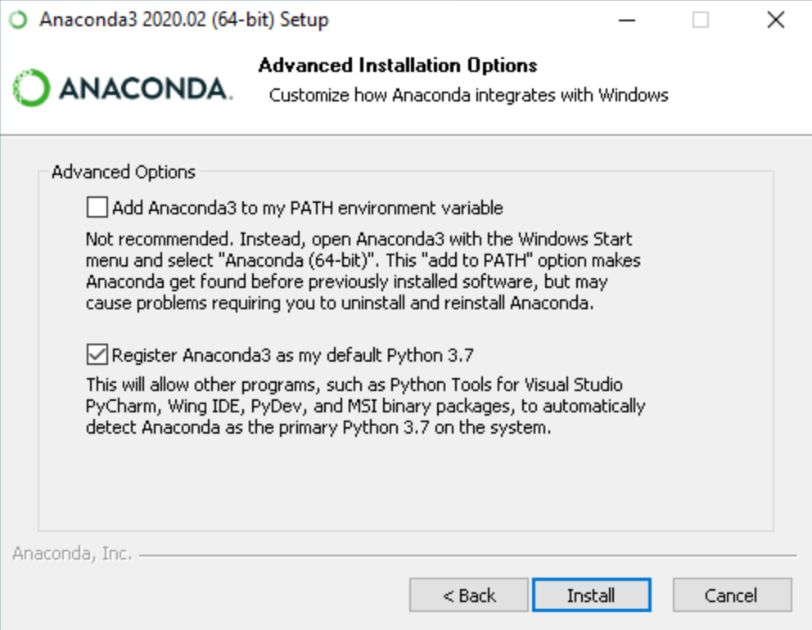

- NOTE: The first empty box sets python installation as your main system python distribution. It is recommended to check this box if you want a unique functional python and you don’t require many different versions of python packages. If you have another python distribution like do not check it to avoid issues.
If you have no idea about if you should check it or not or you don’t understand the previous paragraph you should CHECK IT.

- Go to your MOHID-Lagrangian folder/builScripts
  - Run MakeEnvMOHIDLagrangian.bat

This step will create a new MOHID-Lagrangian environment using anacondas with the packages required to work. In case that you don’t want to create a new environment (or it produces some conflicts and it cannot be installed) and you prefer to use your own Python distribution, it is mandatory to install the following packages in order to run:

- (optional) Install all the required packages using a comand prompt (cmd) and run:
  - pip install xarray numba netcdf4 h5py vtk geopandas cartopy tqdm dask
  - conda install xarray numba netcdf4 h5py vtk geopandas cartopy tqdm dask
- You are ready to run MOHID-Lagrangian.

- RUN A MOHID-Lagrangian test
If python is in your system path (if you use the first python installation way):
- Go to your MOHID-Lagrangian folder.
- Open \MOHID-Lagrangian\RUN_Cases
- Choose a case, go inside the folder case and …
- Double click on RunCase.bat

If your python distribution is not in your system path:
- Open your windows cmd but linked with your Anaconda Distribution
  - Windows icon
  - Write: anaconda prompt
  - Open it
  - Activate your conda environment with: conda activate MyEnvironment
- Go to your MOHID-Lagrangian folder
  - cd yourpath\MOHID-Lagrangian\RUN_Cases
- Go inside a case folder.
  - cd name_of_the_case_folder
- RunCase.bat

Linux Installation guide

As we mention in the prologue this guide is for non beginner users. It assumes that at least you know how to use a terminal and to install packages at your linux distribution. During this installation steps. I am assuming that I am in the $HOME folder or ~.

Download the code
The first step will be to download code with:
>> wget ‘https://github.com/Mohid-Water-Modelling-System/MOHID-Lagrangian/archive/master.zip’ -0 master.zip
And uncompress it with:
>> unzip master.zip
Or in case you prefer to use git just clone it with:
>> git clone https://github.com/Mohid-Water-Modelling-System/MOHID-Lagrangian.git

Install required packages and additional software

2.1 Linux distribution-based software
This installation section was done for Debian based distributions. In case you run a Red-Had based installation or another distribution, please use the respective commands to replace the “apt”.
Once it is cloned, we need to compile the libraries. In order to compile them, we need the following requirements:
- Cmake > 3.5
- Autotools, automake
- M4
- Gfortran > 8.0
If you have a recent linux distribution you must do (with admin privileges):
>>apt-get update
>>apt-get install automake autotools-dev m4 cmake gfortran-8
If you have an Intel Fortran compiler (ifort version 16 or higher), you don’t need to install the gfortran.
Check the cmake and gfortran versions. Please check them with:
>> cmake –version
>> gfortran –version
To make the things run properly, the cmake version should be higher than 3.5 and gfortran higher than 8. The other packages (autotools, automake and m4) didn’t notice a version conflict during the installation.
In case that the CM requirement is not satisfied the compilation will not be run ok and these packages should be installed by hand.

2.2 Cmake by-hand installation (optional)
If your linux distribution do not have these packages versions requirements, you must install them by hand. The cmake package can be install in your home directory with:
>> wget ‘https://github.com/Kitware/CMake/releases/download/v3.17.0/cmake-3.17.0-Linux-x86_64.sh’ - 0 cmake-3.17.0-Linux-x86_64.sh
>> chmod +x cmake-3.17.0-Linux-x86_64.sh
>> ./cmake-3.17.0-Linux-x86_64.sh
During the installation it gives you the option to specify the installation path. Please select your desire folder. If you don’t have admin privileges you must select a folder where you want to install.

2.3 Python distribution
You must have anaconda in order to perform an easy-way installation:
- Open a web navigator
- Go to https://www.anaconda.com/products/individual: and download the Anaconda Distribution for Linux
- During the installation, it will ask you if you want to add the anaconda to the environment PATH variable. It is recommended to anwers ‘yes’ if you have a unique functional python and you don’t require the python of the system for other purposes. If you have another python distribution do not check it to avoid issues.
- Go to your MOHID-Lagrangian folder/builScripts
  - Run MakeEnvMOHIDLagrangian.sh

Compile the libraries
If you could install everything is time to run the script MakeLibraries.sh in MOHID-Lagrangian/ExternalLibs:
If you use gfotran compiler:
>> ~/MOHID-Lagrangian/ExternalLibs/MakeLibraries.sh -gfortran
If you use ifort compiler:
>> ~/MOHID-Lagrangian/ExternalLibs/MakeLibraries.sh -intel
(if you are going to use ifort compiler)
It takes some time to finish, be patient!

Compile the MOHID-Lagrangian
Once all the libraries have been compiled. you can compile the MOHID-Lagrangian with:
>> ~/MOHID-Lagrangian/buildScripts/MakeMohidLagrangian.sh

Test the MOHID-Lagrangian
Go to one of the test cases inside folder /MOHID-Lagrangian/RUN_Cases and just run
>> ./RunCase.sh

