**Name:** Mohid Naghman. **Class:** BS-AI.

**Section:** 4-A. **Roll No:** F23-049.

**Assignment No:** 07

**OS LAB**

1. **Print a message: “Linux is fun!” to the terminal.**

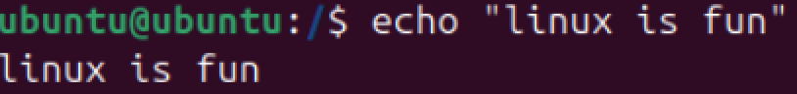

1. **Use echo to print a multi-line message using \n.**

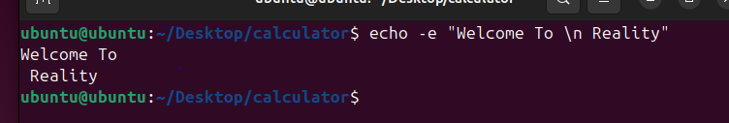

1. **Print the value of an environment variable such as $HOME.**

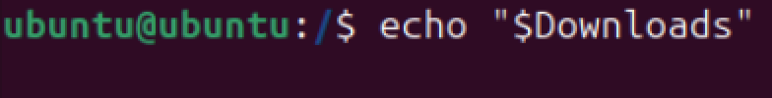

1. **Suppress the newline character when printing “Hello, Linux!”.**

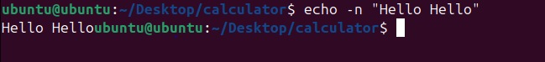

1. **Redirect the output of echo to a file named output.txt.**

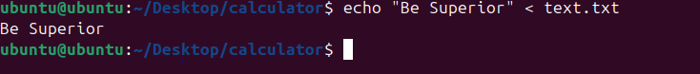

1. **Append the text “New line added” to output.txt.**



1. **Write a simple shell script using echo to print “Script executed successfully!”.**

