AEM Card Creation Task

Developing an Author component to retrieve and display card details:

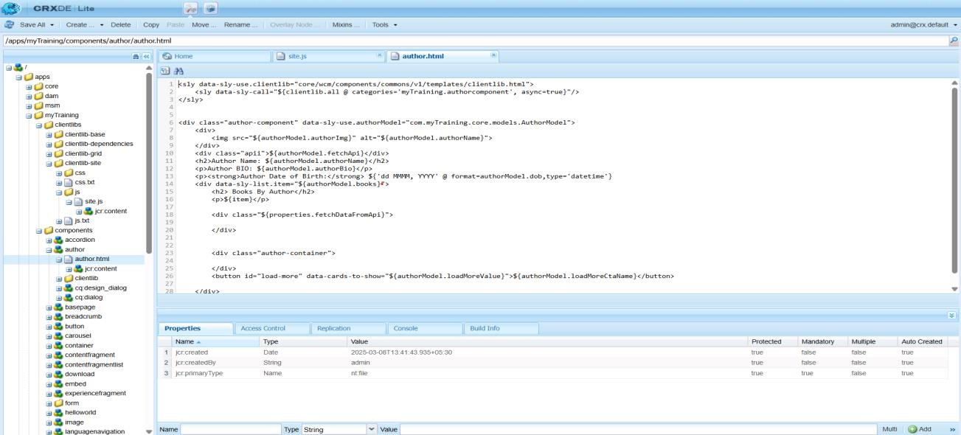

Including site.js in the clientlibs folder to retrieve data from an API URL:

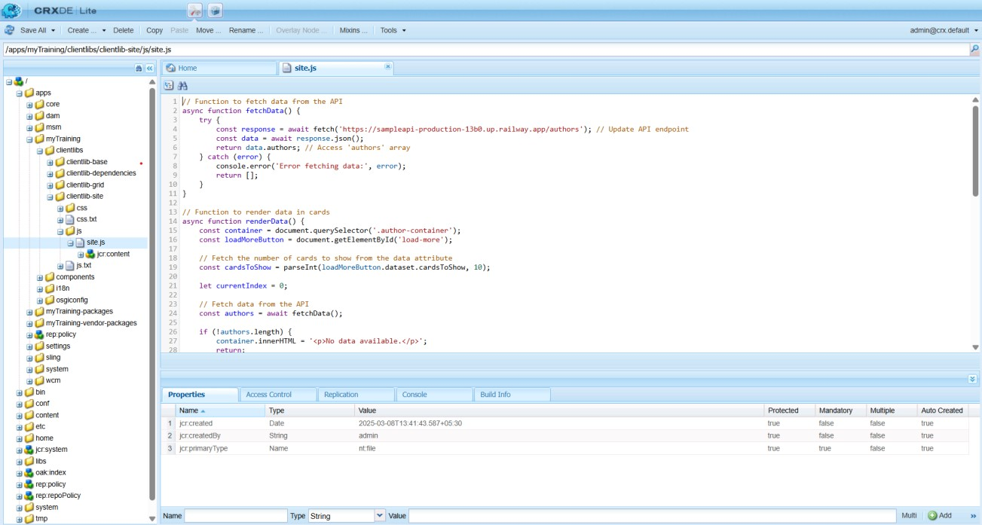

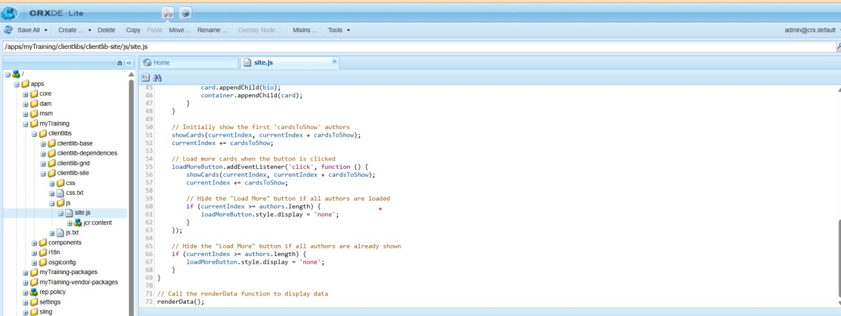

**AUTHOR COMPONENT IMAGE:**

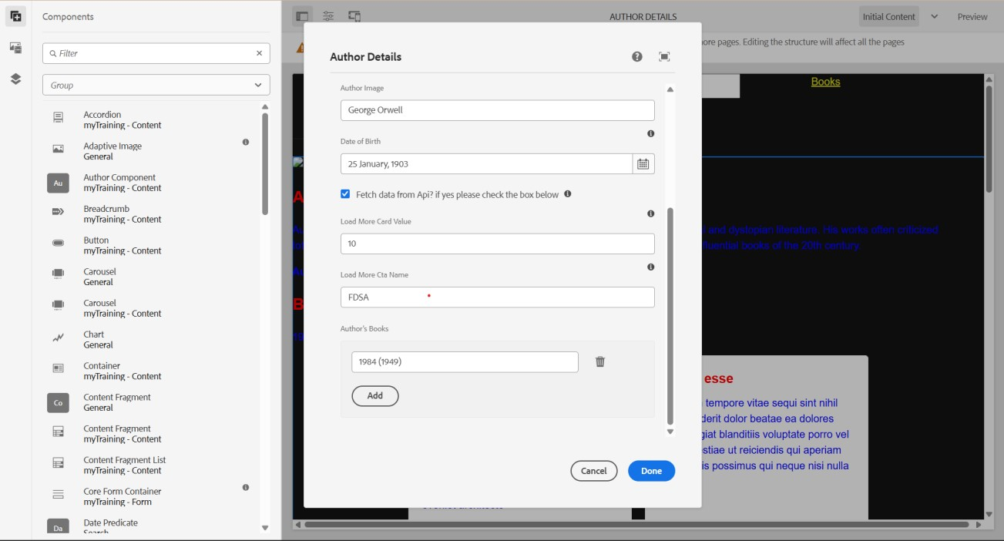

The author card displays details including the author's name and bio:

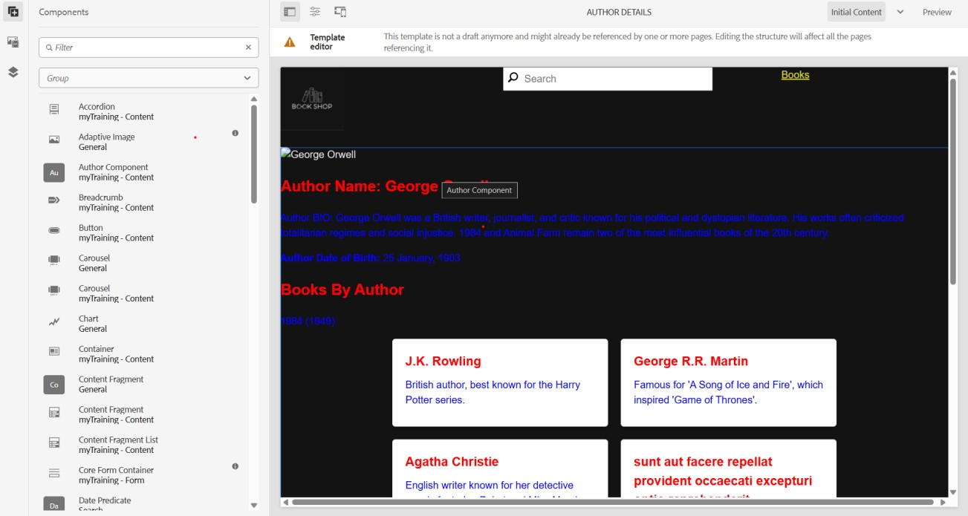

The AuthorModel file has been updated to retrieve details from the API:

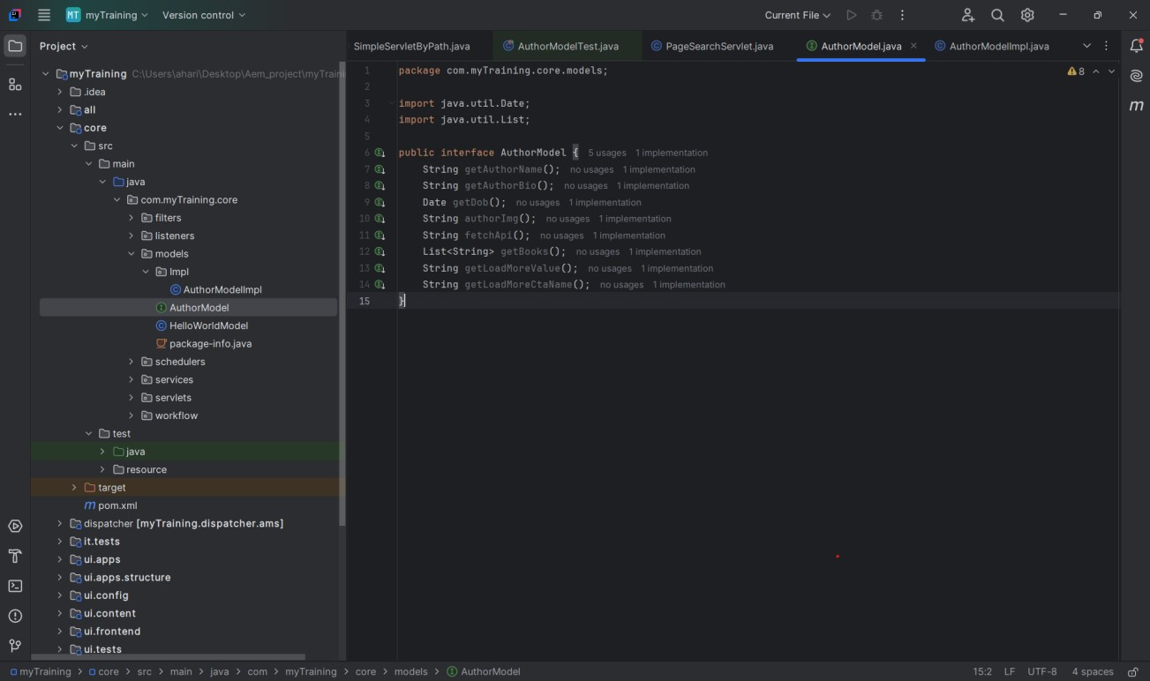

The AuthorModelImpl file has been modified to align with the AuthorModel:

