**Lab Practical #01:**

Study of basic networking commands and IP configuration.

**Practical Assignment #01:**

1. Perform and explain various networking commands listed below:
   1. ipconfig
   2. ping
   3. getmac
   4. systeminfo
   5. traceroute / tracert
   6. netstat
   7. nslookup
   8. hostname
   9. pathping
   10. arp

## ipconfig

### Description:

Displays the IP address, subnet mask, and default gateway for all network adapters. Useful for checking and troubleshooting network configuration on Windows.

### Implementation:

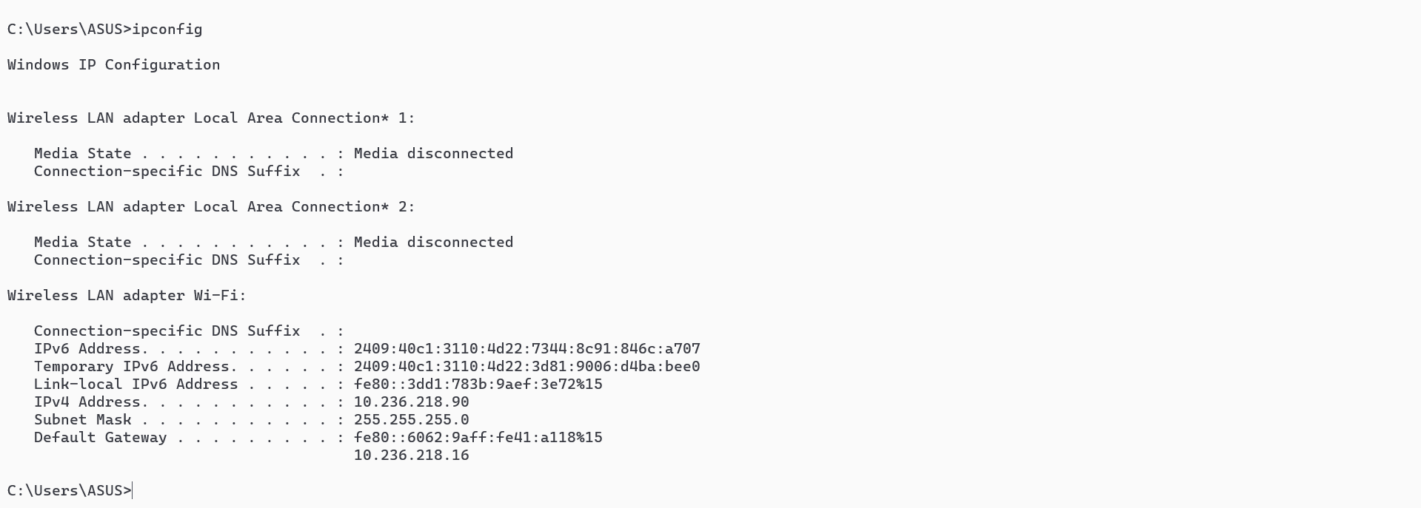

## ping

### Description:

Sends ICMP echo requests to a specified host to check connectivity and response time. Helps diagnose network or internet connection issues.

|  |  |  |
| --- | --- | --- |
| No. | Option | Description |
| 1 | -t | Ping the specified host until stopped. |
| 2 | -n count | Number of echo requests to send. |
| 3 | -l size | Send buffer size. |
| 4 | -w timeout | Timeout in milliseconds to wait for each reply. |

### Implementation:

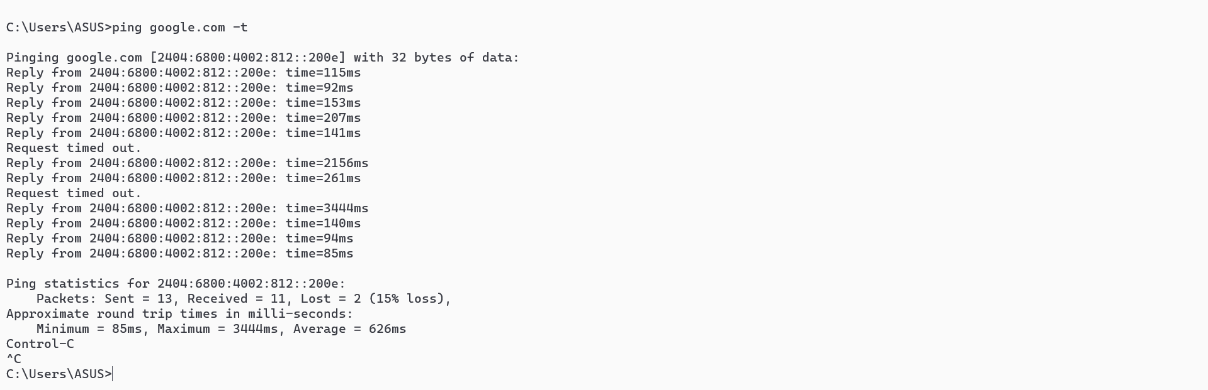

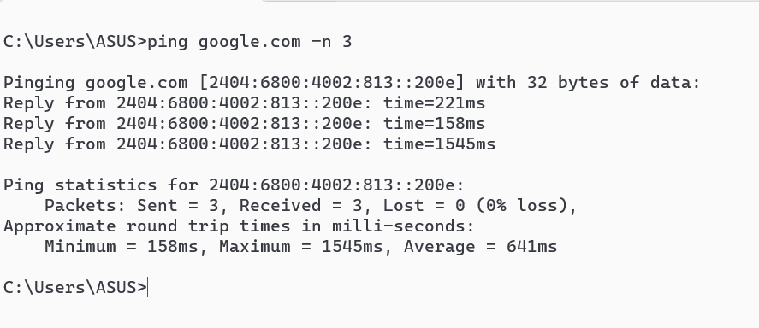

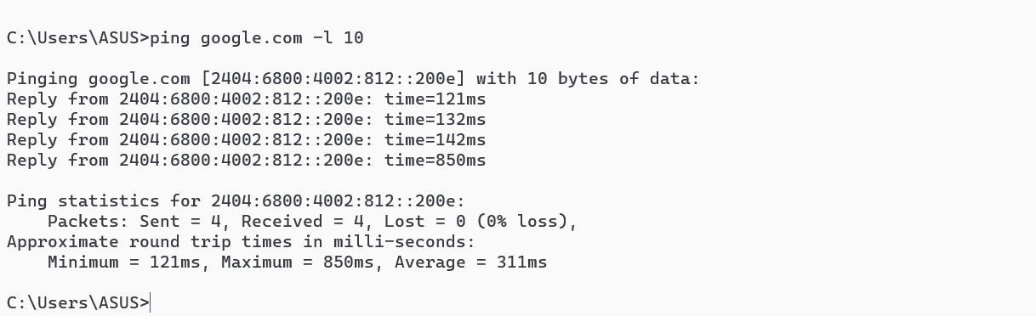

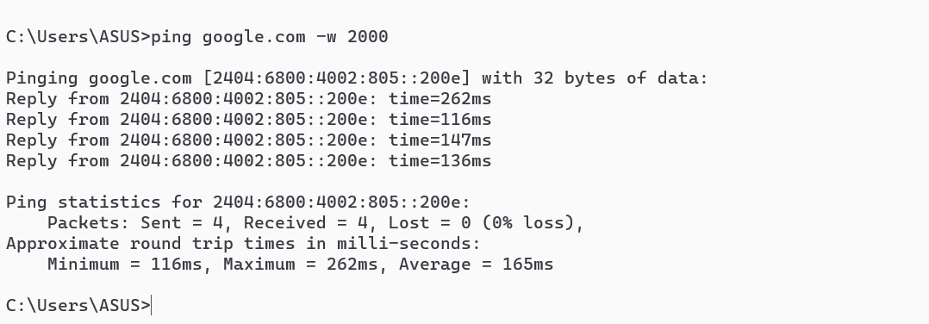

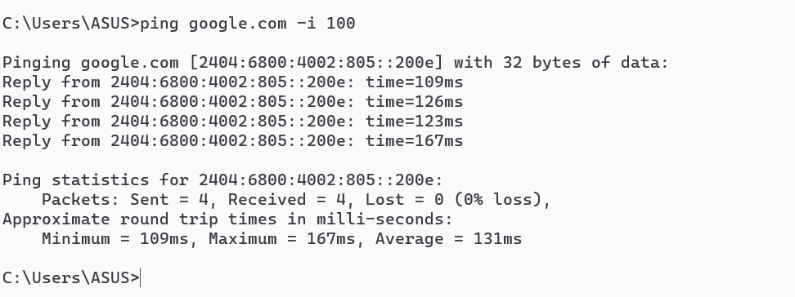

## getmac

### Description:

Displays the MAC (Media Access Control) address of the system's network interfaces. Useful for identifying devices on a network. (Physical Add.)

### Implementation:

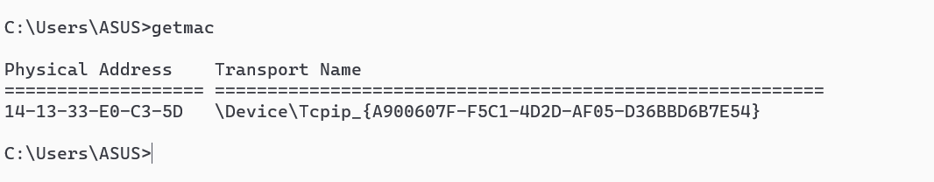

## systeminfo

### Description:

Shows detailed information about the computer's hardware and software, including OS version, processor, memory, and installed updates.

### Implementation:



## tracert

### Description:

Traces the path packets take to a destination, showing each hop along the route. Useful for diagnosing where network delays or failures occur.

|  |  |  |
| --- | --- | --- |
| No. | Option | Description |
| 1 | -d | Do not resolve IP addresses to hostnames (faster output). |
| 2 | -h (max hops) | Set maximum hops (default is 30). Limits how many routers to check. |
| 3 | Only tracert | Work regular with by default 30 hops. |

### Implementation:

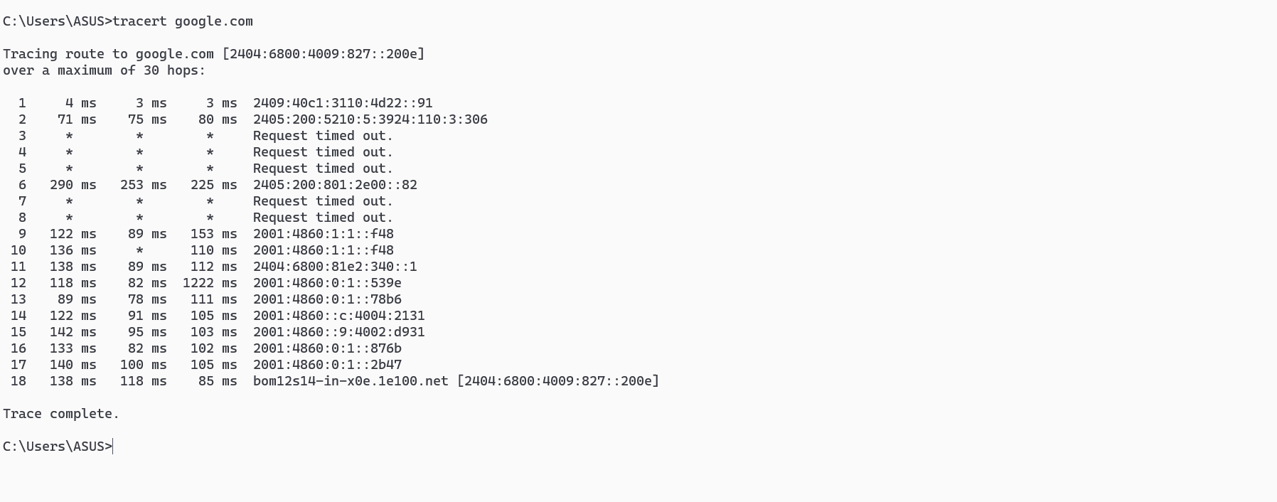

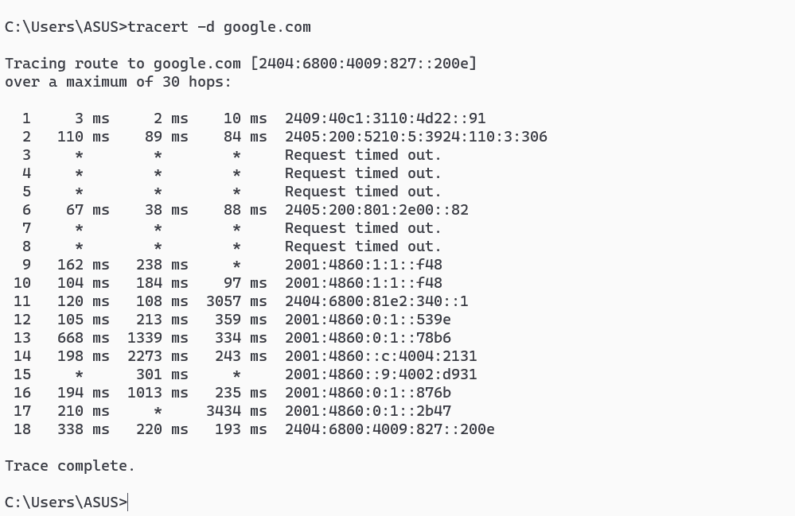

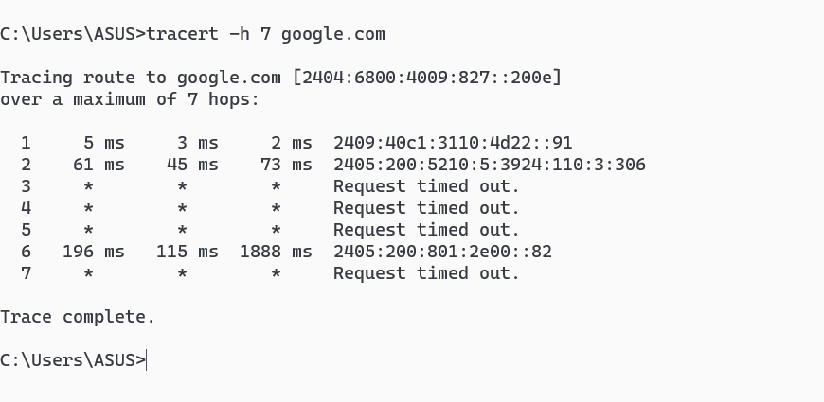

## netstat

### Description:

Displays active network connections, listening ports, and related statistics. Helps identify open ports and active network sessions.

### Implementation:



## nslookup

### Description:

Queries DNS servers to resolve domain names into IP addresses and vice versa. Useful for diagnosing DNS-related issues.

### Implementation:

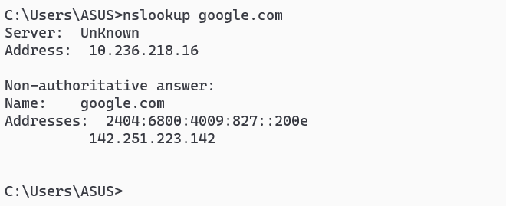

## hostname

### Description:

Displays the name of the current computer. Often used to confirm system identity on a network.

### Implementation:



## pathping

### Description:

Combines the functions of ping and tracert, providing detailed network route and packet loss statistics. Useful for advanced network diagnostics.

|  |  |  |
| --- | --- | --- |
| No. | Option | Description |
| 1 | -g (host list) | Specifies loose source routing along the host list (used rarely). |
| 2 | -h (max host) | Maximum number of hops to search for the target (default is 30). |
| 3 | -n | Prevents the command from resolving IP addresses to hostnames. |
| 4 | -p | Wait time (in milliseconds) between pings (default is 250 ms). |
| 5 | -list(help) (/?) | Displays help information about pathping command and options. |

### Implementation:

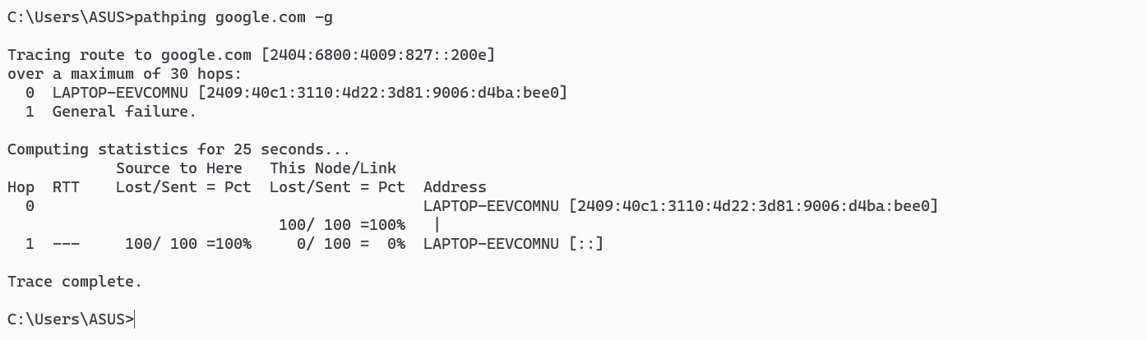

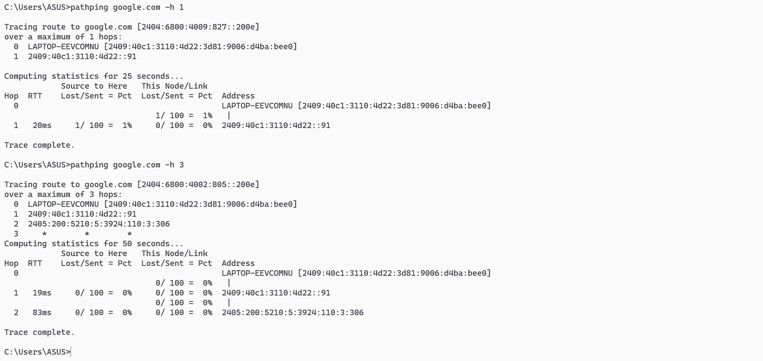

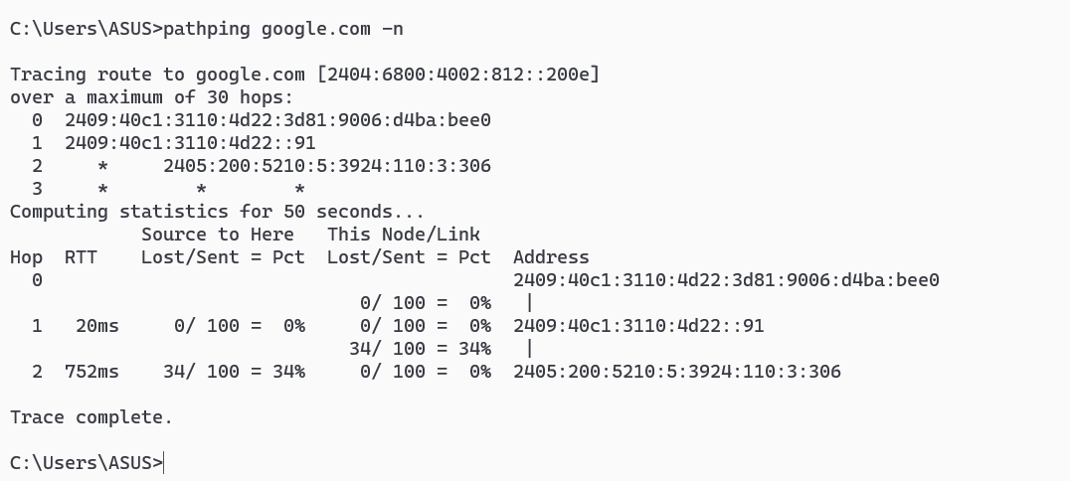

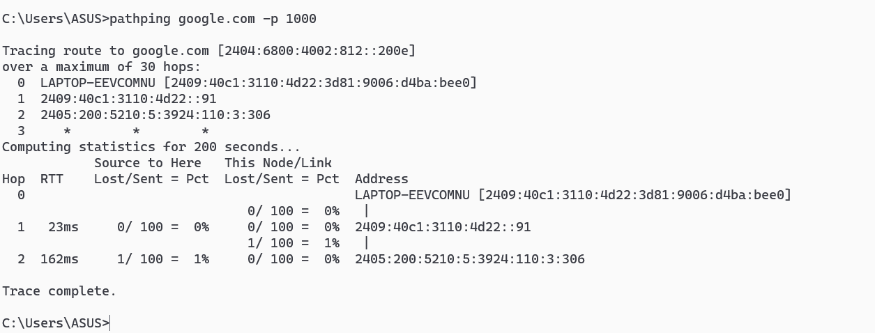

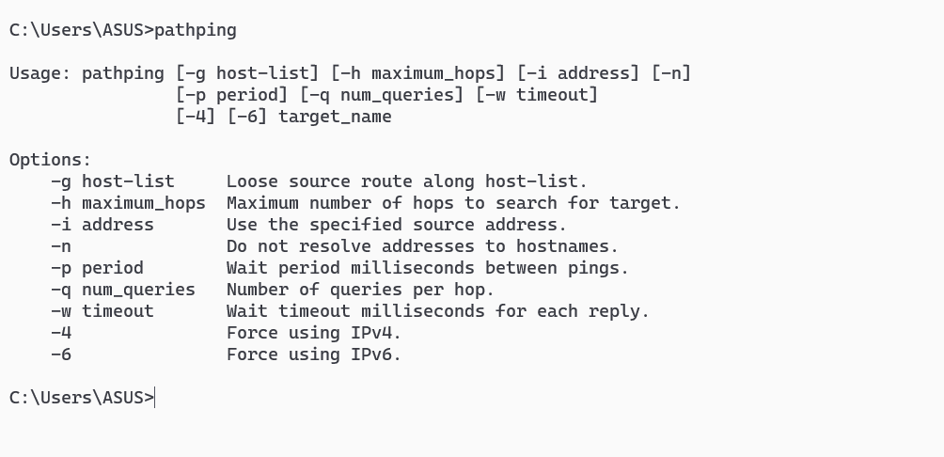

## arp

### Description:

Displays and modifies the Address Resolution Protocol (ARP) cache. The ARP cache maps IP addresses to MAC addresses on a local network.

|  |  |  |
| --- | --- | --- |
| No. | Option | Description |
| 1 | -a | Displays the current ARP entries for all interfaces. |
| 2 | -g | Same as -a; shows ARP table (alias for -a). |
| 3 | -v | Send buffer size. |

### Implementation:

