**Lab Practical #03:**

Study of different types of network cables & connectors and crimping a LAN.

**Practical Assignment #03:**

1. List various networks cable. Also, write short description.
2. Difference between guided and unguided media.
3. Give cross-wired cable and straight through cable diagram (Color Code wise).

## List various networks cable and connectors. Also, write short description.

1. **Unshielded Twisted Pair(UTP) :** 
   * **Description**: The most common type of twisted pair cable used in networking. UTP cables are used extensively in Ethernet networks. They consist of pairs of wires twisted together to reduce electromagnetic interference.
   * 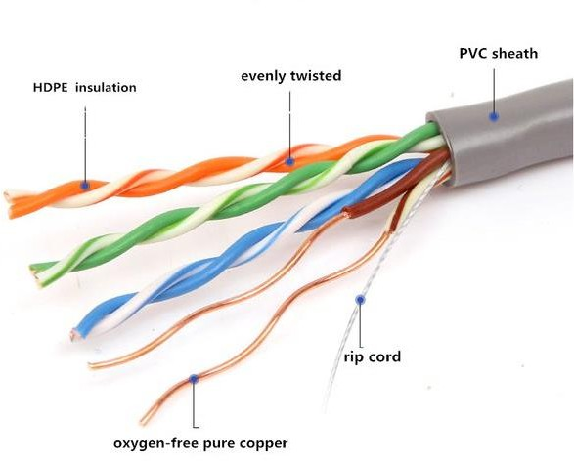**Diagram**:
2. **Shielded Twisted Pair(STP) :** 
   * + - **Description**: Similar to UTP but includes shielding to protect against electromagnetic interference. This shielding can be an overall foil or braid and can also shield each individual pair.
       - 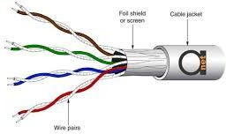**Diagram**:
3. **Coaxial Cables :**

* **Description**: Consist of a central conductor, insulating layer, metallic shield, and protective outer layer. Coaxial cables are known for their high frequency and wide bandwidth capabilities.
  + 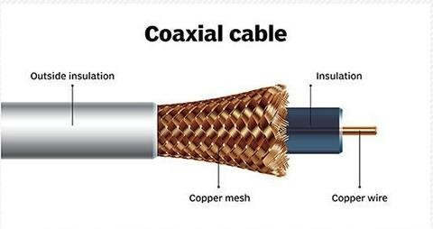**Diagram**:

1. **Fiber Optic Cables :**

* **Description**: Use light to transmit data at very high speeds over long distances. They are made of a glass core surrounded by a cladding layer, and an outer protective jacket. There are two main types: Single-mode (for long distances) and Multimode (for shorter distances).
  + 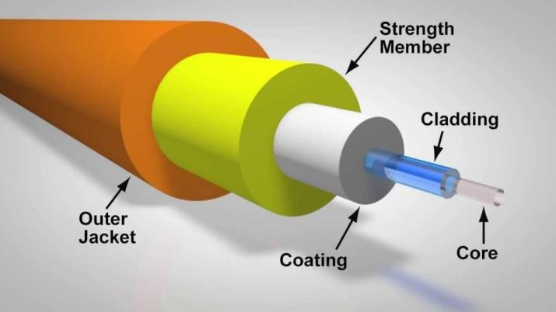**Diagram**:

1. **Difference between guided and unguided media.**

|  |  |  |
| --- | --- | --- |
| **Point** | **Guided Media (Wired)** | **Unguided Media (Wireless)** |
| **Transmission Medium** | Physical cables (copper, fiber optic) | Air, space, vacuum |
| **Alternate Name** | Wired communication | Wireless communication |
| **Signal Guidance** | Confined and guided by the medium | Broadcasted, not confined |
| **Bandwidth** | Generally higher, especially in fiber optics | Variable, depends on the technology and distance |
| **Range** | Limited by the length and type of cable used. | Covers larger distances, especially via satellites and antennas. |
| **Interference** | Susceptible to electromagnetic interference (except fiber) | Susceptible to atmospheric and physical interference |
| **Security** | More secure due to physical connection | More vulnerable to interception |
| **Installation Cost** | Generally higher due to cable and infrastructure costs. | Lower as there is no cabling involved. |
| **Maintenance** | Can be costly and complex | Easier, but may require more frequent adjustments |
| **Mobility** | Limited by the fixed nature of cables | Highly mobile and flexible |
| **Typical Use Cases** | LAN, data centers, broadband internet | Wi-Fi, cellular networks, satellite communication |

## Give cross-wired cable and straight through cable diagram (Color Code wise).

1. Cross-wired Cable Diagram (Color Code)  
     
   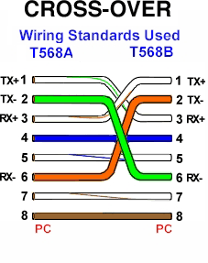

1. Straight Through Cable Diagram (Color Code)

