**Lab Practical #06:**

Study Client-Server Socket programming - TCP & UDP

**Practical Assignment #06:**

1. **Write a C/Java code for TCP Server-Client Socket Programming.**
2. **Write a C/Java code for UDP Server-Client Socket Programming.**
3. **For TCP Server-Client:**

**TCP Server Program:**

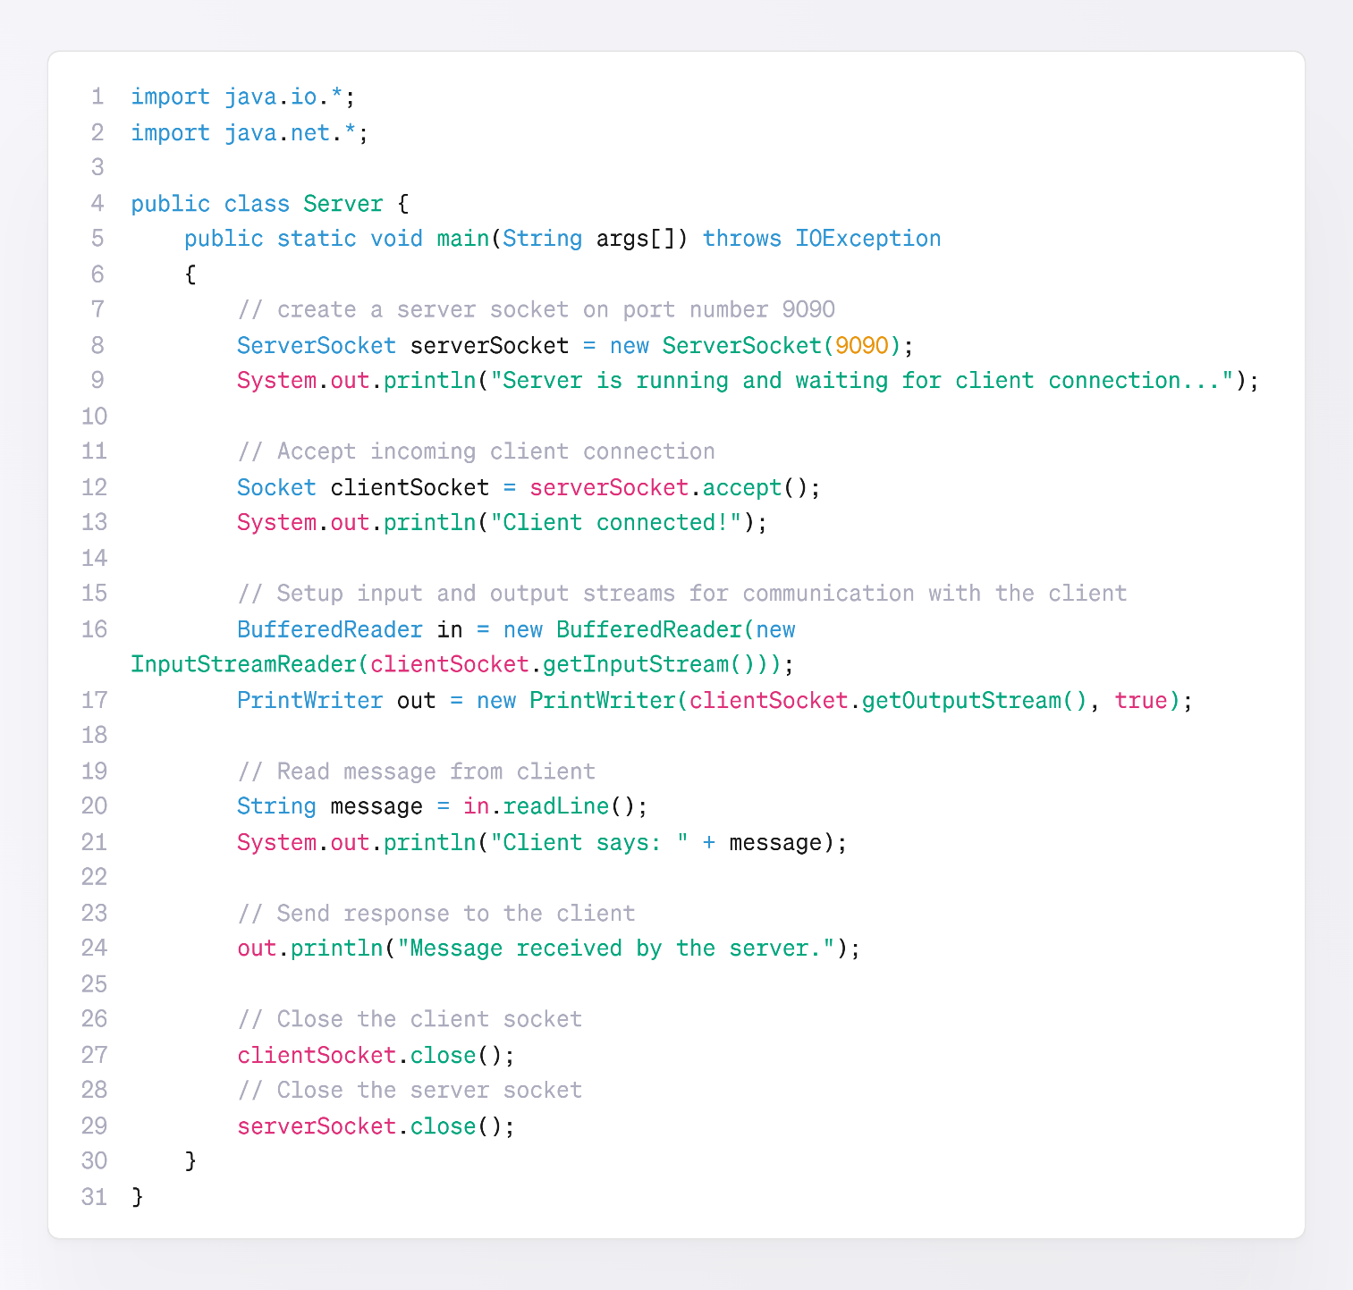

**TCP Client Program:**

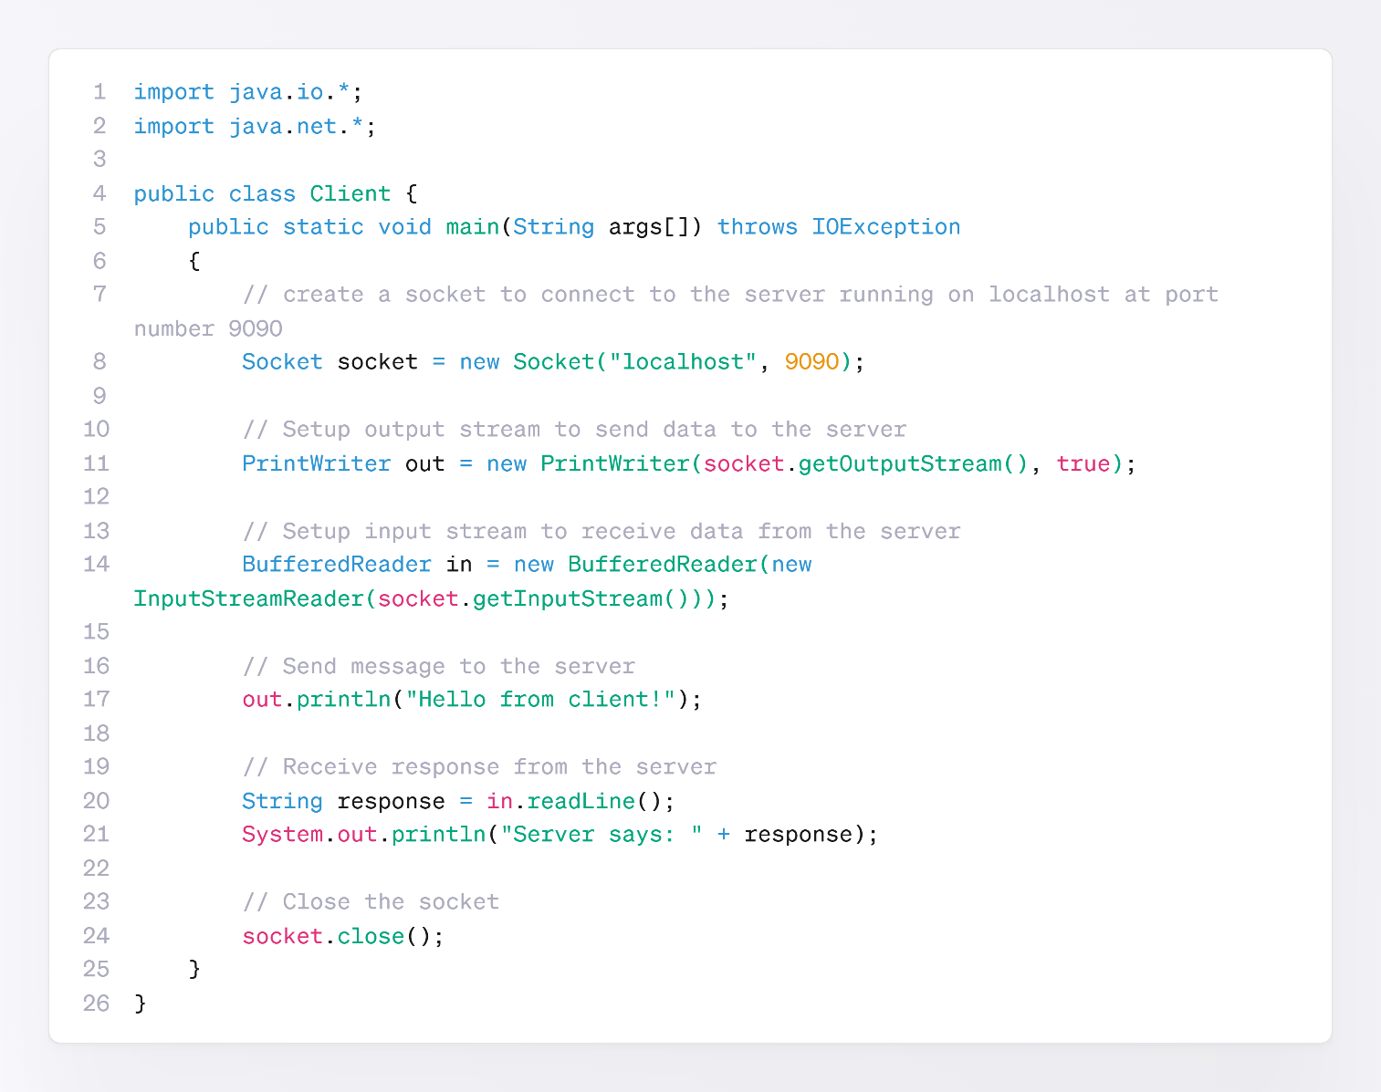

1. **For UDP Server-Client:**

**UDP Server Program:**

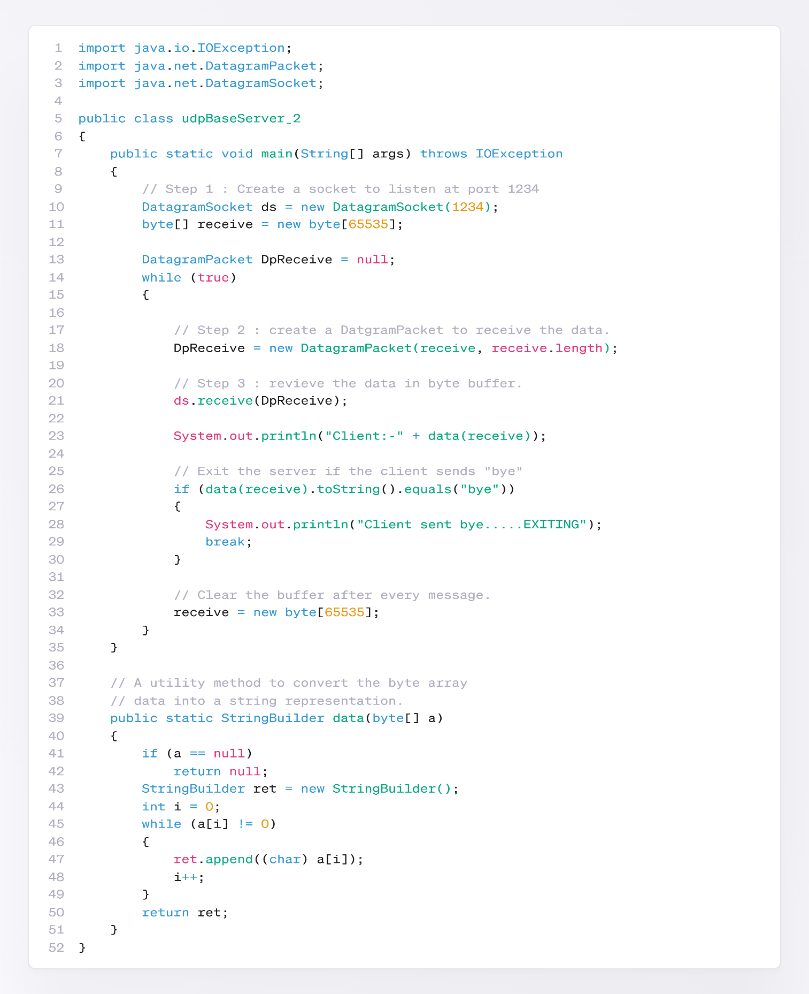

**UDP Client Program:**

