**Lab Practical #09:**

Study Packet capture and header analysis by Wireshark (HTTP, TCP, UDP, IP, etc.)

**Practical Assignment #09:**

1. **Explain usage of Wireshark tool.**
2. **Packet capture and header analysis by Wireshark (HTTP, TCP, UDP, IP, etc.)**

# Wireshark usage:

* Wireshark is a free and open-source network protocol analyzer.
* It is used to capture and inspect packets flowing in a network in real time.
* Common usages:
  + Troubleshooting network issues.
  + Analyzing protocols (HTTP, TCP, UDP, IP, DNS, etc.).
  + Network security monitoring (checking suspicious traffic).
  + Learning how networking protocols work.

# Packet capture and header analysis:

## HTTP

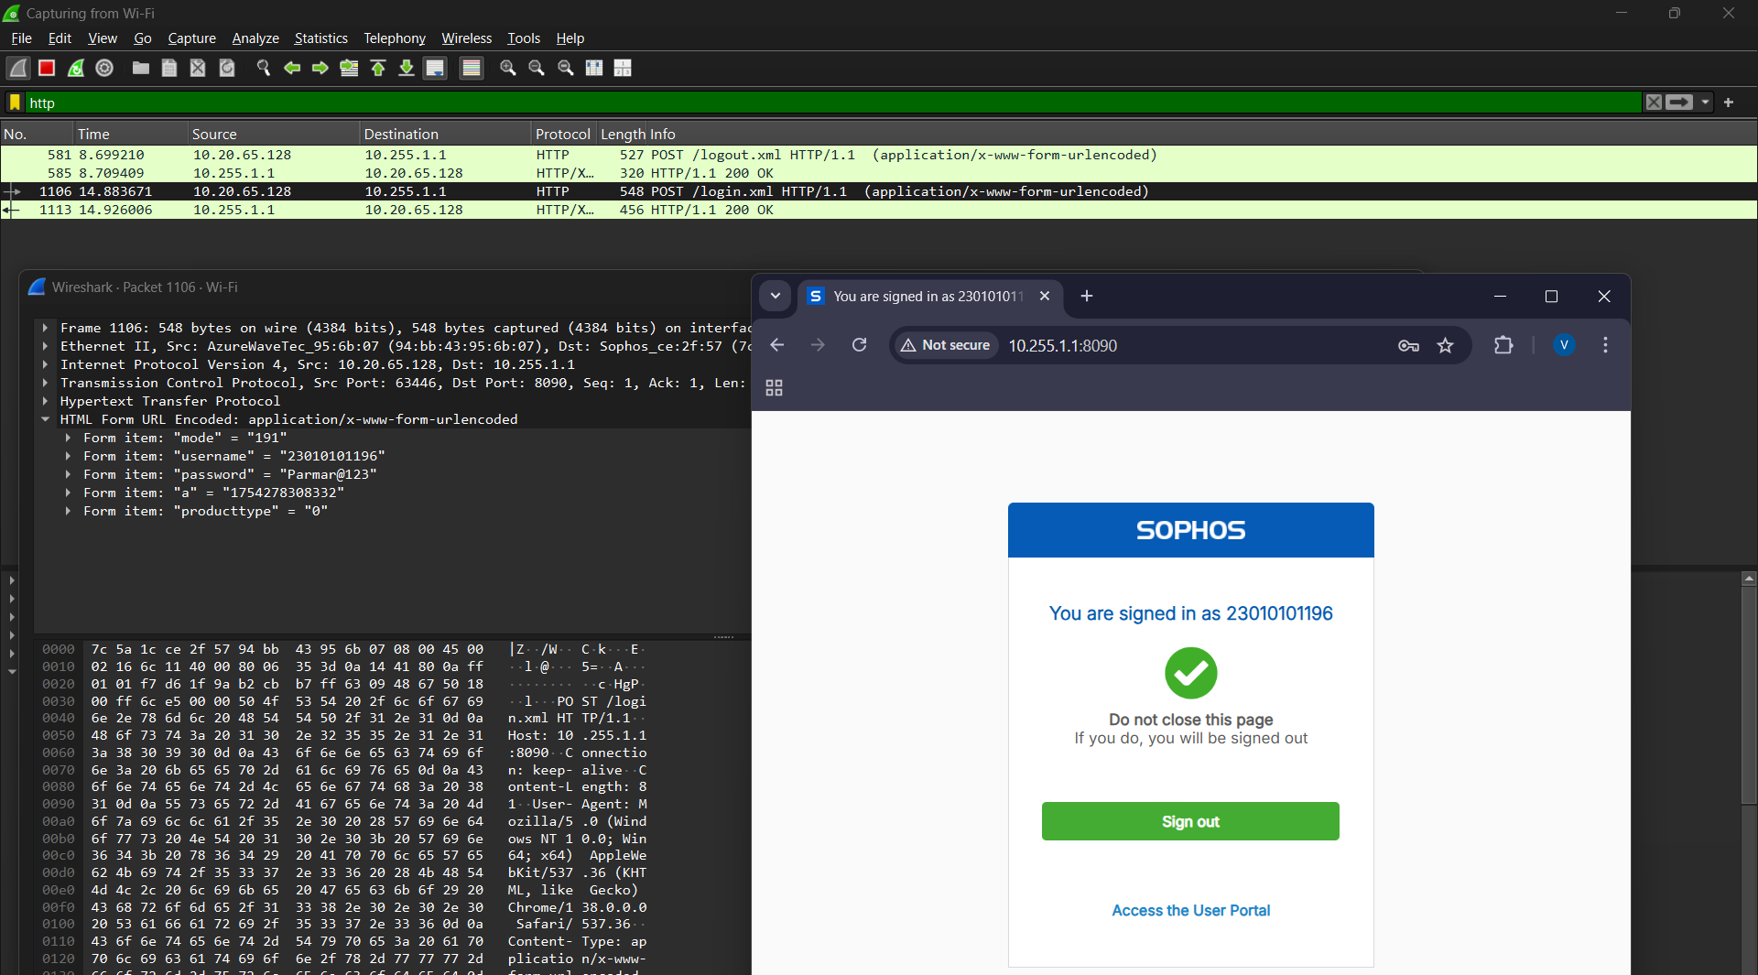

## DNS

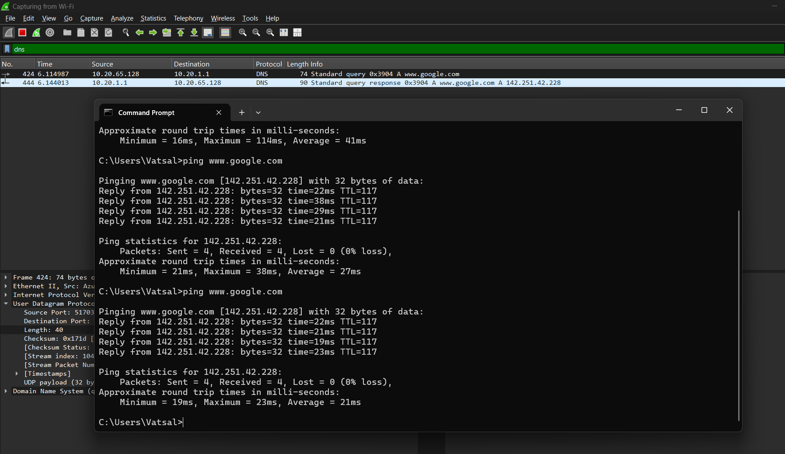

## ICMP

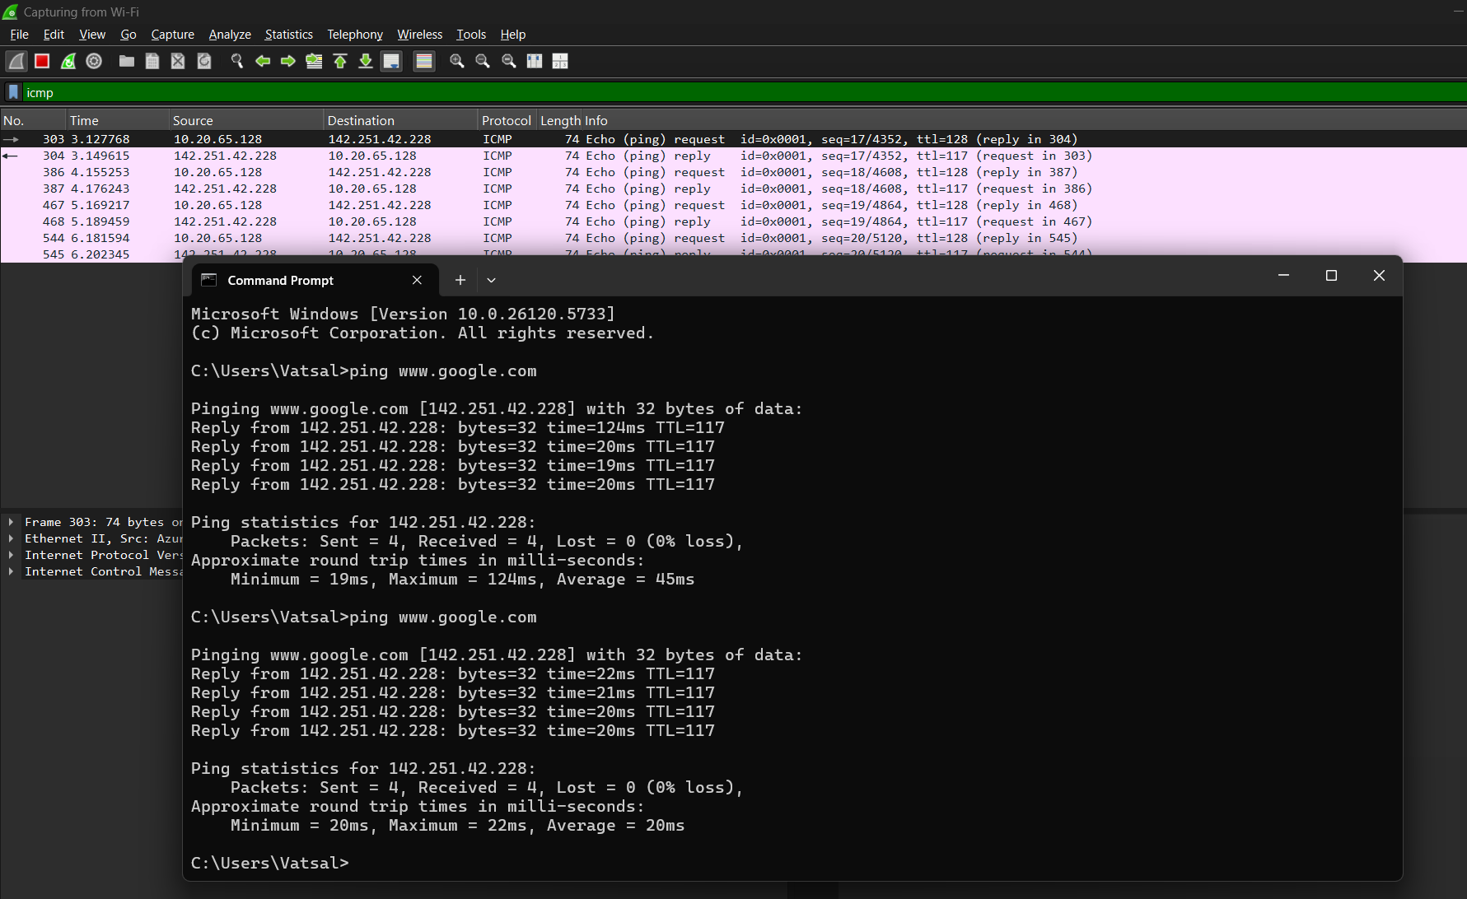

## TCP

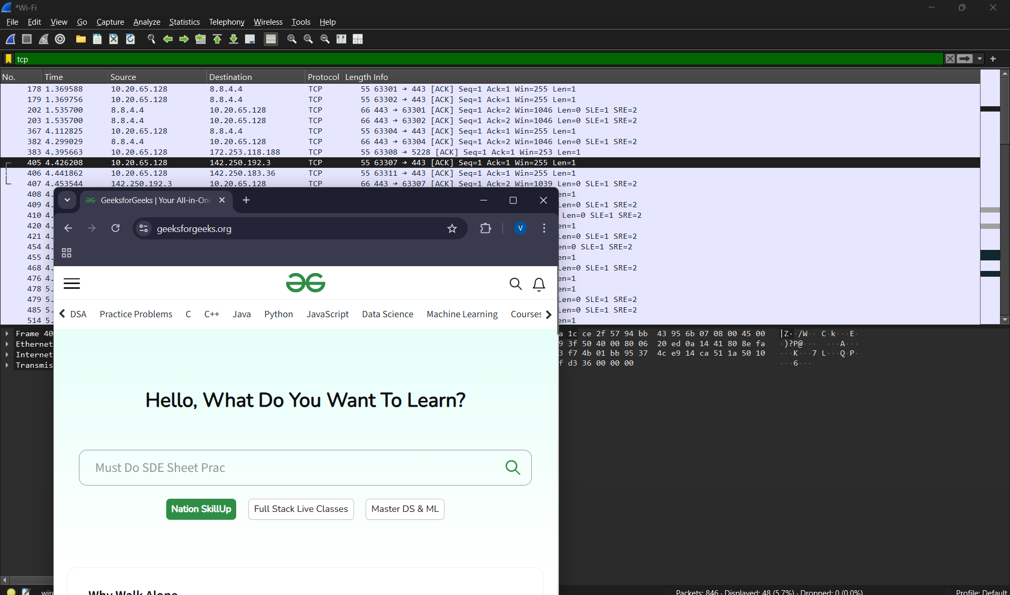

## UDP

