**Lab Practical #11:**

Study the concept of routing using packet tracer. (Dynamic Routing)

**Practical Assignment #11:**

1. Connect the two different networks based on the calculated IP addresses and subnet using a packet tracer.

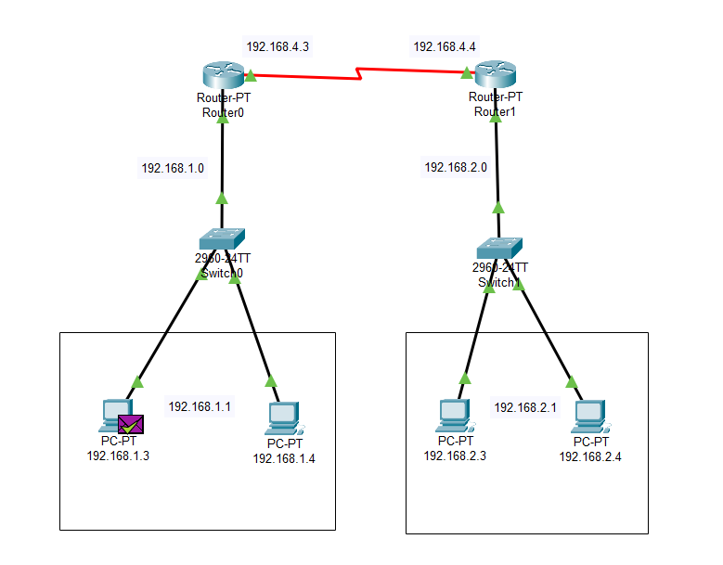

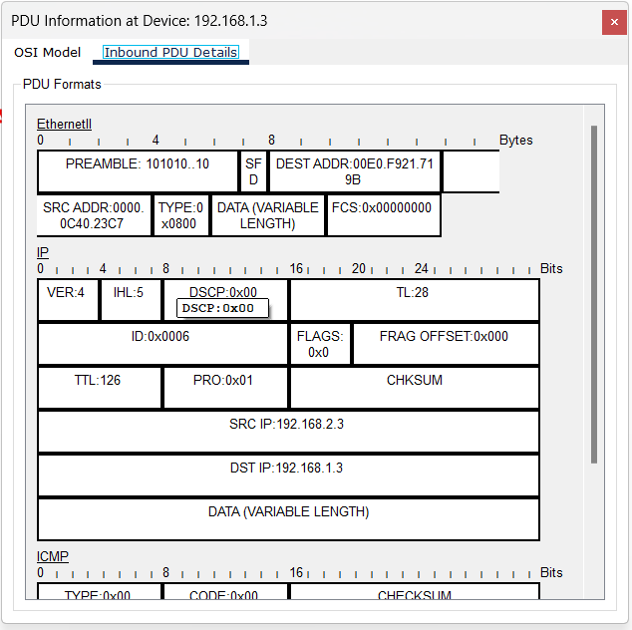

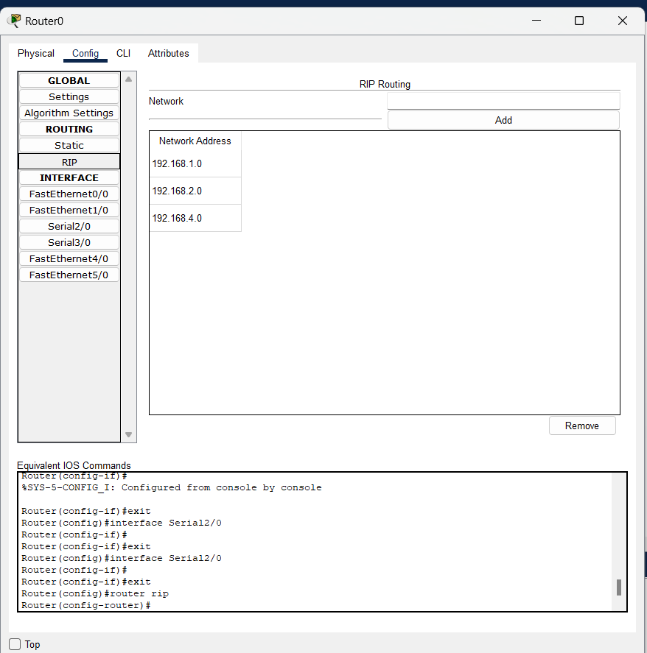

1. Connect the three different networks based on the calculated IP addresses and subnet using a packet tracer.

