**Lab Practical #13:**

To develop network using distance vector routingprotocol and link state routing protocol.

**Practical Assignment #:**

1. **C/Java Program: Distance Vector Routing Algorithm using Bellman Ford's Algorithm.**

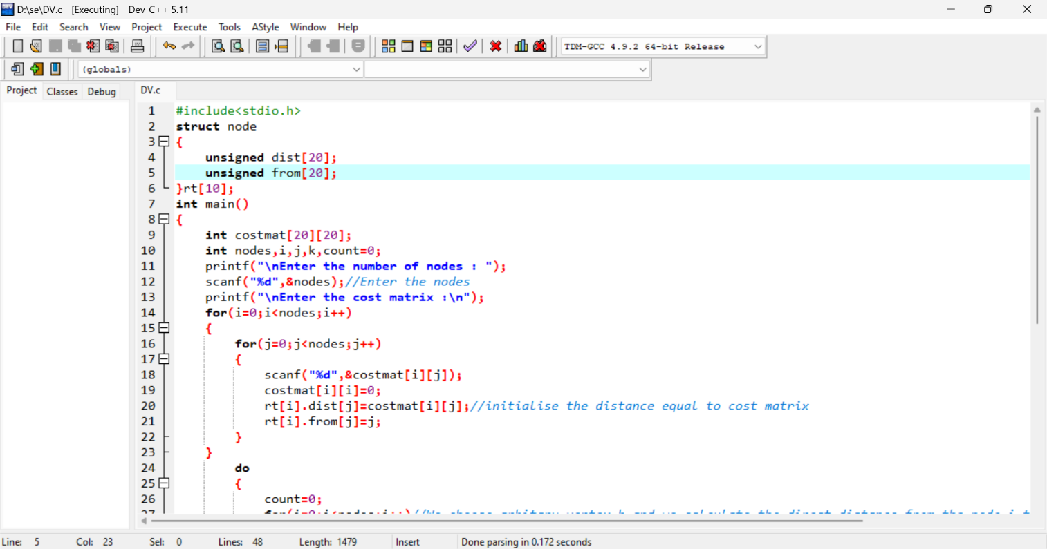

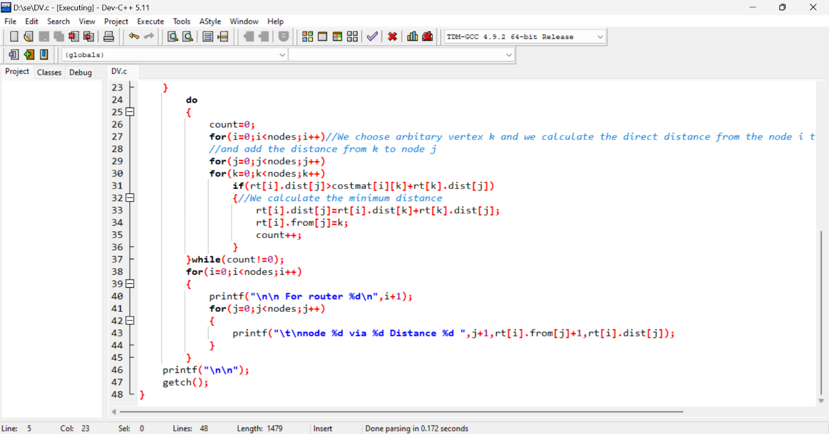

**Output:**

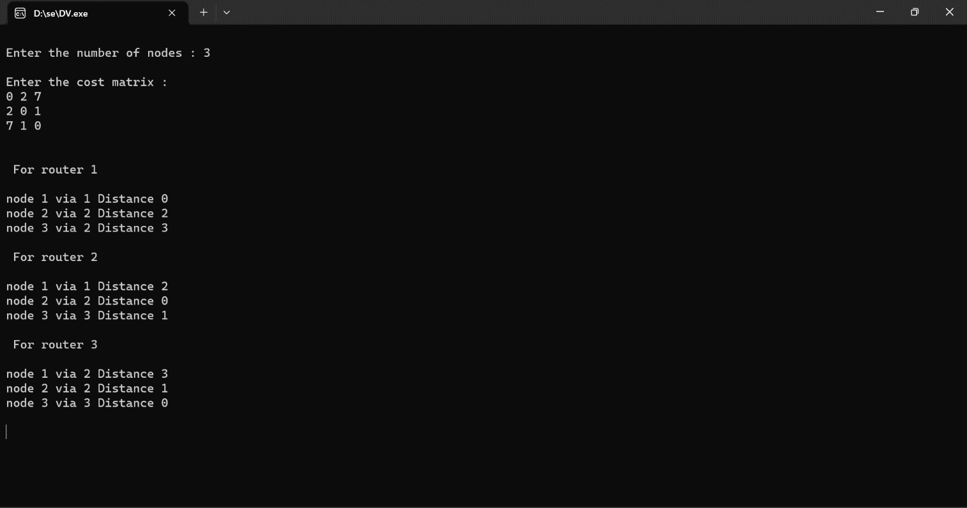

1. **C /Java Program: Link state routing algorithm.**

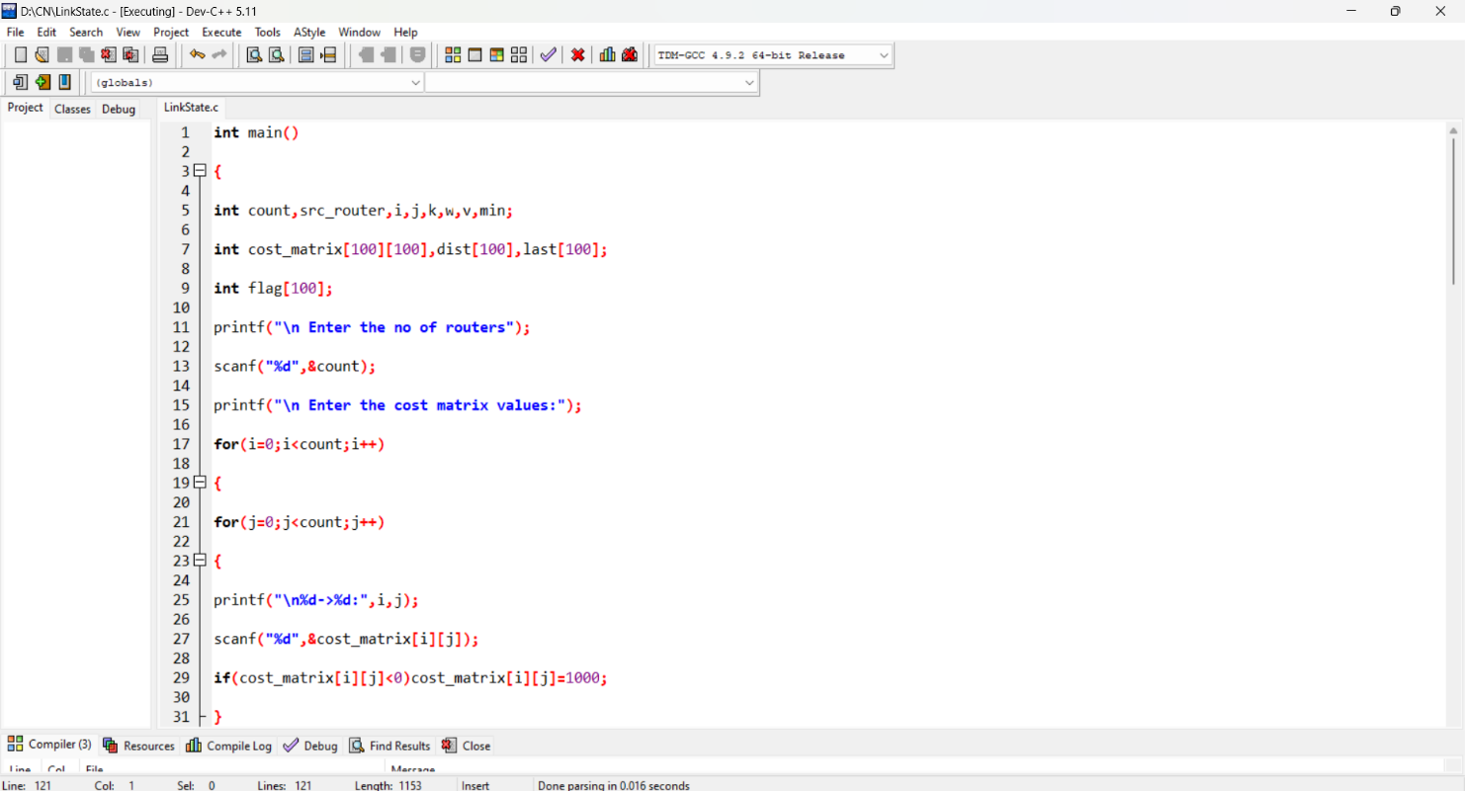

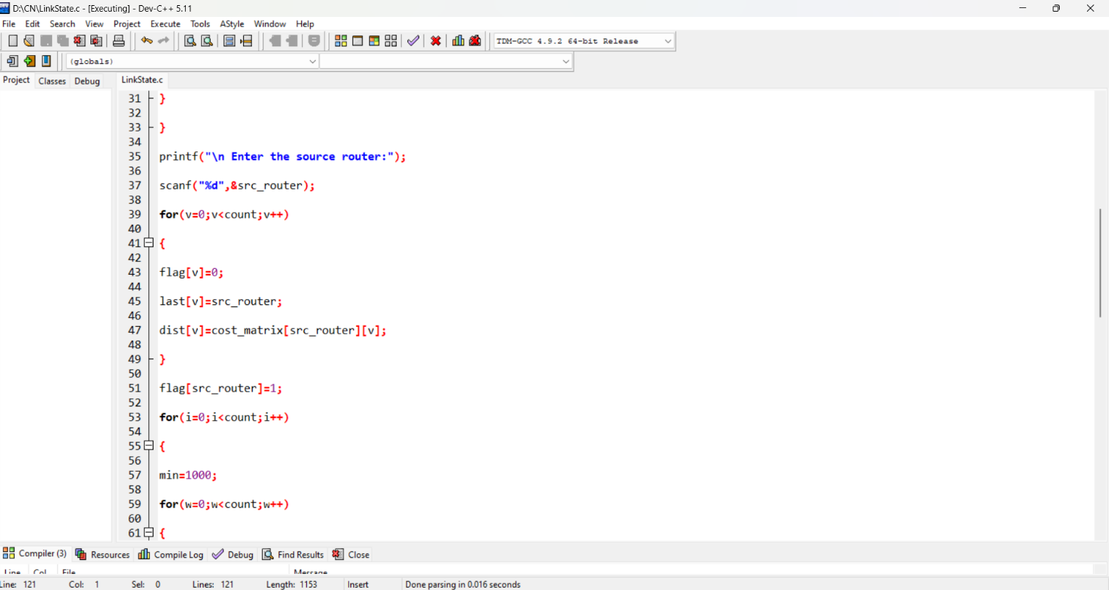

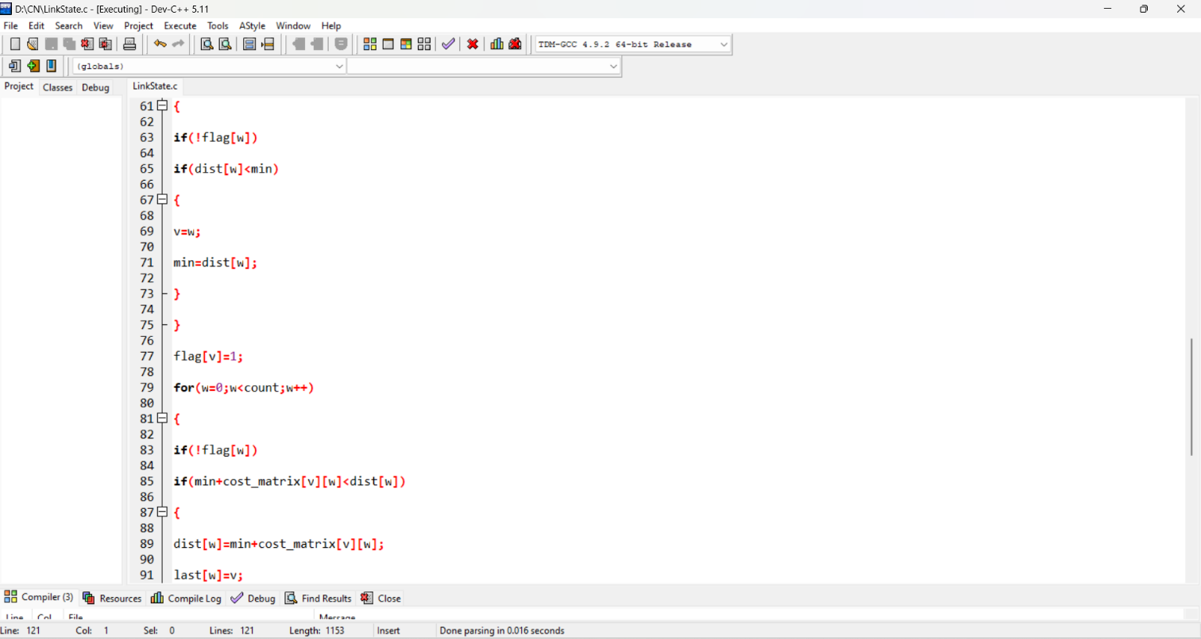

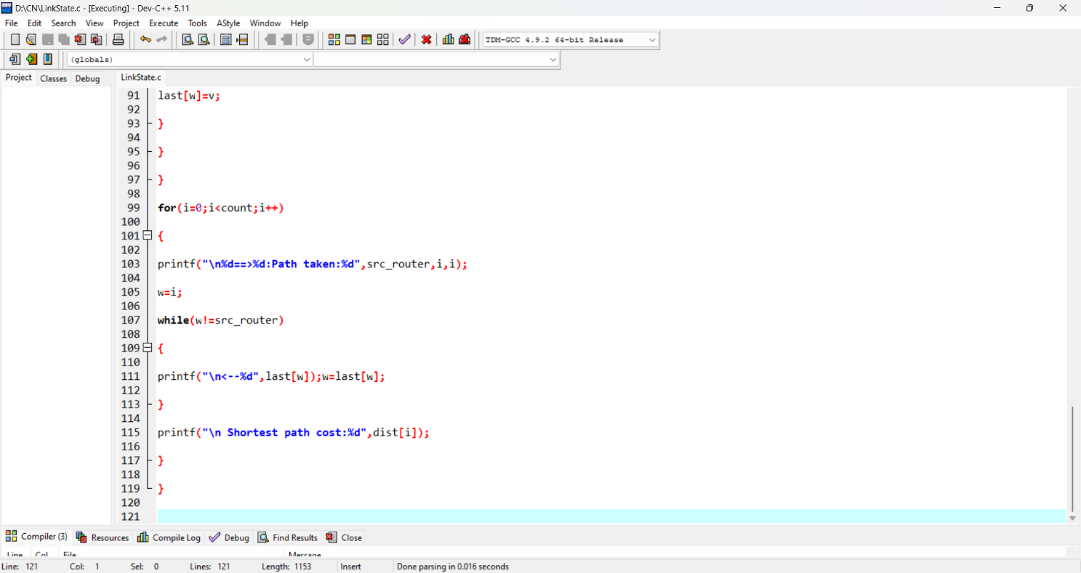

**Output :**

