

Darshan University

A Project Report on

**“LOAN MANAGEMENT SYSTEM”**

Under the subject

**Software Engineering (2101CS503)**

B. Tech, Semester – V

Computer Science & Engineering Department

|  |  |
| --- | --- |
| Submitted By | |
| Student Name: | Enrollment No.: 22010101075 |
| Academic Year  (2023-2024) | |
| Internal Guide  Prof. RAJKUMAR GONDALIYA  Darshan University | Dean-DIET  Dr. Gopi Sanghani  Darshan University |

|  |  |
| --- | --- |
|  | **Computer Science & Engineering Department**  **Darshan University** |

**DECLARATION**

We hereby declare that the SRS, submitted along with the **Software Engineering** **(2101CS503)** for entitled **“Loan Management System”** submitted in partial fulfilment for the Semester-5 of **Bachelor Technology (B. Tech)** in **Computer Science and Engineering (CSE)** Departmentto Darshan University, Rajkot, is a record of the work carried out at **Darshan University, Rajkot** under the supervision of RAJKUMAR GONDALIYAand that no part of any of report has been directly copied from any students’ reports, without providing due reference.

DHRUV JOSHI

Student’s Signature

Date: __________

|  |  |
| --- | --- |
|  | **Computer Science & Engineering Department**  **Darshan University** |

**CERTIFICATE**

This is to certify that the SRS on **“Loan Management System” has** been satisfactorily prepared by **Dhruv Joshi** (**22010101075**) under my guidance in the fulfillment of the course **Software Engineering (2101CS503)** work during the academic year 2023-2024.

|  |  |  |
| --- | --- | --- |
| Internal Guide  Prof. R.B. Gondaliya  Darshan University |  | Dean-DIET  Dr. Gopi Sanghani  Darshan University |

**Acknowledgement**

I wish to express my sincere gratitude to my project guide Prof. RAJKUMAR GONDALIYA and all the faculty members for helping me through my project by giving me the necessary suggestions and advices along with their valuable co- ordination in completing this work.

I also thank my parents, friends and all the members of the family for their precious support and encouragement which they had provided in completion of my work. In addition to that, I would also like to mention the Darshan University personals who gave me the permission to use and experience the valuable resources required for the project from the University premises.

Thus, in conclusion to the above said, I once again thank the faculties and members of **Darshan University** for their valuable support in completion of the project.

Thanking You

**DHRUV JOSHI**

**ABSTRACT**

The loan management system is a computerized system aimed at simplifying the process of managing loans and reducing human effort. This system serves as a tool to transition traditional loan management into a digital format. It includes features not commonly found in manual loan systems, such as client login, quick loan search, and automated tracking of repayments. Clients can log in to view details about their loans, including issued amounts, repayment schedules, and transaction history. There is also an admin login feature that allows loan officers or administrators to oversee and control the entire system. The system is designed with core features, including the ability for administrators to add, view, update, or delete loan and client information. Clients can also request new loans by submitting an online application form. Loan officers, after logging into their admin accounts, can generate various reports, such as client reports, loan issue reports, repayment reports, and defaulter reports. The primary objective of this system is to reduce human intervention and automate as many processes as possible, enhancing the efficiency of loan management.

Main purpose of this system is to reduce human efforts as much as possible.

**Table of Contents**

List of Figures I

List of Tables II

1 Introduction 1

1.1 Product perspective 1

1.2 Product features 1

1.3 Functional Requirement 1

1.3.1 Admin 1

1.3.2 Loan Manager 2

1.3.3 Loan Agent 2

1.3.4 Customer 3

1.4 Non-Functional Requirement 3

1.4.1 Usability: 3

1.4.2 Accuracy: 3

1.4.3 Availability: 3

1.4.4 Maintainability: 3

2 Design and Implementation Constraints 4

2.1 Use case diagram 4

2.2 Activity diagram and Swimlane diagram 5

2.3 Sequence diagram 9

2.4 State diagram 10

2.5 Class diagram 11

2.6 Data flow diagram 12

2.6.1 Context diagram (level-0) 12

3 External interface requirement (Screens) 13

3.1 Screen-1: Registration Form 13

3.2 Screen-2: Login Form 14

3.3 Screen-3: Apply For A Loan 15

3.4 Screen-4 : Upload Identity Documents 16

4 Database design 18

4.1 List of Tables 18

5 Stories and Scenario 20

5.1 Story-1: Add New Loan Record in Loan Management System 20

5.1.1 Scenario# S1.1 20

5.1.2 Scenario# S1.2 20

5.1.3 Scenario# S1.3 21

5.2 Story-2: Manage Due Dates for Loans 21

5.2.1 Scenario# S2.1 21

5.2.2 Scenario# S2.2 21

6 Test cases 22

7 References 26

# List of Figures

Figure 2.1‑1 Use case diagram for Loan management system 4

Figure 2.2‑1 Activity diagram for Loan Request 5

Figure 2.2‑2 Second Activity diagram for Loan Request 6

Figure 2.3‑1 Sequence diagram for Loan Management System 9

Figure 2.4‑1 State diagram of Loan 10

Figure 2.4‑2 State diagram for Librarian 11

Figure 2.5‑1 Class diagram for Library management system 11

Figure 2.6‑1 Context diagram for Loan management system DFD Level-0 12

Figure 2.6‑2 DFD level-1 for Library management system 12

Figure 3.1‑1 Screen-1: Registration Form 13

Figure 3.2‑1 Screen-2: ADD LOAN 14

Figure 3.3‑1 Screen-3: : APPLY FOR LOAN 15

Figure 3.4‑1 Screen-4: UPLOAD IDENTITY DOCUMENTS 16

# List of Tables

Table 3.1‑1 Screen element of Registration form 13

Table 3.2‑1 Screen element of Login form 14

Table 3.3‑1 Screen element of Add borrower book 15

Table 4.1‑1 Table: CUSTOMER TABLE 18

# Introduction

## Product perspective

A Loan Management System (LMS) is a multi-user platform that automates the loan processing and management, including loan approval, disbursement, repayment tracking, and account management for different types of users.

## Product features

**1.2.1** There are three different users who will be using this product:

* Librarian who will be acting as the administrator.
* Member who will be accessing the library.
* Guest who will request for membership.

**1.2.2** The features that are required for the Librarian are:

* Control the movement of books and other material and avoid losing the same.
* Search if you have a specific book in your collection based on the title, author etc.
* Print the spine labels for the book.
* Find what a specific person has borrowed from you. It offers the following modules: Cataloguing, Circulation, and Queries.
* Can issue a book to the student.
* Can view the list of books available in each category.
* Can take the book returned from students.
* Add books and their information to the database.
* Edit the information of the existing books.
* Can check the report of the issued books.
* Can access all the accounts of the students.

**1.2.3** The features that are required for the Member are:

* Can view the different categories of books available in the library.
* Can view the list of books available in each category

## Functional Requirement

### Admin

* User Management: Add, update, or delete users in the system.
* Role Assignment: Assign roles and permissions to different users.
* System Configuration: Configure system settings and parameters.
* Access Control: Manage access rights and permissions.
* Audit Logs: View and manage system audit logs for security and compliance.
* Data Backup: Schedule and manage system backups.
* Report Generation: Generate various administrative and financial reports.
* Notification Management: Configure and send system notifications and alerts.
* Security Management: Implement and manage security policies and procedures.
* Performance Monitoring: Monitor system performance and resource usage.
* Loan Product Management: Create and manage different loan products and their terms.
* Interest Rate Management: Set and update interest rates for various loan products.
* Policy Management: Define and manage policies related to loan approval and disbursement.
* Compliance Management: Ensure the system complies with relevant laws and regulations.
* System Updates: Manage and deploy software updates and patches.

### Loan Manager

* Loan Approval: Review and approve or reject loan applications.
* Loan Application Review: Assess and verify loan application details and documents.
* Loan Disbursement: Authorize the disbursement of approved loan amounts.
* Loan Repayment Schedule: Set and manage loan repayment schedules.
* Risk Assessment: Evaluate and manage the risk associated with loan applications.
* Portfolio Management: Manage the overall loan portfolio and track performance.
* Delinquency Management: Monitor and manage delinquent loans.
* Customer Communication: Communicate with customers regarding their loan status and issues.
* Loan Renewal: Approve or reject requests for loan renewals.
* Loan Restructuring: Manage loan restructuring requests and approvals.
* Credit Scoring: Implement and manage credit scoring models and criteria.
* Document Management: Oversee the management of loan-related documents.
* Compliance Monitoring: Ensure loans are processed in compliance with policies and regulations.
* Performance Analytics: Analyze loan performance data and generate insights.
* Feedback Management: Collect and manage feedback from loan agents and customers.

### Loan Agent

* Loan Application Processing: Assist customers with loan application submissions.
* Customer Onboarding: Help new customers register and onboard to the system.
* Document Collection: Collect and verify required documents from customers.
* Initial Assessment: Conduct initial assessment of loan applications.
* Customer Support: Provide support and answer customer queries regarding loans.
* Loan Status Tracking: Track and update the status of loan applications.
* Field Verification: Conduct field verification of customer information if needed.
* Loan Promotion: Promote loan products to potential customers.
* Customer Education: Educate customers about loan products and terms.
* Data Entry: Enter and update customer and loan information in the system.
* Loan Follow-up: Follow up with customers on pending loan applications.
* Issue Resolution: Resolve issues and escalate complex cases to loan managers.
* Market Research: Conduct market research to understand customer needs and preferences.
* Sales Reporting: Generate and submit sales and performance reports.
* Target Achievement: Work towards achieving loan disbursement targets.

### Customer

* Loan Application: Submit loan applications online.
* Account Registration: Register and create a customer account.
* Profile Management: View and update personal information and documents.
* Loan Status Tracking: Check the status of submitted loan applications.
* Repayment Schedule: View and manage loan repayment schedules.
* Loan Calculator: Use a loan calculator to estimate loan amounts and repayments.
* Document Upload: Upload required documents for loan processing.
* Notification Alerts: Receive notifications about loan status and repayment reminders.
* Support Request: Request support or raise queries regarding loans.
* Transaction History: View history of all transactions related to loans.
* Online Payments: Make loan repayments online.
* Loan Renewal Request: Submit requests for loan renewals.
* Feedback Submission: Provide feedback on loan services and products.
* Product Information: Access detailed information about different loan products.
* Loan Pre-qualification: Check eligibility for loan products using pre-qualification tools.
* These functionalities provide a comprehensive set of features for a loan management system, addressing the needs of all four actors involved.

## Non-Functional Requirement

### Usability:

* The UI should be simple enough for everyone to understand and get the relevant information without any special training. Different languages can be provided based on the requirements.

### Accuracy:

* The data stored about the books and the fines calculated should be correct, consistent, and reliable.

### Availability:

* The System should be available for the duration when the library operates and must be recovered within an hour or less if it fails. The system should respond to the requests within two seconds or less.

### Maintainability:

* The software should be easily maintainable and adding new features and making changes to the software must be as simple as possible. In addition to this, the software must also be portable.

# Design and Implementation Constraints

## Use case diagram

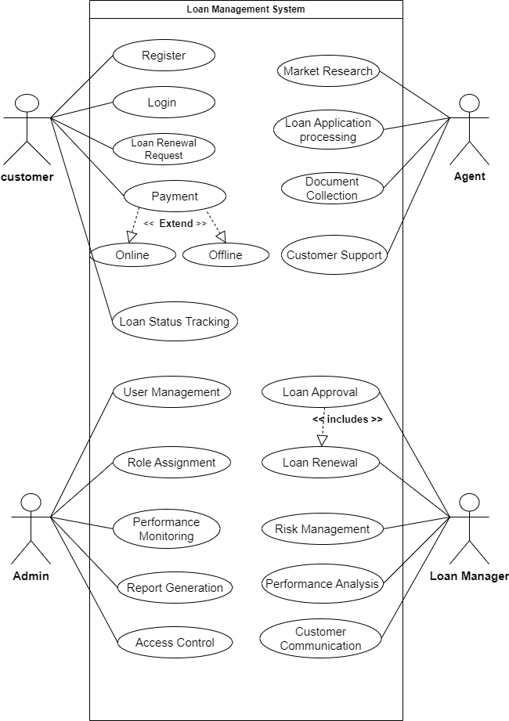

Figure 2.1‑1 Use case diagram for Loan management system

## Activity diagram and Swimlane diagram

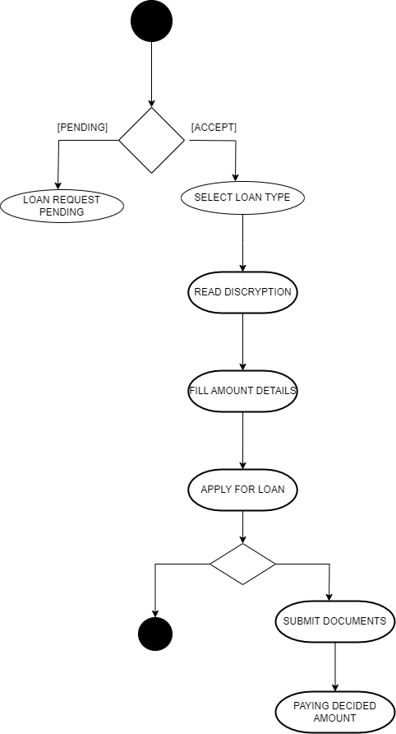

Figure 2.2‑1 Activity diagram for Loan Request

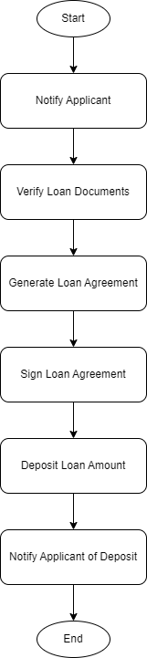

Figure 2.2‑2 Second Activity diagram for Loan Request

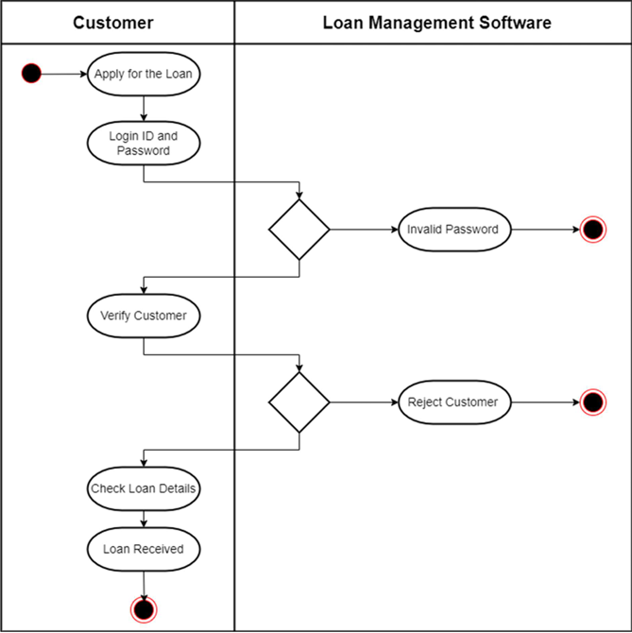

Figure 2.2‑3 Swimlane diagram for Loan Request

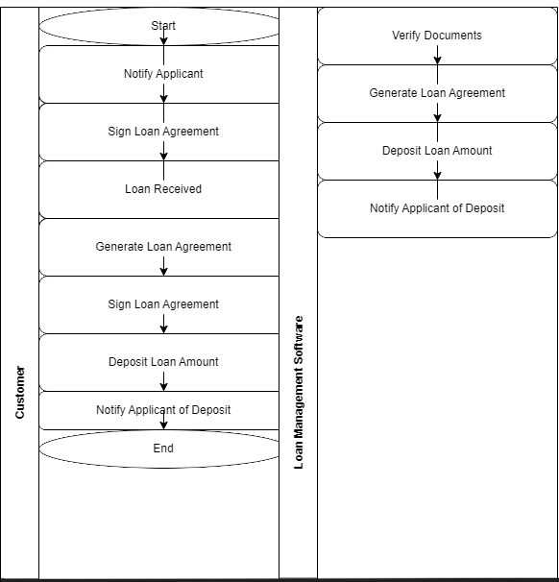

Figure 2.2‑4 Swimlane diagram for Loan Request

## Sequence diagram

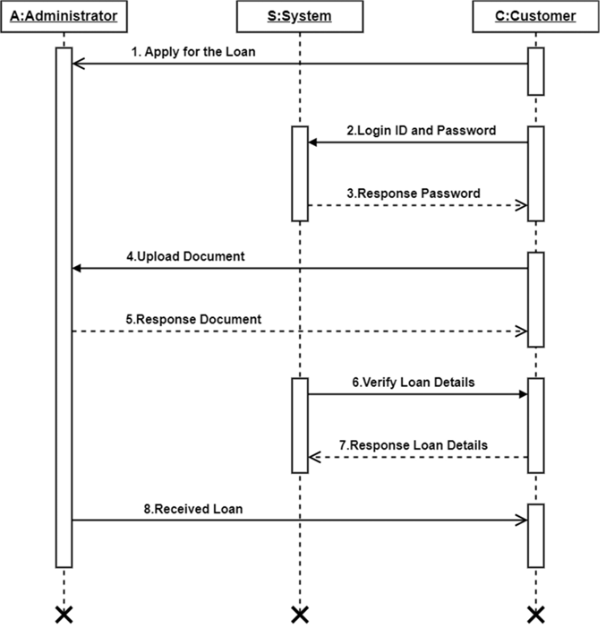

Figure 2.3‑1 Sequence diagram for Loan Management System

## State diagram

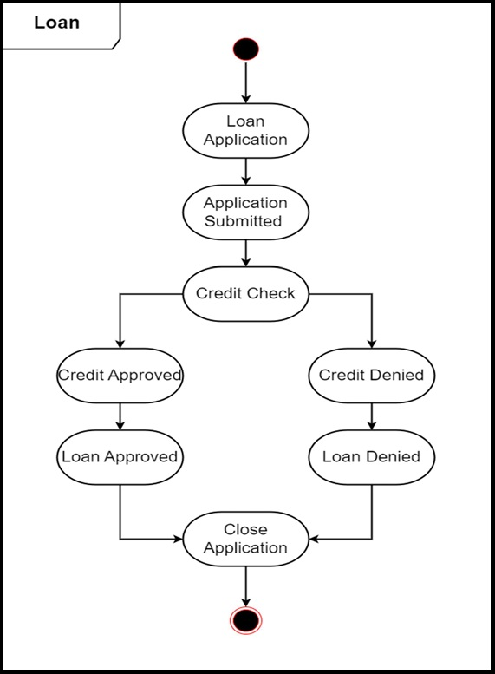

Figure 2.4‑1 State diagram of Loan

Figure 2.4‑2 State diagram for Librarian

## Class diagram

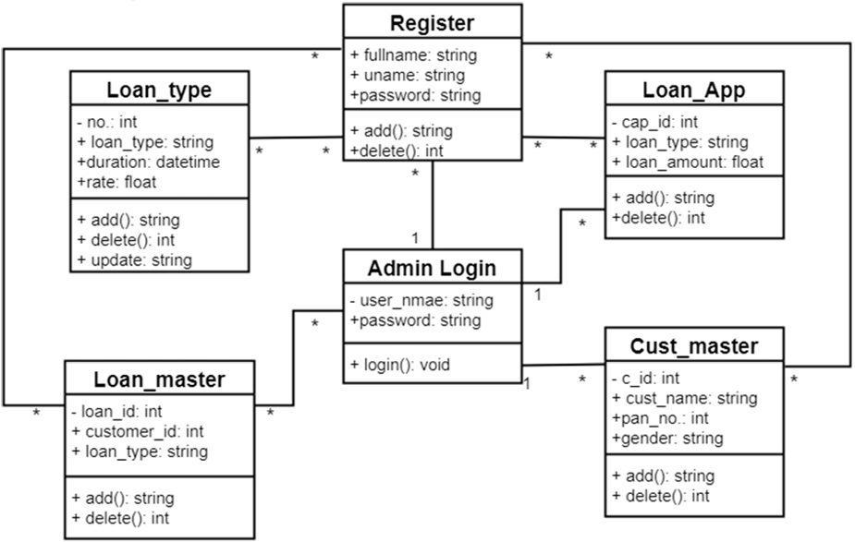

Figure 2.5‑1 Class diagram for Library management system

## Data flow diagram

### Context diagram (level-0)

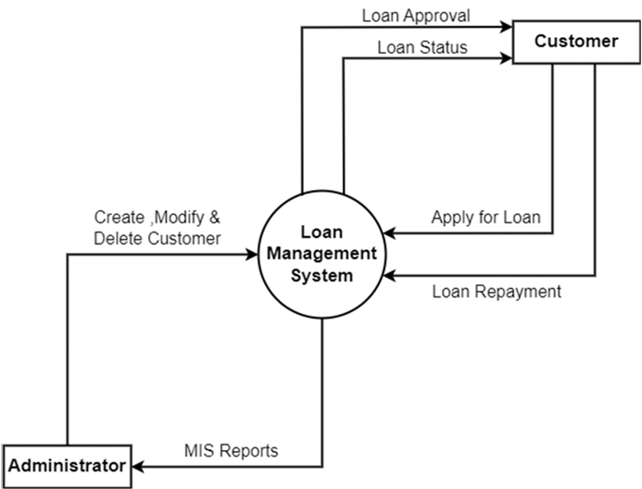

Figure 2.6‑1 Context diagram for Loan management system DFD Level-0

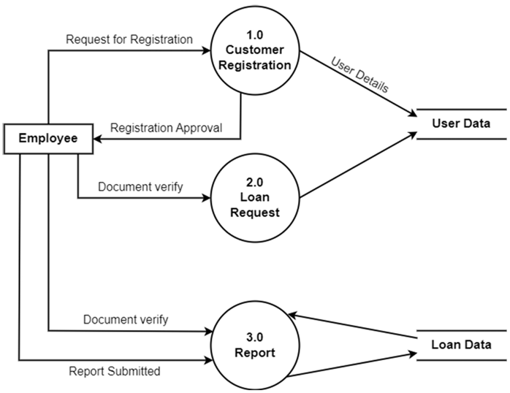

Figure 2.6‑2 DFD level-1 for Library management system

# External interface requirement (Screens)

## Screen-1: Registration Form

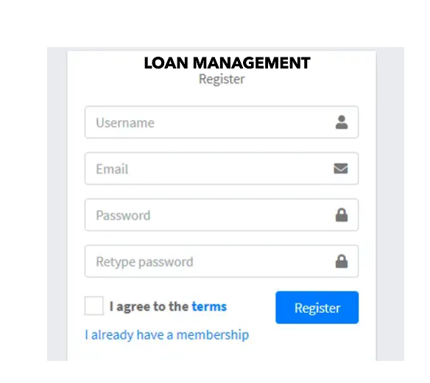

Figure 3.1‑1 Screen-1: Registration Form

**Purpose:** This form will allow the target end-users to register in the system. To register , the following information will be encoded in the system.

|  |  |  |  |  |  |  |  |  |
| --- | --- | --- | --- | --- | --- | --- | --- | --- |
| Sr. | Screen Element | Input Type | | O/M | | 1/N | | Description |
| 1 | Username | Textbox | | M | | 1 | | Username field should be editable and accept the Username. |
| 2 | Password | Password | | M | | 1 | | Password field should be editable and accept the password and display as star or dot. |
| 3 | Remember Me | Checkbox | | M | | 1 | | Saving login credentials through remember me checkbox |
| 4 | I forgot my password | Link | | ------ | | ------ | | Link for navigate to Forgot password page for allows users to recover password. |
| 5 | Register a new membership | Link | | ------ | | ------ | | Link for navigate to membership registration. |
| 6 | Sign in | Button | ------ | | ------ | | Login button navigates to another page even if valid login credentials. | |

Table 3.1‑1 Screen element of Registration form

## Screen-2: Login Form

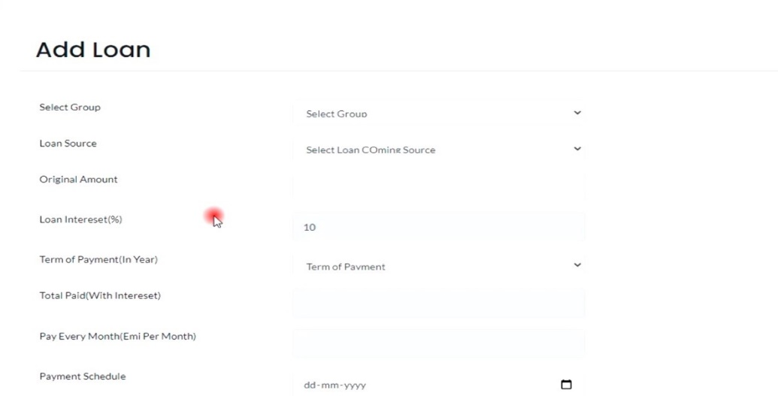

Figure 3.2‑1 Screen-2: ADD LOAN

**Purpose:** This module will allow the system administrator to add, manage, and track loans, enabling the admin to input loan details, calculate interest, and generate a payment schedule for efficient loan management.

Table 3.2‑1 Screen element of Login form

| **Sr.** | **Screen Element** | **Input Type** | **O/M** | **1/N** | **Description** |
| --- | --- | --- | --- | --- | --- |
| **1** | **Select Group** | **Dropdown** | **M** | **1** | **Select a group for the loan** |
| **2** | **Loan Source** | **Dropdown** | **M** | **1** | **Enter the source of the loan** |
| **3** | **Original Amount** | **Textbox** | **M** | **1** | **Enter the original amount of the loan** |
| **4** | **Loan Interest (%)** | **Textbox** | **M** | **1** | **Enter the interest rate of the loan (in percentage)** |
| **5** | **Term of Payment (In Year)** | **Dropdown** | **M** | **1** | **Enter the term of payment in years** |
| **6** | **Total paid** | **Textbox** | **M** | **1** | **Select the source of the loan funds** |
| **7** | **Pay Every Month** | **Textbox** | **M** | **1** | **Enter the amount of payment every month** |

## Screen-3: Apply For A Loan

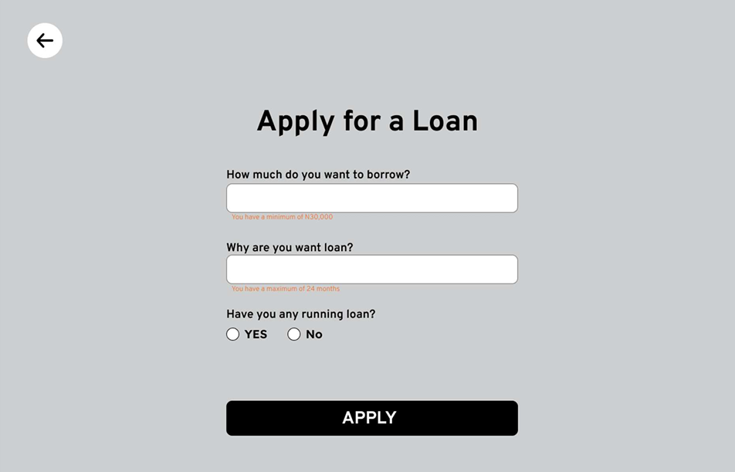

Figure 3.3‑1 Screen-3: : APPLY FOR LOAN

**Purpose:** The purpose of applying for a loan is to acquire financial resources to meet specific needs or goals, whether personal or business-related.

Table 3.3‑1 Screen element of Add borrower book

| **Sr.** | **Field Name** | **O/M** | **1/N** | **Description** |
| --- | --- | --- | --- | --- |
| 1 | Original Amount | M | 1 | Enter the amount you wish to borrow. |
| 2 | Minimum Loan Amount | M | 1 | The minimum amount you can borrow is N 30,000. |
| 3 | Loan Purpose | M | 1 | Select the reason for taking the loan from the dropdown menu. |
| 4 | Existing Loan | M | 1 | Select "Yes" or "No" to indicate whether you currently have any outstanding loans. |

## Screen-4 : Upload Identity Documents

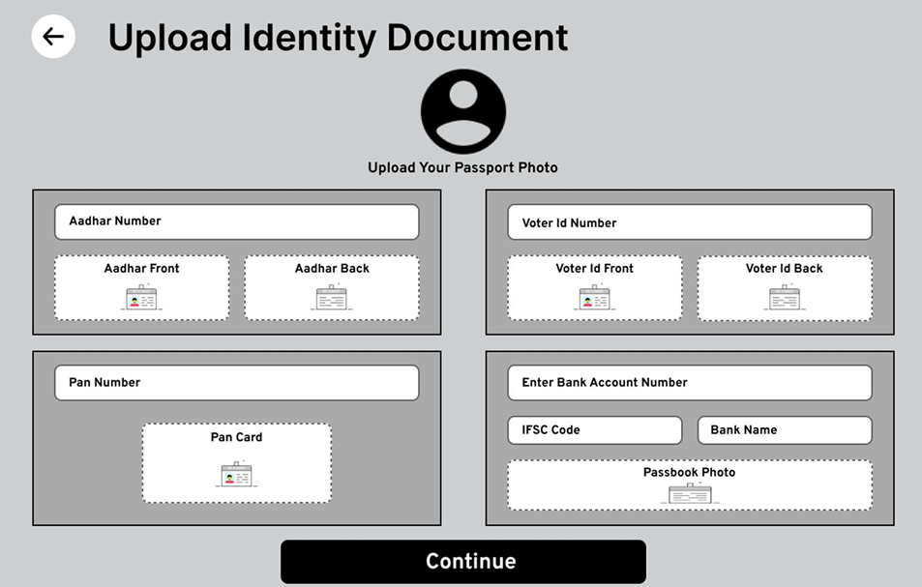

Figure 3.4‑1 Screen-4: UPLOAD IDENTITY DOCUMENTS

**Purpose** : The purpose of uploading an identity document is to verify one's identity securely and comply with authentication requirements for various transactions or services.

| **Sr.** | **Field Name** | **Description** |
| --- | --- | --- |
| 1 | Passport Photo | Please upload a recent passport-size photo. |
| 2 | Aadhar Number | Enter your Aadhar number, a unique 12-digit identification number issued by the Indian government. |
| 3 | Aadhar Front | Upload a scanned copy of the front side of your Aadhar card. |
| 4 | Aadhar Back | Upload a scanned copy of the back side of your Aadhar card. |
| 5 | Pan Number | Provide your PAN (Permanent Account Number) issued by the Income Tax Department of India. |
| 6 | Pan Card | Upload a scanned copy of your PAN card. |
| 7 | Voter Id Number | Enter your Voter ID number issued by the Election Commission of India. |
| 8 | Voter Id Front | Upload a scanned copy of the front side of your Voter ID card. |
| 9 | Voter Id Back | Upload a scanned copy of the back side of your Voter ID card. |
| 10 | Bank Account Number | Input your bank account number. |
| 11 | IFSC Code | Enter the IFSC (Indian Financial System Code) of your bank branch. |
| 12 | Bank Name | Provide the name of your bank. |
| 13 | Passbook Photo | Upload a scanned copy of a page from your bank passbook showing your account details. |
| 14 | Continue | Click "Continue" to proceed with your loan application after uploading all the required documents. |

## Screen-5 : Add New Member

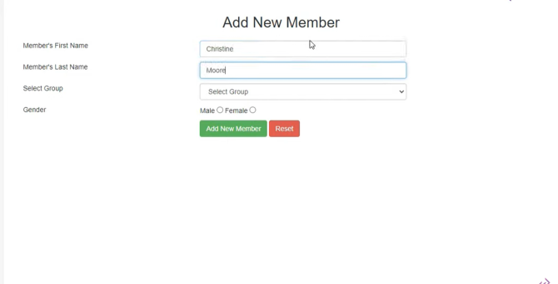

Figure 3.5‑1 Screen-5: Add New Member

**Purpose** : The purpose of adding a new member is to register an individual into a system or organization, enabling them to access relevant services, resources, or participate in group activities in accordance with set rules and privileges.

| **Sr.** | **Field Name** | **Description** |
| --- | --- | --- |
| 1 | Member's First Name | Input field for entering the first name of the new member. |
| 2 | Member's Last Name | Input field for entering the last name of the new member. |
| 3 | Select Group | Dropdown to select a group to which the member belongs. |
| 4 | Gender | Radio buttons to select the gender: Male or Female. |
| 5 | Add New Member Button | Green button to submit the form and add the new member. |
| 6 | Reset Button | Red button to clear the input fields and reset the form. |

# Database design

## List of Tables

* CUSTOMER
* REGESTRATION
* ADMIN
* LOAN

Table 4.1‑1 Table: CUSTOMER TABLE

| **Column Name** | **Data Type** | **Null or NN** | **Keys** | **Constraints** | **Default Value** |
| --- | --- | --- | --- | --- | --- |
| UserID | INT | NN | PRIMARY KEY, AUTO_INCREMENT |  |  |
| Username | VARCHAR(50) | NN | UNIQUE |  |  |
| PasswordHash | VARCHAR(255) | NN |  |  |  |
| FirstName | VARCHAR(50) | NN |  |  |  |
| LastName | VARCHAR(50) | NN |  |  |  |
| Email | VARCHAR(100) | NN |  |  |  |
| Role | ENUM('Loan Manager', 'Customer', 'Admin', 'Agent') | NN |  |  |  |

Table 4.1‑2 Table : REGESTRATION TABLE

| **Column** | **Data Type** | **Null** | **Keys & Constrains** | **Default Value & Description** |
| --- | --- | --- | --- | --- |
| UserID | int | NN | PK (Auto Increment) |  |
| FullName | varchar(100) | NN |  |  |
| Email | varchar(100) | NN |  |  |
| Password | varchar(100) | NN |  |  |

Table 4.1‑3 Table: LOAN TABLE

| **Column Name** | **Data Type** | **Null or NN** | **Keys** | **Constraints** | **Default Value** |
| --- | --- | --- | --- | --- | --- |
| LoanID | INT | NN | PRIMARY KEY, AUTO_INCREMENT |  |  |
| UserID | INT | NN | FOREIGN KEY | REFERENCES Users(UserID) |  |
| LoanAmount | DECIMAL(15,2) | NN |  |  |  |
| InterestRate | DECIMAL(5,2) | NN |  |  |  |
| StartDate | DATE | NN |  |  |  |
| EndDate | DATE | NN |  |  |  |
| Status | ENUM('Pending', 'Approved', 'Rejected', 'Closed') | NN |  |  |  |

Table 4.1‑4 Table: ADMIN TABLE

| **Column** | **Data Type** | **Null** | **Keys & Constrains** | **Default Value & Description** |
| --- | --- | --- | --- | --- |
| AdminID | int | NN | PK (Auto Increment) |  |
| AdminName | varchar(100) | NN |  |  |
| AdminEmail | varchar(100) | NN |  |  |
| Contact | Number(10,0) | NN |  |  |
| DOB | DateTime | NN |  |  |
| Gender | varchar(50) | AN |  |  |

# Stories and Scenario

## Story-1: Add New Loan Record in Loan Management System

|  |  |  |
| --- | --- | --- |
| *Story # S1* | : | As a Loan Officer , I want to add a new loan application into the system So that I can track and process loan requests efficiently.. |
| Priority | **:** | High |
| Estimate | **:** | L |
| Reason | **:** | Capturing loan applications promptly ensures the loan processing workflow is smooth and no request is overlooked |

### Scenario# S1.1

|  |  |  |
| --- | --- | --- |
| *Scenario# S1.1* | : | Adding a New Loan Application with Valid Information |
| Prerequisite | **:** | Loan Officer is logged in to the Loan Management System. |
| Acceptance Criteria | **:** | * GIVEN : * The Loan Officer is navigated to the loan application entry page. Valid applicant information, including name, address, loan amount, and other required details, is ready to be entered. * When: * The Loan Officer selects the "Add New Loan Application" option. * The Loan Officer enters valid applicant details. * The Loan Officer clicks the "Submit" button to save the loan application. |

### Scenario# S1.2

|  |  |  |
| --- | --- | --- |
| *Scenario# S1.2* | : | Attempting to Add a New Loan Application with Missing Information |
| Prerequisite | **:** | Loan Officer is logged in to the Loan Management System. |
| Acceptance Criteria | **:** | **Given: The Loan Officer is navigated to the loan application entry page, and some required fields are left blank (e.g., loan amount or applicant's name). When:**   * **The Loan Officer selects the "Add New Loan Application" option.** * **The Loan Officer attempts to submit the application without filling in all required fields.**   **Then:**   * **The system displays an error message indicating the missing information.** * **The Loan Officer is prompted to complete the required fields before the loan application can be successfully submitted.** |

### Scenario# S1.3

|  |  |  |
| --- | --- | --- |
| *Scenario# S1.3* | : | Attempting to Add a Duplicate Loan Record |
| Prerequisite | **:** | The loan officer is logged into the loan management system, and the loan officer is on the loan catalogue management page. |
| Acceptance Criteria | **:** | **Given**: The loan information, including borrower details, loan type, and loan number, is available, and a loan with the same loan number is already in the catalogue.  **When**: The user clicks on the “Add Loan” button and attempts to add the same loan information (with the same loan number) in the fields.  **Then**: Generate a unique loan ID and generate a loan tracking number for every duplicate entry for the same borrower to differentiate between multiple loans under the same loan type. |

## Story-2: Manage Due Dates for Loans

|  |  |  |
| --- | --- | --- |
| *Story # S3* | : | As loan officer,  I want to manage due dates for loan payments,  So that I can ensure loans are repaid on time and avoid overdue penalties. |
| Priority | **:** | High |
| Estimate | **:** | M |
| Reason | **:** | Proper due date management is crucial for maintaining the financial health of the institution and ensuring borrowers remain in good standing |

### Scenario# S2.1

|  |  |  |
| --- | --- | --- |
| *Scenario# S2.1* | : | Setting a Due Date for a New Loan |
| Prerequisite | **:** | The loan officer is logged into the loan management system and is on the loan creation page. |
| Acceptance Criteria | **:** | **Given**: The borrower details, loan amount, and loan terms (including the due date for the first payment) are available.  **When**: The loan officer sets a due date during the loan creation process and submits the new loan record.  **Then**: The system should save the loan details with the specified due date and generate a reminder notification for the borrower before the due date. |

### Scenario# S2.2

|  |  |  |
| --- | --- | --- |
| *Scenario# S2.1* | : | Updating the Due Date for an Existing Loan |
| Prerequisite | **:** | The loan officer is logged into the loan management system and is on the loan details page of an existing loan. |
| Acceptance Criteria | **:** | **Given**: The loan details are already in the system, and the borrower requests a change in the due date due to valid reasons.  **When**: The loan officer updates the due date in the system.  **Then**: The system should save the new due date, adjust the payment schedule accordingly, and notify the borrower of the new due date and potential changes in payment terms. |

# Test cases

|  |  |  |  |
| --- | --- | --- | --- |
| Project Name: | EMI Calculator | Test Designed by: | Dhruv Joshi |
| Module Name: | **Login** | **Test Designed date:** | 01-10-2024 |
| Release Version: | **1.0** | **Test Executed by:** | **R. B. Gondaliya** |
|  |  | **Test Execution date:** | 15-01-2024 |

|  |  |  |  |  |
| --- | --- | --- | --- | --- |
| Pre-condition: Web application should be accessible | | | | |
| Test Case ID | **Test Title** | **Test Type** | **Description** | **Test Case ID** |
| TC_001 | Login to web application with valid credential | Functional | Login to Loan management system web application through valid credential | TC_001 |
| TC_002 | Login to web application with invalid credential | Functional | Login to Loan management system web application through invalid credential | TC_002 |
| TC_003 | Varify login page elements | GUI | varify that all elements are availabe on login page | TC_003 |
| TC_004 | Password reset functionality | Functional | Verify that the password reset functionality works as expected | TC_004 |

|  |  |
| --- | --- |
| **Test Case Title** | Login to web application with valid credential |
| **Test Type** | Functional |
| **Test Priority** | High |
| **Pre-condition** | Web application should be accessible |

|  |  |  |  |  |  |  |  |
| --- | --- | --- | --- | --- | --- | --- | --- |
| **Test Step** | **Test Case Description** | **Expected Result** | **Actual Result** | **Status** | **Comment** | **Data** | **BUG ID** |
| 1 | Access Web application URL | The site launched properly | Site launched successfully | Pass |  | <https://accounts.google.com/ServiceLogin> |  |
| 2 | Enter valid Username in username field | Username field should be editable and accept the Username | Username input accepted | Pass |  | Username:  Rbgondaliya@gmail.com |  |
| 3 | Enter valid Password in Password field | Password field should be editable and accept the password and display as star or dot | Password input displayed in dot and accepted | pass |  | Password: rbgondaliya |  |
| 4 | Enter valid captcha code in captch field | Captch field should editable and accept captcha and captcha is case sensitive | Captcha input accepted | Pass | Step required when human action validation | get captcha from image which is near by captcha field |  |
| 5 | Click on login button | User should login into site and navigated to dashboard | User navigated to dashboard and username should be display in top of the right side. | pass |  |  |  |

|  |  |
| --- | --- |
| **Test Case Title** | Login to web application with invalid credential |
| **Test Type** | Functional |
| **Test Priority** | Medium |
| **Pre-condition** | Web application should be accessible |

|  |  |  |  |  |  |  |  |
| --- | --- | --- | --- | --- | --- | --- | --- |
| **Test Step** | **Test Case Description** | **Expected Result** | **Actual Result** | **Status** | **Comment** | **Data** | **Bug ID** |
| 1 | Verify that User is not able to Login with invalid Username and invalid Password | Should be display an error message enter wrong username or password | Display an error of wrong username and password | Pass |  |  |  |
| 2 | Verify that User is not able to Login with Valid Username and invalid Password | Should be display an error message enter wrong password | Display an error of wrong password | Pass |  |  |  |
| 3 | Verify that User is not able to Login with invalid Username and Valid Password | Should be display an error message User not found | Display an error Username not found | Pass |  |  |  |
| 4 | Verify that User is not able to Login with blank Username or Password | Set required field validation message for Username and Password | Display an error of wrong username and password | Fail | Not performa a validation function fix it |  | Bug_002 |

|  |  |
| --- | --- |
| **Test Case Title** | Varify login page elements |
| **Test Type** | GUI |
| **Test Priority** | Medium |
| **Pre-condition** | Web application should be accessible |

|  |  |  |  |  |  |  |  |
| --- | --- | --- | --- | --- | --- | --- | --- |
| **Test Step** | **Test Case Description** | **Expected Result** | **Actual Result** | **Status** | **Comment** | **Data** | **Bug ID** |
| 1 | Launch application with the given url | The site launched properly | Site launched successfully | Pass |  | <https://accounts.google.com/ServiceLogin> |  |
| 2 | Verify that the login screen contains elements such as Username, Password, Sign in button, Remember password check box, Forgot password link, and Create an account link. | All listed control displayed properly on the page | Login page loaded successfully | Pass |  |  |  |
| 3 | Verify that cursor is focused on “Username” text box on the page load | Cursor is focused in Username textbox | Cursor focus in Username textbox | Pass |  |  |  |
| 4 | Verify that tab functionality is working properly or not | When tab pressed cursor move in next control | Cursor moving in next control | Pass |  |  |  |
| 5 | Verify that all the fields such as Username, Password has a valid placeholder | All text fields have proper placeholder | All text fields have proper placeholder | Pass |  |  |  |
| 6 | Verify that the labels float upward when the text field is in focus or filled (In case of floating label) | When field is focused or filled, label display on top of the filled | When field is focus or filled, label display on top of the filled | Pass | step required when fields with floating label |  |  |
| 7 | verify that forgot password link working properly | when click on forgot password load forgot passworg page | forgot password link not working | Fail |  |  |  |

| **Test Case Title** | **Test Type** | **Test Priority** | **Pre-condition** |
| --- | --- | --- | --- |
| **Password reset functionality** | **Functional** | **High** | **Web application should be accessible, and the user should have an account** |
| **Varify login page elements** | **GUI** | **Medium** | **Web application should be accessible** |

| **Test Step** | **Test Case Description** | **Expected Result** | **Actual Result** | **Status** | **Comment** | **Data** | **Bug ID** |
| --- | --- | --- | --- | --- | --- | --- | --- |
| **1** | **Verify that the 'Forgot Password' link is visible on the login page** | **'Forgot Password' link should be visible** | **'Forgot Password' link is visible** | **Pass** |  |  |  |
| **2** | **Verify that clicking the 'Forgot Password' link redirects to the password reset page** | **User should be redirected to the password reset page** | **User is redirected to the password reset page** | **Pass** |  |  |  |
| **3** | **Verify that entering a valid registered email sends a password reset email** | **A password reset email should be sent to the user** | **Password reset email is received** | **Pass** |  |  |  |
| **4** | **Verify that entering an invalid/unregistered email displays an appropriate error message** | **Should display an error message: "Email not found"** | **Displays an error: "Email not found"** | **Pass** |  |  |  |
| **5** | **Verify that leaving the email field blank triggers a required field validation message** | **Should display: "Email is required"** | **Displays: "Email is required"** | **Pass** |  |  |  |
| **6** | **Verify that the password reset link in the email allows the user to reset the password successfully** | **User should be able to reset the password via the link** | **User successfully resets the password** | **Pass** |  |  |  |
| **7** | **Verify that after a password reset, the user can log in with the new password** | **User should be able to log in with the new password** | **User is able to log in with the new password** | **Pass** |  |  |  |

# References

* **Loan Policies** : [www.exampleloansite.com/loanpolicies](http://www.exampleloansite.com/loanpolicies)
* **Loan Due Date Management :** [**www.exampleloansite.com/duedate**](http://www.exampleloansite.com/duedate)
* **Loan Officer Guidelines : www.exampleloansite.com/loanguidelines**