**Wireframe Document**

**Wine Data Analytics**

**Revision Number - 1.2**

**Last Date of Revision - 14/11/2022**

**MOHINI NEHETE**

WIREFRAME DOCUMENT DESIGN

**Document Control**

|  |  |  |  |
| --- | --- | --- | --- |
| **Date** | **Version** | **Description** | **Author** |
|  |  |  |  |
| 12/09/2022 | 1.0 | Introduction, | MOHINI NEHETE |
|  |  | Problem Statement |  |
|  |  |  |  |
| 02/10/2022 | 1.1 | Dataset Information, | MOHINI NEHETE |
|  |  | Architecture |  |
|  |  | Description |  |
|  |  |  |  |
| 14/11/2022 | 1.2 | Final Revision | MOHINI NEHETE |
|  |  |  |  |



**Introduction & Problem Statement**

While the wine industry generally has been very proactive about dealing with climate change, from capturing fermentation carbon totrialling new varieties, this is ultimately a political problem. To find an effective solution for this problem you were asked to help in ETL process.

Do ETL : Extract-Transform-Load the dataset and find for me some information from this large data. This is form of data mining.

What all information can be achieved by mining this data, would bebrainstormed by the interns

Find key metrics and factors and show the meaningful relationships between attributes. Do your own research and come up with your findings.

Wine Data Analytics

WIREFRAME DOCUMENT DESIGN

The dataset consists of 16449 rows data. There are 23 columns in the dataset which are mentioned below.

* **Visualization:**

**Bar Chart :-**

Bar chart showing wine type reopens by group.

**Pie Chart :-**

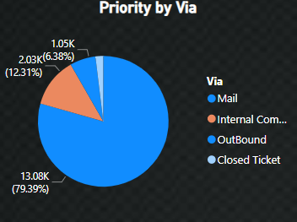

Pie chart showing priority by via.

Wireframe is the process of creating a low-fidelity prototype of Power BI report and dashboard.

