**Axborot tizimlari va texnologiylari yo’nalishi**

**122-20-guruh talabasi**

**Sattorova Mohiraning**

**Algoritmlar va berilganlar strukturasi fanidan**

1. **topshirig’i**
2. **Variant:**

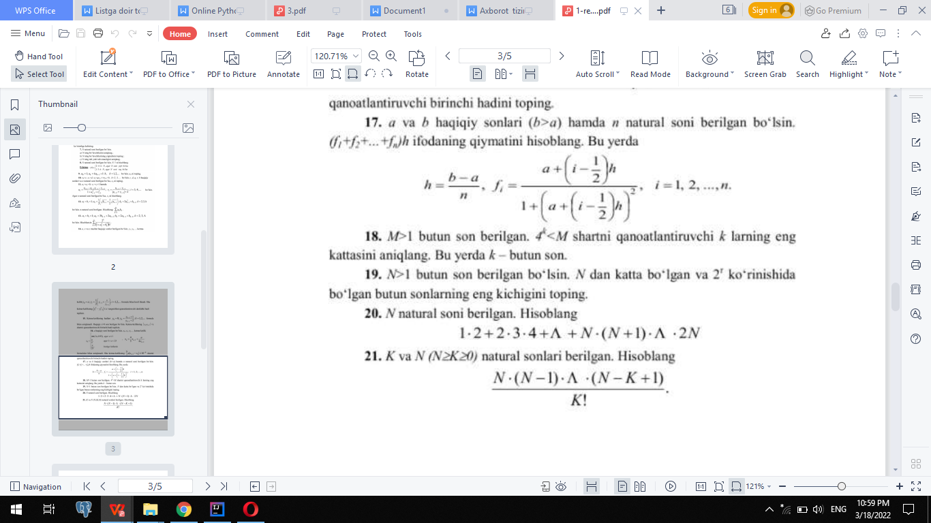

package Algoritm_vazifalar;  
  
import java.util.Scanner;  
  
public class Vazifa_1 {  
 public static void main(String[] args) {  
  
  
 int M,k=0;  
 Scanner scanner=new Scanner(System.*in*);  
 System.*out*.print("M=");  
 M=scanner.nextInt();  
 while (Math.*pow*(4,k)<M){  
 k++;  
 }  
 System.*out*.println("k="+(k-1));  
 }  
}