1. **topshiriq:**

L1 = [ 1 2 3 4 5 ]

L2 = [ 8 5 3 4 3 3 6 ]

L3 = [ 7 4 4 3 8 25 ]

1- L4 = L1+L2+L3 ni toping

2- L4 ro’yxatdan eng katta(kichik) elementni toping.

3- Eng ko’p qatnashgan elementlarni toping.

4- L4 ni to’plam sifatida shakllantiring.

5- To’plmani Kesishmasi bo’sh to’plam bo’lgan ikkita teng bo’lakka ajrating.

6- Ajratilgan bo’laklar ustida DSU algoritmini qo’llang.

7- Ajratilgan bo’laklardan quyidagi dastur kodi bo’yicha hisoblash ishlarini

amalga oshiring.

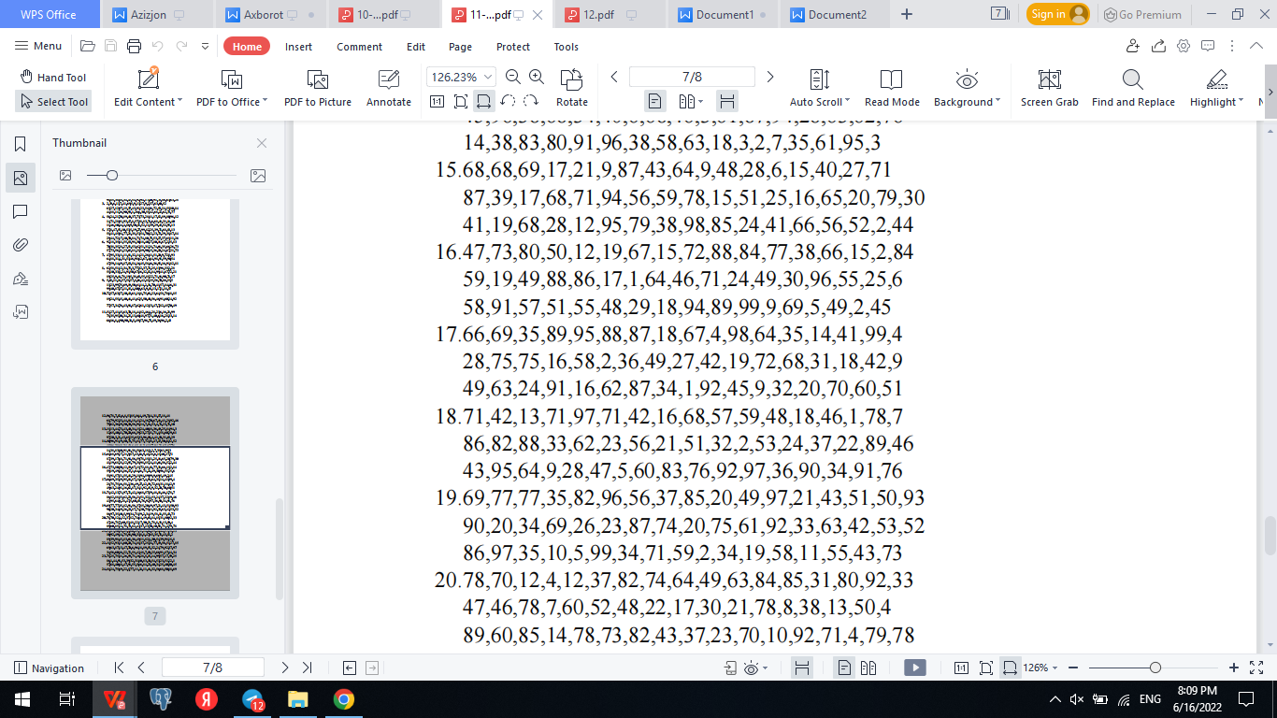

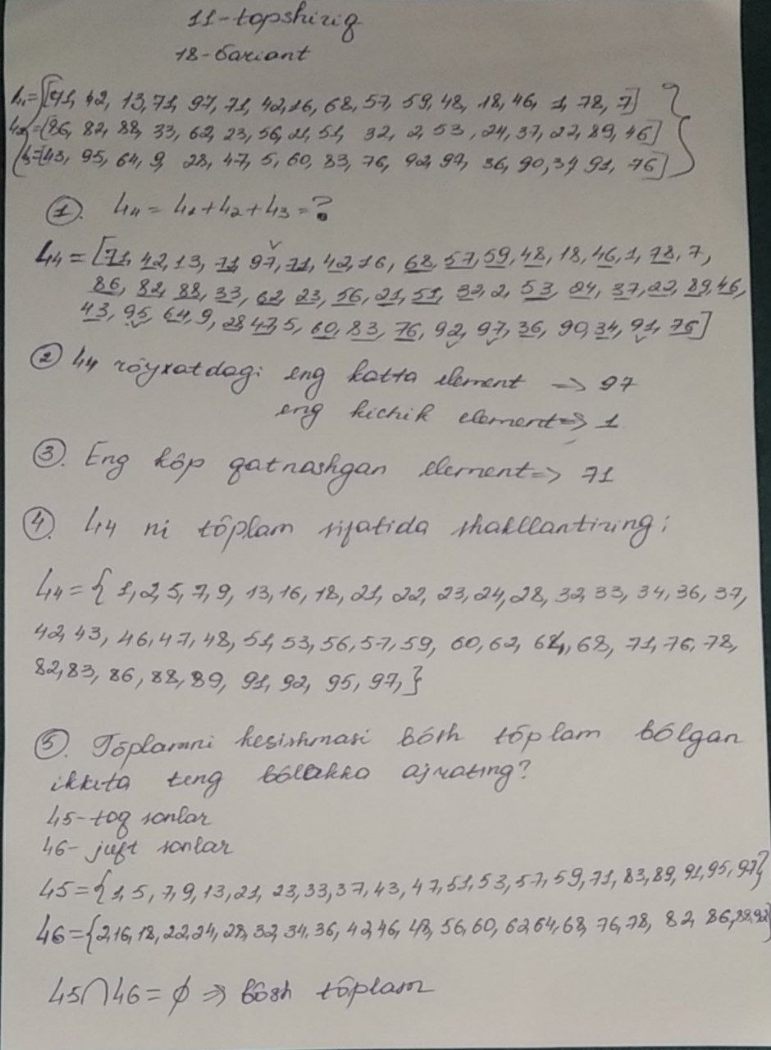

# Online Python compiler (interpreter) to run Python online.

# Write Python 3 code in this online editor and run it.

# 1-ISH:

L1=[71,42,13,71,97,71,42,16,68,57,59,48,18,46,1,78,7]

L2=[86,82,88,33,62,23,56,21,51,32,2,53,24,37,22,89,46]

L3=[43,95,64,9,28,47,5,60,83,76,92,97,36,90,34,91,76]

L4=L1+L2+L3

print("L4: ",L4)

# 2-ISH:

eng_katta=max(L4)

print("L4 ro'yhatdagi eng katta element:",eng_katta)

eng_kichik=min(L4)

print("L4 ro'yhatdagi eng kichik element:", eng_kichik)

# 3-ISH:

count=0

maxcount=1

element=L4[0]

for i in range(len(L4)):

count=1

for j in range(i):

if L4[i]==L4[j]:

count+=1

if maxcount<count:

element=L4[i]

maxcount=count

print("Nechi marta qatnashayabdi:",maxcount,'marta,',"qaysi element:",element)

# 4-ISH:

toplam=set(L4)

print("to'plam: ",toplam)

#5-ISH

print("Royhat uzunligi: ",len(toplam))

S1=[int(i) for i in toplam][:22]

S2=[int(i) for i in toplam][23:]

print(S1)

print(S2)

# 6- ISH:

son=int(input("Biron son kiriting? "))

if(son in S1):

print("bu son shu ro'yhatga kiradi",S1)

if(son in S2):

print("bu son shu ro'yhatga kiradi",S2)

**Javobi:**

L4: [71, 42, 13, 71, 97, 71, 42, 16, 68, 57, 59, 48, 18, 46, 1, 78, 7, 86, 82, 88, 33, 62, 23, 56, 21, 51, 32, 2, 53, 24, 37, 22, 89, 46, 43, 95, 64, 9, 28, 47, 5, 60, 83, 76, 92, 97, 36, 90, 34, 91, 76]

L4 ro'yhatdagi eng katta element: 97

L4 ro'yhatdagi eng kichik element: 1

Nechi marta qatnashayabdi: 3 marta, qaysi element: 71

to'plam: {1, 2, 5, 7, 9, 13, 16, 18, 21, 22, 23, 24, 28, 32, 33, 34, 36, 37, 42, 43, 46, 47, 48, 51, 53, 56, 57, 59, 60, 62, 64, 68, 71, 76, 78, 82, 83, 86, 88, 89, 90, 91, 92, 95, 97}

Royhat uzunligi: 45

[1, 2, 5, 7, 9, 13, 16, 18, 21, 22, 23, 24, 28, 32, 33, 34, 36, 37, 42, 43, 46, 47]

[51, 53, 56, 57, 59, 60, 62, 64, 68, 71, 76, 78, 82, 83, 86, 88, 89, 90, 91, 92, 95, 97]

Biron son kiriting? 13

bu son shu ro'yhatga kiradi [1, 2, 5, 7, 9, 13, 16, 18, 21, 22, 23, 24, 28, 32, 33, 34, 36, 37, 42, 43, 46, 47]