**122-20-guruh talabasi Sattorova Mohiraning**

**Algoritmlar va berilganlar strukturasi**

**fanidan 2-amaliy topshirig’I**

1. **VARIANT**

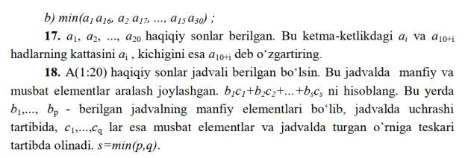

package Algoritm_vazifalar;  
  
import java.util.Scanner;  
  
public class Algoritm_2 {  
 public static void main(String[] args) {  
  
 Scanner scanner=new Scanner(System.*in*);  
 int n,index1=0,index2=0,count=0;  
 double k;  
 System.*out*.println("Elementlar sonini (1;20) oraliqda kiriting: ");  
 n=scanner.nextInt();  
 double[] a=new double[n];  
 for(int i=0;i<n;i++) {  
 System.*out*.println(i+1+"-element:");  
 a[i]=scanner.nextDouble();  
 if(a[i]>0){  
 count++;  
 }  
 }  
 double[] musbat=new double[count];  
 double[] manfiy=new double[n-count];  
 for(int i=0;i<n;i++) {  
 if(a[i]>0){  
 musbat[index1]=a[i];  
 index1++;  
 }  
 else {  
 manfiy[index2] = a[i];  
 index2++;  
 }  
 }  
 int x,y,index=0,sum=0;  
 x=musbat.length;  
 y=manfiy.length;  
 if(x<y){  
 index=x;  
 }  
 else {  
 index=y;  
 }  
 for(int i=0;i<index;i++){  
 sum+=manfiy[i]*musbat[index-1-i];  
 }  
 System.*out*.println("sum="+sum);  
 }  
}