**122-20-guruh talabasi Sattorova Mohiraning**

**Algoritmlar va berilganlar strukturasi**

**fanidan 4-amaliy topshirig’I**

1. **VARIANT**
2. **topshiriq. Hash table:**

using System;

using System.Collections.Generic;

using System.ComponentModel;

using System.Data;

using System.Drawing;

using System.Linq;

using System.Text;

using System.Threading.Tasks;

using System.Windows.Forms;

namespace struktura

{

public partial class Form1 : Form

{

public Form1()

{

InitializeComponent();

}

private void label3_Click(object sender, EventArgs e)

{

}

private void button1_Click(object sender, EventArgs e)

{

string[] son = richTextBox1.Text.Split();

int[] numb = new int[son.Length];

int k = Convert.ToInt32(textBox2.Text);

bool holat = false;

for (int i = 0; i < son.Length; i++)

{

numb[i] = Convert.ToInt32(son[i]);

}

for (int i = 0; i < numb.Length; i++)

{

for (int j = 0; j < numb.Length; j++)

{

if (k == numb[i] + numb[j])

{

holat = true;

richTextBox2.Text = true.ToString();

break;

}

}

}

if (!holat)

{

richTextBox2.Text = false.ToString();

}

}

private void button2_Click(object sender, EventArgs e)

{

bool holat2 = false;

string[] arr = richTextBox4.Text.Split();

for (int i = 0; i < arr.Length; i++)

{

for (int j = 0; j < arr.Length; j++)

{

if (arr[i] == arr[j] && i != j)

{

holat2 = true;

richTextBox3.Text = true.ToString();

break;

}

}

}

if (!holat2)

{

richTextBox3.Text = false.ToString();

}

}

private void button3_Click(object sender, EventArgs e)

{

richTextBox5.Clear();

int son = Convert.ToInt32(textBox2.Text);

string[] array1 = textBox3.Text.Split();

string[] array2 = textBox4.Text.Split();

string[] array3 = textBox5.Text.Split();

string[] array4 = textBox6.Text.Split();

int[] numb1 = new int[array1.Length];

int[] numb2 = new int[array2.Length];

int[] numb3 = new int[array3.Length];

int[] numb4 = new int[array4.Length];

for (int i = 0; i < array1.Length; i++)

{

numb1[i] = Convert.ToInt32(array1[i]);

}

for (int i = 0; i < array2.Length; i++)

{

numb2[i] = Convert.ToInt32(array2[i]);

}

for (int i = 0; i < array3.Length; i++)

{

numb3[i] = Convert.ToInt32(array3[i]);

}

for (int i = 0; i < array4.Length; i++)

{

numb4[i] = Convert.ToInt32(array4[i]);

}

for (int i = 0; i < array1.Length; i++)

{

for (int j = 0; j < array2.Length; j++)

{

for (int k = 0; k < array3.Length; k++)

{

for (int l = 0; l < array4.Length; l++)

{

if ((numb1[i] + numb2[j] + numb3[k] + numb4[l]) == son)

{

richTextBox5.Text += (numb1[i] + ", " + numb2[j] + ", " + numb3[k] + ", " + numb4[l] + "\n");

}

}

}

}

}

}

}

}

**Masala-1**

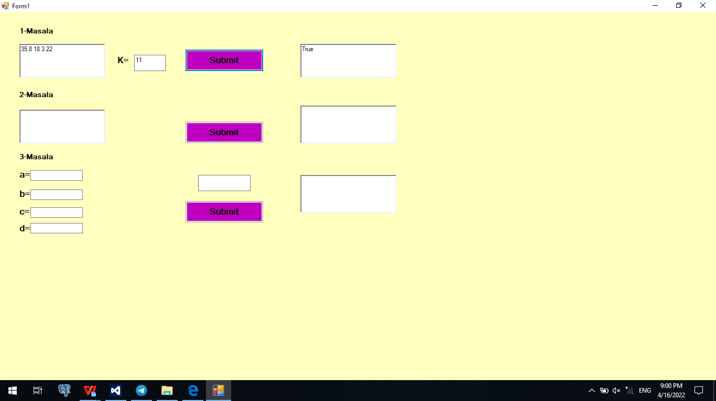

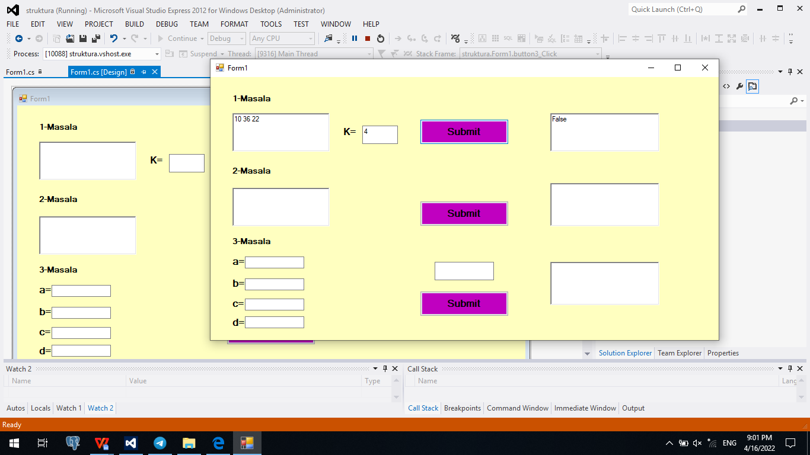

**Masala-2**

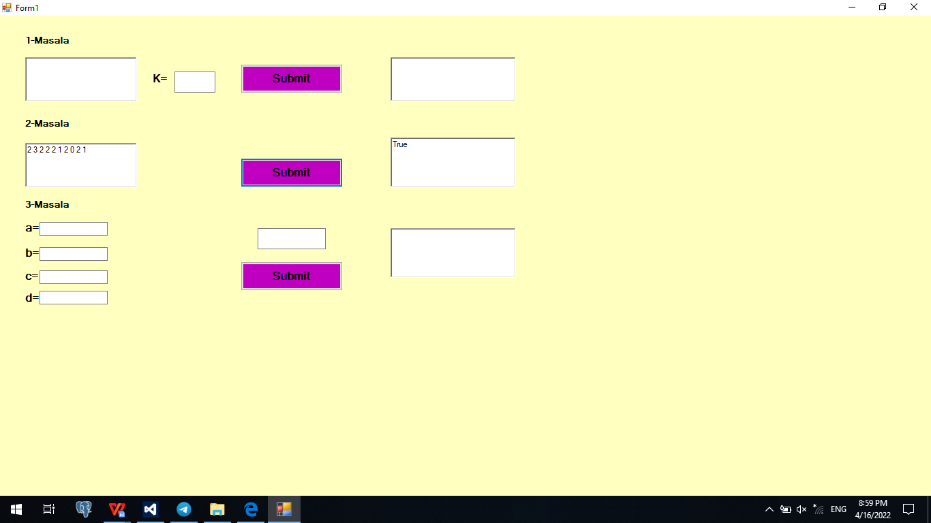

**Masala-3**

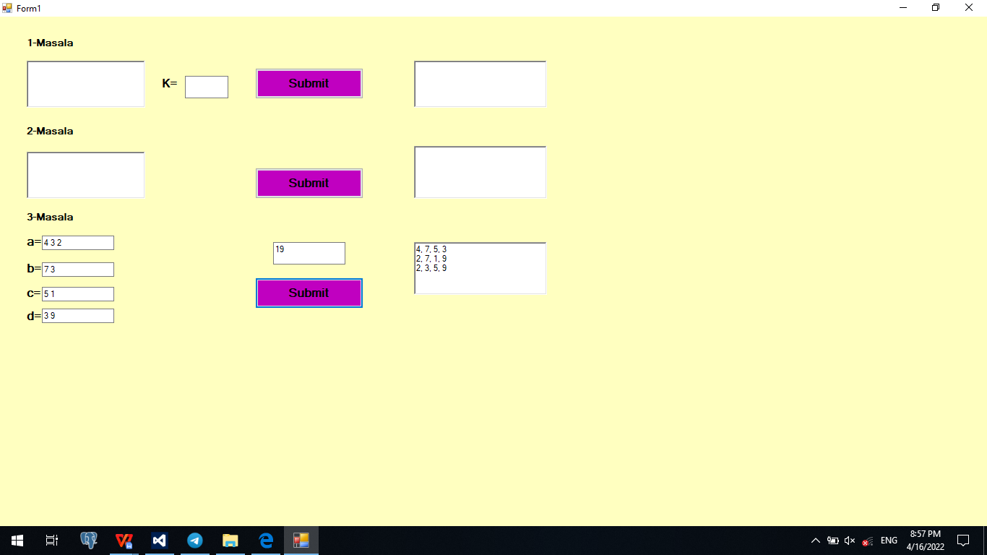

**4.1 topshiriq. Qat’iy ortib borayotgan bog'langan ro'yxat yagona bog'langan ro'yxatning bolishini hisobga olgan holda head, tugunlarning qiymatlari qat'iy ortib borayotgan tartibda tartiblanganligini qaytaring.**

using System;

using System.Collections.Generic;

using System.ComponentModel;

using System.Data;

using System.Drawing;

using System.Linq;

using System.Text;

using System.Threading.Tasks;

using System.Windows.Forms;

namespace struktura_2

{

public partial class Form1 : Form

{

public Form1()

{

InitializeComponent();

}

private void button1_Click(object sender, EventArgs e)

{

String[] satr = textBox1.Text.Split();

int[] list = new int[satr.Length];

bool holat = false;

for (int i = 0; i < satr.Length; i++)

{

list[i] = Convert.ToInt32(satr[i]);

}

for (int i = 0; i < list.Length - 1; i++)

{

if (!(list[i] < list[i + 1]))

{

holat = true;

break;

}

}

if (holat)

{

textBox2.Text = "Yolg'on";

}

else

{

textBox2.Text = "Rost";

}

}

private void button2_Click(object sender, EventArgs e)

{

List<string> ikkilik = new List<string>(textBox3.Text.Split(' '));

double s = 0;

for (int i = ikkilik.Count - 1, j = 0; i >= 0; j++, i--)

{

s += Convert.ToDouble(ikkilik[i]) * Math.Pow(2, j);

}

textBox4.Text = s.ToString();

}

private void button3_Click(object sender, EventArgs e)

{

textBox6.Clear();

string[] str = textBox5.Text.Split();

int l = 0;

bool hol = false;

for (int i = 0; i < str.Length; i++)

{

for (int j = i + 1; j < str.Length; j++)

{

if (str[i] == str[j])

{

str[j] = " ";

hol = true;

}

}

if (hol) str[i] = " ";

hol = false;

}

for (int i = 0; i < str.Length; i++)

{

if (str[i] != "")

{

textBox6.Text += str[i] + " ";

}

}

}

private void button4_Click(object sender, EventArgs e)

{

textBox8.Clear();

List<string> array = new List<string>(textBox7.Text.Split());

string maqsad = textBox9.Text;

foreach (var i in array)

{

if (!(maqsad == i))

{

textBox8.Text += i + " ";

}

}

}

}

}

**Masala-1**

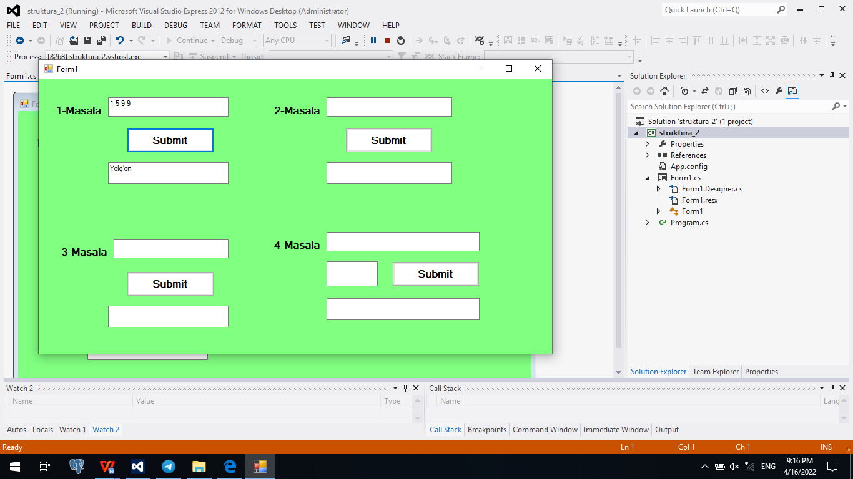

**Masala-2**

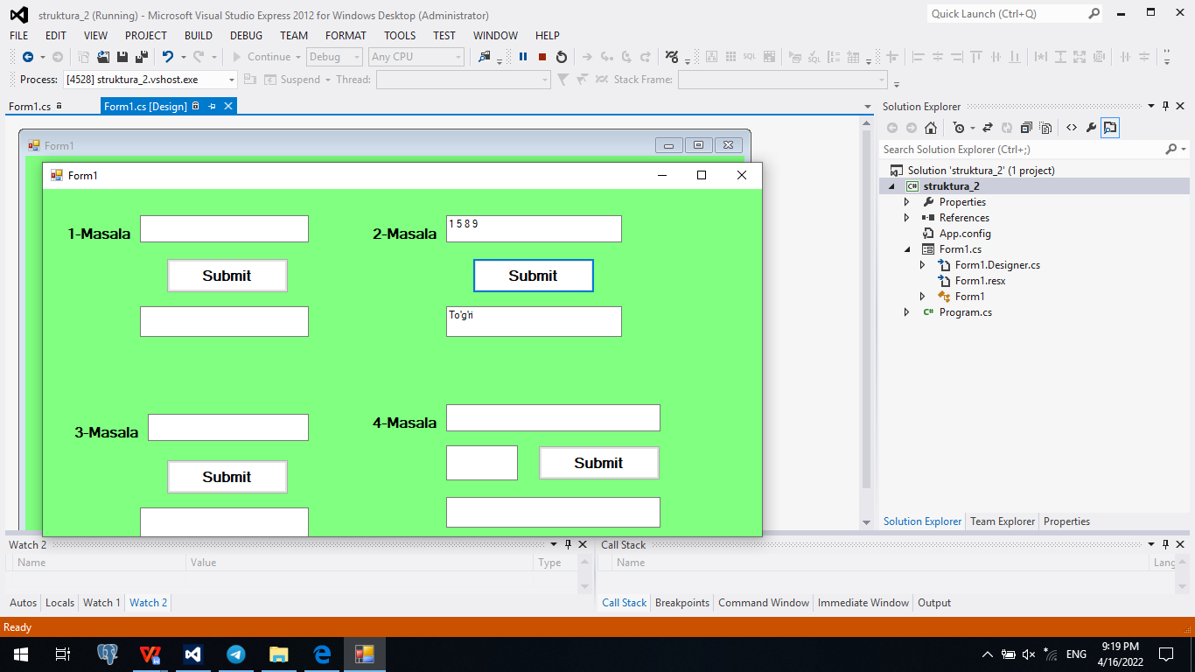

**Masala-3**

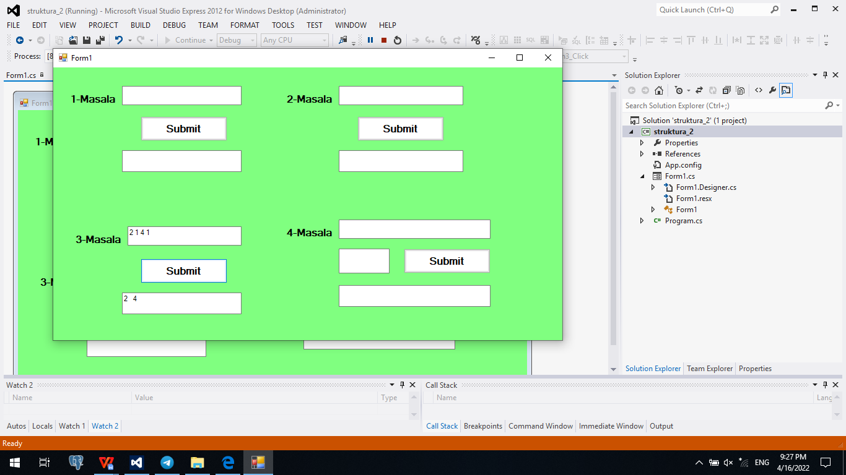

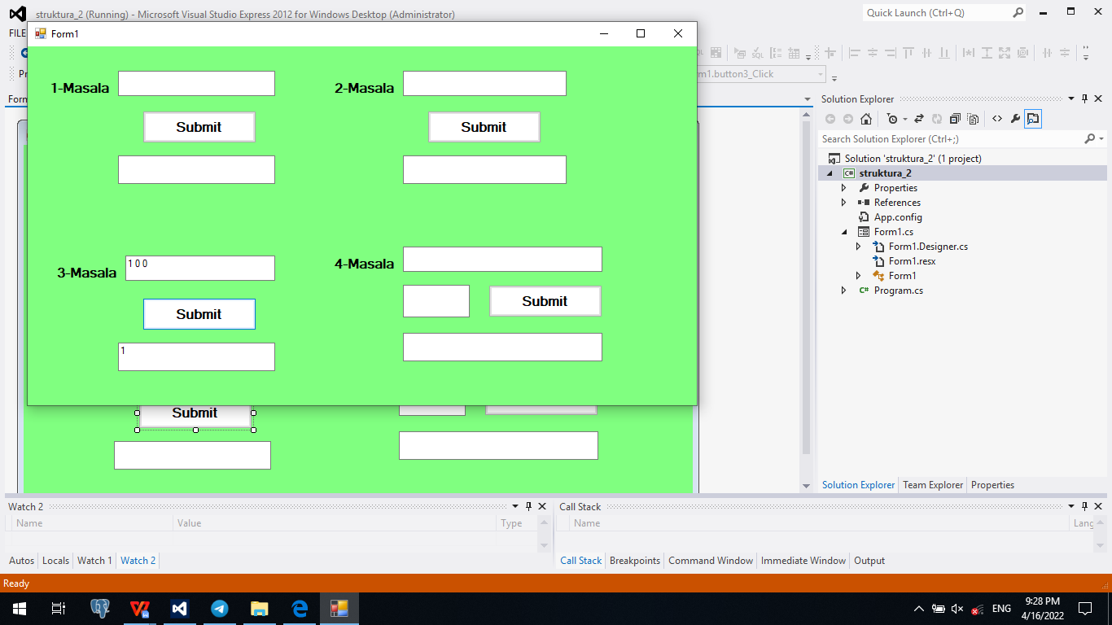

**Masala-4**

