Answers: Trigonometry (radians)

Summary

Answers to the questions on trigonometry, using radians to measure angles.

*These are the answers to* [*Questions: Trigonometry (radians)*](../questions/qs-trigonometry-radians.qmd)*.*

**Please attempt the questions before reading these answers!**

### Q1

You are given the triangle below.

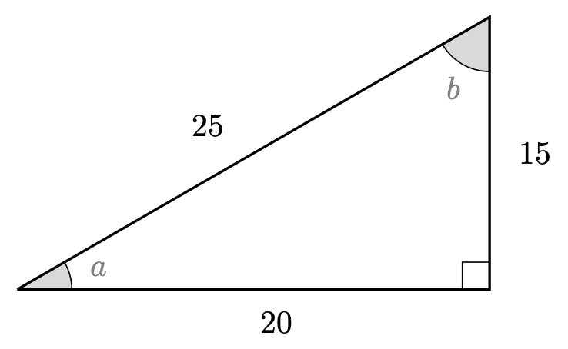

Q1. Triangle

Here,

### Q2

Using the triangle below, solve the following equations.

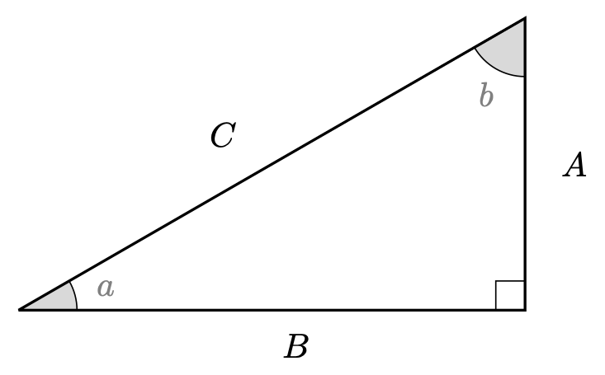

Q2. Triangle

2.1.

2.2.

2.3. (to three decimal places)

2.4.

2.5.

2.6. .

### Q3

3.1.

3.2.

3.3.

3.4.

3.5.

3.6.

3.7.

3.8.

3.9.

## Version history and licensing

v1.0: initial version created 08/23 by Dzhemma Ruseva, Ellie Gurini, Ciara Cormican as part of a University of St Andrews STEP project.

* v1.1: edited 05/24 by tdhc, and split into versions for both degrees and radians.

[This work is licensed under CC BY-NC-SA 4.0.](https://creativecommons.org/licenses/by-nc-sa/4.0/?ref=chooser-v1)