**Requirements to execute this project:**

1. Jupyter notebook including the following libraries:

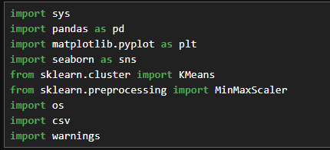

1. The CSV files required to **Train** and T**est** the data.

* Spotify_data.csv

This csv file includes the spotify data that is required to train the Clustering Model.

* Input_tracks.csv

This csv file contains the track list according to the user’s preferences.