1) Set up a bug tracking project in Jira

In JIRA to create a defect would be to create an issue of the type “Bug”.

2) Defect reporting needs the following information recorded for every issue:

Defect ID

Defect title

Defect description (steps to reproduce)

Environment information

Screenshot(attachment)

Severity

Assign it to someone

Status- All the statuses in the bug life cycle

3) Defect Life Cycle:

All bug life cycle statuses as in Bugzilla (or any other popular bug tracker) can be accomplished here too:

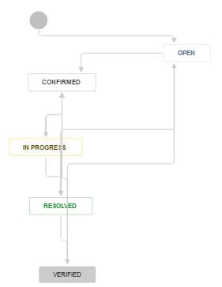

4) Comments and collaboration with the Dev Team

5) Linking the defect to a requirement to enable traceability

6) Defects can be imported from a CSV file

7) Defects can be exported into Word, XML, and printable formats

8) Comprehensive Issue Reports: