**Analysing the Neighbourhoods of London**

**Mohit Gupta**

**December, 2020**

**Introduction**

**Background**

Central London is the most famous and expensive place to own a property or start a business. Upcoming businessmen always want to own a business / shop at a place where they earn most profit based on the locality and nearby businesses.

**Problem**

Data includes location data of various post codes of central London. This project aims to predict the location appropriate for starting a new business or owning a property in central London.

**Interest**

The beneficiary is the group of people who intend to own a business or property in central London.

**Data acquisition and cleaning**

**Data sources**

Location data has been retrieved from various websites which provide geographical coordinates related data based on the post codes in central London. Central London is divided into 2 parts east and west. Eastern central London has 3 post codes EC1, EC2 and EC3. On the other hand, Western central London has 2 post codes WC1 and WC2. Apart from this, foursquare API has been used to find out the other venues in a particular post codes.

**Data cleaning**

Geographical coordinates related data was stored in a python dictionary and then transformed into a panda dataframe.

**Feature selection**

After data cleaning, there were 430 samples and 123 features in the data.

**Exploratory Data Analysis**

Location of the postcodes in central London is as follows-

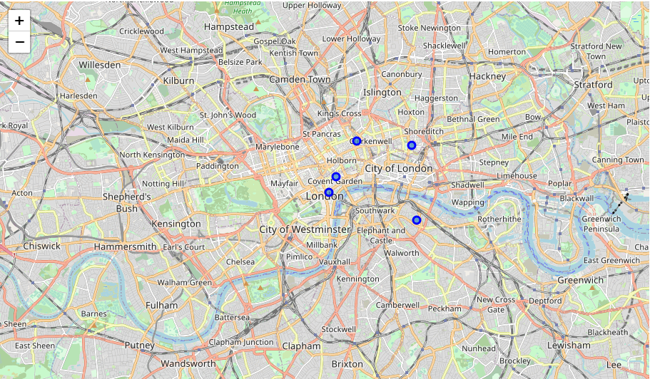

Venues selected based on the foursquare API are plotted on the map as follows. Venues that come under post code EC1 are plotted as red dots, for EC2 as green dots, for EC3 as blue dots, for WC1 as white dots and for WC2 as black dots.

