Relocation of the claims operations floor
The claims operations team moves to level 4 on 6 April. Marisol Vantongeren coordinates the move and can be reached at marisol.vantongeren@brightwater-mutual.example or on +1 (503) 555-0849.
Desk allocations were agreed with the union representative, Kwabena Asante, after the staff consultation. Personal storage must be cleared by 3 April.
Workstream | Approver | Staff ID
Seating plan | Yuki Thornbury | BWM-48213
Network cut-over | Callum Ferreira-Wynn | BWM-52914
Access badges | Marisol Vantongeren | BWM-61432
Current ticket queue for the move:
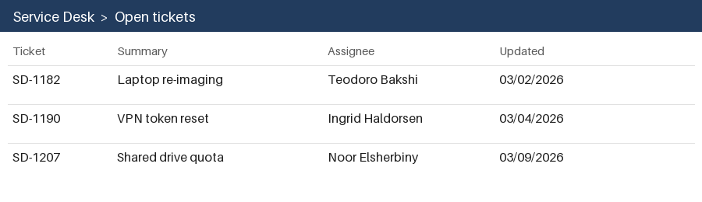
Questions about accessibility adjustments go to the facilities desk; individual needs are handled confidentially and are not recorded in this memo.

