|  |
| --- |
| **Experiment No. 9**  **Title: Case study – Big data platform / analytics as business need** |

**Batch: B1** **Roll No.: 1714124**  **Experiment No.: 9**

**Title: Coffee House Recommender Using Azure Machine Learning Studio.**

______________________________________________________________________________

**Resources needed: Microsoft Azure Machine Learning Studio**

**______________________________________________________________________________**

**Setup of Microsoft Azure Machine Learning Studio:**

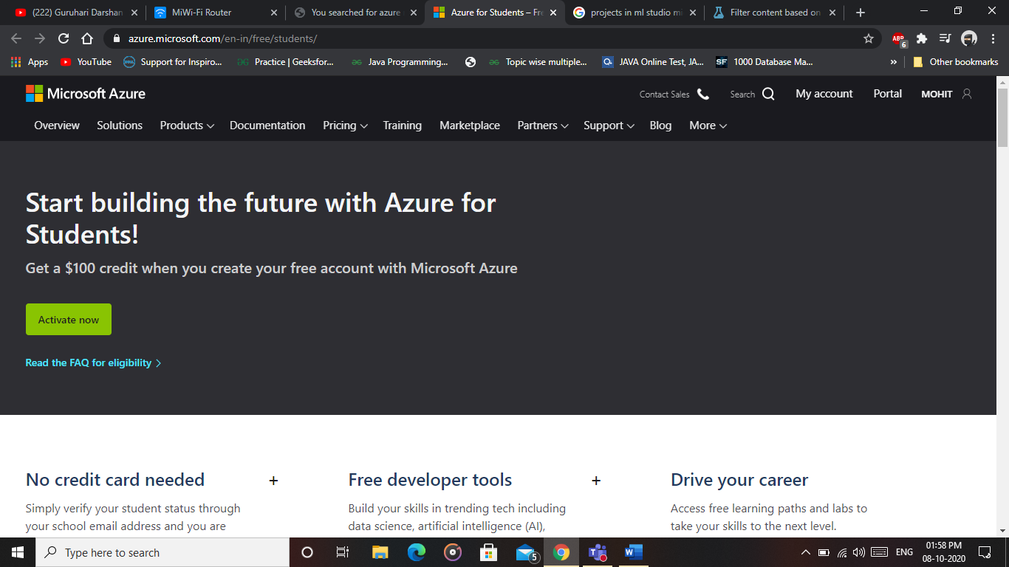

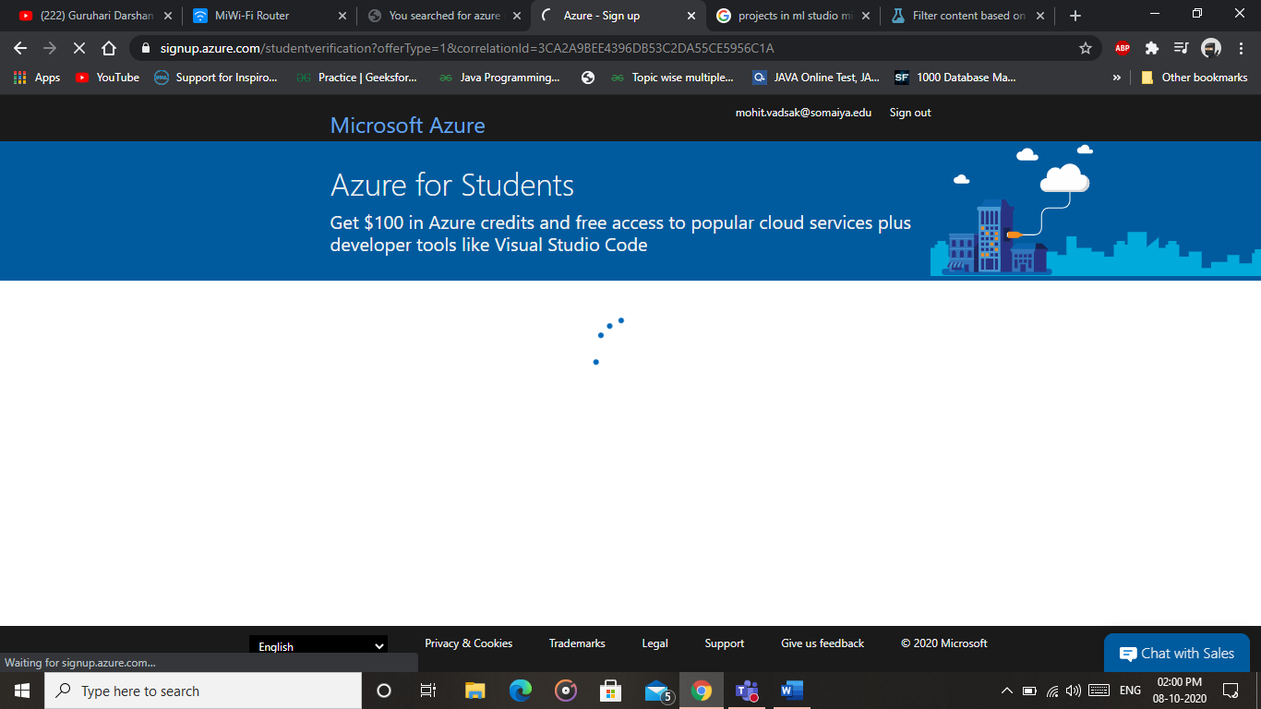

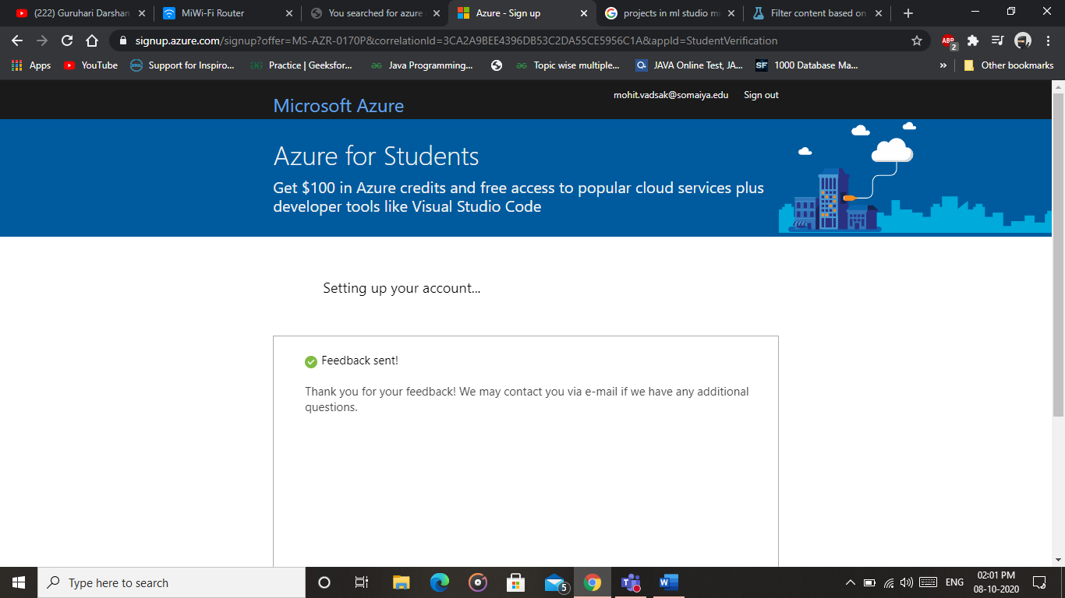

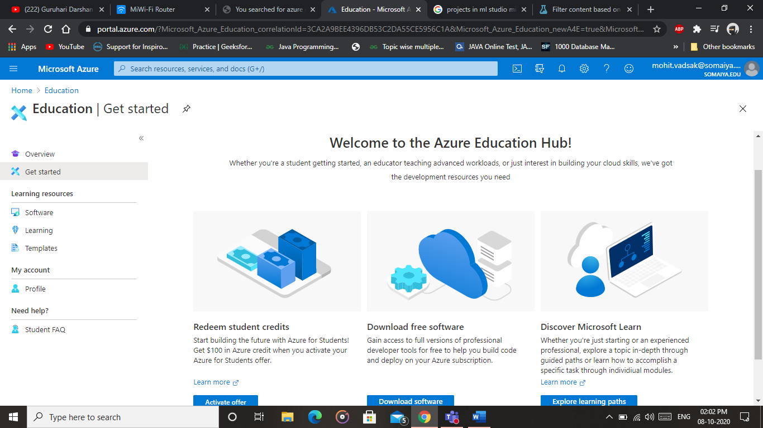

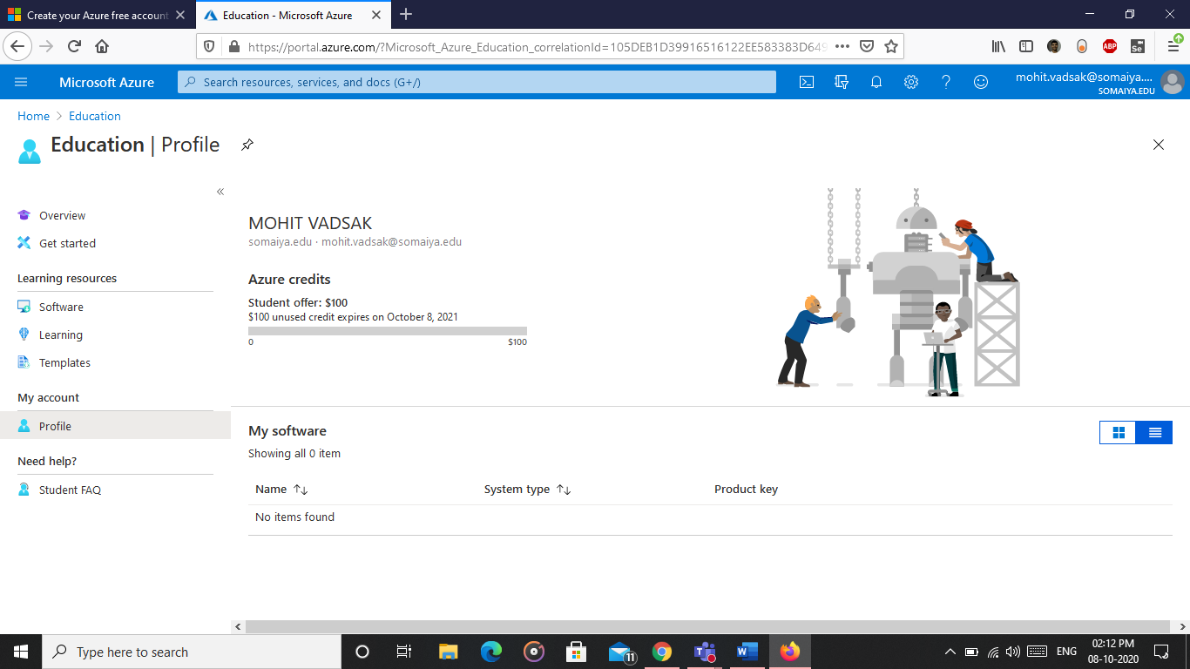

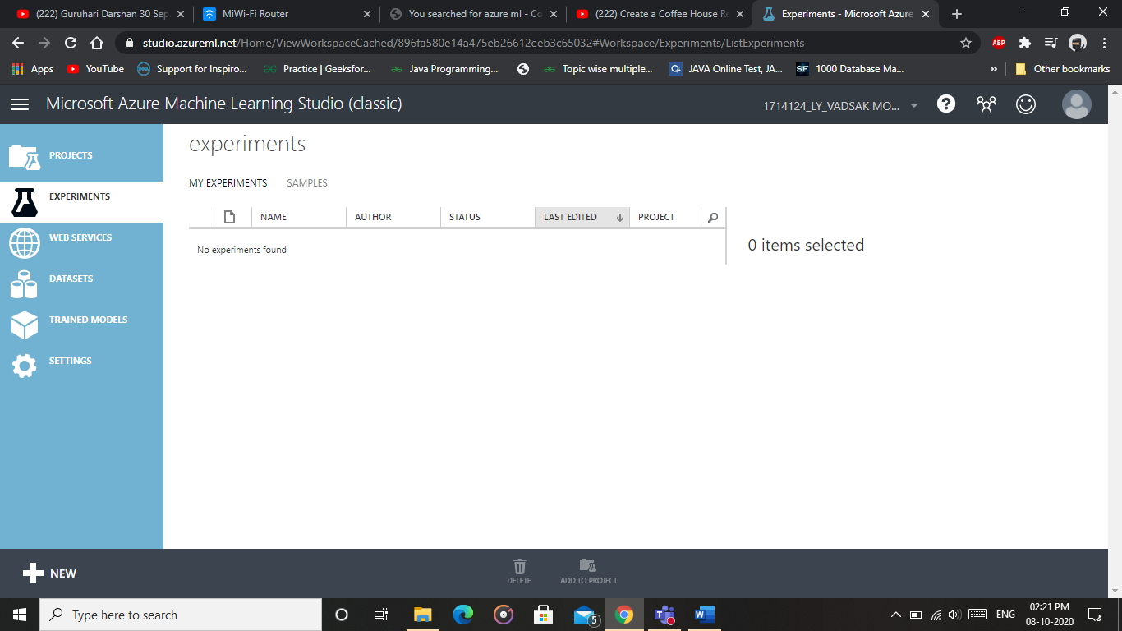

**Azure Machine Learning Studio:**

Azure Machine Learning Studio is web-based integrated development environment (IDE) for developing data experiments. It is closely knit with the rest of Azure’s cloud services and that simplifies development and deployment of machine learning models and services.

**Development of Recommender Model:**

Add the datasets to your Azure ML Studio Portal. Upload the Datasets from Local Computer

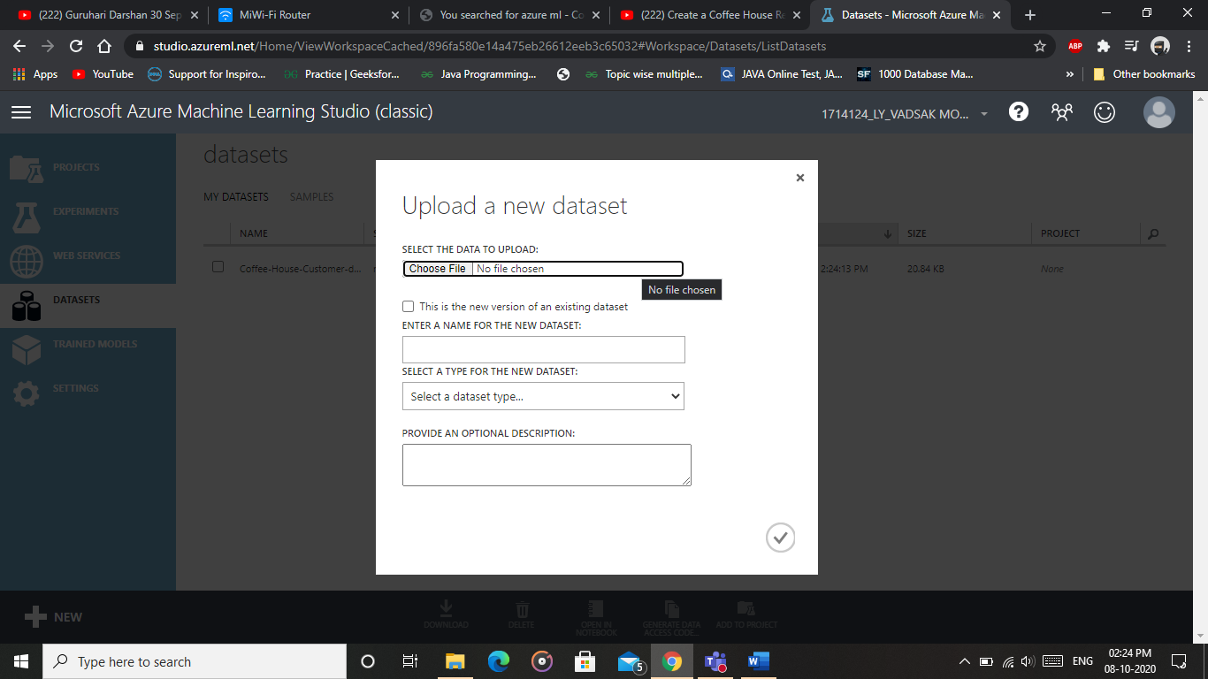

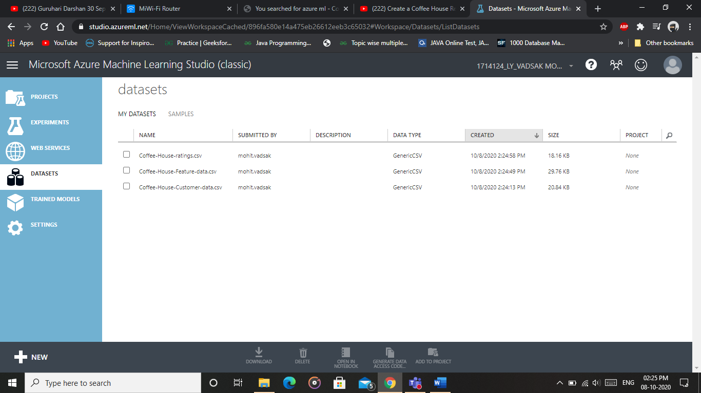

Go to experiments to create a new experiment

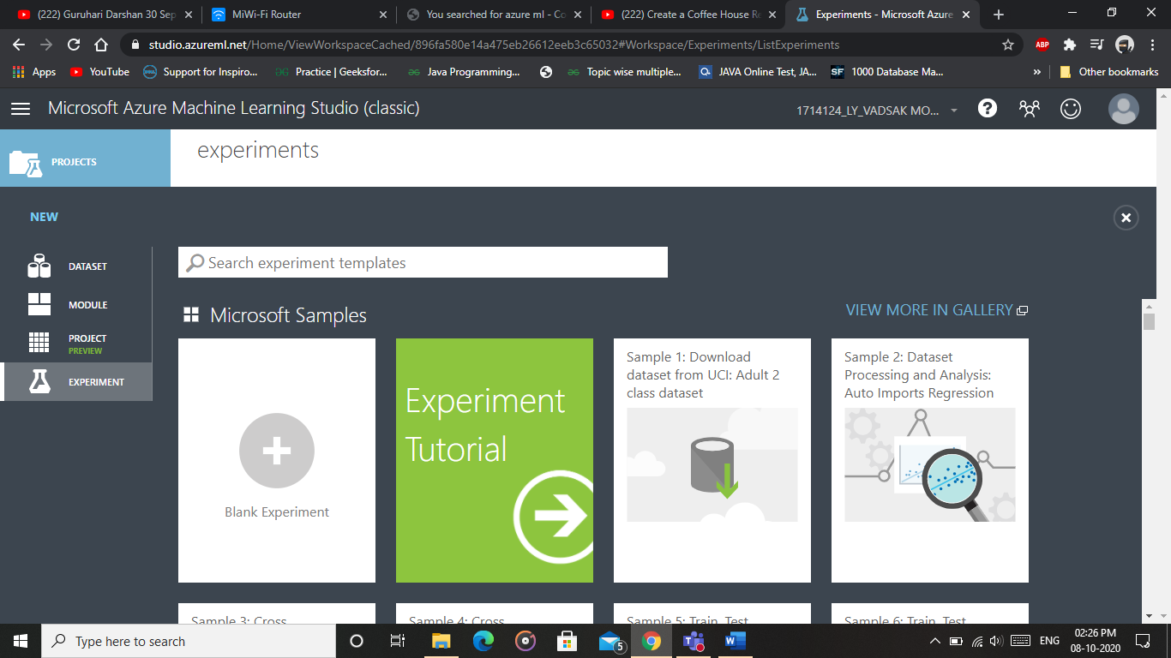

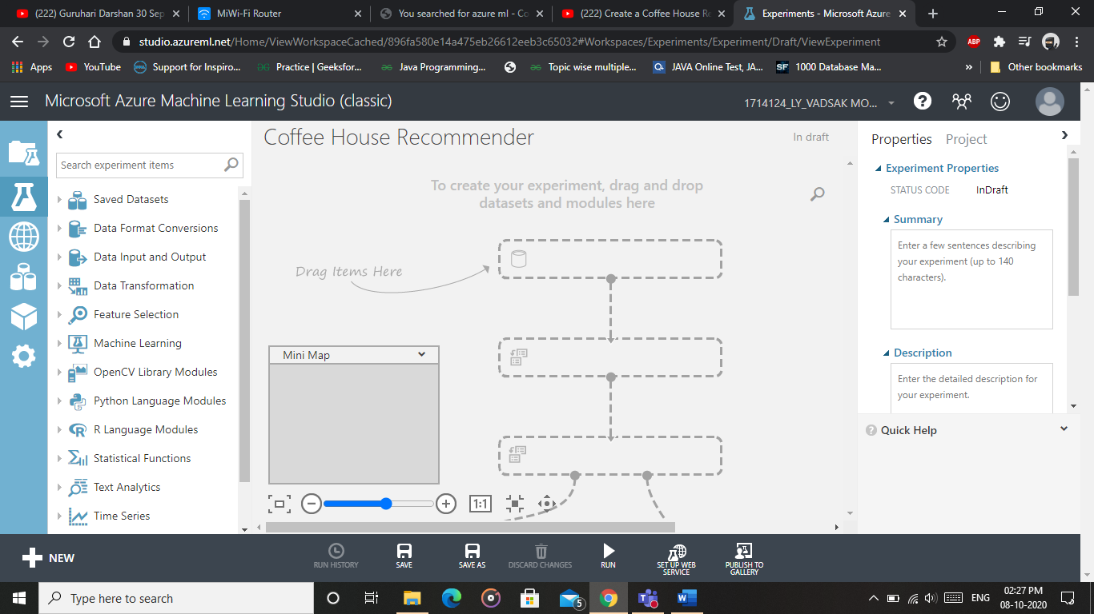

Import the datasets from Saved Datasets and drag it to your workspace

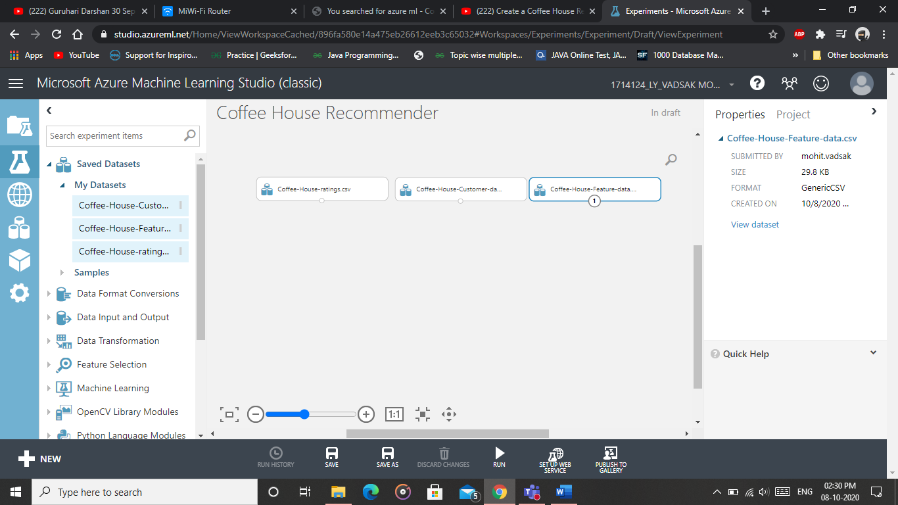

To visualize the datasets Right click on dataset and select visualize

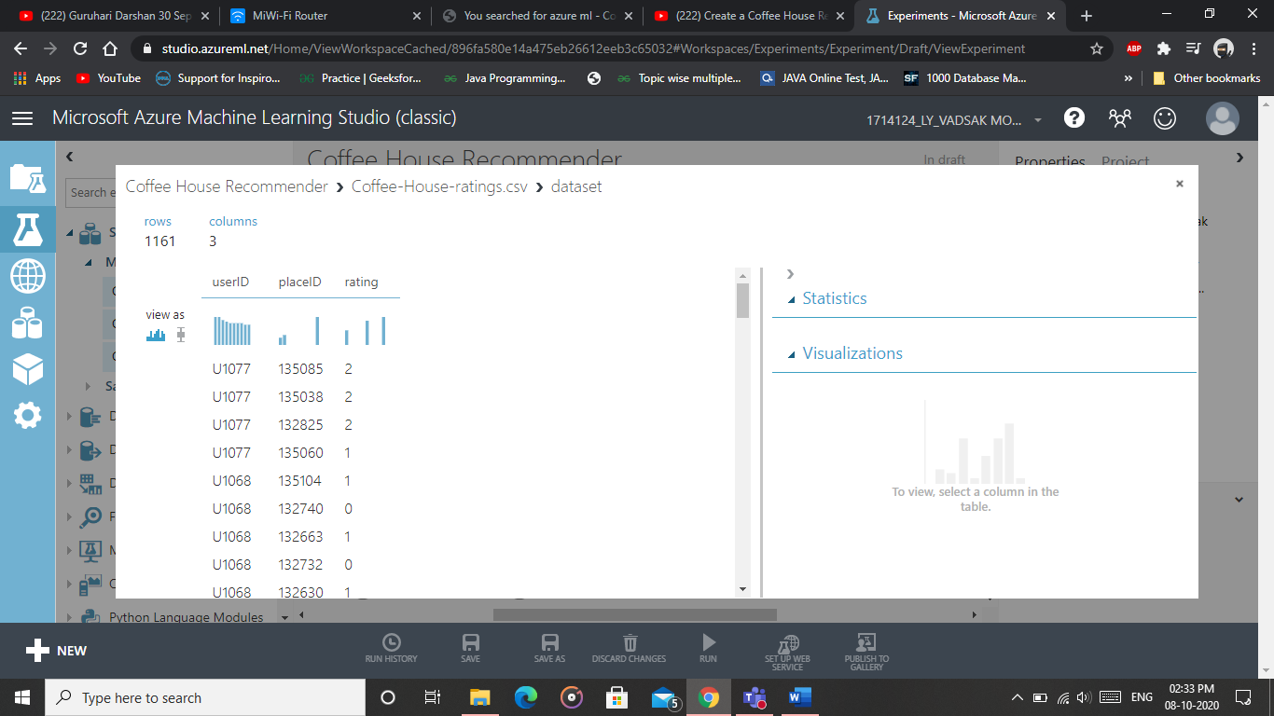

Select the split data module from Data Transformation Field and then connect the first dataset with that module to split the data into 2 parts. In Properties of that Split Data Module Recommender Split.

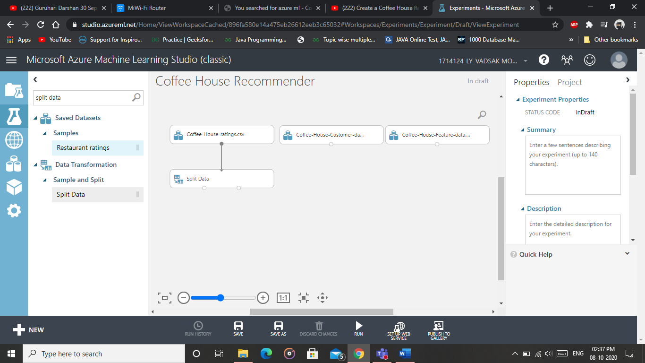

Select the Select Columns from dataset option and drag it to the Workspace

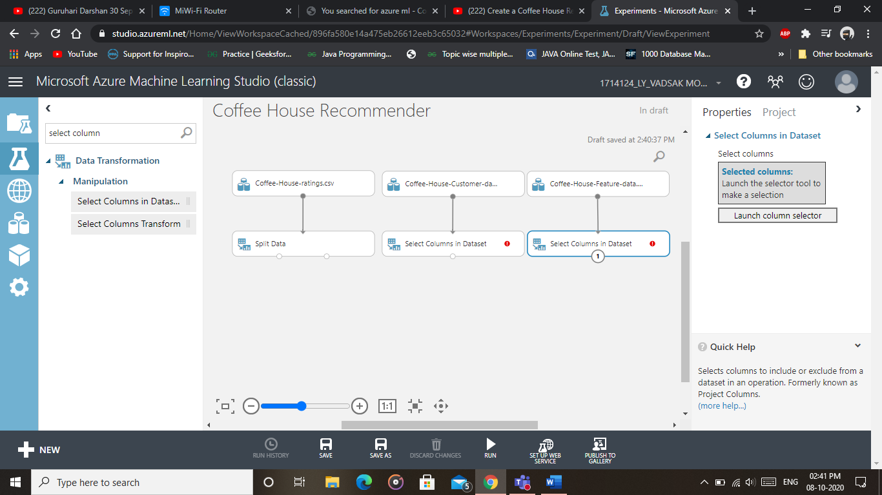

Launch the column selector and select those columns you need for your experiment

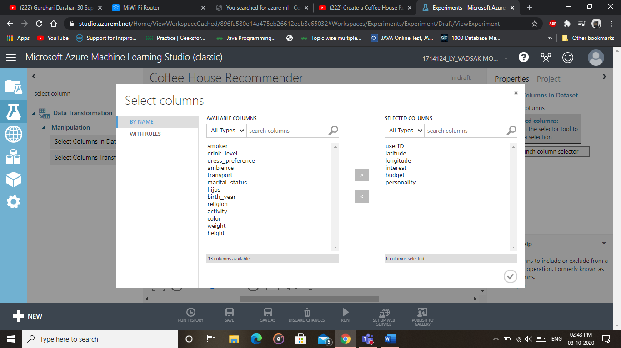

Now add the Train Matchbox Recommender to the Workspace.

It requires 3 features 1.Training Dataset 2. User Features 3. Item Features

*Train Matchbox Recommender: It reads a dataset of user-item-rating triples and, optionally, some user and item features. It returns a trained Matchbox recommender. You can then use the trained model to generate recommendations, find related users, or find related items, by using the* Score Matchbox Recommender *module.*

*The Matchbox recommender combines these approaches, using collaborative filtering with a content-based approach. It is therefore considered a hybrid recommender.*

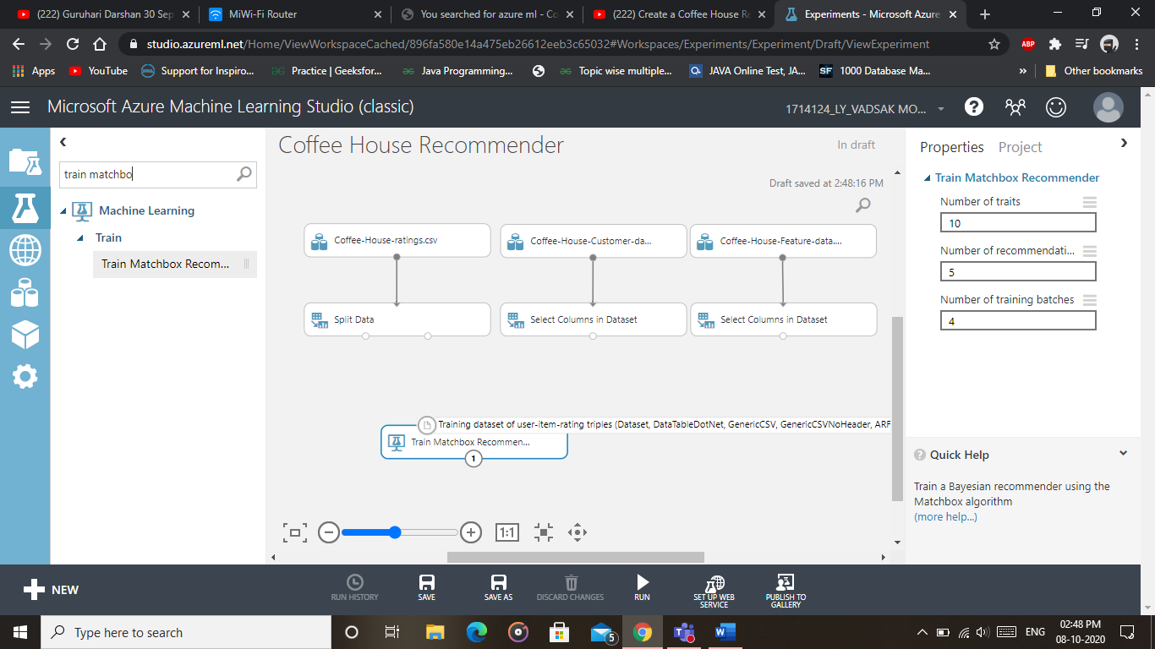

Add the Score Matchbox Recommender which is used to score a dataset

It requires more inputs than trained recommender

*Score Matchbox Recommender:*

The Matchbox recommender can generate four different kinds of predictions:

* Predict ratings for a given user and item
* Recommend items to a given user
* Find users related to a given user
* Find items related to a given item

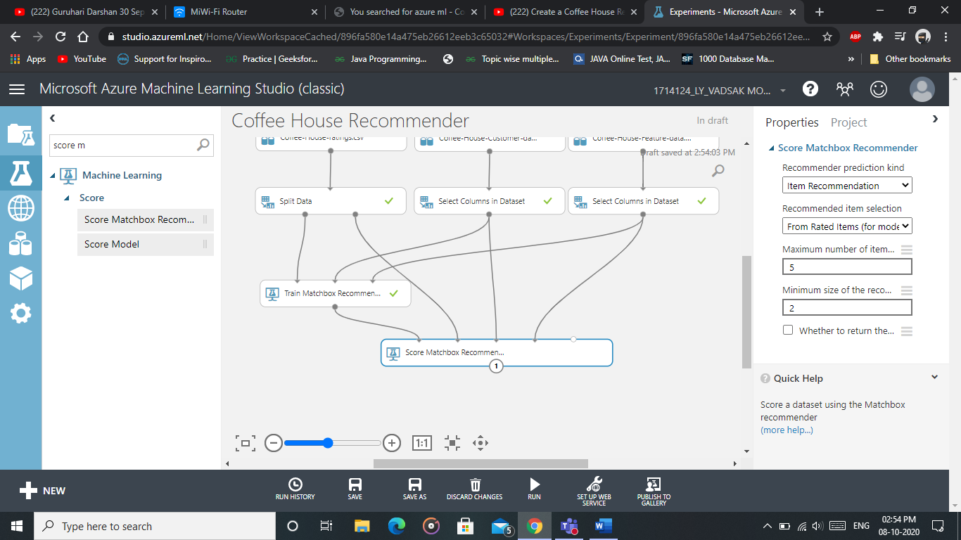

So now clicking on Scored Dataset and we will get the Results which displays 5 items to each user.

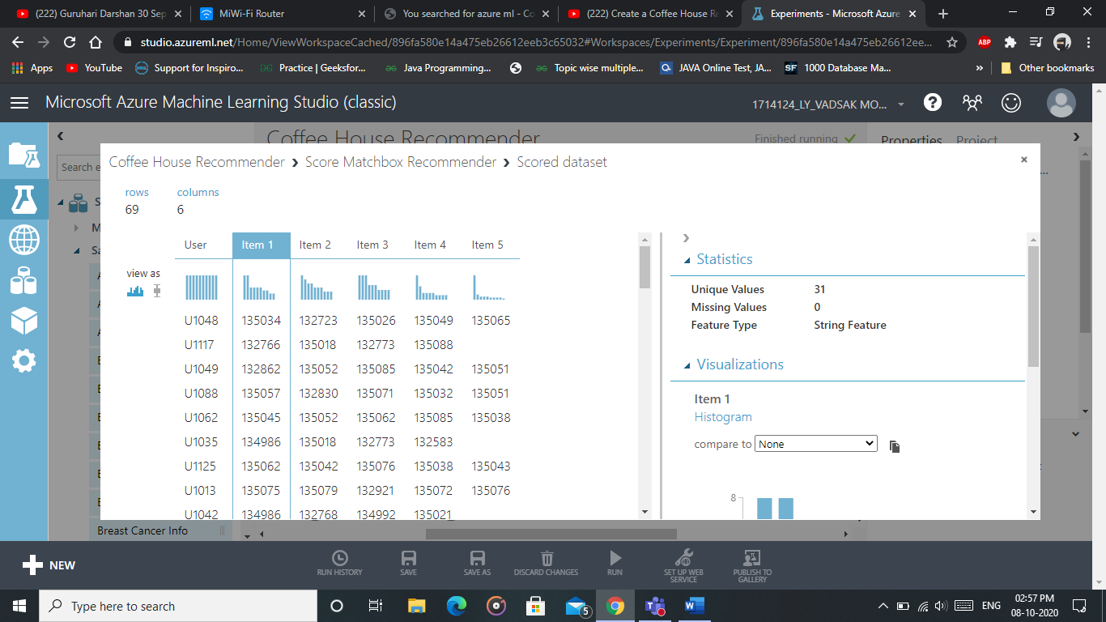

So the final model is

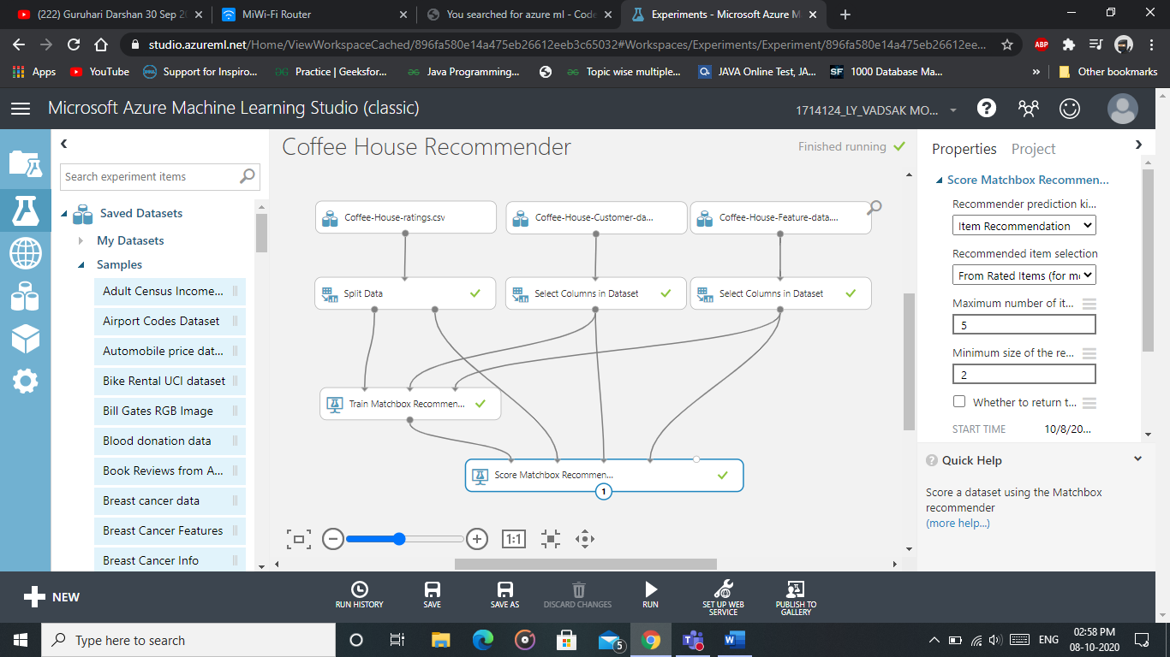

**Publishing to Gallery:**

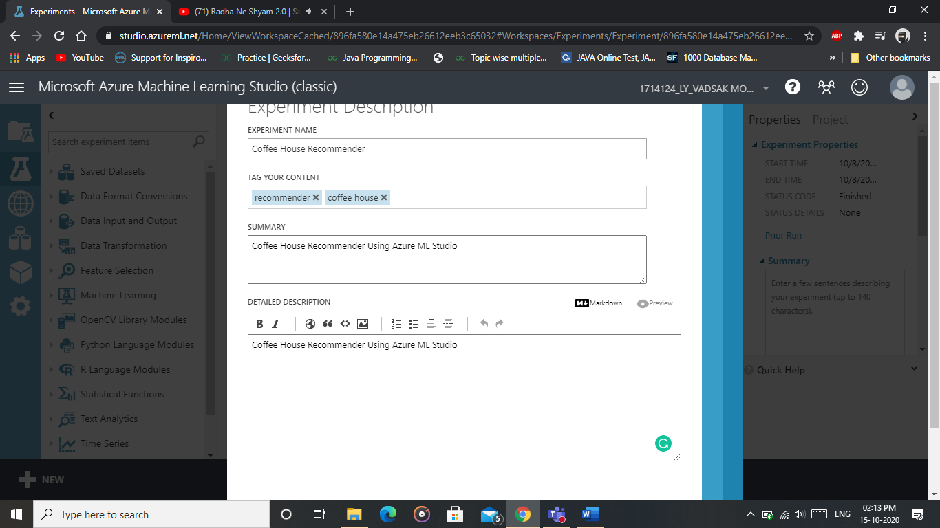

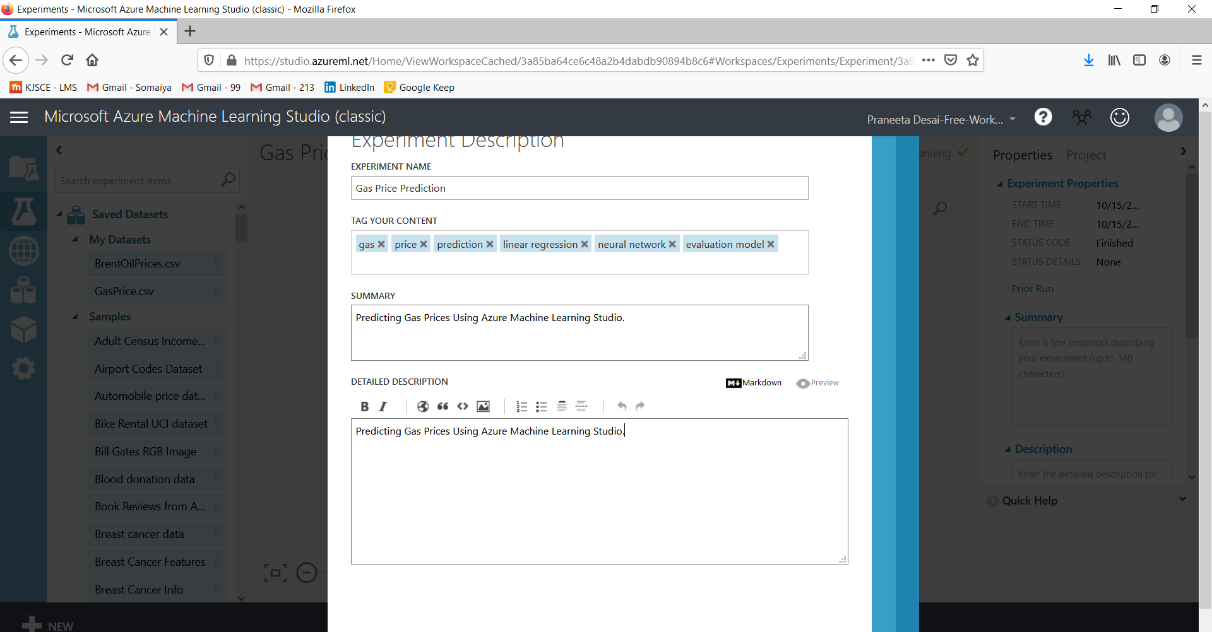

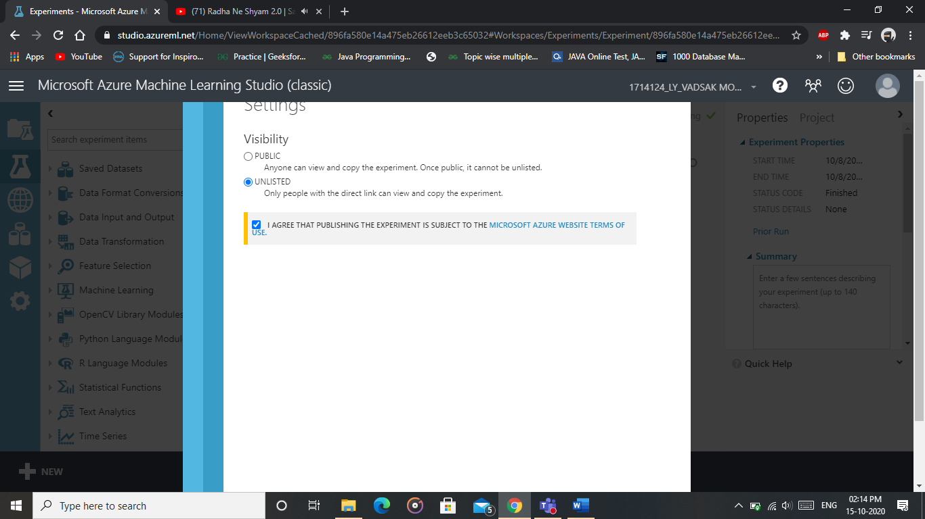

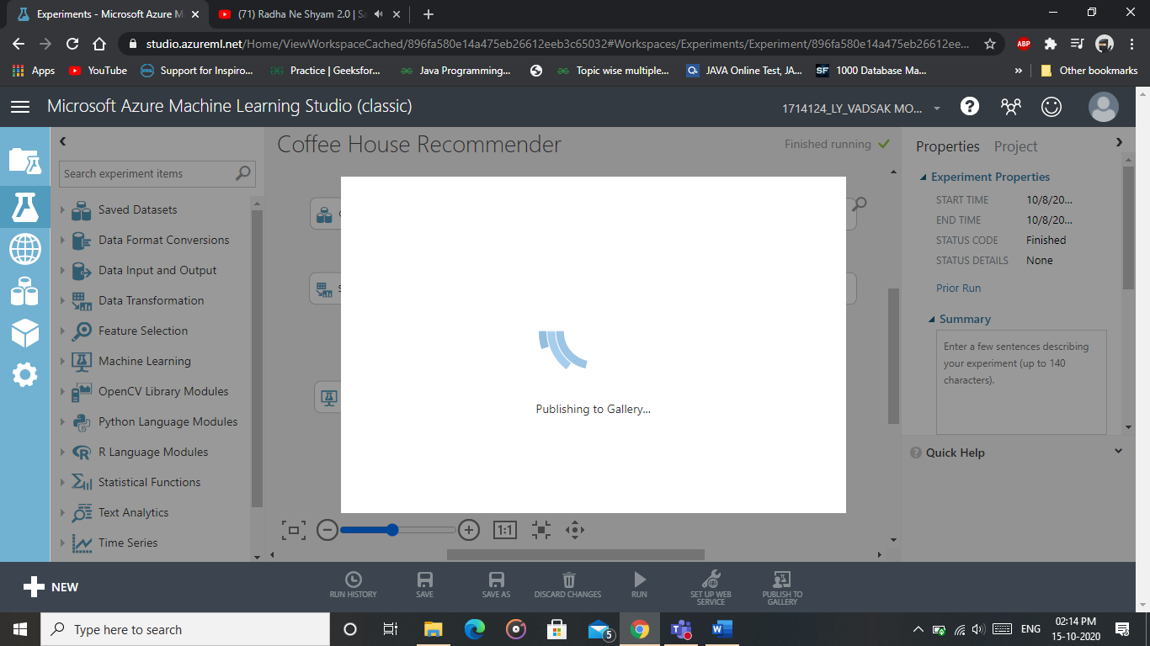

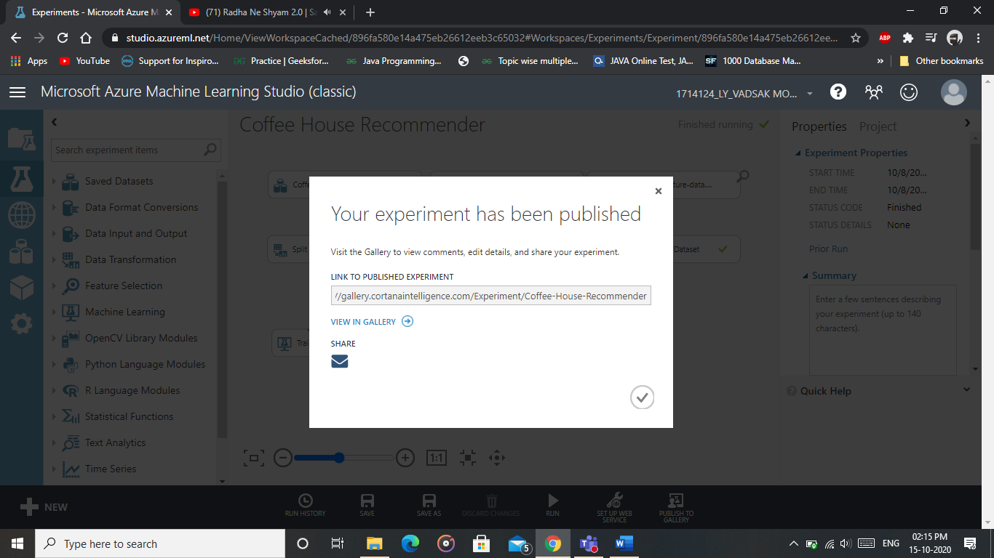

**Gallery Link:** [**https://gallery.cortanaintelligence.com/Experiment/Coffee-House-Recommender**](https://gallery.cortanaintelligence.com/Experiment/Coffee-House-Recommender)

**Azure Gallery Link:** [**https://gallery.azure.ai/Experiment/Coffee-House-Recommender**](https://gallery.azure.ai/Experiment/Coffee-House-Recommender)

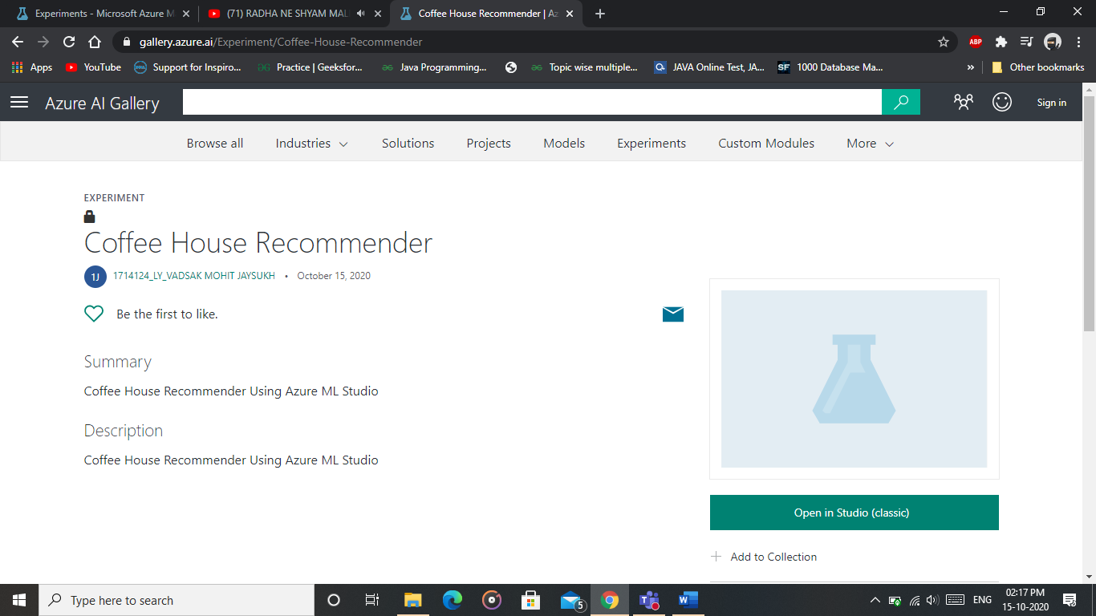

**______________________________________________________________________________**

**Outcomes: Realize adequate perspectives of big data analytics in various applications.**

**______________________________________________________________________________**

**Conclusion:**

**In this experiment, we implemented a recommendation system using Azure Machine Learning Studio. We used the drag and drop functionalities to implement Coffee House Recommender System.**

**______________________________________________________________________________**

**Grade: AA / AB / BB / BC / CC / CD /DD**

**Signature of faculty in-charge with date**

**___________________________________________________________________________**

**References:**

**Books/ Journals/ Websites:**

1. <https://www.codestories.gr/index.php/2019/01/13/video-tutorial-coffee-house-recommendation-service-with-azure-ml/>
2. <https://www.codemag.com/article/1709071/Getting-Started-with-Machine-Learning-Using-Microsoft-Azure-ML-Studio>
3. <https://studio.azureml.net/>
4. <https://docs.microsoft.com/en-us/azure/machine-learning/classic/sample-experiments>