Data Visualization Lab — Practical No. 7
R Programming with Power BI - BLOG
SYMBIOSIS INSTITUTE OF TECHNOLOGY

NAME – Mohit Mayank Shrivastava
PRN - 24070126116
AIML B2

Practical No. 7
Retail Sales & Profit Analysis: Advanced Analytics with R and Power BI
Course: Data Visualization Lab (TE7663) | Semester: V | Academic Year: 2026-2027

1. Introduction
Dashboards show what happened in a business, but they rarely explain why it happened or what is likely to happen next. In this practical I combine Power BI Desktop with R to go one step further: I clean the Sample Superstore dataset, run statistical summaries and R visualizations on it, fit a regression model to predict profit, and bring those R outputs into an interactive dashboard alongside native Power BI visuals.
This post follows the same order as the work: the setup and dataset, the summary statistics, the four R visualizations, the advanced analytics model, the dashboard, the interpretation of the results and the conclusion.

Objectives
- Configure R with Power BI Desktop and load the dataset.
- Handle missing values and duplicate rows before analysis.
- Execute R scripts inside Power BI and generate descriptive statistics.
- Create at least four R-based visualizations.
- Implement one statistical technique: multiple linear regression to predict profit.
- Build an interactive dashboard with at least five KPI cards, four R visuals, four Power BI visuals, slicers and filters.
- Interpret the results and summarize the business insights.

2. Dataset, Setup and Data Cleaning
The dataset is the Sample Superstore order data, which contains 9,994 order lines. The columns used in this analysis are listed below.
Field | Use in this analysis
Sales | Revenue per order line; numeric measure for the correlation and regression
Quantity | Units per order line; numeric measure
Discount | Discount rate applied to the order line; grouped into discount levels
Profit | Target variable for the distribution, discount and regression analysis
Category, Sub-Category | Product hierarchy used for the donut and bar visuals and as a regression factor
Region, Segment | Geography and customer segment used for slicers and the region visual
Order date | Quarterly trend and the Year slicer

Setup
R was installed and configured as the R home directory in Power BI Desktop, which allows R script visuals and R script data transformations inside the report. The dataset was imported into Power BI and cleaned in Power Query. Missing values were handled and duplicate rows were removed before any R script ran.
After cleaning, every analysed column shows 9,994 valid values in the summary table below, so no column is left with gaps for the statistics or the models.

3. R Script Execution and Summary Statistics
The first R step is a descriptive summary of the four numeric measures plus the derived profit margin. The table below is taken from the Key Metrics Summary on the dashboard.
Variable | Count | Mean | Median | Min | Max | Std Dev
Profit | 9,994 | 28.66 | 8.67 | -6,599.98 | 8,399.98 | 234.26
Profit Margin | 9,994 | 0.12 | 0.27 | -2.75 | 0.50 | 0.47
Discount | 9,994 | 0.16 | 0.00 | 0.00 | 0.80 | 0.21
Sales | 9,994 | 229.86 | 54.49 | 0.44 | 22,638.48 | 623.25
Quantity | 9,994 | 3.79 | 3.00 | 1.00 | 14.00 | 2.23

The gap between the mean and the median for Sales (229.86 against 54.49) shows a strongly right-skewed distribution: most orders are small and a few very large orders pull the average up. Profit has a mean of only 28.66 but a range from about -6,600 to about 8,400, so the typical order is close to break-even while a small number of orders carry large gains or losses. That pattern shapes the visualizations below.

4. R-Based Visualizations
Four visuals were created in R using ggplot2. Each subsection shows the script and the output it produced.

4.1 Distribution of Order-Line Profit
A histogram shows how profit is spread across all order lines. The axis is trimmed to -500 to 700 so the central mass is readable, and a dashed line marks break-even at zero.
Step: R script for the profit histogram
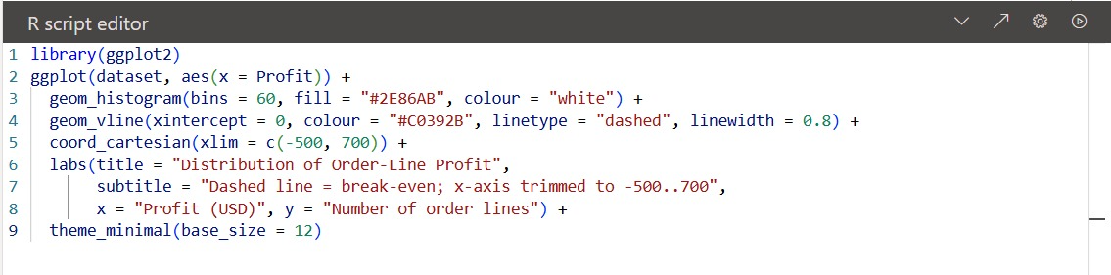
Output
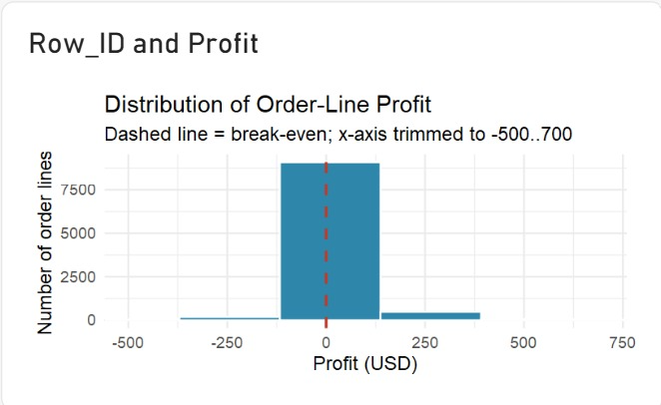
Most order lines sit close to zero profit, in a tall bar just to the right of break-even. The left tail, where the loss-making orders are, is long but thin, and very few orders fall above about 400 USD within the plotted range.

4.2 Profit by Discount Level
A boxplot of profit for each discount level shows how the spread of profit changes as discounts increase. The dashed line again marks break-even.
Step: R script for the discount boxplot
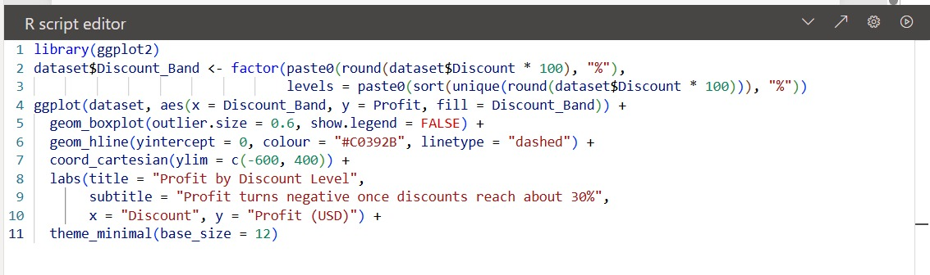
Output
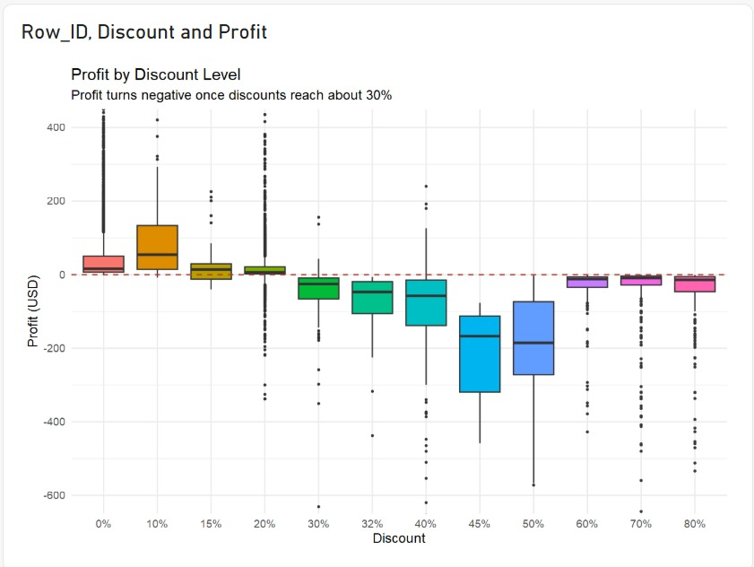
Up to about 20% discount, the median profit stays positive. From 30% onward, the median moves below break-even, and between 45% and 50% the typical order loses roughly 150 to 200 USD. The 60% to 80% levels stay negative, though with smaller losses. The subtitle of the chart summarizes the finding: profit turns negative once discounts reach about 30%.

4.3 Correlation Matrix of Numeric Measures
A correlation heatmap summarises how strongly each pair of numeric measures moves together, on a scale from -1 to 1.
Step: R script for the correlation matrix
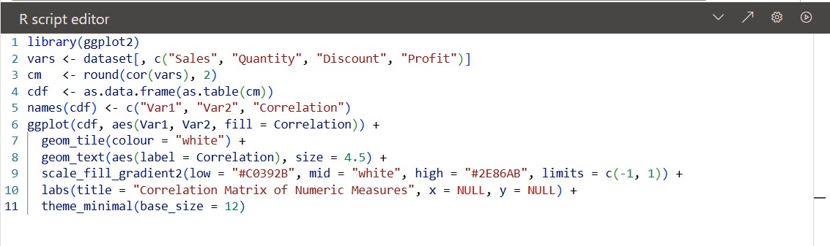
Output
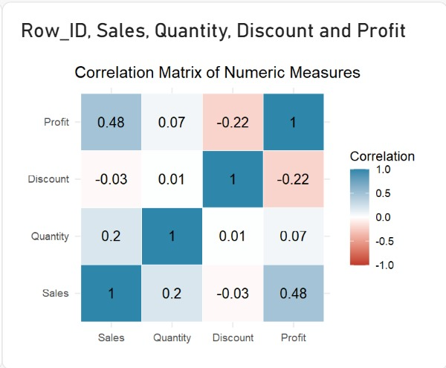
Sales and Profit are moderately positively correlated (0.48), and Discount is negatively correlated with Profit (-0.22). Discount has almost no relationship with Sales (-0.03) or Quantity (0.01). Quantity is only weakly related to Sales (0.20) and barely related to Profit (0.07). Correlation shows direction and strength of association only; it does not show cause.

4.4 Actual versus Predicted Profit
This visual checks how well the regression model in Section 5 predicts profit. Each point is one order line: the horizontal axis is the predicted value and the vertical axis is the actual value. Points on the dashed line would be predicted perfectly.
Step: R script for the regression plot
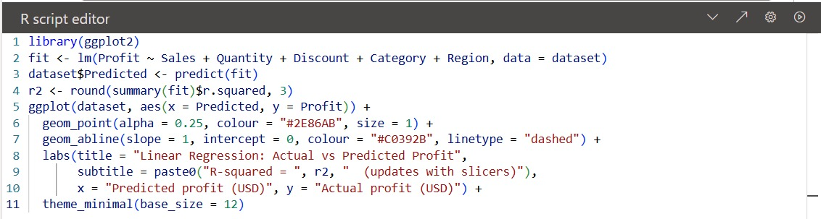
Output
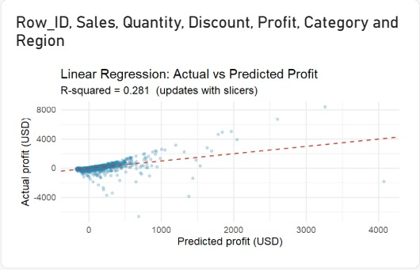
The model's predictions are clustered near zero and the points fan out as predictions grow. The R-squared value of 0.281 is printed in the subtitle, and the points show that large actual profits and losses are poorly predicted.

5. Advanced Analytics: Multiple Linear Regression
The advanced analytics technique is a multiple linear regression that predicts Profit from Sales, Quantity, Discount, Category and Region. The model is fitted with lm() in R, predictions are stored in the dataset as a new column, and the R-squared value is computed from the model summary and displayed in the chart subtitle.
The model explains about 28% of the variation in profit (R-squared = 0.281). That is enough to show that these variables carry real signal, but not enough to predict individual orders reliably. Profit depends on factors that are not in this dataset, and extreme values have a large effect on a linear fit. The model is therefore useful for direction and comparison, not for setting the profit of a single order.

6. The Interactive Dashboard
The dashboard is a single page built in Power BI Desktop. The header holds four slicers: Year, Segment, Region and Category. Below them is a row of six KPI cards, followed by four Power BI visuals, four R visuals and a Key Metrics Summary table. Every visual responds to the slicers, so selecting a year or region updates the cards, the charts and the R-squared value together.
Output: dashboard screenshot
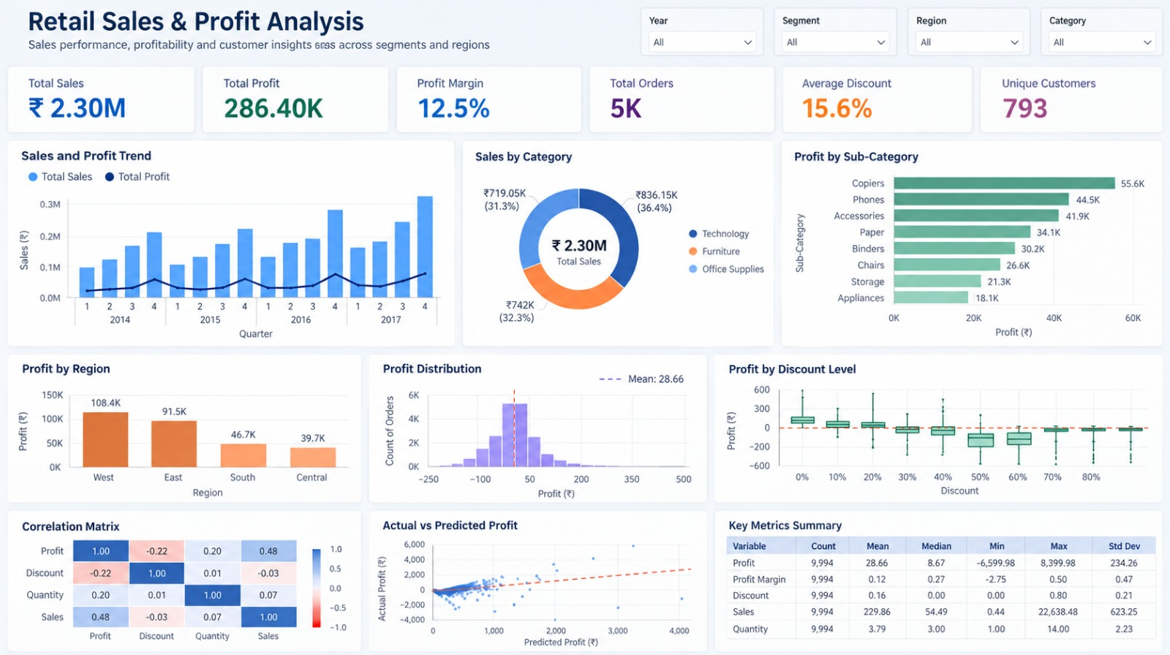

KPI cards
KPI | Value on dashboard
Total Sales | 2.30M
Total Profit | 286.40K
Profit Margin | 12.5%
Total Orders | 5K
Average Discount | 15.6%
Unique Customers | 793

Visual summary
- Power BI visual. Sales and Profit Trend (Power BI): quarterly sales bars from 2014 to 2017 with a profit line.
- Power BI visual. Sales by Category (Power BI): donut chart of Technology, Furniture and Office Supplies.
- Power BI visual. Profit by Sub-Category (Power BI): bar chart ranking sub-categories by profit.
- Power BI visual. Profit by Region (Power BI): bar chart of West, East, South and Central.
- R visuals. Profit Distribution, Profit by Discount Level, Correlation Matrix and Actual vs Predicted Profit: the four R visuals from Section 4.

7. Analysis and Interpretation

Sales and categories
Total sales are about 2.30 million USD. Technology leads with 836.15 thousand (36.4%), followed by Furniture at 742 thousand (32.3%) and Office Supplies at 719.05 thousand (31.3%). The three categories are close in size, so no single category dominates revenue.

Profit and regions
Total profit is 286.40 thousand, a margin of 12.5%. West (108.4 thousand) and East (91.5 thousand) together produce about 70% of that profit, while South (46.7 thousand) and Central (39.7 thousand) contribute the rest. Among the sub-categories shown, Copiers earns the most profit at 55.6 thousand, well ahead of Phones at 44.5 thousand.

Trend over time
Quarterly sales rise from 2014 to 2017. In every year shown, Q4 is the highest quarter, which suggests a seasonal peak at the end of each year. Profit rises with sales, but it is a much smaller share of each bar, in line with the 12.5% margin.

Discounts and profitability
The discount analysis is the clearest warning in the data. Profit is positive at low discount levels and turns negative from about 30%. Because Discount has a negative correlation with Profit (-0.22), deeper discounts tend to reduce profit, even though they do not raise sales in a measurable way (correlation -0.03 with Sales).

Model accuracy
The regression explains 28% of profit variation, so it is a modest model. Its errors are largest for the orders with the biggest profits and losses, which is why the scatter fans out. The model should support decisions such as checking discount policy, not replace order-level judgement.

8. Key Insights and Conclusion
- Discounts. Profit is sensitive to discounting. Above about 30% discount the median order loses money, and losses are steepest at 45% to 50%.
- Geography. West and East generate about 70% of profit, so regional performance concentrates in two areas.
- Categories. Sales are spread almost evenly across Technology, Furniture and Office Supplies.
- Seasonality. Q4 is the strongest quarter every year, which is useful for planning stock and staffing.
- Model. The regression achieves R-squared 0.281, so it describes the trend but cannot predict individual orders precisely.
In conclusion, this practical showed how R and Power BI can work together: R handled the statistics, the correlation analysis, the four visualizations and the regression model, and Power BI turned those outputs into an interactive dashboard that responds to slicers. The most actionable finding is that deep discounts erode profit, while the West and East regions and the Q4 peak are the main places where profit is concentrated.

