
BALAJI PUBLIC SCHOOL
C B S E A F F I L I A T E D · B A L L A B G A R H , H A R Y A N A

I N F O R M A T I C S P R A C T I C E S
PROJECT FILE

Table of Contents

1. System Architecture3
2. Modules & Packages Used3
3. Main Menu — Code & Output5
4. Patient Portal Module6
4.1 Registering a Patient6
4.2 Database Table — Before & After Registration7
4.3 Fetching Patient Details by ID7
5. Doctor's Portal Module9
6. Appointments Module13
7. More Hospital Services — Departments18
8. Laboratory Test Booking21
9. Ambulance Services24
10. Billing Portal28
11. Emergency Information30
12. About the Hospital32
13. Project Roles34

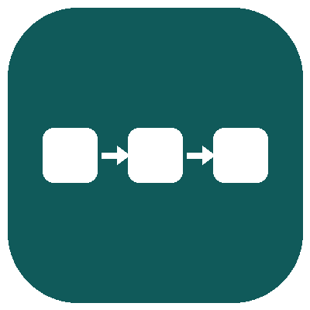 1. System Architecture
This section presents the overall structure of the project — the flow of data between the CLI, the processing modules, and the MySQL database — through a single consolidated diagram.
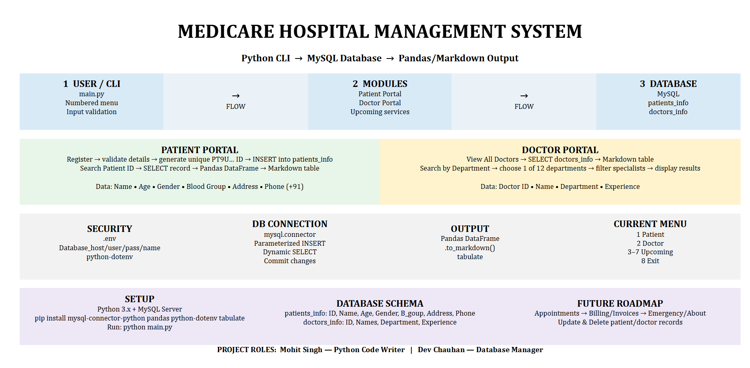
Fig 1: System architecture — data flow from the CLI through the processing modules to the MySQL database.
 2. Modules & Packages Used
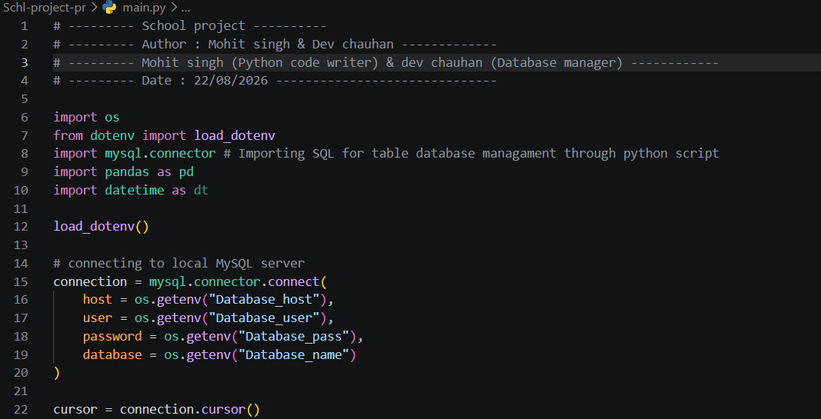
Fig 2: Code — importing the modules required by the program.
- os — used to securely read the database host, username, password, and name from the .env file.
- load_dotenv (from dotenv) — loads the environment variables defined in the .env file into the Python program.
- mysql.connector — connects the Python program to the MySQL database and executes SQL queries.
- pandas — structures query results into DataFrames and renders them as clean, readable tables.

 3. Main Menu — Code & Output
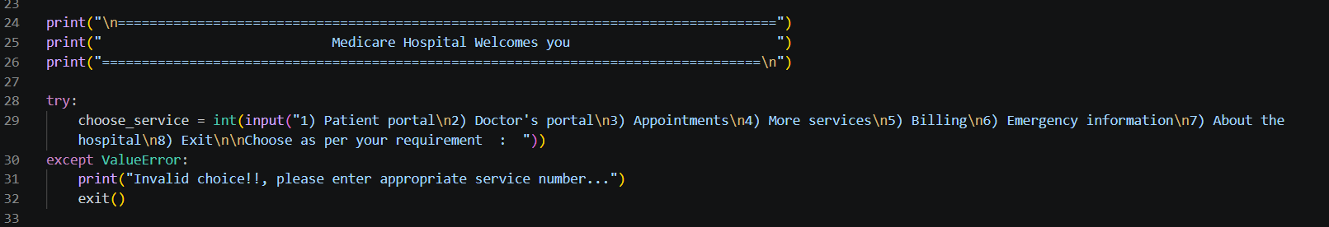
Fig 3: Code — displaying the main menu.
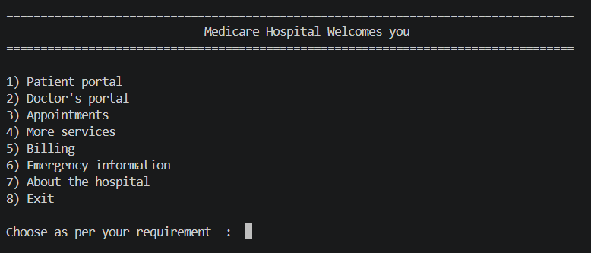
Fig 4: Output — main menu as seen by the user.
The main menu offers the following services:
- Patient Portal
- Doctor Portal
- Appointments
- More Services — Departments & Laboratory Tests
- Billing
- Emergency Information
- About the Hospital
- Exit
 4. Patient Portal Module
4.1 Registering a Patient
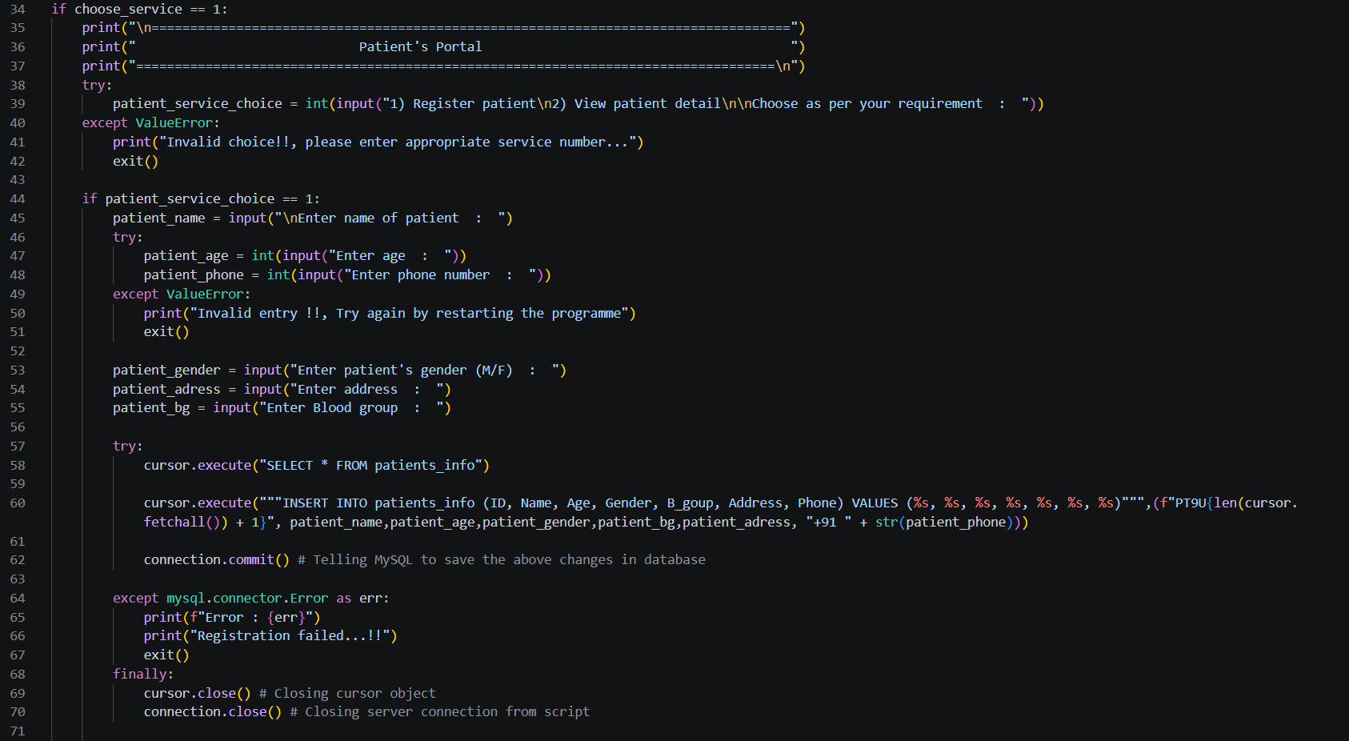
Fig 5: Code — registering a new patient.
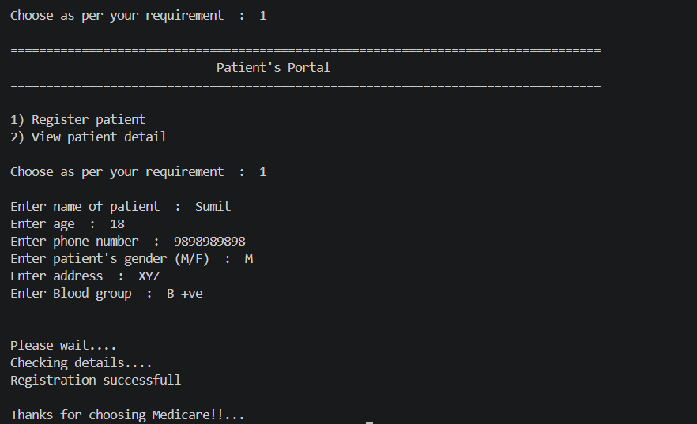
Fig 6: Output — patient registered successfully.
4.2 Database Table — Before & After Registration
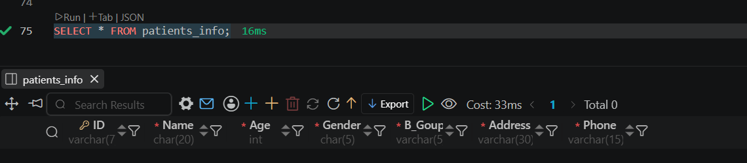
Fig 7: Database table before registration (empty).
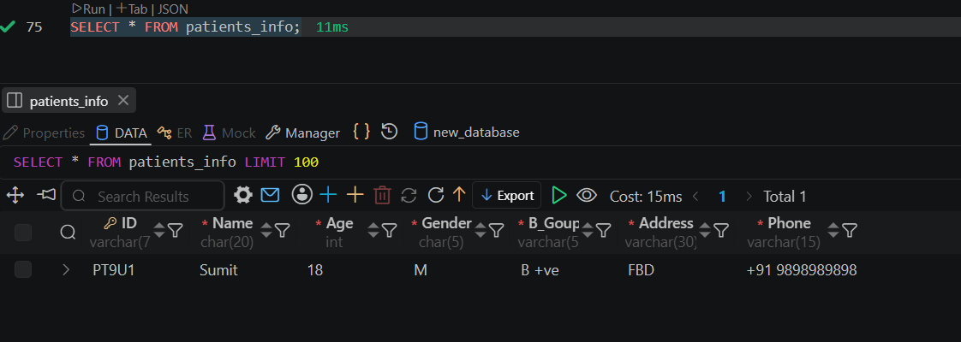
Fig 8: Database table after registration via the program.
4.3 Fetching Patient Details by ID
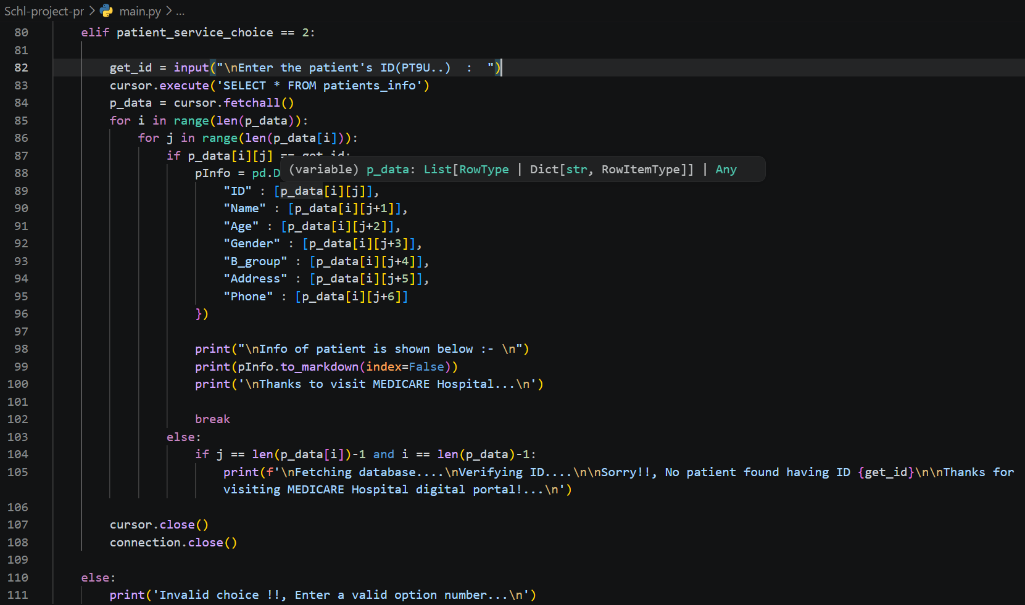
Fig 9: Code — fetching patient details using the patient ID.
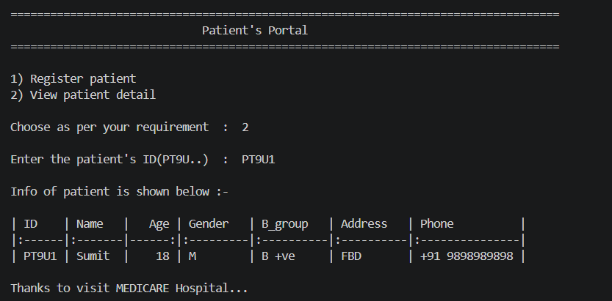
Fig 10: Output — patient details retrieved.

 5. Doctor's Portal Module
5.1 Viewing All Doctors
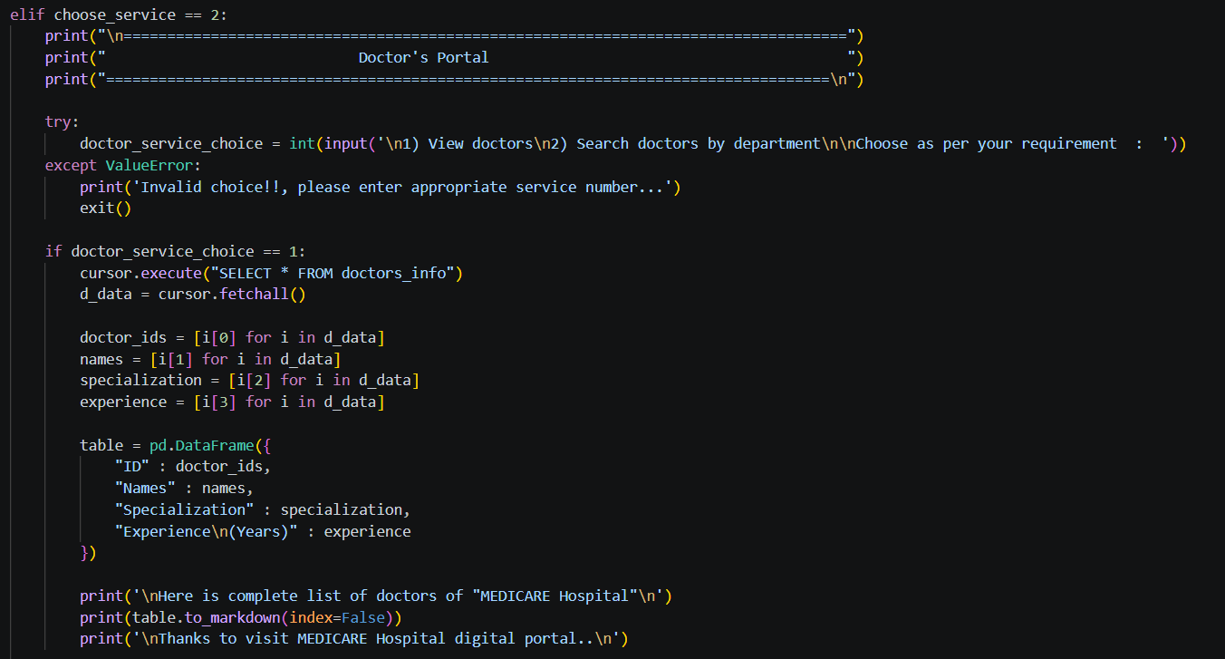
Fig 11: Code — viewing and searching doctors.
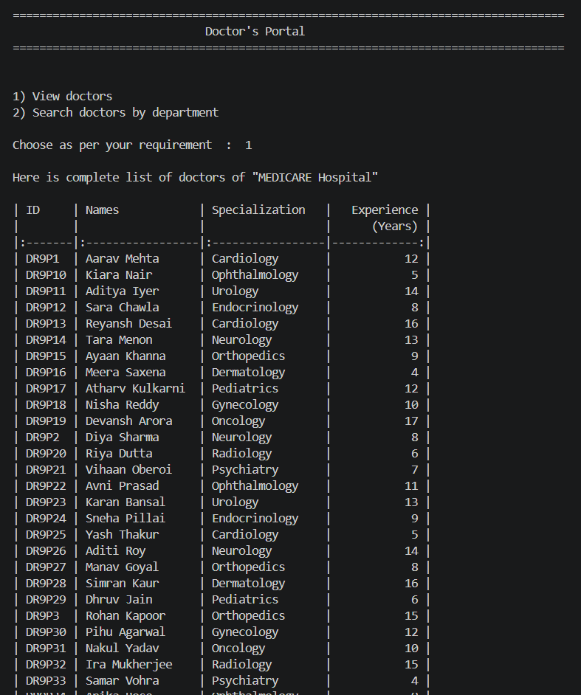
Fig 12: Output — complete list of doctors registered with the hospital.
5.2 Doctors Directory (Database Table)
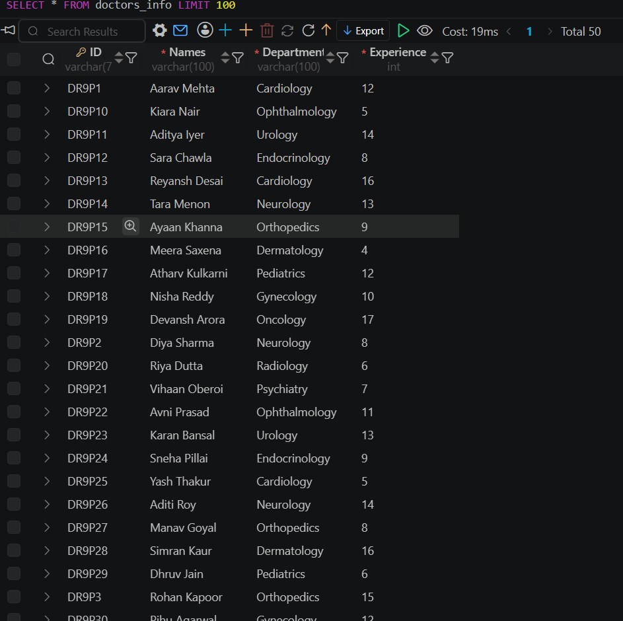
Fig 13: Database table — doctors_info, storing every doctor's specialization and experience.
5.3 Searching Doctors by Department
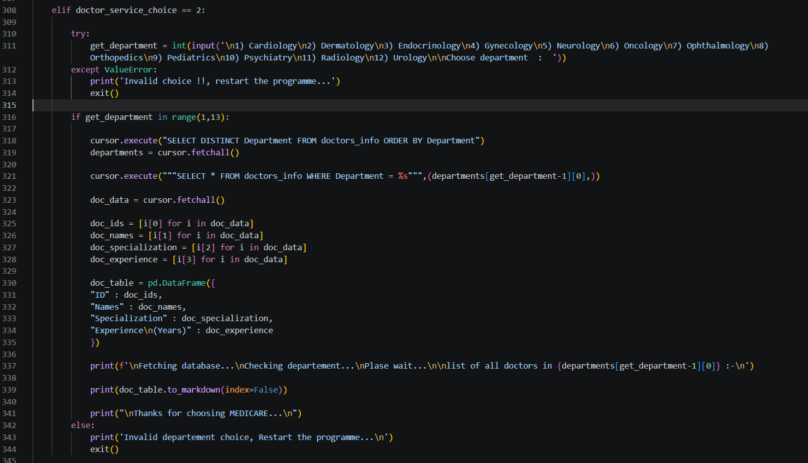
Fig 14: Code — fetching doctors filtered by department.
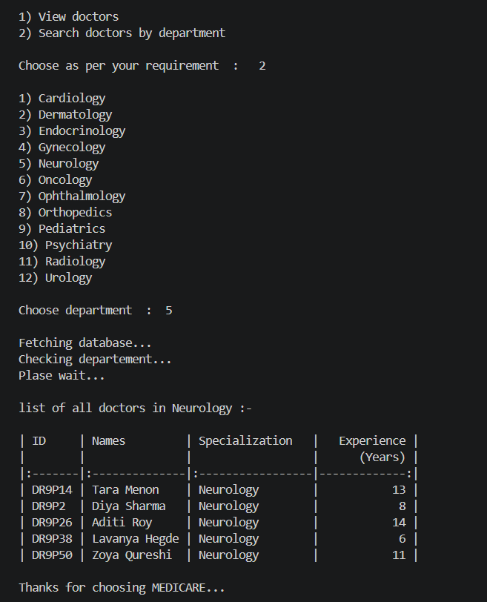
Fig 15: Output — doctors list filtered by department (Neurology).

 6. Appointments Module
The Appointments module lets a patient book a new appointment, view an existing one, or cancel it — while preventing a single patient from holding two active appointments at once.
6.1 Booking an Appointment
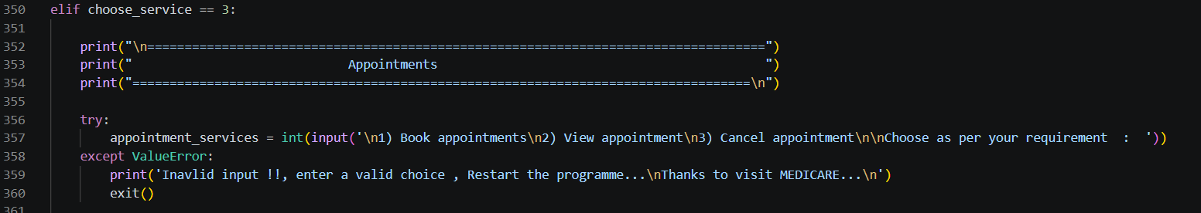
Fig 16: Code — the Appointments menu.
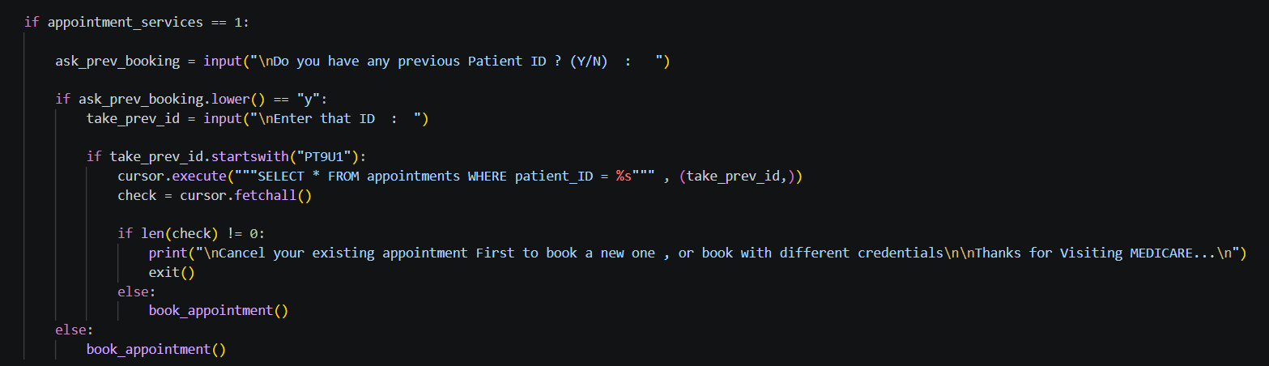
Fig 17: Code — checking for an existing appointment before allowing a new booking.
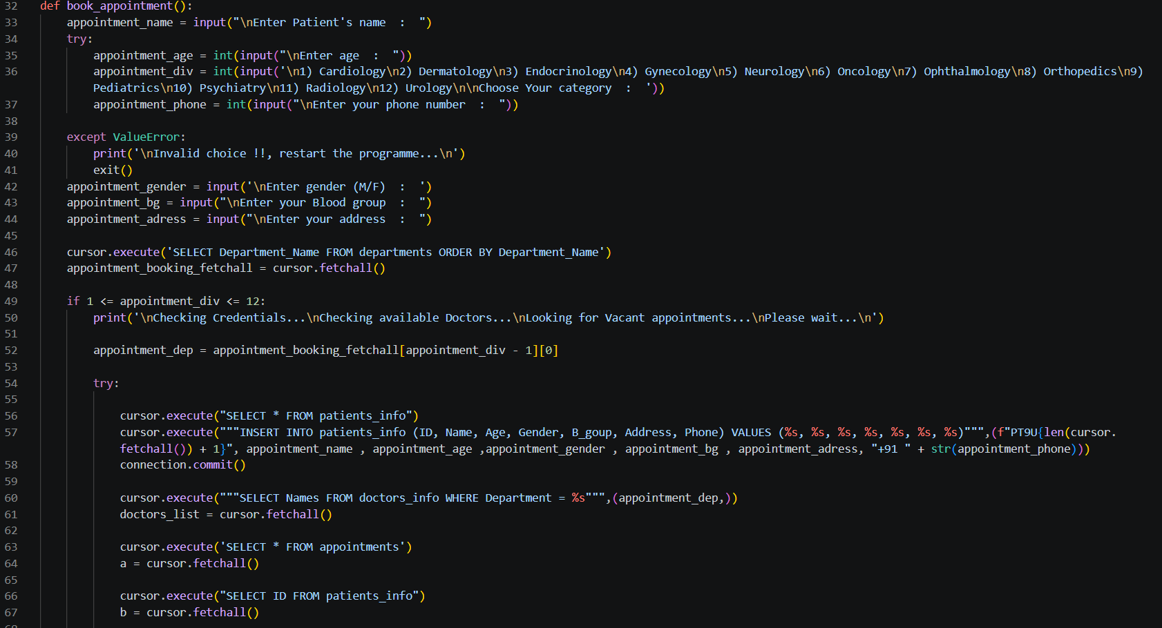
Fig 18: Code — department selection and appointment booking logic.
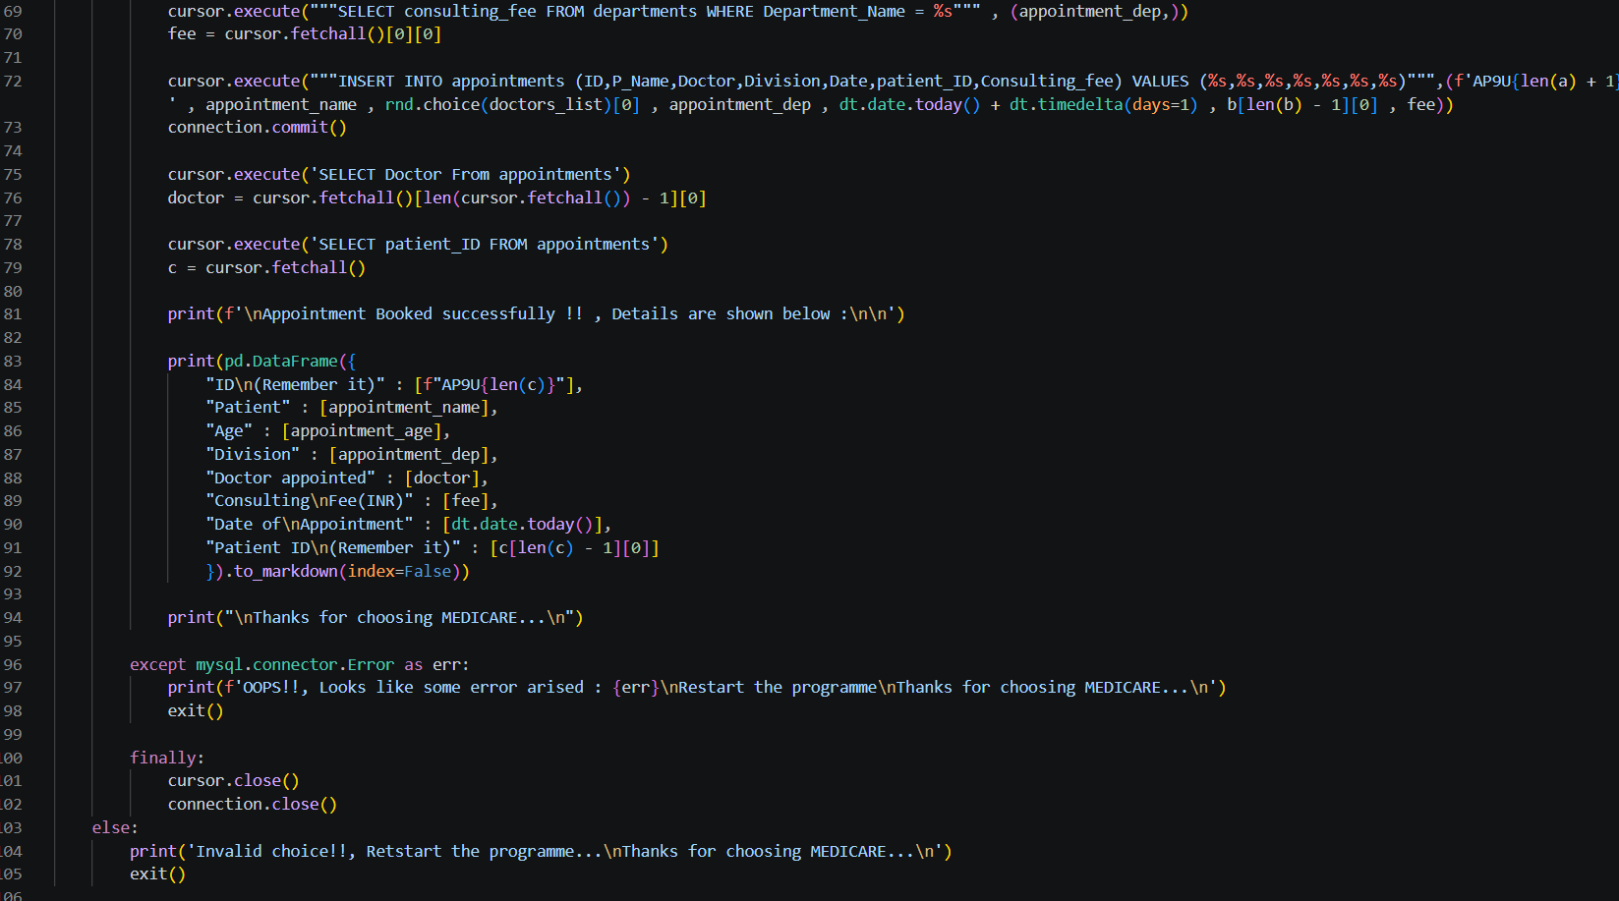
Fig 19: Code — inserting the new appointment record and committing it to the database.
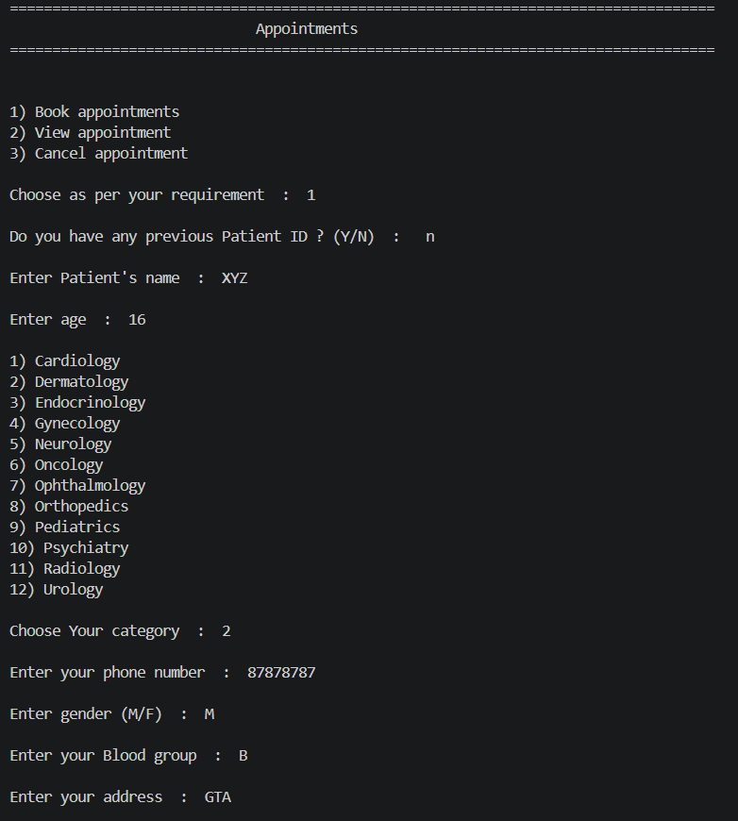
Fig 20: Output — booking an appointment end-to-end (patient details, department, doctor).
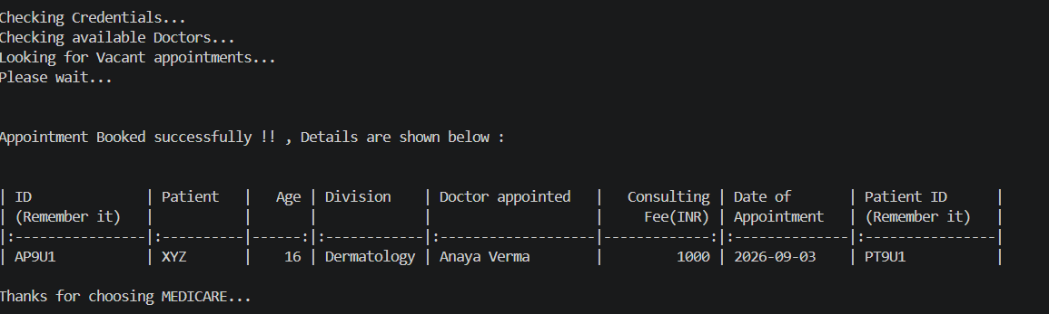
Fig 21: Output — booking confirmation with full appointment details.
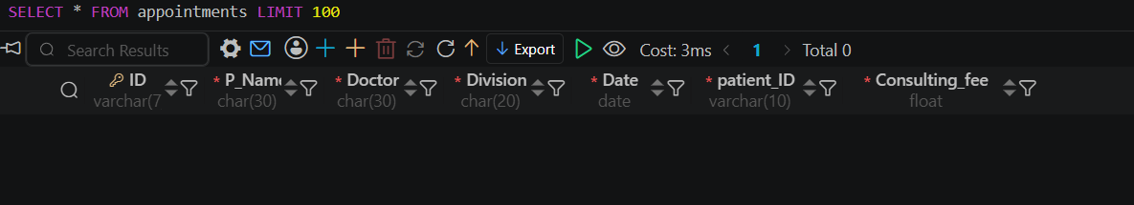
Fig 22: Database table — appointments, before booking (empty).
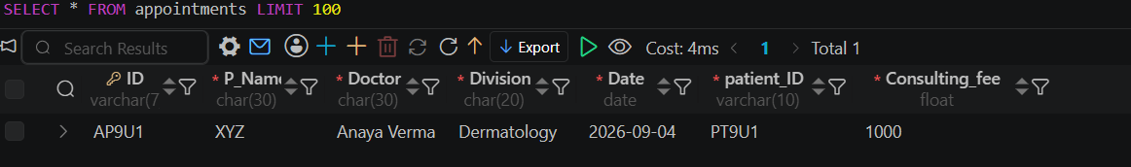
Fig 23: Database table — appointments, after a successful booking.
6.2 Viewing an Appointment
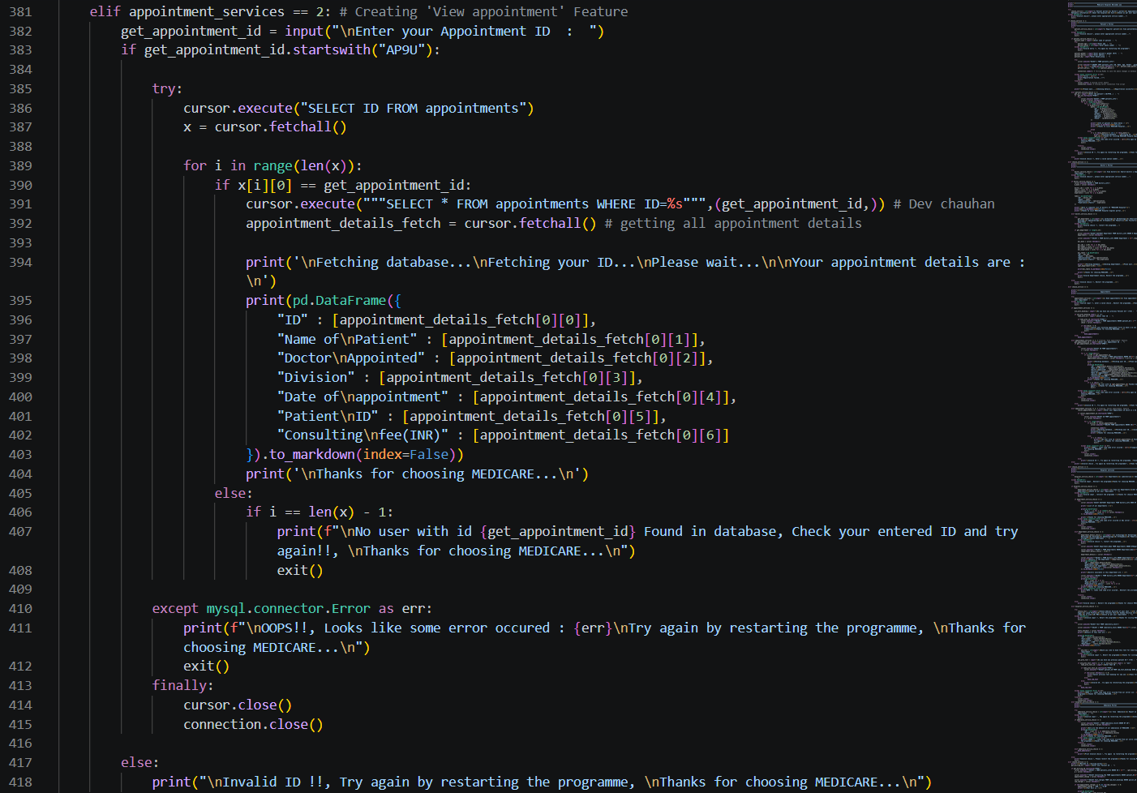
Fig 24: Code — retrieving appointment details by appointment ID.
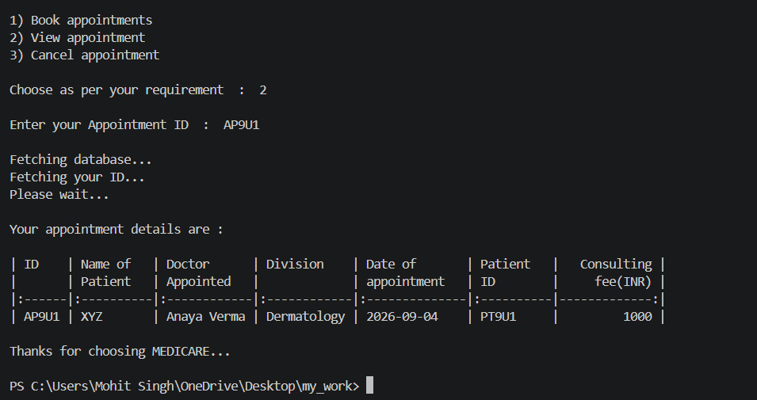
Fig 25: Output — appointment details fetched from the database.
6.3 Cancelling an Appointment
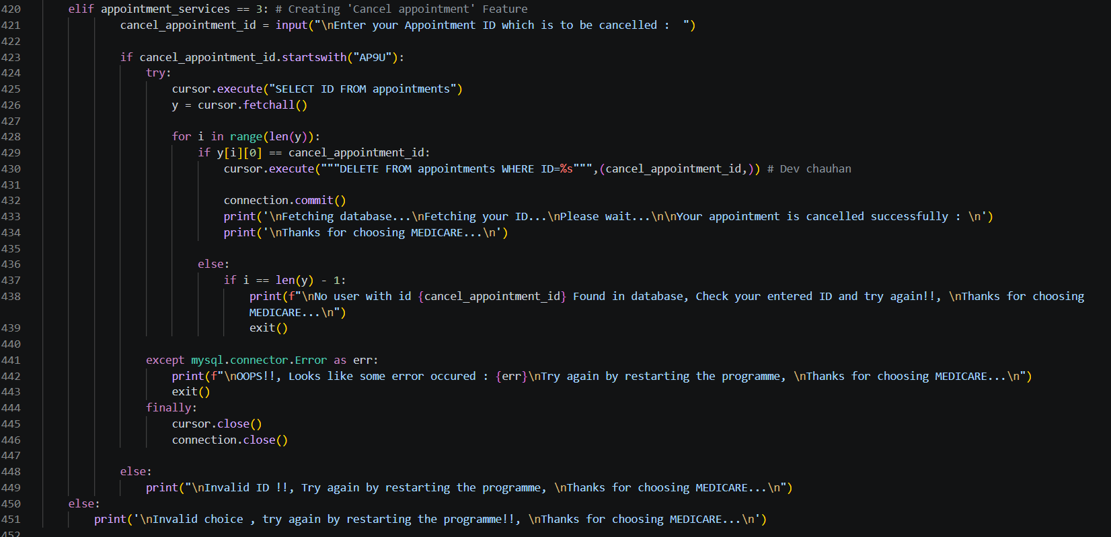
Fig 26: Code — cancelling an appointment by ID.
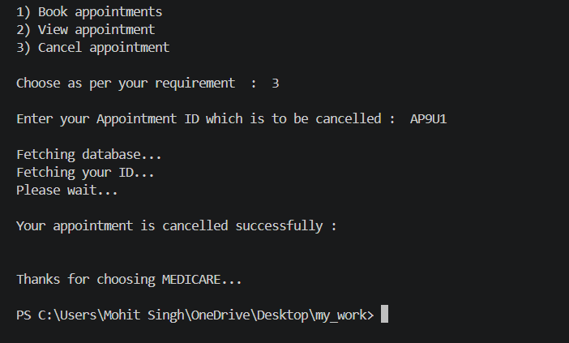
Fig 27: Output — appointment cancelled successfully.
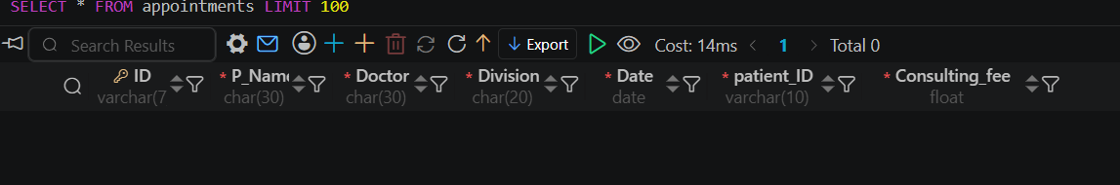
Fig 28: Database table — appointments, after cancellation (record removed).

 7. More Hospital Services — Departments
Beyond appointments, the hospital services menu lets a patient browse every department the hospital offers, and drill into a specific department for more detail.
7.1 Viewing All Departments
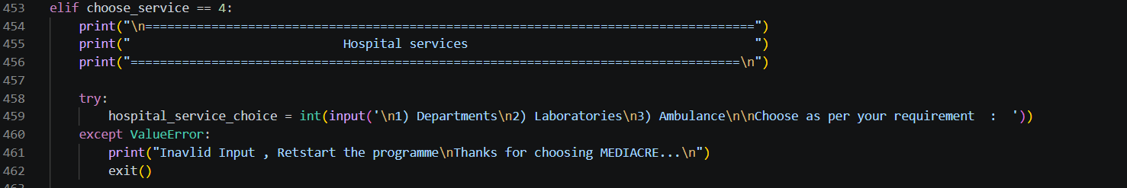
Fig 29: Code — the hospital services menu.
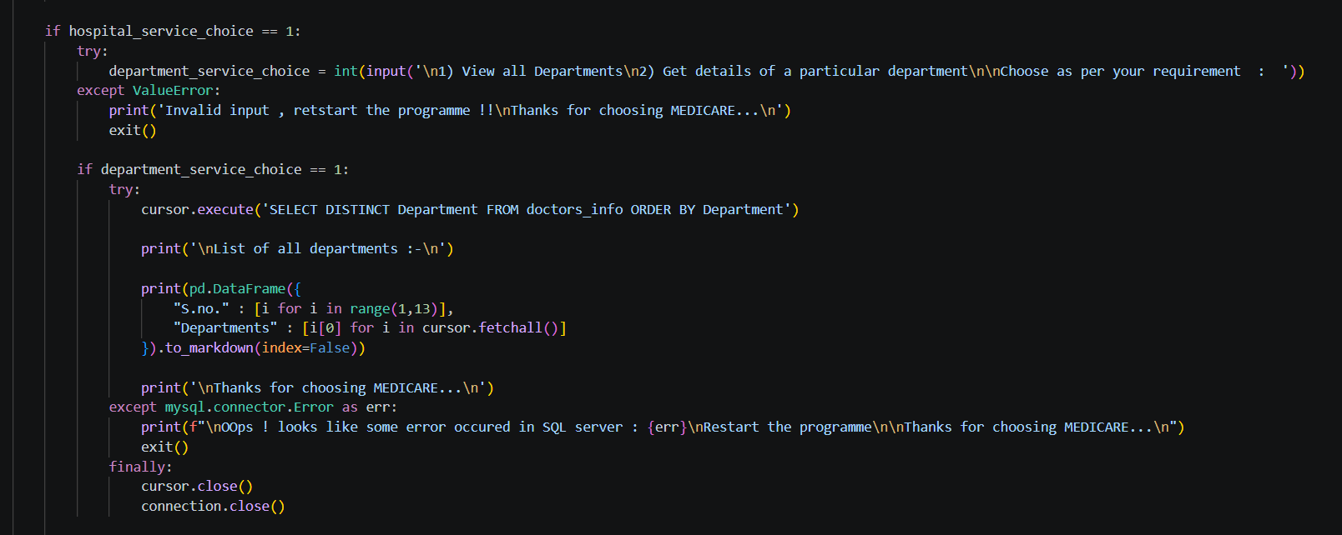
Fig 30: Code — fetching the full list of departments.
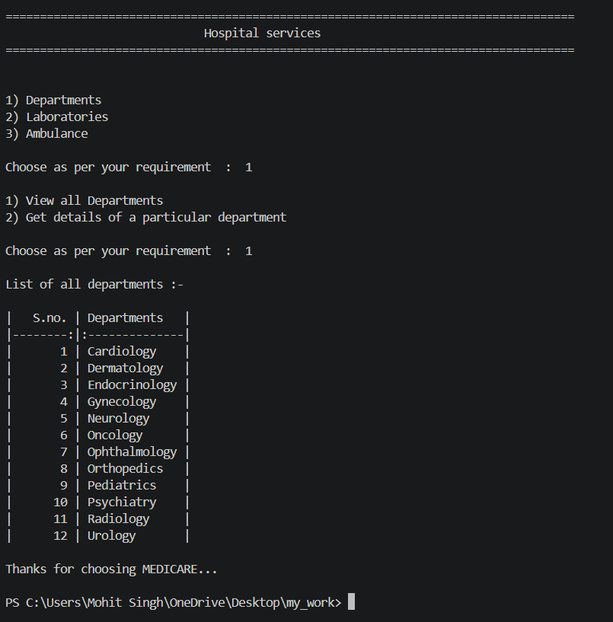
Fig 31: Output — list of all departments at Medicare Hospital.
7.2 Department Detail Lookup
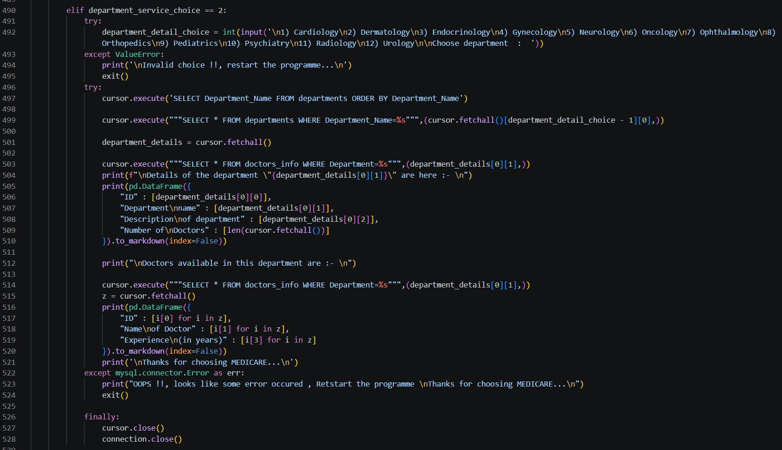
Fig 32: Code — fetching detail and doctor list for a chosen department.
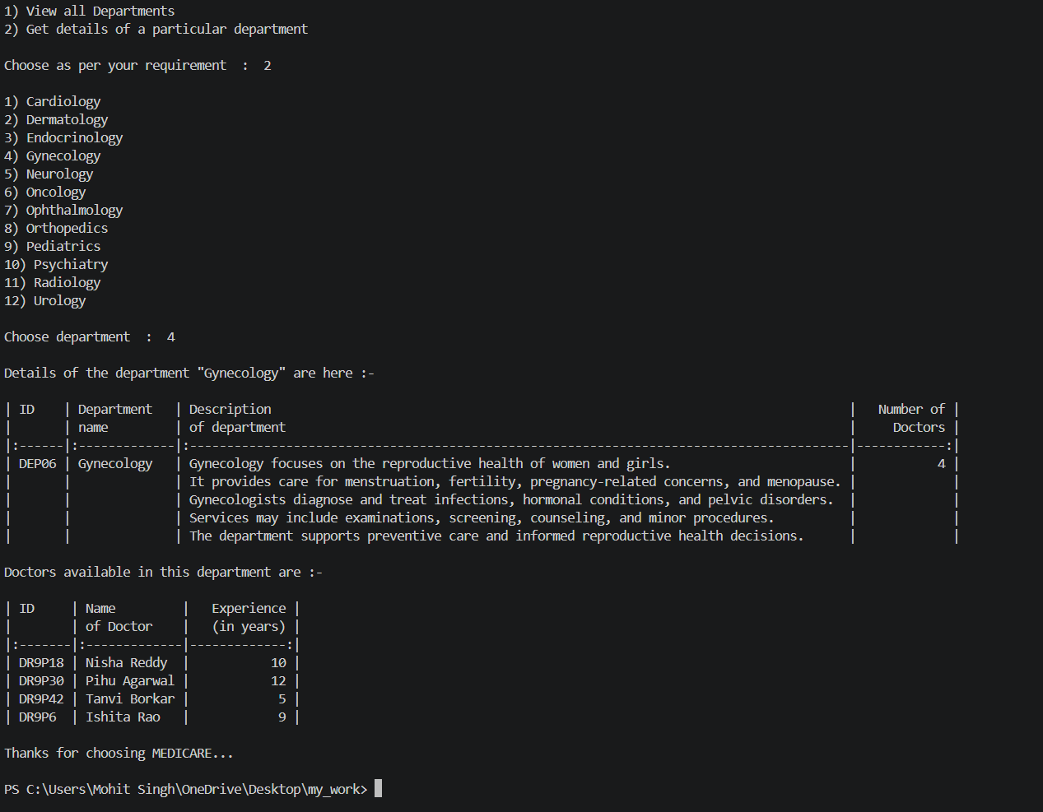
Fig 33: Output — department detail for Gynecology, including its doctors.

 8. Laboratory Test Booking
Patients can look up a lab test by medical division, check its charges, and book it for the next day — with the same double-booking safeguard used for appointments.
8.1 Looking Up a Test
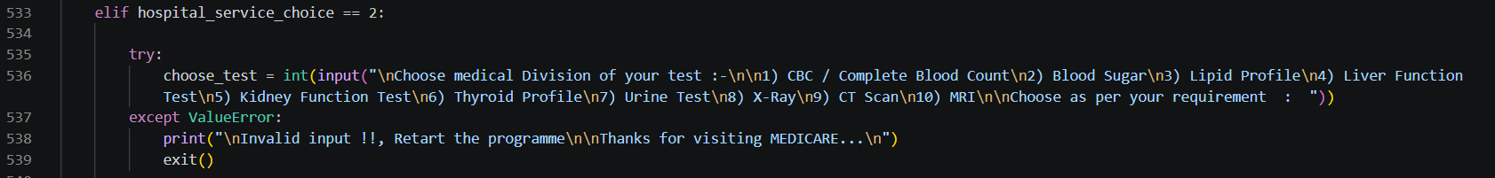
Fig 34: Code — the laboratory test division menu.
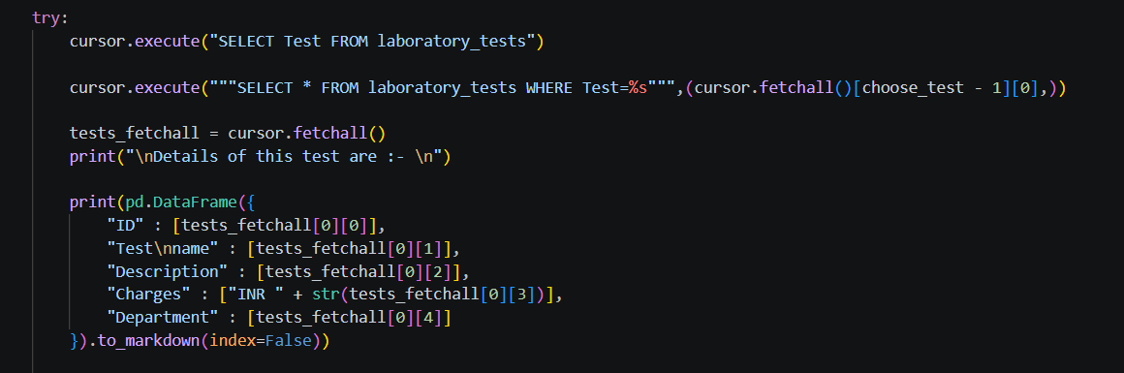
Fig 35: Code — fetching test details for the chosen division.
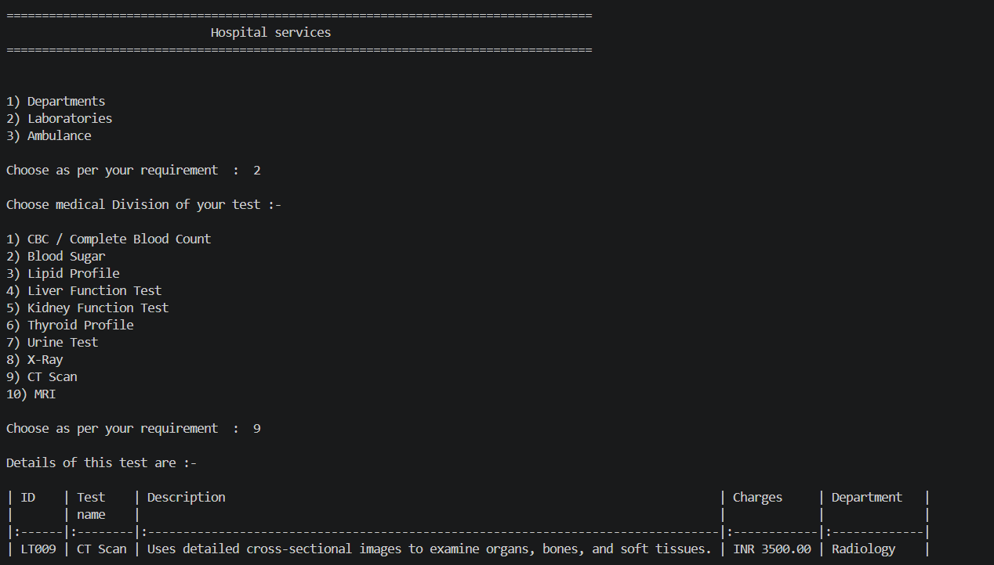
Fig 36: Output — test details for a CT scan under Radiology.
8.2 Booking a Test
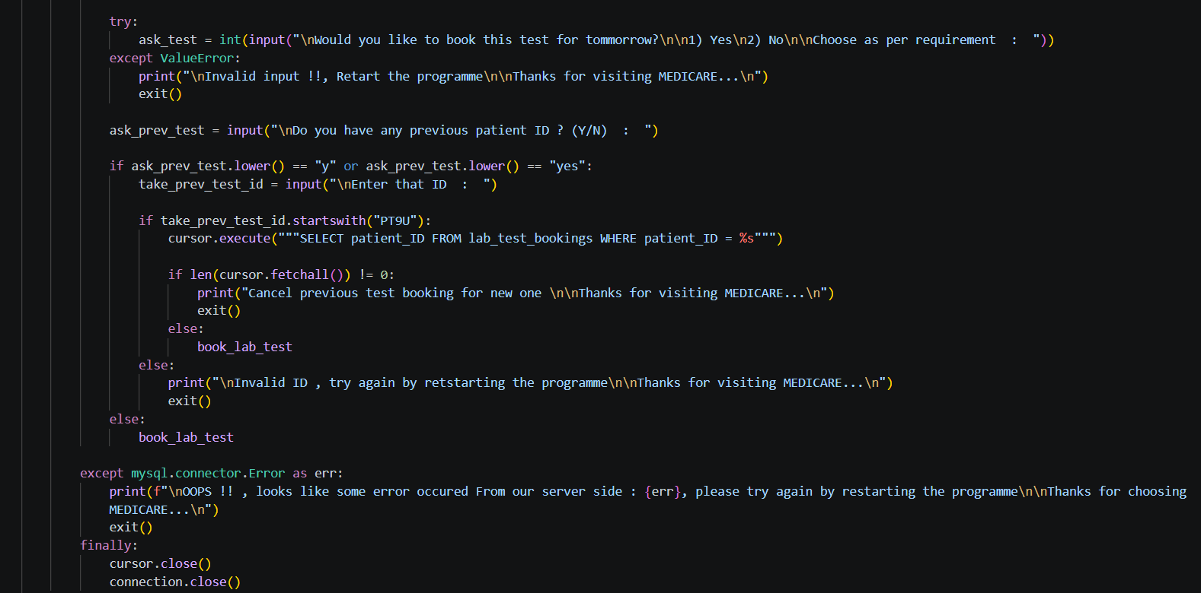
Fig 37: Code — checking for a previous booking before confirming a new one.
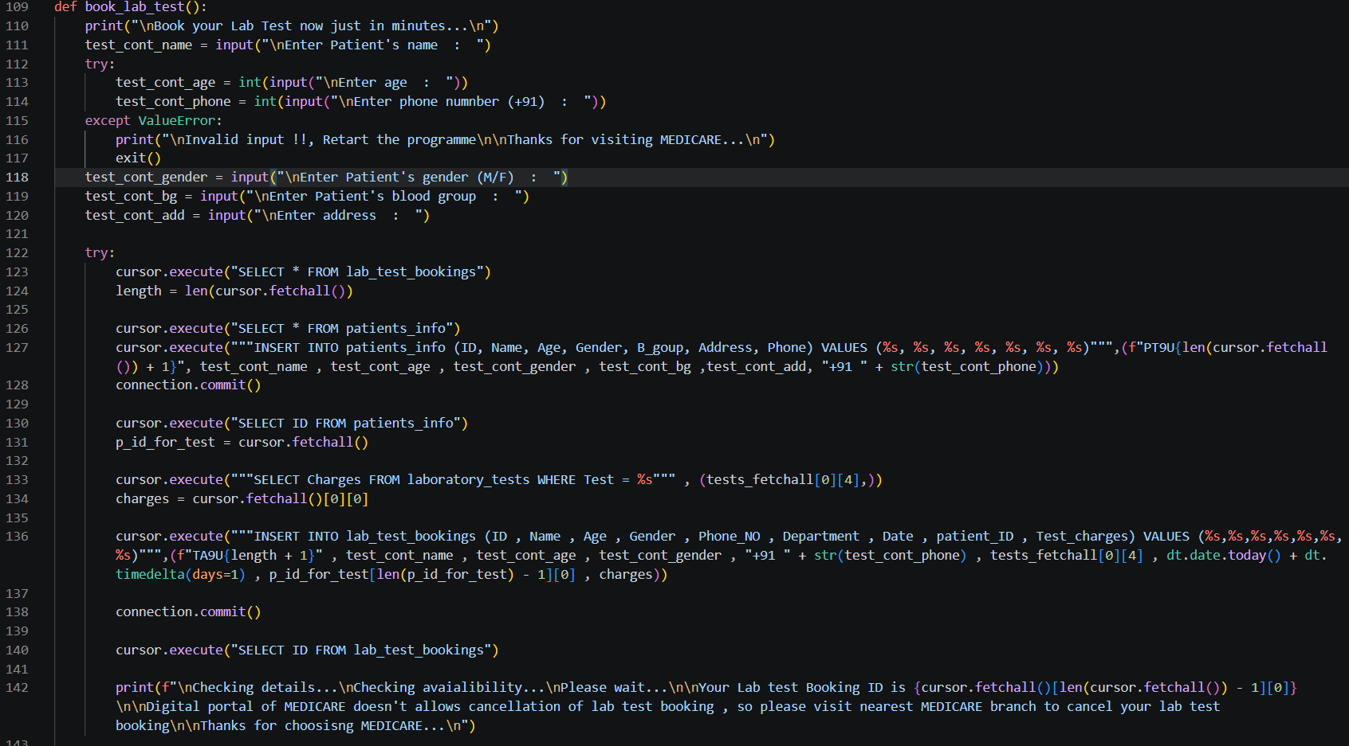
Fig 38: Code — book_lab_test() function, recording the booking in the database.
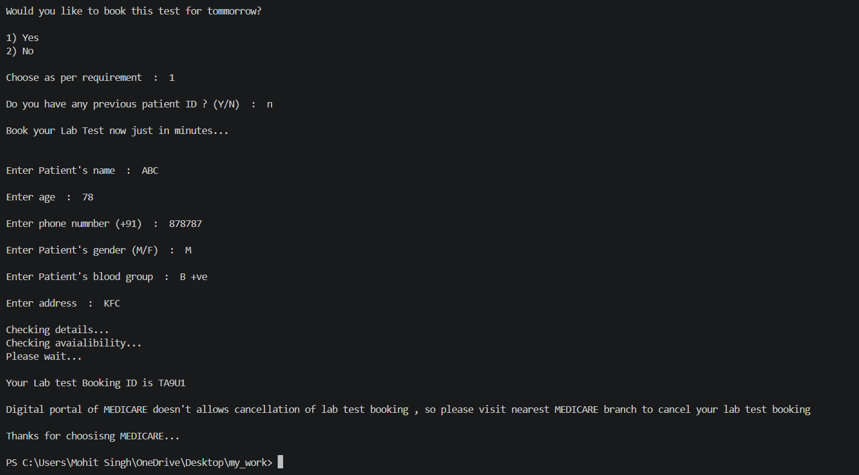
Fig 39: Output — booking a laboratory test end-to-end.
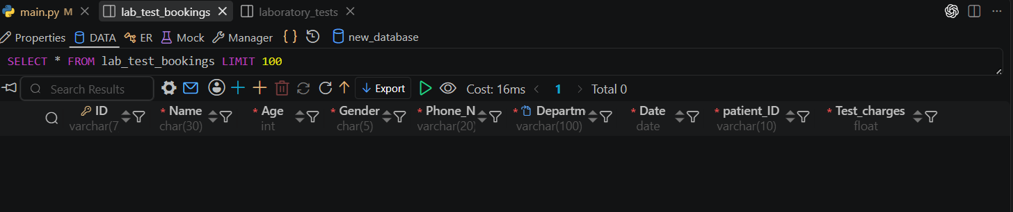
Fig 40: Database table — lab_test_bookings, before the new booking.
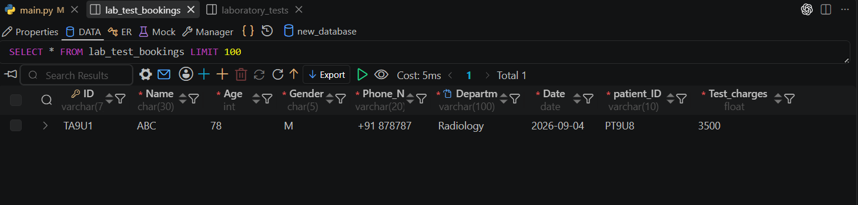
Fig 41: Database table — lab_test_bookings, after the new booking.

 9. Ambulance Services
The ambulance module shows the live status of every ambulance in the fleet, and can assign an available ambulance to a patient on request.
9.1 Viewing Ambulance Status
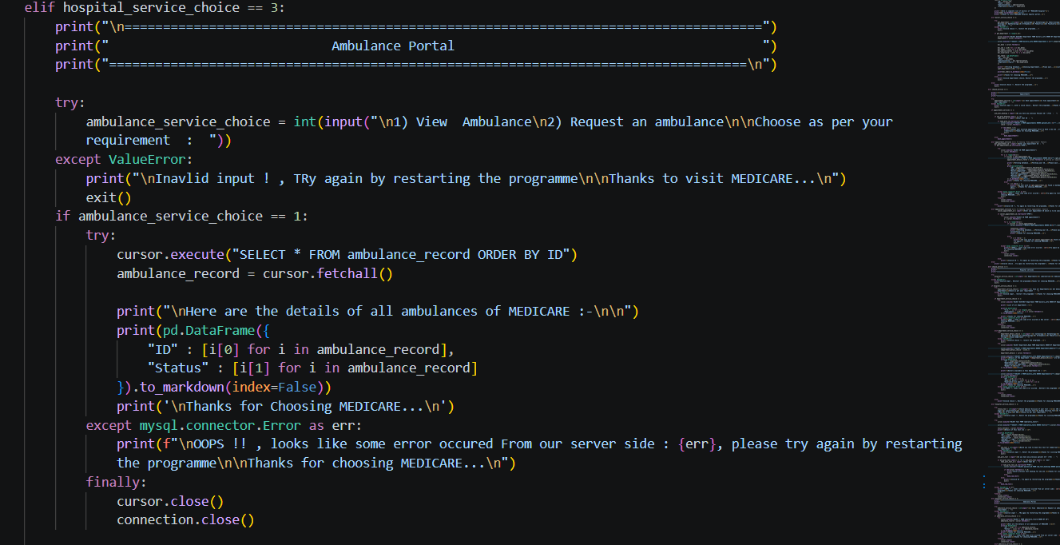
Fig 42: Code — the ambulance portal menu and status lookup.
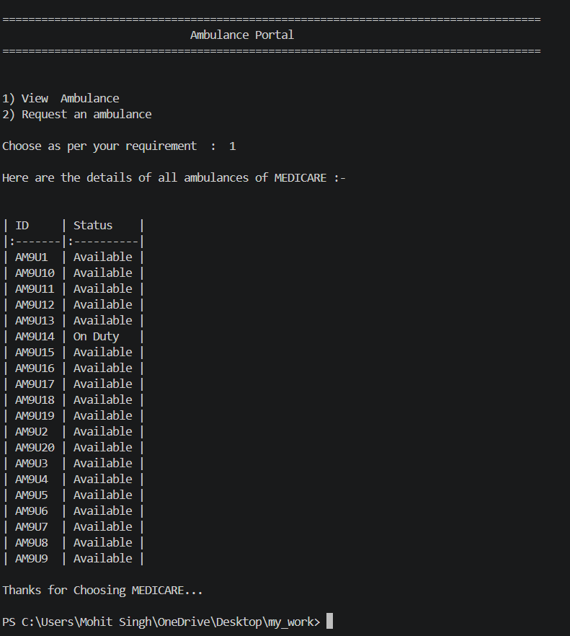
Fig 43: Output — live status of every ambulance (Available / On Duty).
9.2 Booking an Ambulance
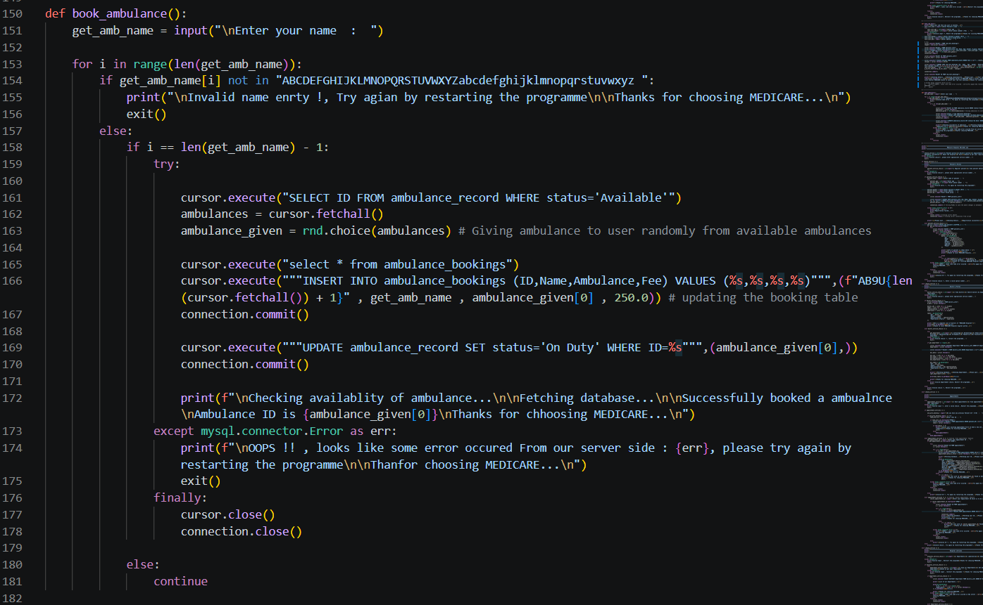
Fig 44: Code — book_ambulance() function, randomly assigning an available ambulance and updating its status.
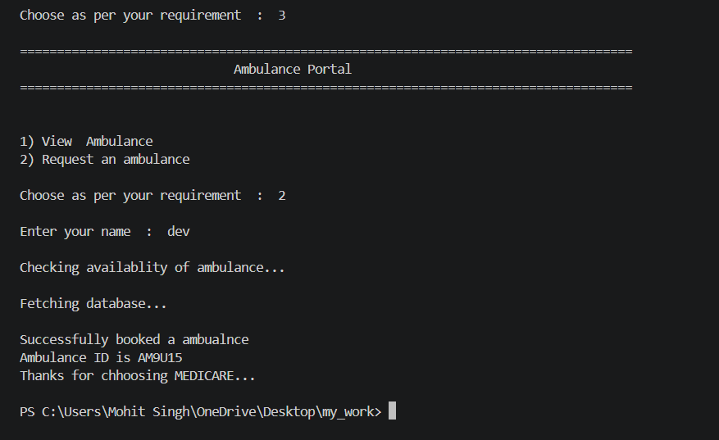
Fig 45: Output — booking an ambulance end-to-end.
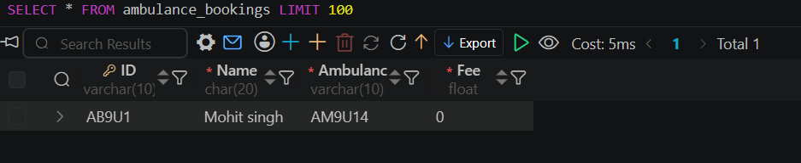
Fig 46: Database table — ambulance_bookings, record created for the new booking.
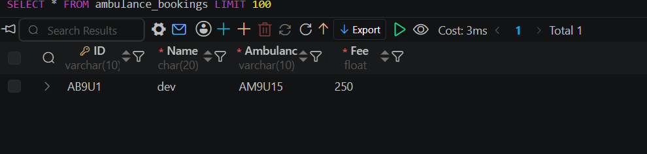
Fig 47: Database table — ambulance_bookings, updated with the final fee once confirmed.

Fig 48: The assigned ambulance is marked "On Duty" in the ambulance status table.

 10. Billing Portal
The billing portal totals a patient's consulting fee and lab test charges from the appointments and lab_test_bookings tables and presents a single consolidated bill.
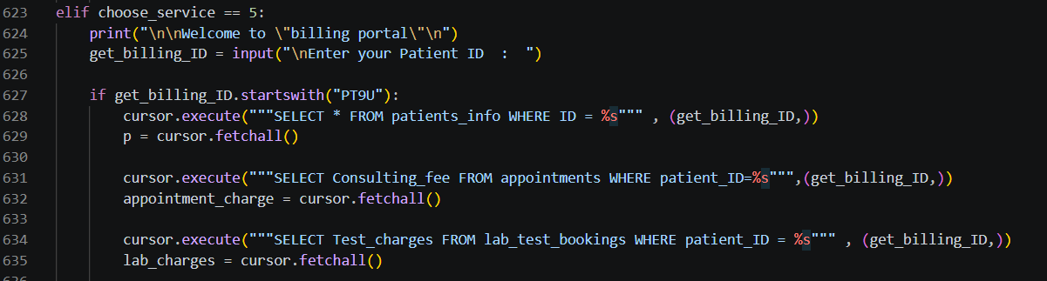
Fig 49: Code — starting the billing lookup for a given patient ID.
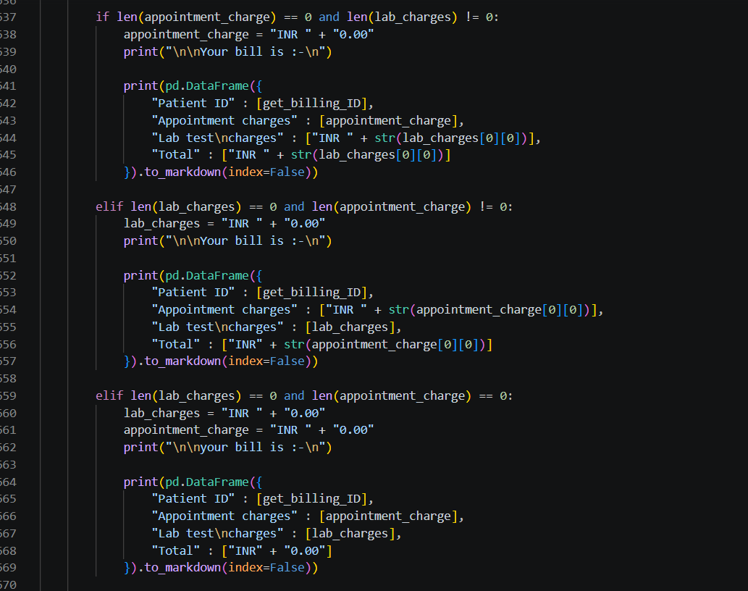
Fig 50: Code — computing the bill from appointment and lab charges.
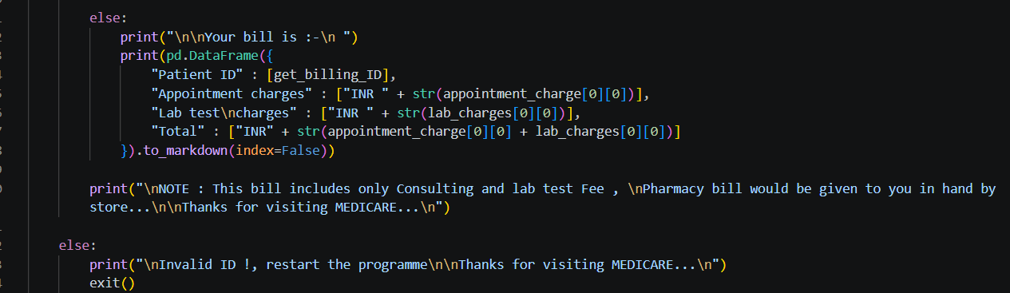
Fig 51: Code — presenting the final bill as a table, with a note on what it includes.
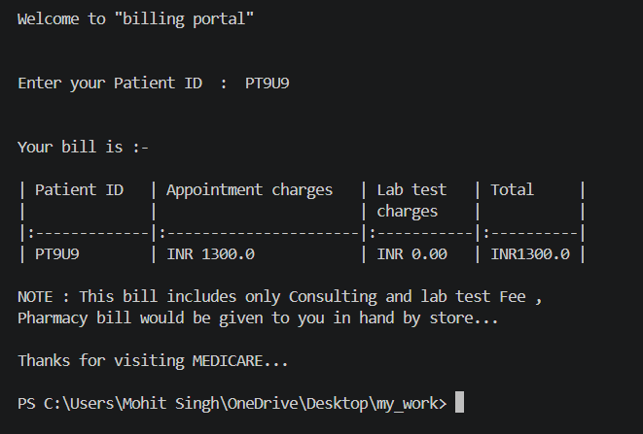
Fig 52: Output — a patient's consolidated bill from the billing portal.

 11. Emergency Information
This section gives patients instant access to emergency contact numbers and current service availability, with the option to request an ambulance immediately.
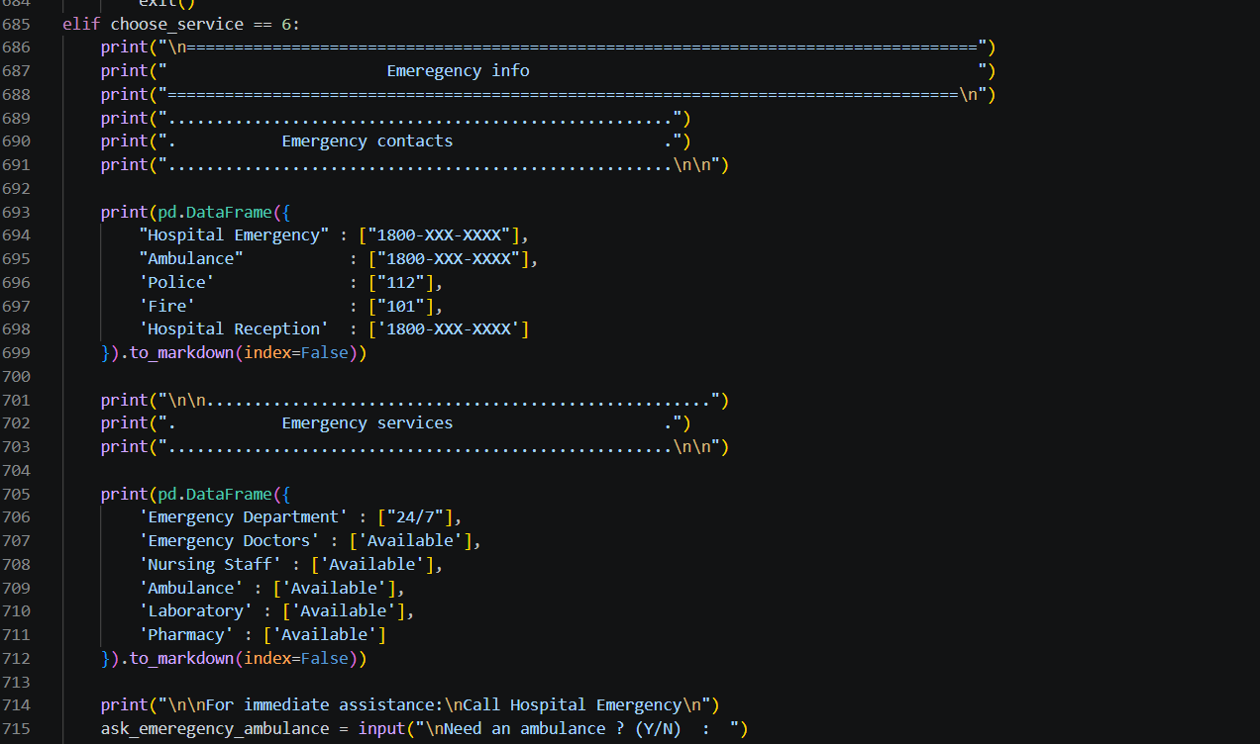
Fig 53: Code — building the emergency contacts and services tables.
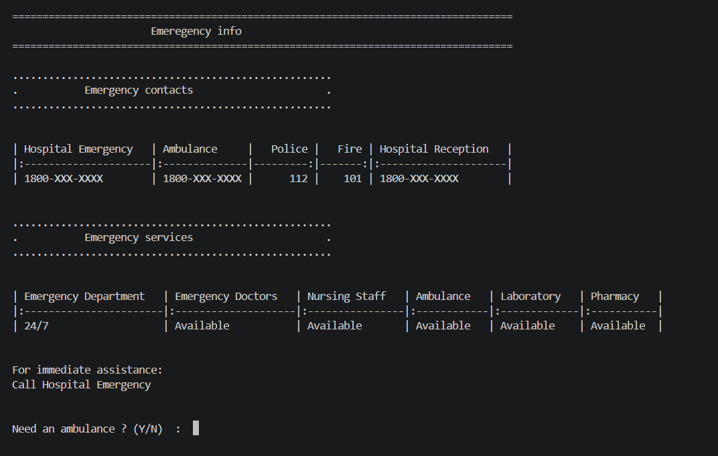
Fig 54: Output — emergency contacts and live service availability.
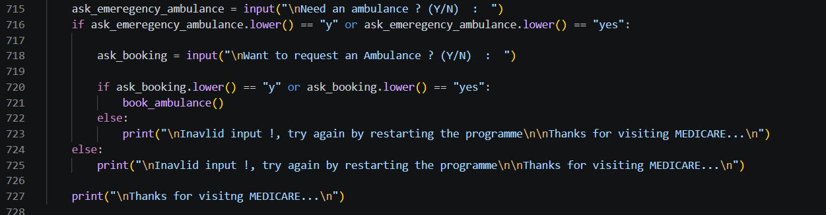
Fig 55: Code — offering an immediate ambulance request from the emergency screen.

 12. About the Hospital
The final menu option presents a formatted profile of Medicare Hospital — its overview, departments, mission, facilities, and contact details — rendered directly in the terminal from a Markdown string.
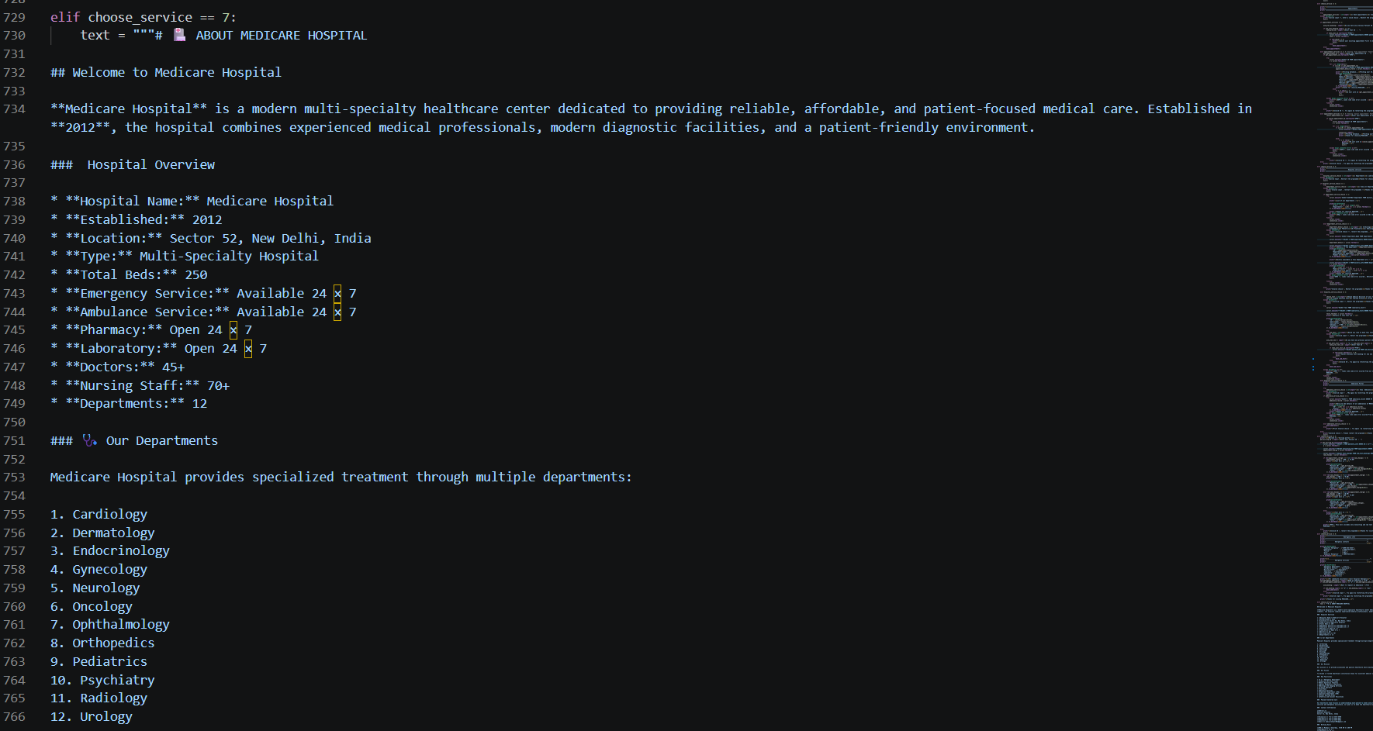
Fig 56: Code — the hospital's profile, written as Markdown and rendered to the terminal.
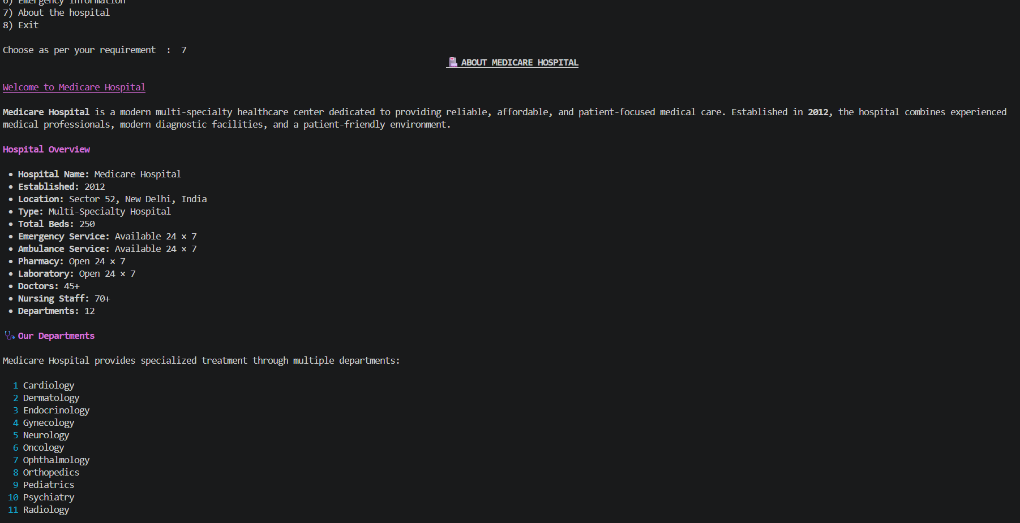
Fig 57: Output — hospital overview and department list.
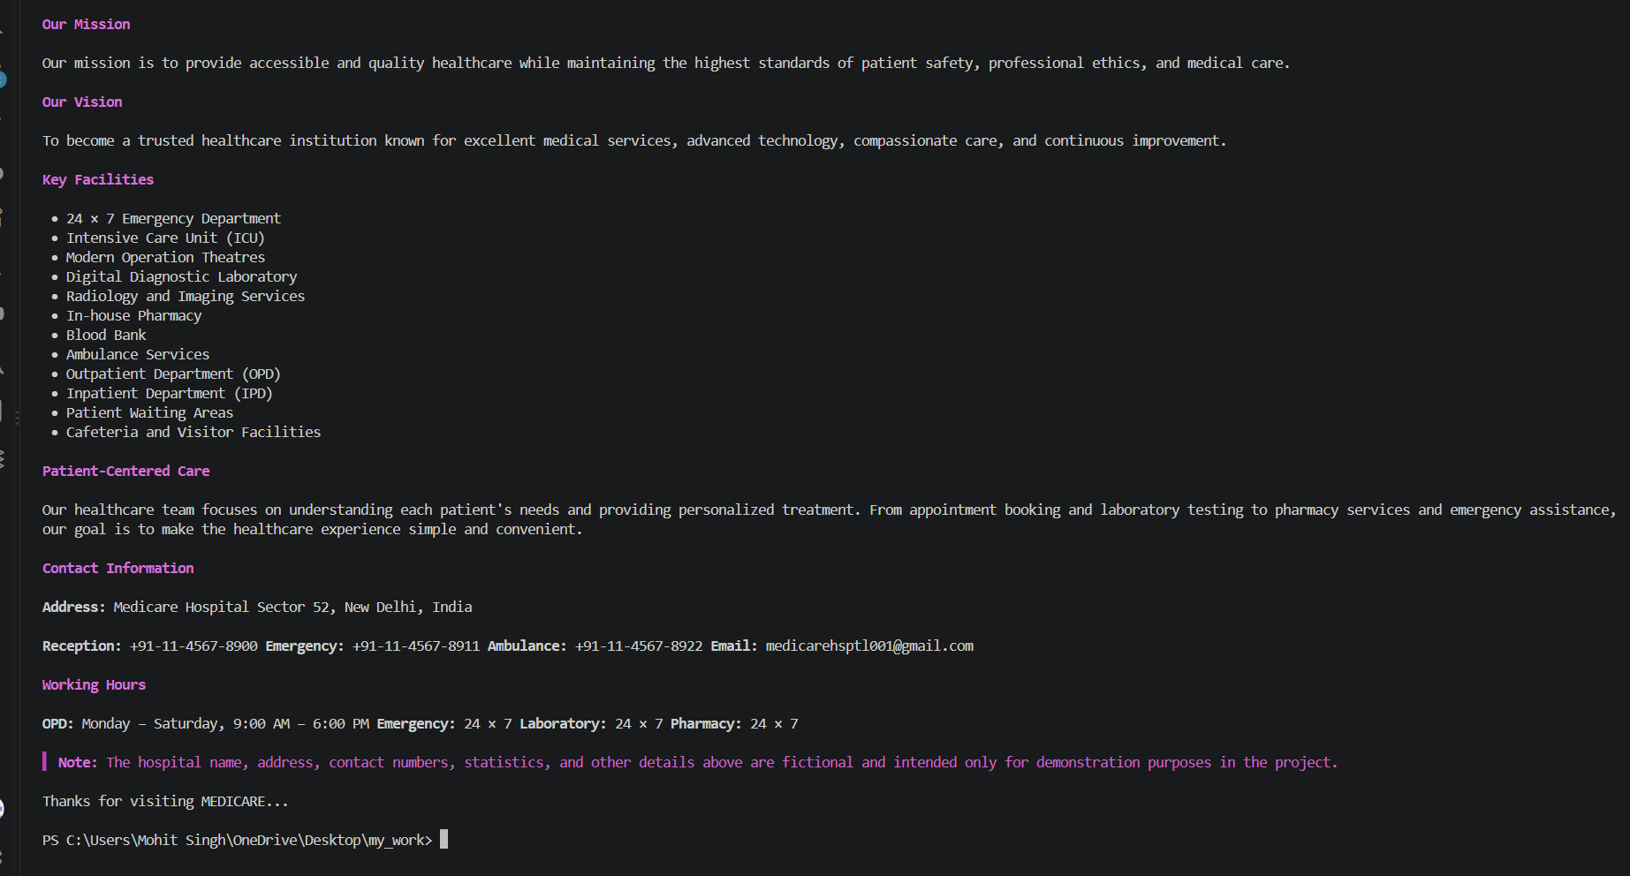
Fig 58: Output — mission, vision, key facilities, and contact information.

 13. Project Roles
Name | Role
Mohit Singh | Python Code Writer
Dev Chauhan | Database Manager
Together, Mohit Singh and Dev Chauhan designed and built the Medicare Hospital Management System as their Class XII Informatics Practices project.

