Balaji Public School
IP Project
Academic session 2026-27
Terminal based Hospital management system
Mohit Singh & Dev Chauhan

Balaji Public School

Project work

Subject – IP

Submitted by – Mohit Singh and Dev Chauahan

Class - XII A

Academic session 2026-27

Teacher – Mrs. Uma Sagar

Topic – Terminal based Hospital management system
(Using Python and SQL)

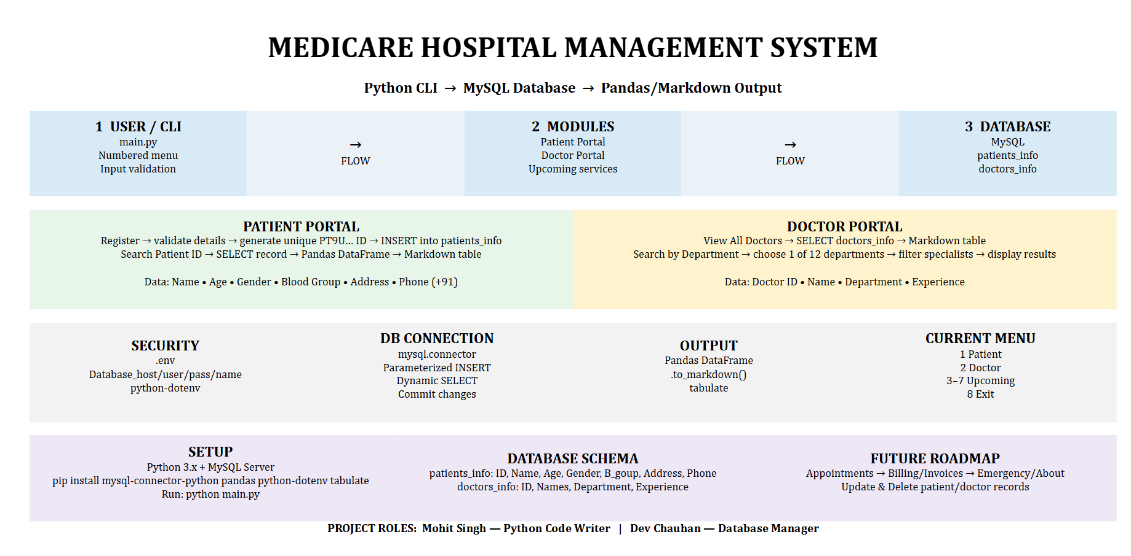
fig 1.1

- Structure of project
- Flow of elements and processing
- Visual flow diagram of complete project

Modules and packages used
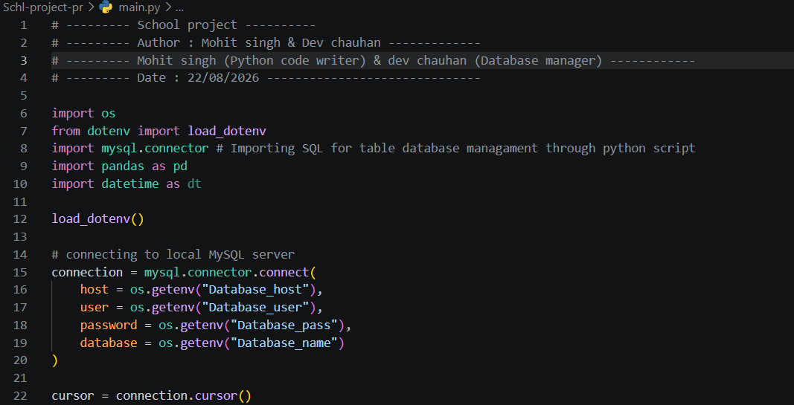

Fig 1.2

- ‘os’ for getting password and host name from .env file

- ‘load_dotenv’ from ‘dotenv’ for getting .env variables in python file

- ‘mysql.connector’ for connecting MySQL databse with python fille

- ‘pandas’ for creating tables using DataFrames

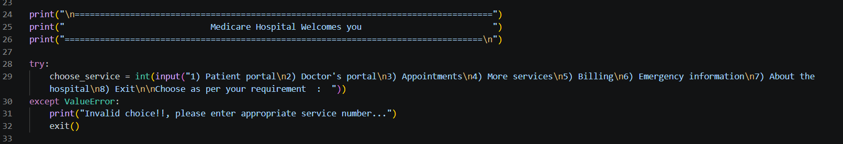
Output
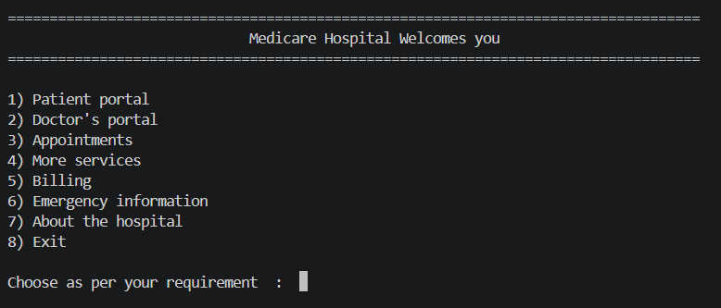

Fig 1.3

- Patient portal
- Doctor portal
- Appointments (upcoming)
- More services (upcoming)
- Billing (upcoming)
- Emergency info (upcoming)
- About hospital (upcoming)
- Exit (upcoming)

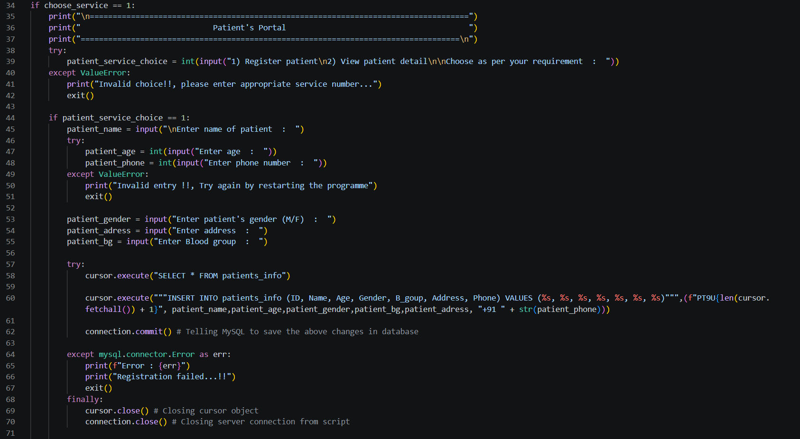
Patient’s Portal – Registering patient

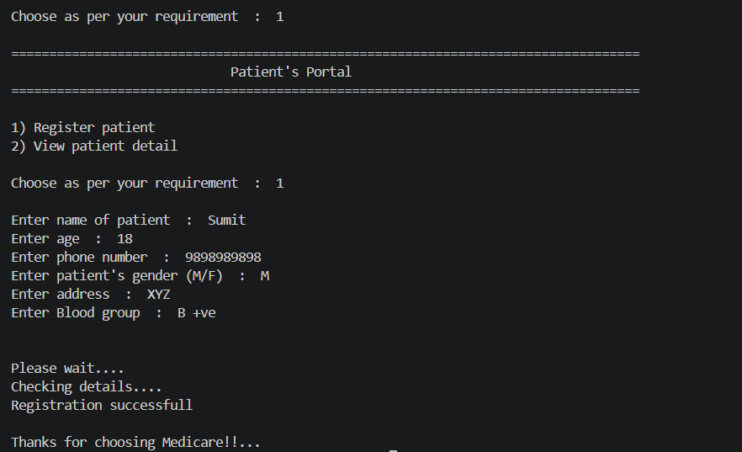
Output

Empty Table of patients Registered

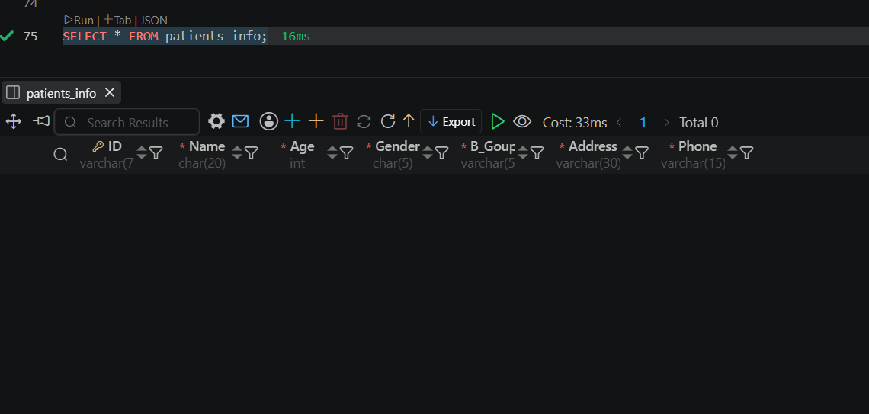

Fig 1.6

Table after Registration of patient through Program

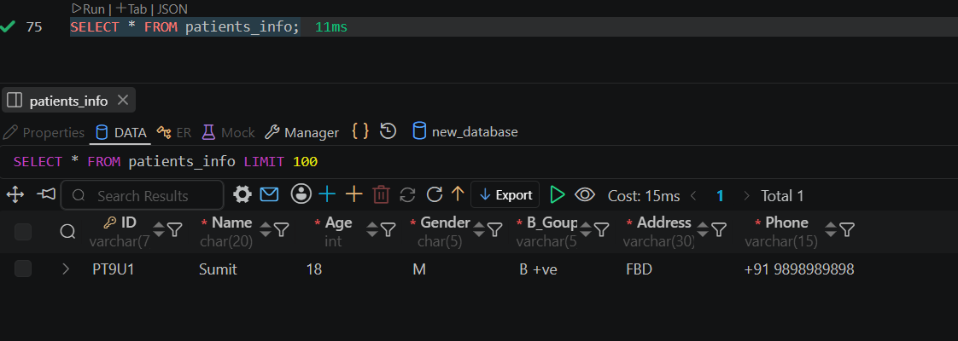

Insertion of data in table using SQL query Through Python script by cursor.execute("""INSERT INTO patients_info (ID, Name, Age, Gender, B_goup, Address, Phone) VALUES (%s, %s, %s, %s, %s, %s, %s)""",(f"PT9U{len(cursor.fetchall()) + 1}", patient_name,patient_age,patient_gender,patient_bg,patient_adress, "+91 " + str(patient_phone)))

1.2) Getting Patient detail through patient ID from the table
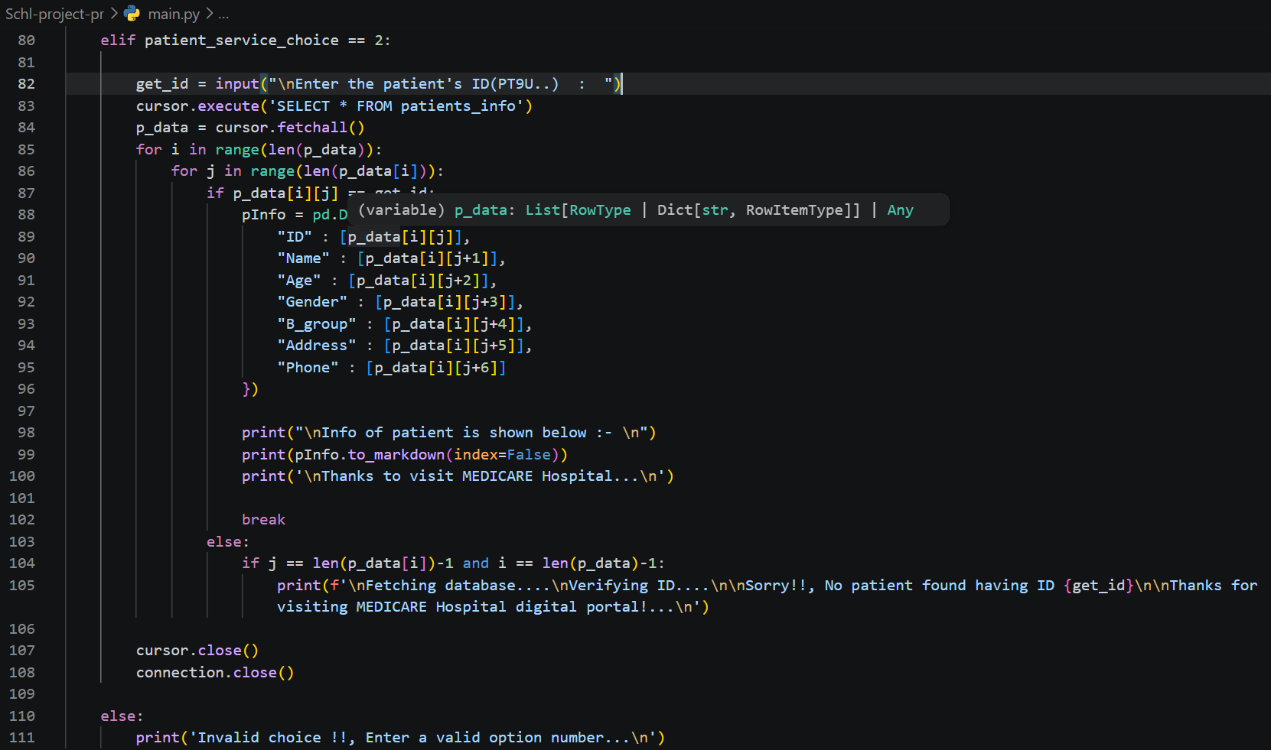

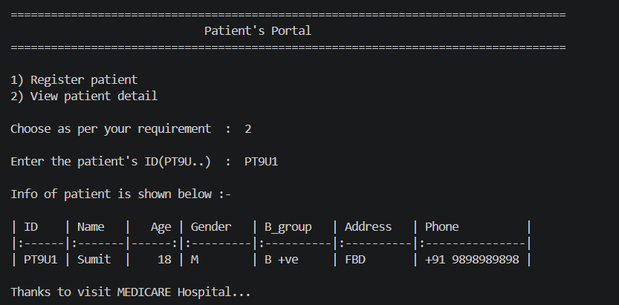
DataFrame({

