
BALAJI PUBLIC SCHOOL
C B S E A F F I L I A T E D · B A L L A B G A R H , H A R Y A N A

INFORMATICS PRACTICES
PROJECT FILE
Terminal-Based Hospital Management System
(Using Python & MySQL)
Submitted By | Mohit Singh & Dev Chauhan
Class | XII – A
Academic Session | 2026 – 27
Subject Teacher | Mrs. Uma Sagar

Table of Contents

1. System Architecture 3
2. Modules & Packages Used 3
3. Main Menu — Code & Output 4
4. Patient Portal Module 5
4.1 Registering a Patient 5
4.2 Database Table — Before & After Registration 6
4.3 Fetching Patient Details by ID 6
5. Project Roles 7

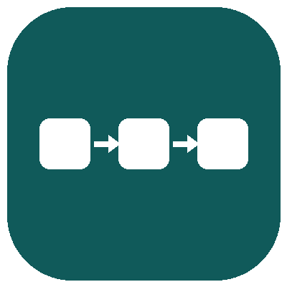 1. System Architecture
This section presents the overall structure of the project — the flow of data between the CLI, the processing modules, and the MySQL database — through a single consolidated diagram.
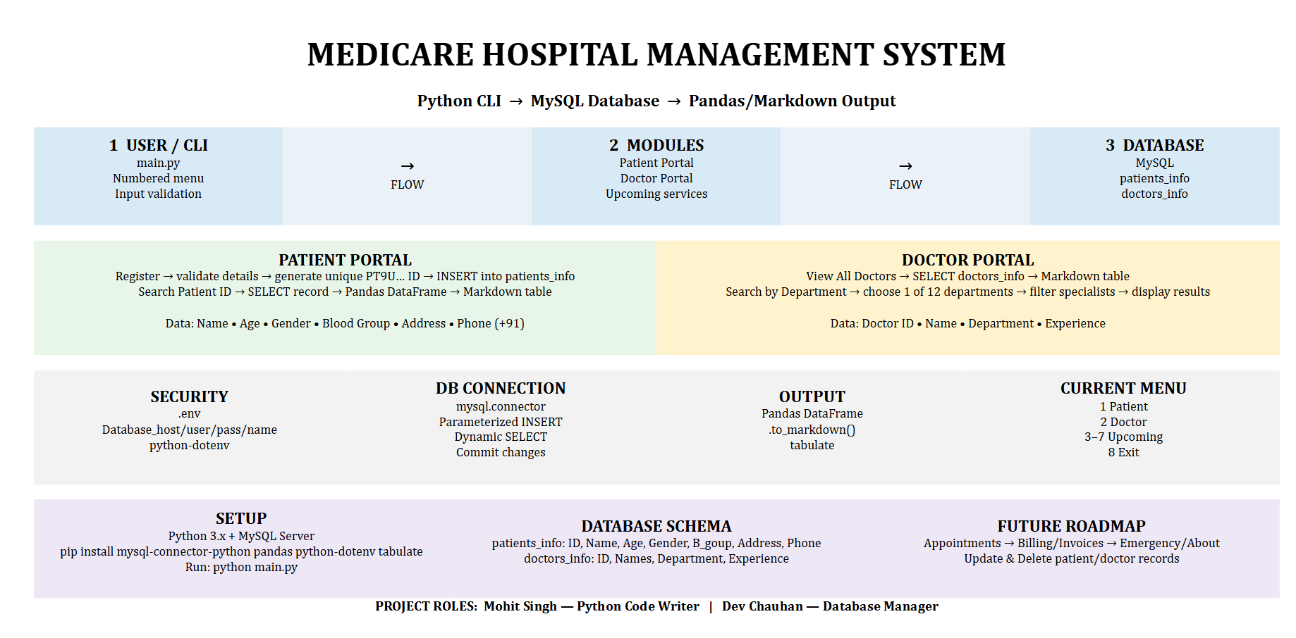
Fig 1: System architecture — data flow from the CLI through the processing modules to the MySQL database.

 2. Modules & Packages Used
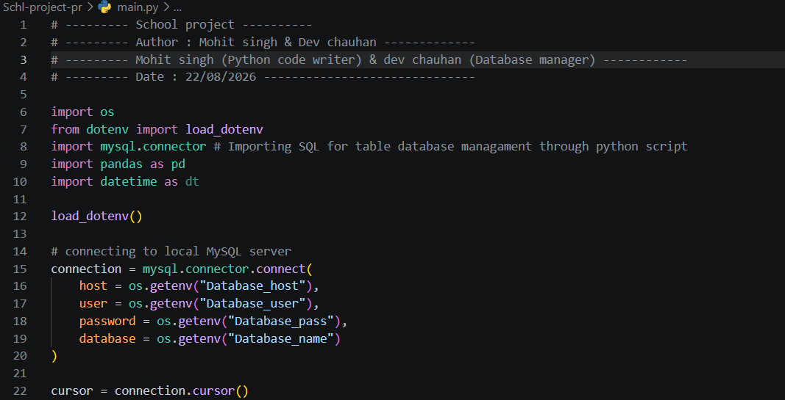
Fig 2: Code — importing the modules required by the program.
- os — used to securely read the database host, username, password, and name from the .env file.
- load_dotenv (from dotenv) — loads the environment variables defined in the .env file into the Python program.
- mysql.connector — connects the Python program to the MySQL database and executes SQL queries.
- pandas — structures query results into DataFrames and renders them as clean, readable tables.

 3. Main Menu — Code & Output
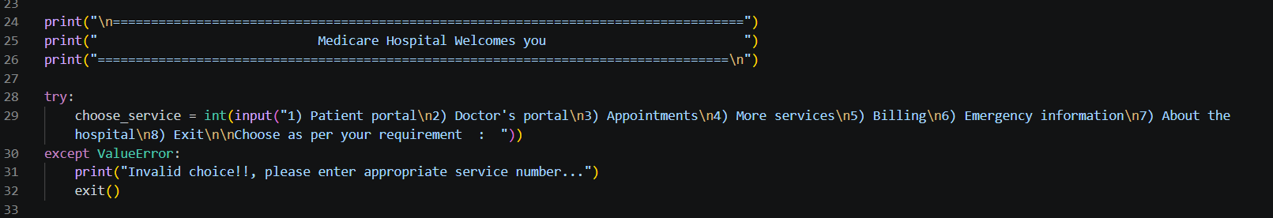
Fig 3: Code — displaying the main menu.
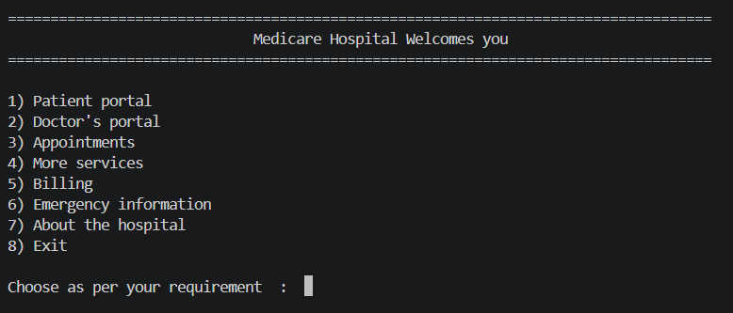
Fig 4: Output — main menu as seen by the user.
The main menu offers the following services:
- Patient Portal
- Doctor Portal
- Appointments (planned enhancement)
- More Services (planned enhancement)
- Billing (planned enhancement)
- Emergency Information (planned enhancement)
- About the Hospital (planned enhancement)
- Exit

 4. Patient Portal Module

4.1 Registering a Patient
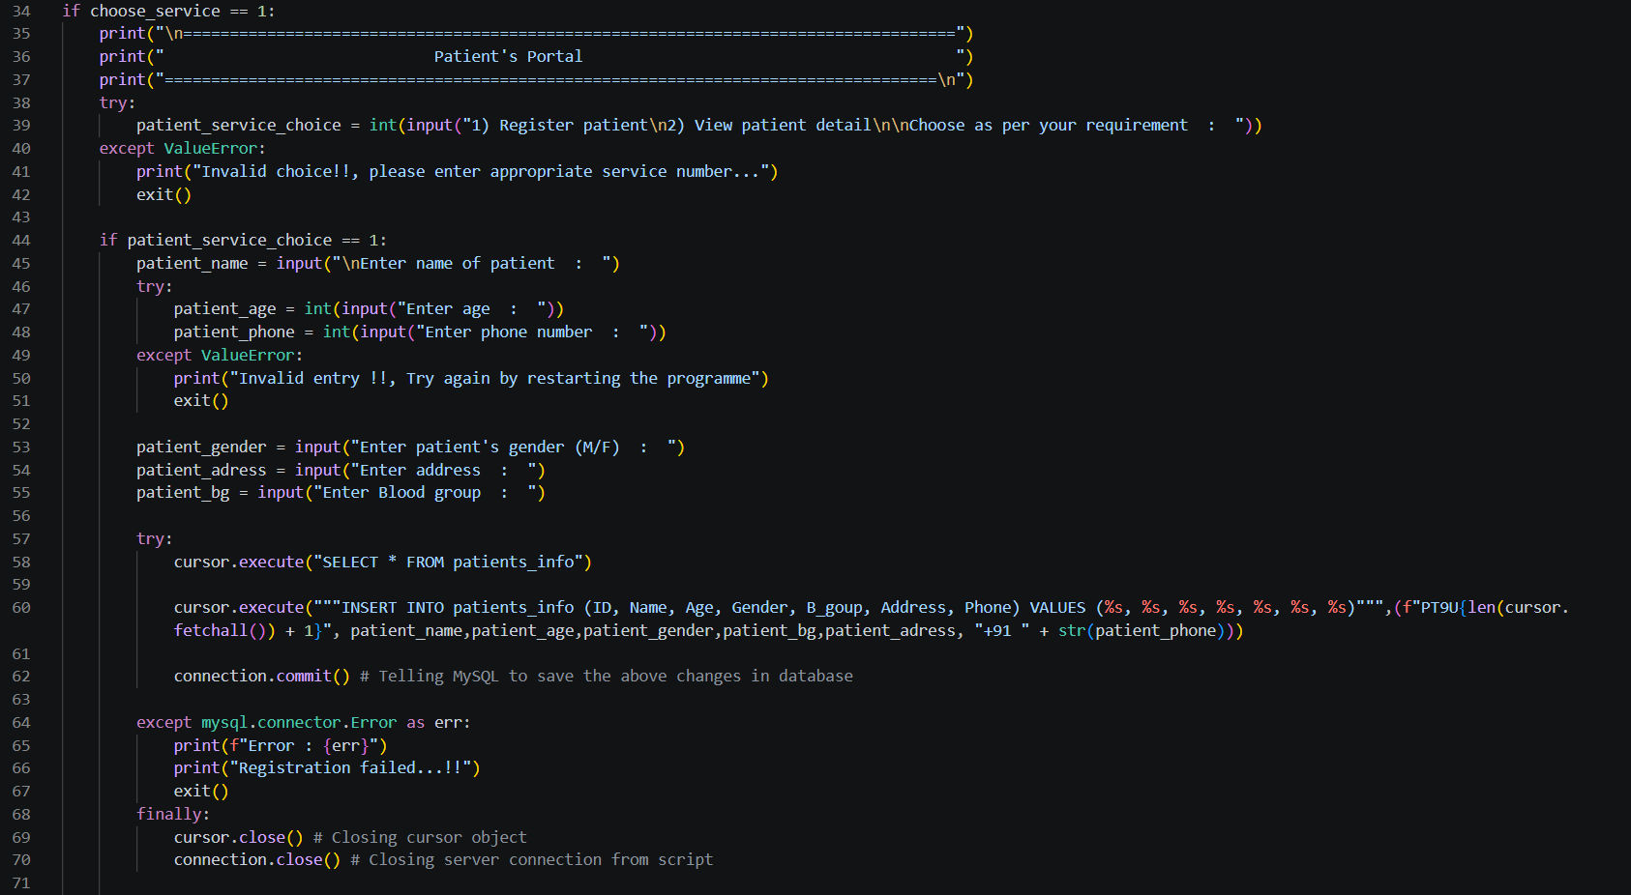
Fig 5: Code — registering a new patient.
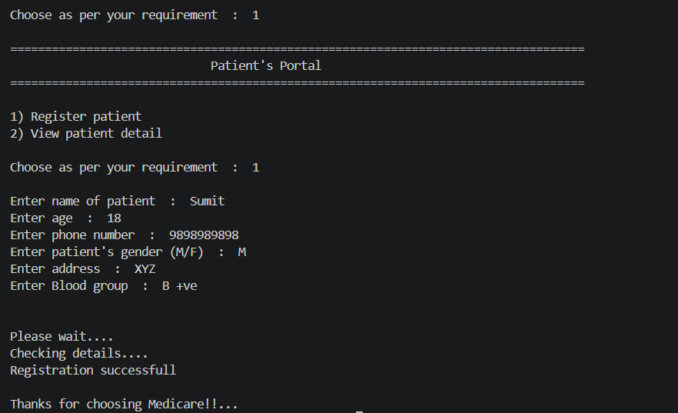
Fig 6: Output — patient registered successfully.

4.2 Database Table — Before & After Registration
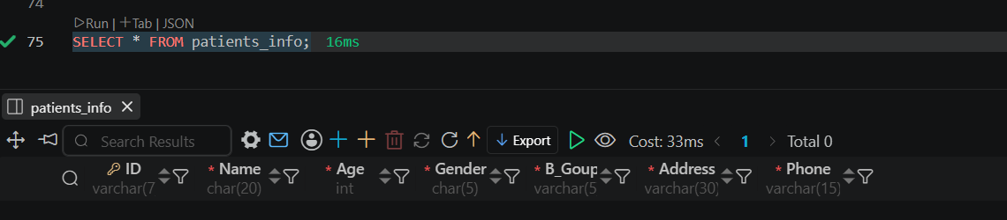
Fig 7: Database table before registration (empty).
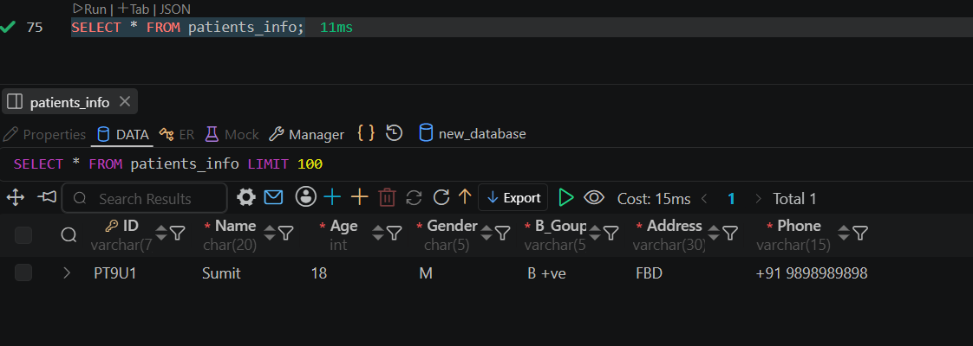
Fig 8: Database table after registration via the program.

4.3 Fetching Patient Details by ID
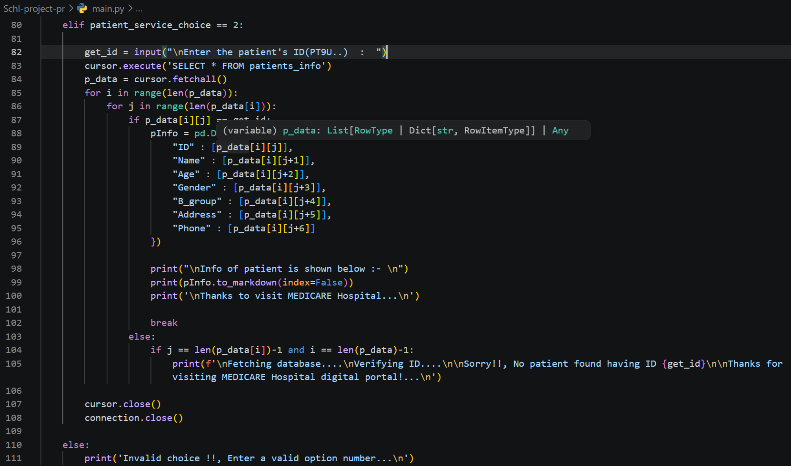
Fig 9: Code — fetching patient details using the patient ID.
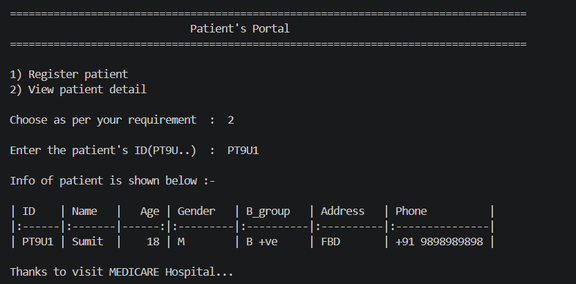
Fig 10: Output — patient details retrieved.

 5. Project Roles
Mohit Singh | Python Code Writer
Dev Chauhan | Database Manager
Together, Mohit Singh and Dev Chauhan designed and built the Medicare Hospital Management System as their Class XII Informatics Practices project.

