Online Job Portal

A PROJECT REPORT

Submitted by

Tahiliani Mohit DilipKumar[19BECE30118]
Makvana Kalpesh Bharatbhai[19BECE30091]

In fulfillment for the award of the degree
of
BACHELOR OF ENGINEERING
in
Computer Engineering

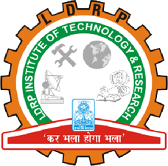

LDRP Institute of Technology and Research, Gandhinagar
Kadi Sarva Vishwavidyalaya
01, 2024
LDRP Institute of Technology and Research
Gandhinagar

CE-IT Department
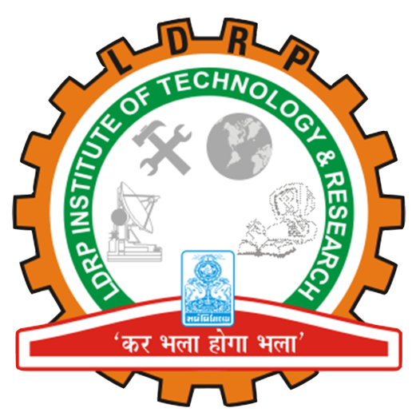

CERTIFICATE
This is to certify that the Project Work entitled “Online Job Portal” has been carried out by Mohit Tahiliani (19BECE30118) under my guidance in fulfilment of the degree of Bachelor of Engineering in Computer Engineering Semester-8 of Kadi Sarva Vishwavidyalaya University during the academic year 2023-2024.

Prof. Pratik Modi Prof. Sandeep Modha
Internal Guide Head of the Department
LDRP ITR LDRP ITR

LDRP Institute of Technology and Research
Gandhinagar

CE-IT Department

CERTIFICATE
This is to certify that the Project Work entitled “Online Job Portal” has been carried out by Kalpesh Makvana (19BECE30091) under my guidance in fulfilment of the degree of Bachelor of Engineering in Computer Engineering Semester-8 of Kadi Sarva Vishwavidyalaya University during the academic year 2023-2024.

Prof. Pratik Modi Prof. Sandeep Modha
Internal Guide Head of the Department
LDRP ITR LDRP ITR
Presentation-I for Project-I
1. Name & Signature of Internal Guide
2. Comments from Panel Members
3. Name & Signature of Panel Members

ACKNOWLEDGEMENT: -

I take this opportunity to humbly express our thankfulness to all those concerned with my project. First of all, I am thankful to LDRP ITR for undertaking this project. I am sincerely indebted to Prof. Pratik Modi for giving me the opportunity to work on this project. Her continuous guidance and help have proved to be a key to my success in overcoming the challenges that I have faced during my project work. Her support made the project a pleasantly memorable one. Without his help at all stages in spite of her own work load; the completion of the project would not have been possible.

I express my sincere gratitude to Prof. SANDEEP MODHA for his valuable guidance and positive feedback. There are so many persons without whose help I would never have conceived and learnt, to whom I would like to express my gratitude – my friends, colleagues, and of course CE Department of LDRP ITR. Last but not least I am thankful to almighty GOD and my PARENTS for giving me such a good atmosphere to work hard and to succeed.

With regards,
MOHIT TAHILIANI
Kalpesh Makvana

