**IoT Course Lab -- 1**

**Task#1:**

Write a Python program to solve the quadratic equation: **ax2 + bx + c = 0**. Take the values of a, b and c as per your convenience. Alternatively, you can get these values as inputs from user side.

**Code:**

**import math**

**a=float(input('Enter a\n'))**

**b=float(input('Enter b\n'))**

**c=float(input('Enter c\n'))**

**d_2=b**2-4*a*c**

**if(d_2>=0):**

**d=math.sqrt(d_2)**

**root1=(-b+d)/(2*a)**

**root2=(-b-d)/(2*a)**

**print(f'x1:{root1}')**

**print(f'x2:{root2}')**

**else:**

**d=math.sqrt(-d_2)**

**print('Imaginary Roots')**

**real=-b/(2*a)**

**im=d/(2*a)**

**print(f'z1:{real}+i({im}),z2:{real}-i({im})')**

**Output**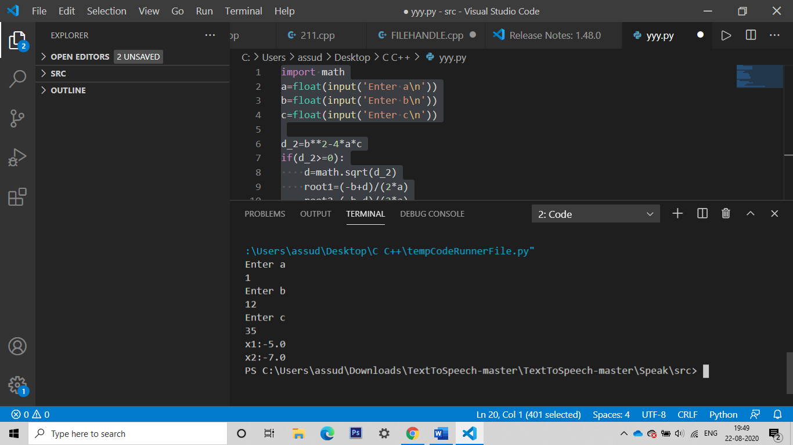

**Task#2:** Write a Python program to check if year is a leap year or not. The value of year must be supplied by the user as an input.

**Code:**

year=int(input('Enter Year:\n'))

if(year%4==0):

    print('Leap Year')

else:

    print('Not a Leap Year')

**Output:**



