**IoT Lab Assignment -- 3**

**Question-1)**

1. How to interface a stepper motor with Raspberry-pi-3? Explain briefly with the help of a neat and clean circuit diagram.
2. Also, write a Python program to continuously rotate the **four-coil stepper motor** clockwise at a **step-angle of 90 degrees**.

**Hint:** Inside an infinite loop, use the proper bit sequence (using GPIO pins) to excite the coils in requisite order. To stop the motor, we can kill the program using ctrl + c.

Answer-a)

We can control the stepper motor by using a 4 bit sequence with one-hot encoding. Each bit will correspond to a pin on the Raspberry Pi. We use 4 pins due to there being 4 coils in the stepper motor which we can energize. The one-hot encoding ensures that at a time, only a single coil is energized. The energized coil creates a magnetic field, which causes the rotor (a permanent magnet) to align with it. This is only in the case we want 4 steps. For 8 steps, we can energize two consecutive coils. And the resultant magnetic field would be mid-way between the two. This way, we can use steps of 45 degrees as well. We will need a ULN2003 motor driver to interface a unipolar stepper motor with the Raspberry Pi

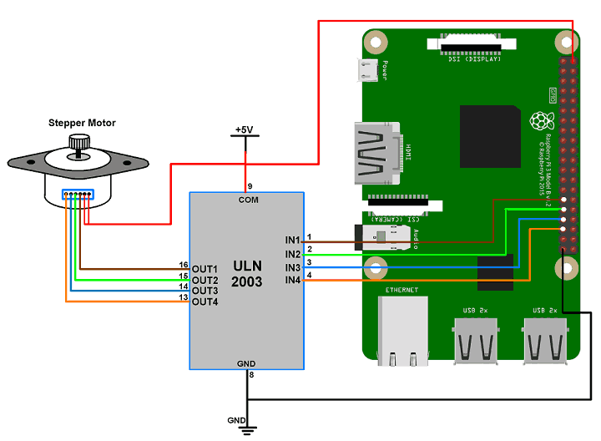

b)

import RPi.GPIO as GPIO

from time import sleep

import sys

motor_channel = (29,31,33,35)

GPIO.setmode(GPIO.BOARD)

GPIO.setup(motor_channel, GPIO.OUT)

while True:

GPIO.output(motor_channel, (GPIO.HIGH,GPIO.LOW,GPIO.LOW,GPIO.LOW))

sleep(0.5)

GPIO.output(motor_channel, (GPIO.HIGH,GPIO.HIGH,GPIO.LOW,GPIO.LOW))

sleep(0.5)

GPIO.output(motor_channel, (GPIO.LOW,GPIO.HIGH,GPIO.HIGH,GPIO.LOW))

sleep(0.5)

GPIO.output(motor_channel, (GPIO.LOW,GPIO.LOW,GPIO.HIGH,GPIO.HIGH))

sleep(0.5)

******************************************************************************************************************************************************************************