**IoT Course Assignment – 4**

**Question-1)**

1. How to interface a **servo motor** with Raspberry-pi-3? Explain briefly with the help of a neat and clean circuit diagram.
2. Also, write a Python program to rotate the servo motor at the angles of 0 degree, 90 degrees and 180 degrees in a cyclic order (i.e. 180 degrees must again be followed by 0-degree rotation and so on).

**Coding Hints:**

(i) Use an infinite loop.

(ii) To stop the motor, we must be able to kill the program using ctrl + c.

**Logic Hints:**

The servo motors (e.g. SG 90) rotates at the angles of **0, 90 and 180-degree** if the input pulse has widths of **0.5, 1.5 and 2.5 ms** respectively.

To achieve the above-mentioned pulse widths, we can use a 50 Hz PWM signal (*with 50 % duty cycle*) and subsequently change its duty cycle for getting the desired pulse width.

For 50 Hz PWM signal (*with 50 % duty cycle*): Time Period = 20 ms

And the signal will be HIGH for first 10 ms and LOW for last 10 ms.

* **For 0-degree rotation**, we need only 0.5 ms of pulse width (HIGH State) which is 2.5 % of 20 ms. So, for 0-degree rotation, the required duty cycle is 2.5 % of that 50 Hz PWM signal.
* Similarly, for 90-degree rotation, the requisite duty cycle is 7.5 % of that 50 Hz PWM signal.
* And for 180-degree rotation, the requisite duty cycle is 12.5 % of that 50 Hz PWM signal.

**Task (a) :**

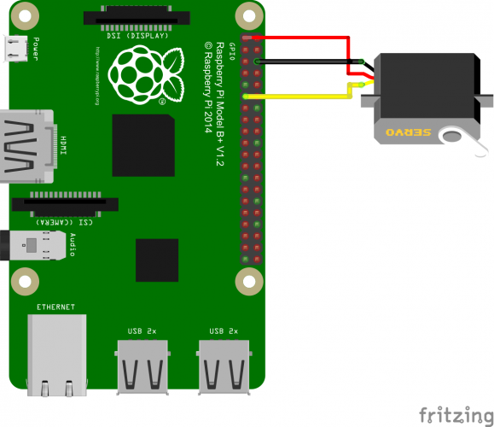

A servo motor is an essential component in Robotics that consists of a DC Motor, Gears and a Feedback based Position Control System. It’s main purpose is to control the speed and angular position of its shaft. The signal pin – of the servo motor is connected to the PWM output of the Raspberry Pi (this is essentially the controller). The shaft of the servo motor then varies based on the Pulses from the PWM output. The pins of the servo motor are connected to the pins of the raspberry pi interface and the duty cycle of the PWM signal is varied to get the needed angle of rotation. Furthermore, the servo motor is controlled by the 3 pins – PWM, VCC and GND (Pin 12).

For 0-Degree rotation, required duty cycle = 2.5% of the 50Hz PWM signal

For 90-Degree rotation, required duty cycle = 7.5% of the 50Hz PWM signal

For 180-Degree rotation, required duty cycle = 12.5% of the 50Hz PWM signal

**Task (b) :**

import RPi.GPIO as GPIO

import time

servoPIN = 12

GPIO.setmode(GPIO.BOARD)

GPIO.setup(servoPIN, GPIO.OUT)

p = GPIO.PWM(servoPIN, 50)

p.start(2.5)

try:

while True:

time.sleep(0.5)

p.ChangeDutyCycle(7.5)

time.sleep(0.5)

p.ChangeDutyCycle(12.5)

time.sleep(0.5)

p.ChangeDutyCycle(2.5)

except KeyboardInterrupt:

p.stop()

GPIO.cleanup()

sys.exit(0)

************************************************************************************************************************************************************************************************