**IoT Assignment 6**

Question 1 ) Explore the online resources to get familiar with **FC-28 soil moisture sensor**?

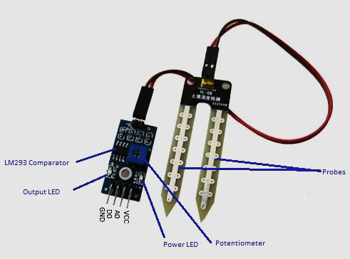

What is the function of signal pins ‘**A0**’, ‘**D0**’ and the **potentiometer**? Explain in brief.

Thereafter, interface the FC-28 sensor with Raspberry-pi to read the moisture data form **pin D0** (of FC-28 sensor). [Just mention the connections, diagram is not mandatory].

***For your info, at pin D0, FC-28 can give the digital output only (1 or 0) based on the moisture threshold set through potentiometer. If the measured moisture is lower than the threshold, D0 is HIGH (‘1’). Similarly, if the measured moisture is higher than the threshold value (i.e. threshold is crossed), the D0 will become LOW (‘0’)****.*

Write is Python program to print “***Moisture Level is lower than the threshold***” OR “***Moisture Level is higher than the threshold***” based on the data values (1 or 0) read from D0 pin of FC-28.

--------------------------------------------------------------------------------------------------------------

**Ans 1: Explanation of Sensor**

On the FC-28 sensor, we have 2 probes connected to an LM393 comparator board. When the soil moisture is low, the resistance between the probes will be high, as the conductivity of soil is low. Conversely, when the moisture is high, the resistance will be lower. This property can be used to design a system around this sensor to detect and take action, like turning on a pump using a relay, for example.

From the sensor output, we have 4 pins: Vcc,GND,A0 and D0, and additionally a potentiometer.

* VCC: For power
* A0: Analog output
* D0: Digital output
* GND: Ground

**A0:** This pin gives us the moisture level as analog values from 0 to 1023. **We can use the sensor in analog mode to get a readout of the moisture level**.

**D0:** This pin gives us a single bit digital value (1 or 0) depending on the moisture from the probes, compared with the potentiometer value. **The sensor in digital mode can be used to turn on a relay for example and take appropriate action.** When the output from the pin is 0, the LED on the board will also light up.

**Potentiometer:** We can set the threshold for the digital pin to change state, by adjusting this potentiometer value, **i.e. we can use the potentiometer to set the moisture level for the D0 pin to change states.**

To interface the sensor to the Raspberry Pi, first, connect the probes to the 2 input pins on the comparator board. Now, we want to use the digital mode. So, we connect the D0 pin on the comparator board to GPIO pin 11 (in Board Mode) on Raspberry Pi. Lastly, we connect Vcc and GND on the comparator board to pins 1 (3v3) and 6 (GND) respectively.

**Ans 2: Python Code**

import RPi.GPIO as GPIO

from time import sleep

GPIO.setmode(GPIO.BOARD)

GPIO.setwarnings(False)

sensor_pin = 7

GPIO.setup(sensor_pin, GPIO.IN)

try:

while True:

moisture_level = GPIO.input(sensor_pin)

if(moisture_level == 0):

print("Moisture Level is Higher than Threshold")

else:

print("Moisture Level is Lower than Threshold")

sleep(5)

except KeyboardInterrupt:

print("Quit")

GPIO.cleanup()

**********************************************************************************************************************************************************************************