**IoT Assignment - 8**

**Question 1)** Explore the online resources to get familiar with **HC-SR04 ultrasonic sensor**.

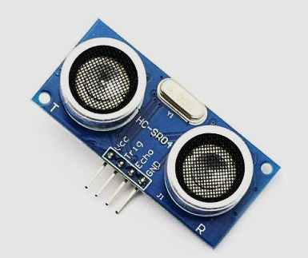

**What is the functions of signal pins ‘Trig’ and ‘Echo’? Explain in brief.**

Ans)

The **HC-SR04** ultrasonic sensor is a very useful sensor for taking distance measurements. The distance can be converted to units like centimetres/inches/feet. This sensor is used in robotics for obstacle avoidance and also used in automation to check the height of a fluid in a tank.

The sensor has two drums

* One drum serves as a sound trigger
* The other serves as an echo receiver

The time between sound sent and time received is used to compute distance.

Taken speed of sound =343m/s=34300cm/s

distance=velocity*time

distance=34300cm/seconds*tseconds

where t = half of Taken time between trigger and echo received

**Thereafter, interface the HC-SR04 sensor with Arduino-Uno for distance measurement applications. [Just mention the connections, diagram is not mandatory].**

**Also, write an Arduino program to find the distance of an object placed in front of the HC-SR04 sensor and display the result (measured distance) on the serial monitor.**

Ans)

Complete list of components for this circuit

* Arduino Nano
* HC-SR04 Ultrasonic Sensor
* Jumper wires
* Breadboard

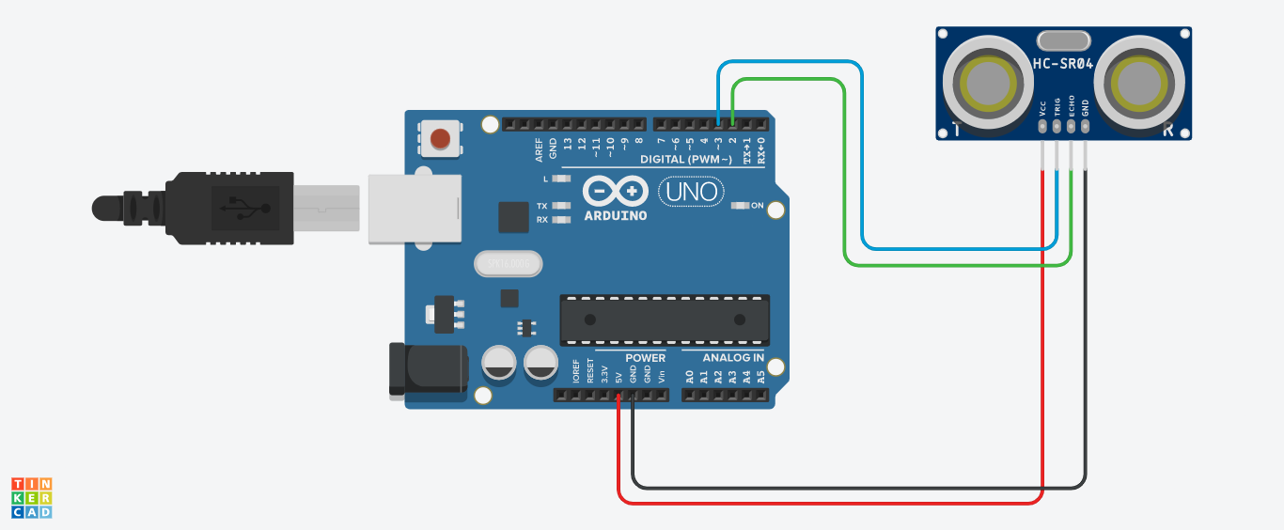The serial monitor will do communication at 9600 baud rate. Trig pin is connected to pin 3, echo is connected to pin 2 on the Arduino Uno board. GND and VCC are connected to GND and 5v on the microcontroller respectively. Values distance are displayed on the serial monitor.

Code:

int trig = 3;

int echo=2;

int distance;

int duration;

void setup()

{

Serial.begin(9600);

pinMode(trig,OUTPUT);

pinMode(echo,INPUT);

void loop()

{

digitalWrite(trig,LOW); //put trig off

delay(2);

digitalWrite(trig,HIGH); //puts trig on

delay(20);

digitalWrite(trig,LOW); //puts trig off

duration=pulseIn(echo,HIGH);

distance=duration/57.8;

Serial.print("Distance ==");

Serial.println(distance);

}

**********************************************************************************************************************************************************************************