**ANALYSIS OF BINARY SEARCH TREE – AVL TREE – TREAPS**

**TEST FILE 1 : TEST_1.txt**

**Total operrations : 10000**

**No of insertions: 7325**

**No of deletions: 2675**

**PARAMETERS:**

**---n = number of nodes**

**---log n is of base 2**

1. **TOTAL TIME OF OPERATIONS (MACHINE DEPENDENT)**

|  |  |
| --- | --- |
| **TREES** | **EMPIRICAL VALUE** |
| **BST** | **0.026s** |
| **AVL** | **0.018s** |
| **TREAP** | **0.015s** |

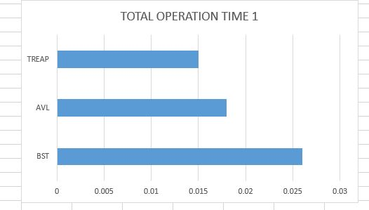

1. **TREE HEIGHT OF FINAL TREE**

|  |  |  |
| --- | --- | --- |
| **TREES** | **THEORATICAL VALUE(min – max)** | **EMPIRICAL VALUE** |
| **BST** | **O(log n) to O(n) =12.18 - 4649** | **29** |
| **AVL** | **O(log n)=13** | **15** |
| **TREAP** | **O(log n) to O(n) =12.18 - 4649** | **30** |

1. **AVERAGE HEIGHT OF NODES IN FINAL TREE**

|  |  |
| --- | --- |
| **TREES** | **EMPIRICAL VALUE** |
| **BST** | **3.288817** |
| **AVL** | **1.316689** |
| **TREAP** | **3.439785** |

1. **KEY COMPARISIONS**

|  |  |
| --- | --- |
| **TREES** | **EMPIRICAL VALUE** |
| **BST** | **74228** |
| **AVL** | **106394** |
| **TREAP** | **84453** |

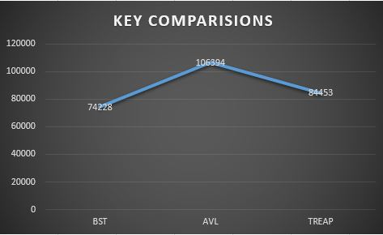

1. **NUMBER OF ROTATIONS**

|  |  |
| --- | --- |
| **TREES** | **EMPIRICAL VALUE** |
| **AVL** | **5853** |
| **TREAP** | **17125** |

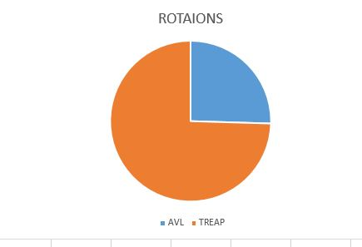

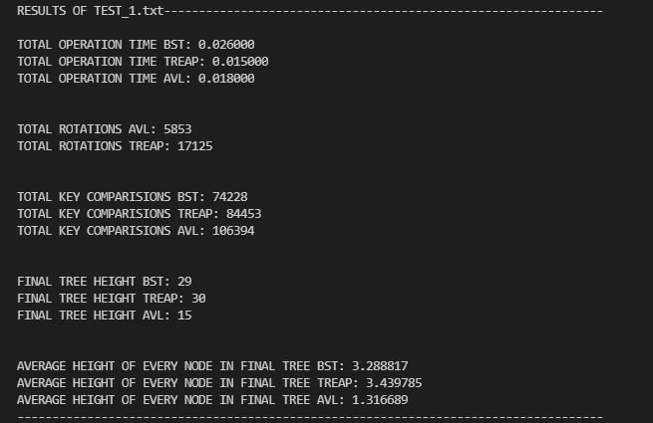

**TEST FILE 2 : TEST_2.txt**

**Total operrations : 20000**

**No of insertions: 14270**

**No of deletions: 5730**

**PARAMETERS:**

1. **TOTAL TIME OF OPERATIONS(MACHINE DEPENDENT)**

|  |  |
| --- | --- |
| **TREES** | **EMPIRICAL VALUE** |
| **BST** | **0.096s** |
| **AVL** | **0.035s** |
| **TREAP** | **0.031s** |

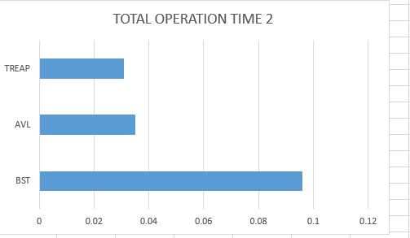

1. **TREE HEIGHT OF FINAL TREE**

|  |  |  |
| --- | --- | --- |
| **TREES** | **THEORATICAL VALUE** | **EMPIRICAL VALUE** |
| **BST** | **13.45 – 11192** | **32** |
| **AVL** | **13** | **16** |
| **TREAP** | **13.45 - 11192** | **34** |

1. **TREE HEIGHT OF NODES IN FINAL TREE**

|  |  |
| --- | --- |
| **TREES** | **EMPIRICAL VALUE** |
| **BST** | **3.301974** |
| **AVL** | **3.163594** |
| **TREAP** | **3.446976** |

1. **KEY COMPARISIONS**

|  |  |
| --- | --- |
| **TREES** | **EMPIRICAL VALUE** |
| **BST** | **176250** |
| **AVL** | **251667** |
| **TREAP** | **203415** |

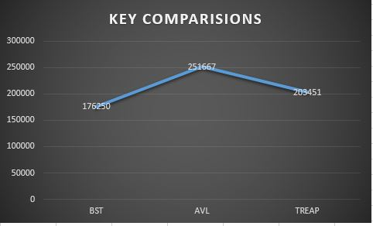

1. **NUMBER OF ROTATIONS**

|  |  |
| --- | --- |
| **TREES** | **EMPIRICAL VALUE** |
| **AVL** | **9882** |
| **TREAP** | **29725** |

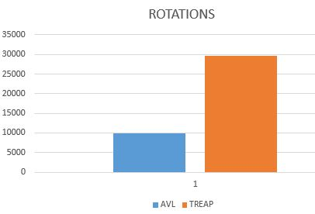

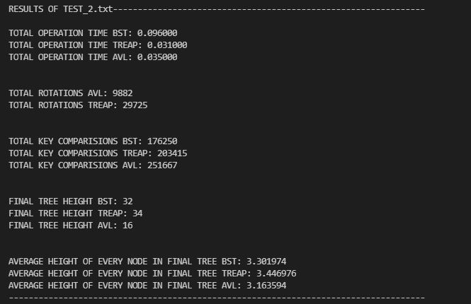

**TEST FILE 3 : TEST_3.txt**

**Total operrations : 30000**

**No of insertions: 20556**

**No of deletions: 9444**

**PARAMETERS:**

1. **TOTAL TIME OF OPERATIONS(MACHINE DEPENDENT)**

|  |  |
| --- | --- |
| **TREES** | **EMPIRICAL VALUE** |
| **BST** | **0.048s** |
| **AVL** | **0.054s** |
| **TREAP** | **0.046s** |

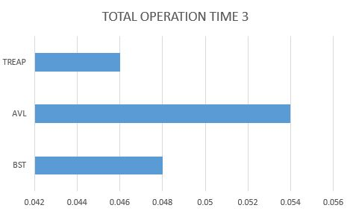

1. **TREE HEIGHT OF FINAL TREE**

|  |  |  |
| --- | --- | --- |
| **TREES** | **THEORATICAL VALUE** | **EMPIRICAL VALUE** |
| **BST** | **13.89 -15250** | **32** |
| **AVL** | **13.99** | **17** |
| **TREAP** | **13.89 - 15250** | **35** |

1. **AVERAGE HEIGHT OF NODES IN FINAL TREE**

|  |  |
| --- | --- |
| **TREES** | **EMPIRICAL VALUE** |
| **BST** | **3.301029** |
| **AVL** | **2.160227** |
| **TREAP** | **3.453478** |

1. **KEY COMPARISIONS**

|  |  |
| --- | --- |
| **TREES** | **EMPIRICAL VALUE** |
| **BST** | **278435** |
| **AVL** | **391194** |
| **TREAP** | **327421** |

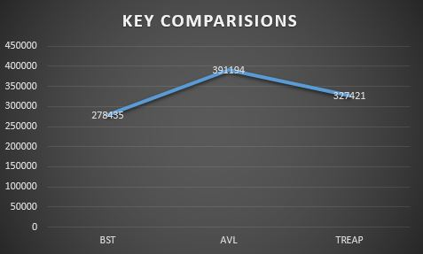

1. **NUMBER OF ROTATIONS**

|  |  |
| --- | --- |
| **TREES** | **EMPIRICAL VALUE** |
| **AVL** | **11245** |
| **TREAP** | **35885** |

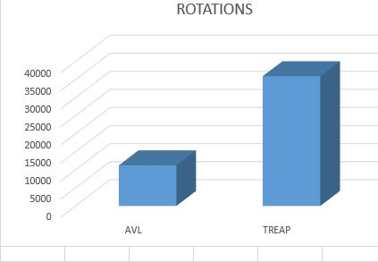

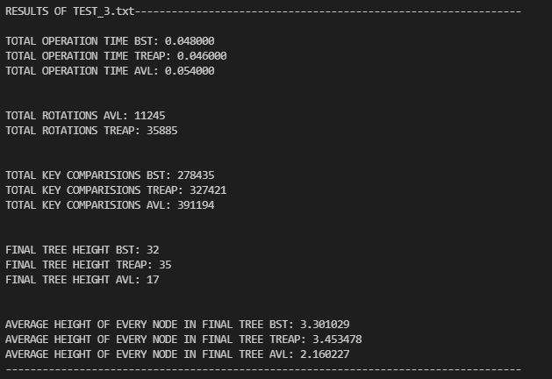

**TEST FILE 4 : TEST_4.txt**

**Total operrations : 50000**

**No of insertions: 30299**

**No of deletions: 19701**

**PARAMETERS:**

1. **TOTAL TIME OF OPERATIONS(MACHINE DEPENDENT)**

|  |  |
| --- | --- |
| **TREES** | **EMPIRICAL VALUE** |
| **BST** | **0.089s** |
| **AVL** | **0.088s** |
| **TREAP** | **0.078s** |

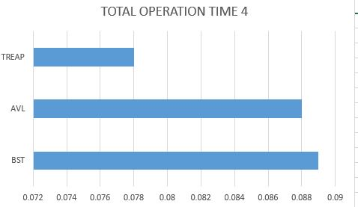

1. **TREE HEIGHT OF FINAL TREE**

|  |  |  |
| --- | --- | --- |
| **TREES** | **THEORATICAL VALUE** | **EMPIRICAL VALUE** |
| **BST** | **13.52 – 11746** | **30** |
| **AVL** | **13** | **16** |
| **TREAP** | **13.52 - 11746** | **34** |

1. **AVERAGE HEIGHT OF NODES IN FINAL TREE**

|  |  |
| --- | --- |
| **TREES** | **EMPIRICAL VALUE** |
| **BST** | **3.223206** |
| **AVL** | **3.335612** |
| **TREAP** | **3.461139** |

1. **KEY COMPARISIONS**

|  |  |
| --- | --- |
| **TREES** | **EMPIRICAL VALUE** |
| **BST** | **468061** |
| **AVL** | **650598** |
| **TREAP** | **607567** |

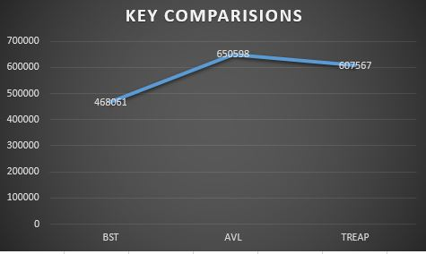

1. **NUMBER OF ROTATIONS**

|  |  |
| --- | --- |
| **TREES** | **EMPIRICAL VALUE** |
| **AVL** | **16509** |
| **TREAP** | **51530** |

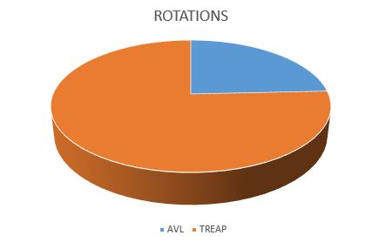

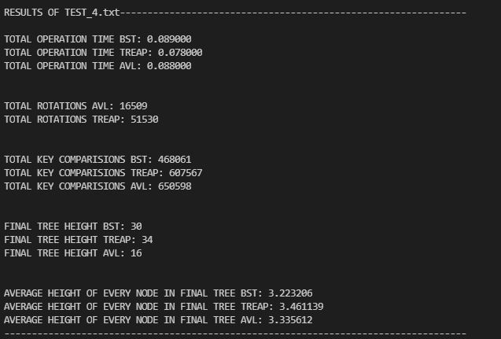

**TEST FILE 5 : TEST_5.txt**

**Total operrations : 65000**

**No of insertions: 32760**

**No of deletions: 32240**

**PARAMETERS:**

1. **TOTAL TIME OF OPERATIONS(MACHINE DEPENDENT)**

|  |  |
| --- | --- |
| **TREES** | **EMPIRICAL VALUE** |
| **BST** | **0.119s** |
| **AVL** | **0.115s** |
| **TREAP** | **0.101s** |

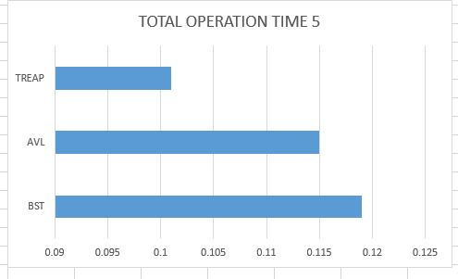

1. **TREE HEIGHT OF FINAL TREE**

|  |  |  |
| --- | --- | --- |
| **TREES** | **THEORATICAL VALUE** | **EMPIRICAL VALUE** |
| **BST** | **9.03 -522** | **21** |
| **AVL** | **7.99** | **11** |
| **TREAP** | **9.030 - 522** | **17** |

1. **AVERAGE HEIGHT OF NODES IN FINAL TREE**

|  |  |
| --- | --- |
| **TREES** | **EMPIRICAL VALUE** |
| **BST** | **3.151052** |
| **AVL** | **4.725490** |
| **TREAP** | **3.349904** |

1. **KEY COMPARISIONS**

|  |  |
| --- | --- |
| **TREES** | **EMPIRICAL VALUE** |
| **BST** | **585416** |
| **AVL** | **816805** |
| **TREAP** | **805076** |

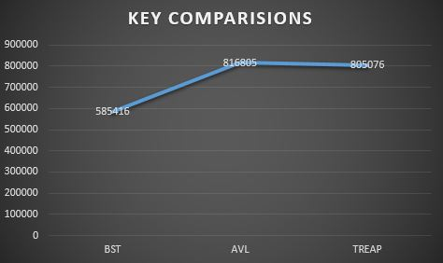

1. **NUMBER OF ROTATIONS**

|  |  |
| --- | --- |
| **TREES** | **EMPIRICAL VALUE** |
| **AVL** | **23960** |
| **TREAP** | **74575** |

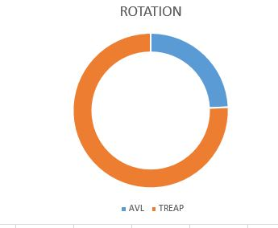

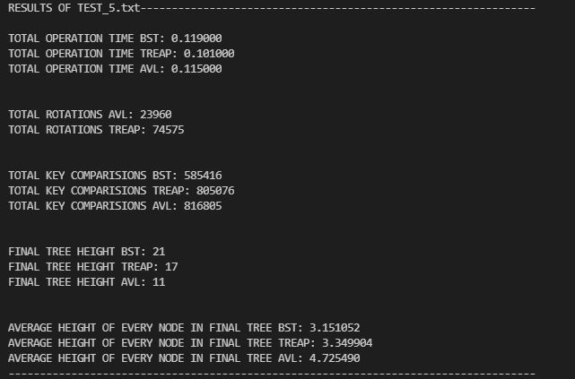

**TEST FILE 6 : TEST_6.txt**

**Total operrations : 65500**

**No of insertions:32768**

**No of deletions: 32732**

**PARAMETERS:**

1. **TOTAL TIME OF OPERATIONS(MACHINE DEPENDENT)**

|  |  |
| --- | --- |
| **TREES** | **EMPIRICAL VALUE** |
| **BST** | **0.103s** |
| **AVL** | **0.114s** |
| **TREAP** | **0.099s** |

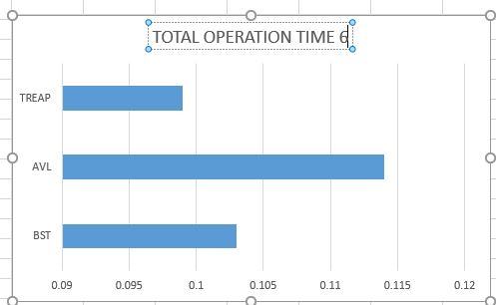

1. **TREE HEIGHT OF FINAL TREE**

|  |  |  |
| --- | --- | --- |
| **TREES** | **THEORATICAL VALUE** | **EMPIRICAL VALUE** |
| **BST** | **5.16 – 35** | **9** |
| **AVL** | **5** | **6** |
| **TREAP** | **5.16 - 35** | **8** |

1. **AVERAGE HEIGHT OF NODES IN FINAL TREE**

|  |  |
| --- | --- |
| **TREES** | **EMPIRICAL VALUE** |
| **BST** | **2.722222** |
| **AVL** | **2.483871** |
| **TREAP** | **2.777778** |

1. **KEY COMPARISIONS**

|  |  |
| --- | --- |
| **TREES** | **EMPIRICAL VALUE** |
| **BST** | **549300** |
| **AVL** | **798469** |
| **TREAP** | **774954** |

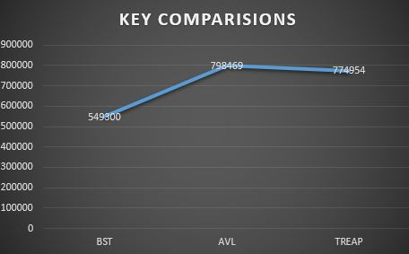

1. **NUMBER OF ROTATIONS**

|  |  |
| --- | --- |
| **TREES** | **EMPIRICAL VALUE** |
| **AVL** | **33211** |
| **TREAP** | **97625** |

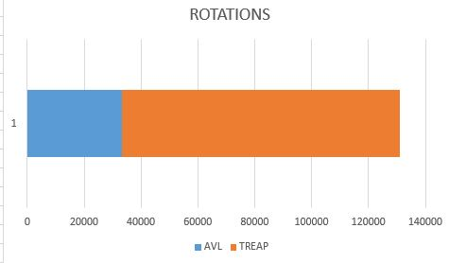

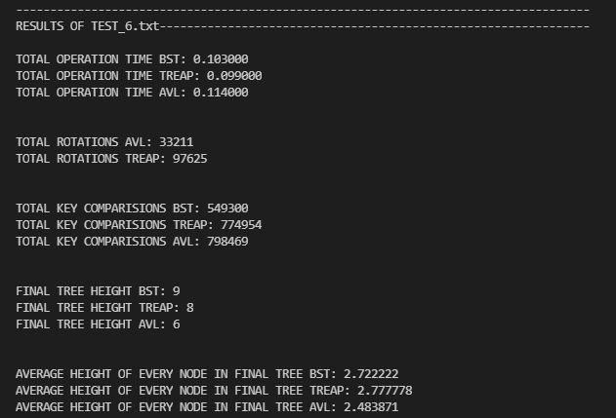

**FINAL CONCLUSION ON PERFORMANCE OF THESE 3 TREES:**

|  |  |  |
| --- | --- | --- |
| **PARAMETERS** | **EFFICIENT TREE** |  |
| **TOTAL TIME OF OPERATIONS** | **TREAP** | **TREAP TIME IS LESS THAN AVL AND BST** |
| **TREE HEIGHT OF FINAL TREE** | **AVL** | **AVL VALUE IS LESS THAN BST AND TREAP** |
| **AVERAGE HEIGHT OF NODE IN FINAL TREE** | **BST AND AVL** | **BST AND AVL VALUES ARE CLOSE AND LESS THAN TREAP** |
| **KEY COMPARISIONS** | **BST** | **BST < TREAP < AVL** |
| **NO OF ROTATIONS** | **AVL** | **AVL < TREAP** |