In visual Code editor if you write => Html:5 (Emmet Abbrevation) will give the basic skeleton for html.

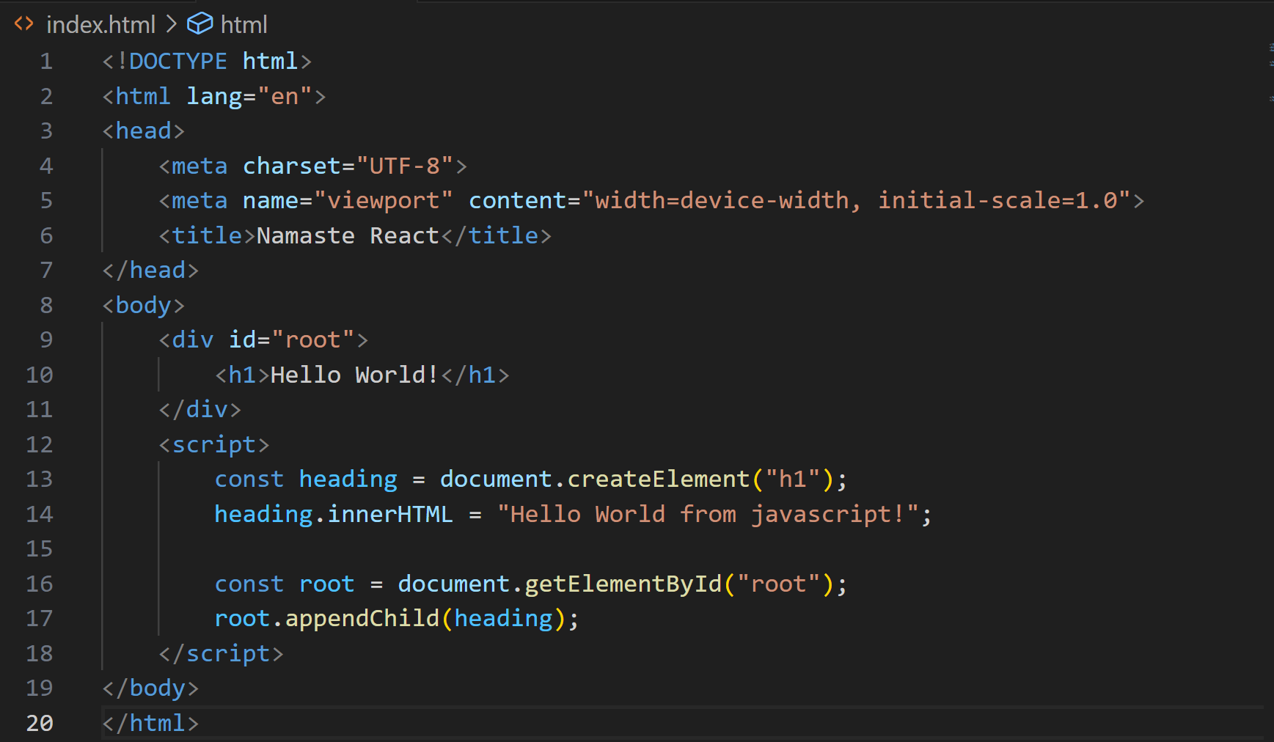

In above hello world created using javascript.

Injecting react into project:

1) Using CDN-react: 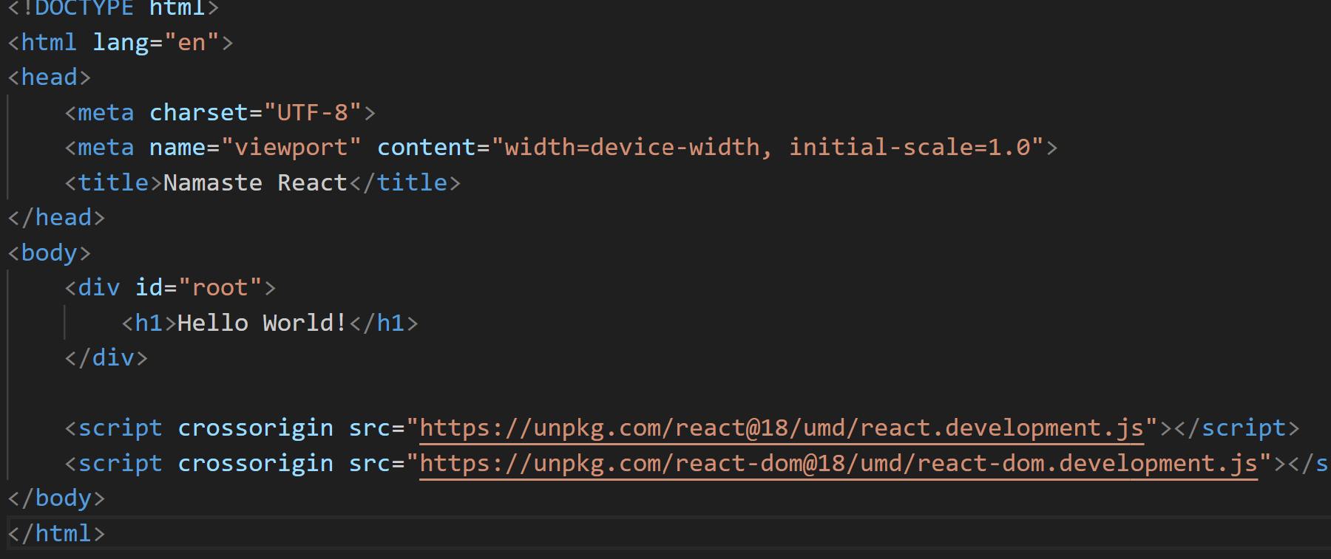

A cross-origin request is a request for a resource (e.g. style sheets, iframes, images, fonts, or scripts) from another domain.

CORS is used to manage cross-origin requests.

CORS stands for Cross-Origin Resource Sharing, and is a mechanism that allows resources on a web page to be requested from another domain outside their own domain. It defines a way of how a browser and server can interact to determine whether it is safe to allow the cross-origin request. CORS allows servers to specify who can access the assets on the server, among many other things.

* Why we have two react files above?  
  First is the core react file which can be used in browser and mobile app.  
  Second file react dom is only used in browser to have dom operations.   
  So react is used at multiple places that’s why we have two different files here.

React comes with a philosophy to manipulate DOM which is most expensive operation in Web Pages , is to do it with javascript. It optimizes dom manipulation.

Segreagate code into js and css.

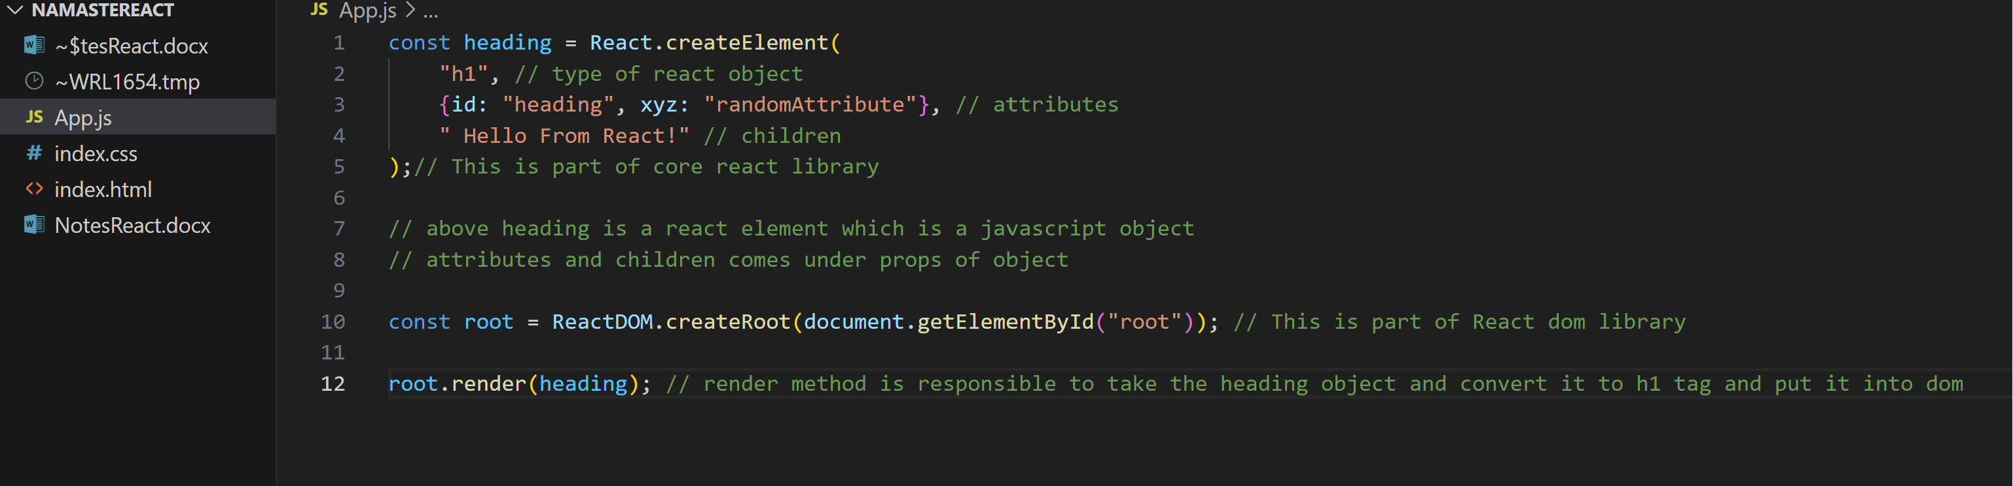

**Create Nested Elements in react:**

Note: React cannot only be written in JSX, it can also be written in javascript only like we are doing right now. But this makes code unreadable and complex. So we use JSX.

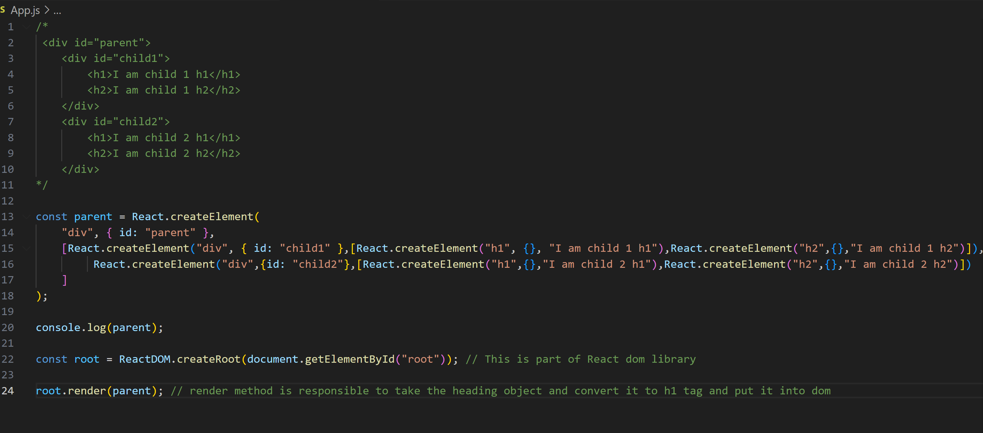

As you can see that so much needs to be written to get simple nested structure. So here JSX comes into picture.   
Also in above console will throw error below which we will get rid of in future:

Root.render **replaces** the existing content inside root element.

React only works inside your root element. So above and below portion of html will works the same. That’s why we call react as a library. Since it can be applied to a small portion of page. It is not a fully fledged framework.. its some piece of javascript code.