3rd Order Active Low Pass Filter Project
This project is part of the ECE215 course (Monsoon 2025) and focuses on the design, simulation, and PCB implementation of a 3rd order active low-pass filter (LPF) with a cutoff frequency of 1 kHz and a flat-band gain of approximately 12 dB. The design follows the problem statement and theoretical background provided in the course project document.

1. Project Overview (As per Problem Statement)
The objective is to design a third-order active low-pass filter using op-amps and passive components. The filter consists of two stages: a first-order active RC stage and a second-order Sallen–Key stage. Key specifications include a 60 dB/decade roll-off, adjustable gain using a variable resistor, and acceptable tolerances on cutoff frequency and gain.

2. LTspice Simulation
The circuit was first implemented and verified in LTspice. AC analysis was performed to confirm the cutoff frequency, gain, and slope of attenuation. The simulation helped validate component values before hardware implementation.
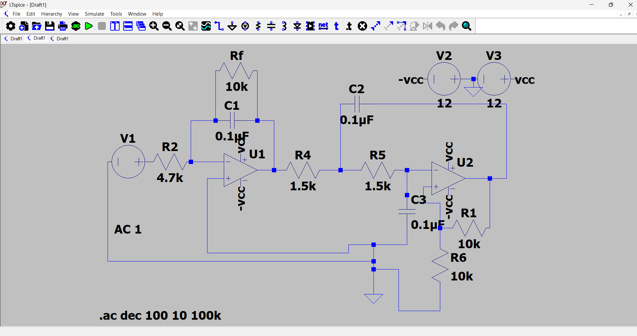

3. Theory and Component Value Selection
The filter design is based on a 3rd order Butterworth response, chosen for its maximally flat passband. The first stage implements a first-order low-pass response using an op-amp with RC feedback. The second stage is a Sallen–Key low-pass filter providing a second-order response. Component values were selected by comparing the theoretical transfer function with the standard Butterworth polynomial.

4. KiCad Schematic Design
After successful simulation, the circuit was recreated in KiCad. The schematic captures all resistors, capacitors, op-amps (LM741), power connections, and connectors required for PCB fabrication.
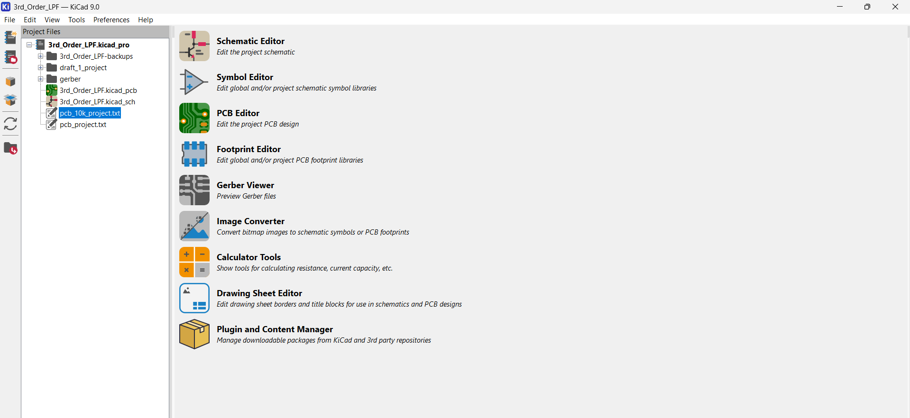

5. PCB Layout Design
The PCB was designed in KiCad PCB Editor with careful routing to minimize noise and ensure signal integrity. Component placement was optimized for clarity and manufacturability. All connections were verified using DRC checks.
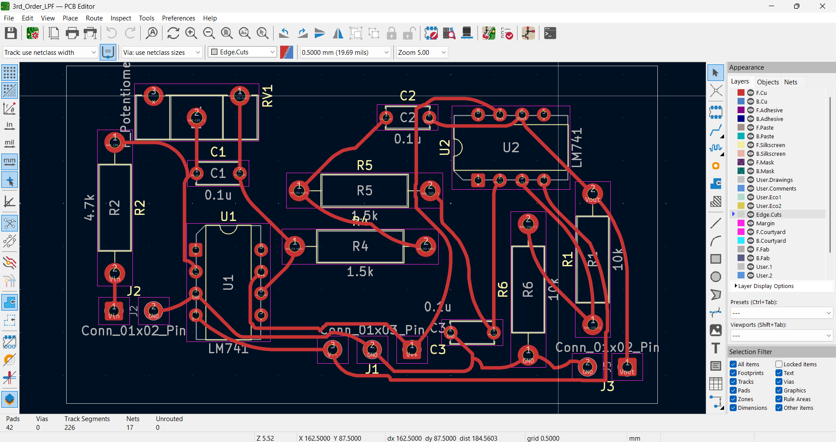

6. Final Notes
This project demonstrates the complete workflow of analog filter design: theoretical analysis, circuit simulation, schematic capture, and PCB layout. The final design meets the given specifications within acceptable tolerances.

