**Software Requirements Specification**

AI DRIVEN VIDEO CREATION

USING TREND ANALYSIS

**Prepared by**

**Mohit Patel- 22DCS069**

**Nir Patel- 22DCS072**

**Megha Joshi- D23DCS166**

Contents

1. Introduction 3

1.1 Purpose 3

1.2 Scope 3

1.3 Definitions, Acronyms, and Abbreviations 3

1.4 References 3

1.5 Overview 4

2. Overall Description 5

2.1 Product Perspective 5

2.2 Product Functions 5

2.3 User Characteristics 6

1. Content Creators: 6

2. News Agencies: 6

3. Marketing Teams: 6

4. General Users: 6

2.4 Constraints 7

2.5 Assumptions and Dependencies 7

3. System Features 8

3.1 Functional Requirements 8

3.2 Non-Functional Requirements 9

3.3 Interface Requirements 9

3.4 Database Requirements 9

4. System Models 10

4.1 Activity Diagram 10

4.2Sequence Diagrams 11

4.3Entity Relation Diagram 12

5. Agile Implementation Plan 14

5.1 Sprints Overview 14

5.2 Sprint Backlog 14

# Introduction

## Purpose

The purpose of this Software Requirements Specification (SRS) is to define the functional and non-functional requirements of the **AI-Driven Video Creation Using Trend Analysis** system. The system is designed to automate the detection of trending topics, summarize related news articles, analyze sentiment, and generate scripts based on analyzed data. While the project is partially completed with trend analysis, summarization, sentiment analysis, and script generation implemented, the subsequent steps involving audio conversion and video creation are yet to be developed.

## Scope

This project automates the creation of engaging video content based on trending topics using AI techniques. It integrates APIs for real-time trend analysis, NLP-based news summarization, sentiment analysis, and AI-powered script generation. The system aims to assist content creators, marketers, and news agencies in quickly producing video content with minimal manual effort. Future extensions will include AI-generated voice narration and video synthesis, making the system a fully automated content creation tool.

## Definitions, Acronyms, and Abbreviations

* **AI**: Artificial Intelligence.
* **NLP:** Natural Language Processing.
* **VADER:** Valence Aware Dictionary and Sentiment Reasoner.
* **TTS:** Text-to-speech.
* **API:** Application Programming Interface.
* **Synthesia/D-ID/HeyGen/Wav2Lip:** AI powered video generation platforms.

## References

* Google Trends API Documentation
* Twitter API Documentation
* VADER Sentiment Analysis Documentation
* Synthesia AI Video Documentation

## Overview

This document describes the system’s functionalities, interfaces, constraints, and implementation plan. It will guide developers, stakeholders, and testers to ensure smooth execution of the project and future extensions related to AI-driven audio and video synthesis.

# Overall Description

## 2.1 Product Perspective

The system is a web-based application that integrates multiple AI-driven tools for real-time content generation. It follows a modular architecture, allowing independent execution of each phase of content creation, from trend detection to AI-powered video synthesis. The system is currently capable of analyzing trends, summarizing news, conducting sentiment analysis, and generating textual scripts. The upcoming implementation phases will focus on transforming the generated scripts into audio narration and video production using AI-generated visuals and animations.

## 2.2 Product Functions

## Here’s an overview of the product functions for your Event Management System:

1. Trend Detection:

* The system fetches trending topics from Google Trends, Twitter, and other relevant sources to identify viral content in real-time.

1. News Summarization:

* Using NLP, the system extracts and summarizes key insights from related news articles.

1. Sentiment Analysis:

* The VADER model classifies the sentiment of summarized news into Positive, Negative, or Neutral to determine the narrative approach.

1. Script Generation:

* AI-driven script generation based on the sentiment and summarized news, ensuring a structured storytelling format.

5. Audio Conversion (Pending Implementation):

* AI-generated voice-over to transform the script into audio narration.

6. Video Creation (Pending Implementation):

* AI-driven video synthesis using platforms like Synthesia, D-ID, or HeyGen.

7. Multilingual Support:

* Expanding capabilities to create content in multiple languages to cater to a global audience.

These functions collectively aim to provide a comprehensive and seamless event management experience, catering to the needs of both organizers and participants.

## 2.3 User Characteristics

## Here’s a breakdown of the key characteristics of your Event Management System:

## 1. Content Creators:

* Require automated content generation to enhance their productivity and engagement.

## 2. News Agencies:

* Need quick adaptation to trending topics with AI-assisted news summarization.

## 3. Marketing Teams:

* Utilize AI-generated content to maintain relevance and boost audience interaction.

## 4. General Users:

* Social media influencers or bloggers who need a simplified tool for automated video generation.

## These characteristics reflect the app’s commitment to delivering a comprehensive, engaging, and user-friendly event management solution, addressing the needs of both organizers and attendees effectively.

## 2.4 Constraints

* The system must process and generate script-based content in under 3 minutes.
* API rate limits of Twitter and Google Trends must be considered to avoid excessive API calls.
* Ethical AI considerations must be enforced to prevent misinformation or biased content generation.
* Future implementations for audio conversion and video creation must support multiple output formats and resolution options.

## 2.5 Assumptions and Dependencies

* Users have stable internet access to fetch trend data and process AI-based tasks.
* APIs for trend detection, sentiment analysis, and AI-generated video must be available and functioning.
* The system architecture should allow scalability to accommodate audio and video synthesis modules in the future.

# 3. System Features

## Functional Requirements

**3.1.1 Trend Detection Module**

* Fetches trending topics in real-time from sources like Google Trends and Twitter.
* Filters trends based on predefined categories or user preferences.

**3.1.2 News Summarization Module**

* Extracts and summarizes news articles related to trending topics.
* Uses NLP models to highlight key insights and remove redundant information.

**3.1.3 Sentiment Analysis Module**

* Analyzes the summarized news content to determine sentiment.
* Classifies content into Positive, Negative, or Neutral categories to influence script generation.

**3.1.4 Script Generation Module**

* Generates engaging scripts based on sentiment analysis and summarized content.
* Adapts script tone according to detected sentiment for enhanced storytelling.

**3.1.5 Audio Conversion Module (To Be Implemented)**

* Converts AI-generated scripts into voice narration using TTS models.
* Supports various languages and voice tones for customization.

**3.1.6 Video Creation Module (To Be Implemented)**

* Utilizes AI tools like Synthesia, D-ID, or HeyGen to generate video content.
* Combines AI-generated voices with visuals and animations.

## Non-Functional Requirements

**3.2.1. Performance**

* The system should generate scripts in under 3 minutes and later accommodate audio/video generation in reasonable time.

**3.2.2. Scalability**

* The architecture must support seamless integration of AI-powered audio and video features.

**3.2.3. Security**

* User data and API keys should be encrypted to prevent unauthorized access.

**3.2.4. Reliability**

* Ensure stable API responses and fault-tolerant processing for continuous workflow.

## Interface Requirements

* 1. **User Interface (UI)**
* A dashboard to allow users to input trends, generate scripts, and view results.

**2. Admin Interface**

* A backend system to monitor API integrations and system health.

**3. Third-Party API Integration**

* Connectivity with Google Trends, Twitter, NLP models, and AI video generation tools.

## Database Requirements

* Store user-generated content, trend analysis reports, and script logs.
* Maintain logs of API interactions and user preferences.

# 4. System Models

## 4.1 Activity Diagram

Figure 1 Activity Diagram

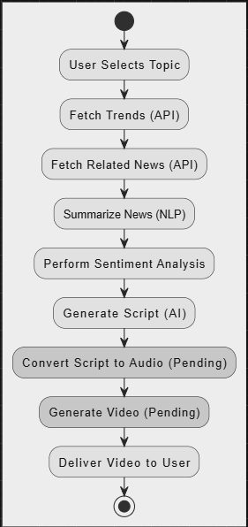

## Sequence Diagrams

Figure 2 Sequence Diagram

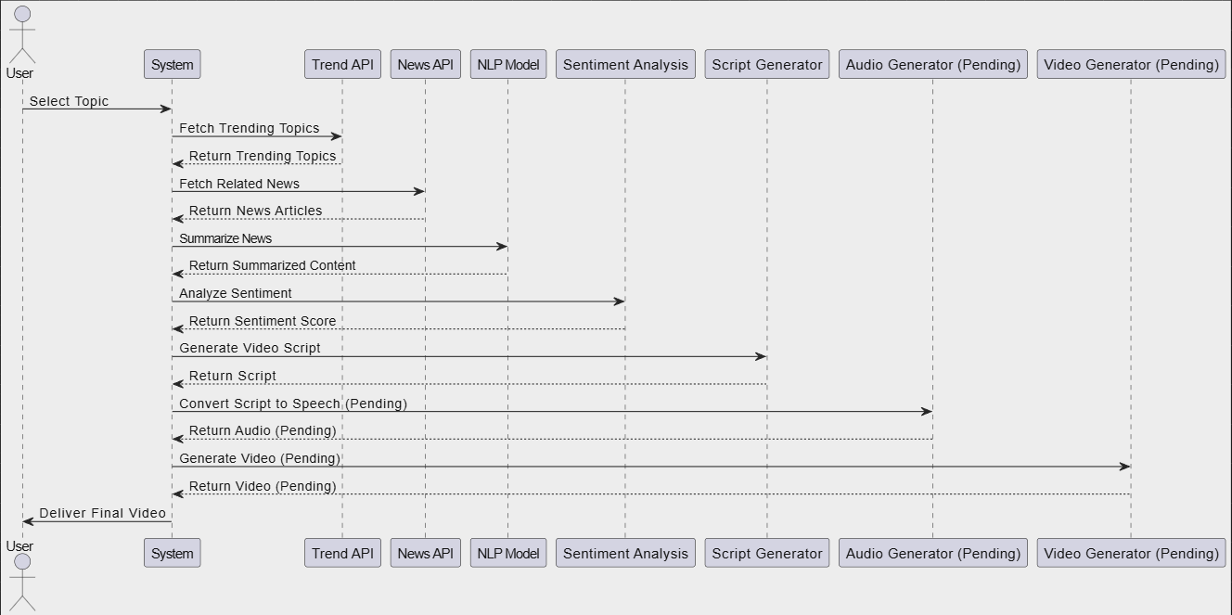

## 4.3 Entity Relation Diagram

Figure 3.1 ERD Diagram

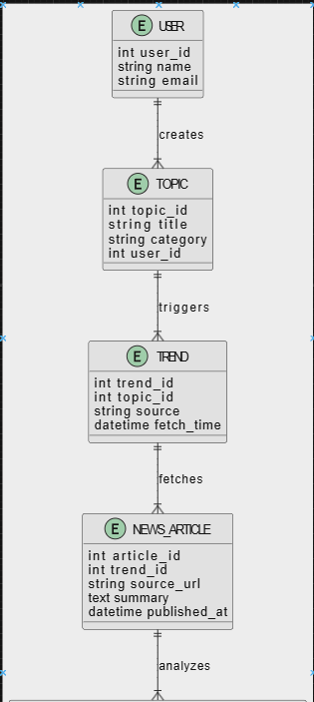

Figure 3.2 ERD Diagram

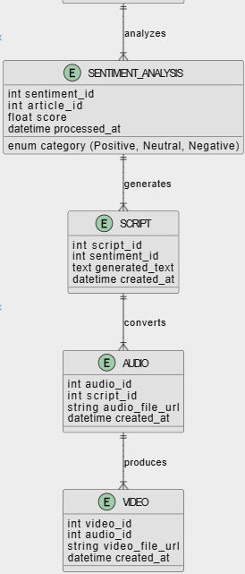

# 5. Agile Implementation Plan

## 5.1 Sprints Overview

Sprint Goals:

Sprint 1:

Setup and API integration (Google Trends, News APIs).

Sprint 2:

Implement NLP-based summarization and sentiment analysis.

Sprint 3:

Develop AI script generation module.

Sprint 4:

Integrate TTS-based audio conversion.

Sprint 5:

Implement AI video generation.

Sprint 6:

Final testing and optimization.

## 5.2 Sprint Backlog

* Current focus: Refining trend analysis, news summarization, and sentiment analysis.
* Future backlog: AI-generated voice narration and video processing.