**SEAM CARVING FOR CONTENT-AWARE IMAGE RESIZING**

**Submitted by:**

MOHIT KUMRA (9913103538)

SARTHAK BHUTANI (9913103524)

ROHIT KUMAR(9913103518)

**Under the supervision of:**

Mr. BANSIDHAR JOSHI

(Deptt of CSE/IT)



**December – 2016**

**Submitted in partial fulfillment of the Degree of**

**BACHELOR OF TECHNOLOGY**

**IN**

**COMPUTER SCIENCE AND ENGINEERING**

**DEPARTMENT OF COMPUTER SCIENCE ENGINEERING & INFORMATION TECHNOLOGY**

**JAYPEE INSTITUTE OF INFORMATION TECHNOLOGY, NOIDA**

**(I)**

**TABLE OF CONTENTS**

**Chapter No. Topics Page No.**

Student Declaration II

Certificate from the Supervisor III

Acknowledgment IV

Summary V

List of Tables VI

List of Figures VII

**Chapter-1** **Introduction** 9-10

1.1 General Introduction

1.2 List some relevant current/open problems.

1.3 Problem Statement

1.4 Overview of proposed solution approach and Novelty/benefits

**Chapter-2** **Background Study** 11-25

2.1 Literature Survey

2.1.1 Summary of papers

2.1.2 Integrated summary of the literature studied

2.1.3 solution to the problem framed

2.2 Details of Empirical Study

**Chapter 3: Analysis, Design and Modeling**  26-31

3.1 Requirements Specifications

3.2 Functional and Non-Functional requirements

3.3 Overall architecture with component description and dependency details

3.4 Design Documentation

3.4.1 Use Case diagrams

3.4.2 Class diagrams / Control Flow Diagrams (whichever is applicable)

3.4.3 Sequence Diagram/Activity diagrams (whichever is applicable)

3.4.4 Data Structures and Algorithms / Protocols

3.5 Risk Analysis and Mitigation Plan

**Chapter-4 Implementation and Testing 3**2-45

4.1 Implementation details and issues

4.2 Testing

4.2.1 Limitations of the solution

4.2.2 Testing Plan

4.2.3 Component decomposition and type of testing required

**Chapter-5 Findings & Conclusion** 46

5.1 Findings

5.2 Conclusion

5.3 Future Work

References 47

Brief Bio-data (Resume) of Student

**(II)**

**DECLARATION**

I/We hereby declare that this submission is my/our own work and that, to the best of my knowledge and belief, it contains no material previously published or written by another person nor material which has been accepted for the award of any other degree or diploma of the university or other institute of higher learning, except where due acknowledgment has been made in the text.

Place: Noida Signature:

Date: 20/12/2016 Name: Mohit Kumra

Enrollment No: 9913103538

Place: Noida Signature:

Date: 20/12/2016 Name: Sarthak Bhutani

Enrollment No: 9913103524

Place: Noida Signature:

Date: 20/12/2016 Name: Rohit Kumar

Enrollment No: 9913103518

Signature:

**(III)**

**CERTIFICATE**

This is to certify that the work titled “**SEAM CARVING FOR CONTENT-AWARE IMAGE RESIZING**” submitted by **“MOHIT KUMRA, SARTHAK BHUTANI & ROHIT KUMAR”** in partial fulfillment for the award of degree of B.Tech Computer Science Engineering of Jaypee Institute of Information Technology University, Noida has been carried out under my supervision. This work has not been submitted partially or wholly to any other University or Institute for the award of this or any other degree or diploma.

Signature of Supervisor ……………………...

Name of Supervisor Bansidhar Joshi

Designation Assistant Professor

Date 20, December-2016

**(IV)**

**ACKNOWLEDGEMENT**

We would like to place on record our deep sense of gratitude to **Mr. Bansidhar Joshi**, Jaypee Institute of Information Technology, India for her generous guidance, help and useful suggestions.We express my sincere gratitude to **Prof. Shelly Sachdeva** and **Mrs. Anubhuti Roda Mohindra**, Dept. of Computer Science for her stimulating guidance, continuous encouragement and supervision throughout the course of present work.

We also wish to extend our thanks to classmates for their insightful comments and constructive suggestions to improve the quality of this project work.

Members:-

Signature of Student ……………………...

Name of Student Mohit Kumra

Enrollment Number 9913103538

Date 20, December-2016

Signature of Student ……………………...

Name of Student Sarthak Bhutani

Enrollment Number 9913103524

Date 20, December-2016

Signature of Student ……………………...

Name of Student Rohit Kumar

Enrollment Number 9913103518

Date 20, December-2016

**(V)**

**SUMMARY**

Image Processing is an important technology for processing on images. The analysis and manipulation of a digitized image and improves its quality. Processing offers a number of techniques for process on image such as Image Resizing, Image Enhancement etc. Image re-sizing is a key technique for displaying images on different devices, and it has attracted much attention in the past few years.

Our Project aims at implementing the Seam Carving Technique,one of the techniques used for content aware image re-sizing including reduction and expansion. A seam is defined as an optimal 8-connected path of low energy pixels crossing the image from top to bottom, or left to right. The importance of a pixel is defined by an energy function based on the image gradient.Image Resizing can be more effectively achieved with a better understanding of image semantics. Content-aware image re-sizing has been a promising theme in the communities of image processing and computer vision.

__________________ __________________

Signature of Student Signature of Supervisor

Name Mohit Kumra Name Bansidhar Joshi

Date 21, December-2016 Date 21, December, 2016

__________________

Signature of Student

Name Sarthak Bhutani

Date 21, December-2016

__________________

Signature of Student

Name Rohit Kumar

Date 21, December-2016

**(VI)**

**LIST OF FIGURES**

|  |  |  |
| --- | --- | --- |
| 1. | Image Re-targeting Methods | Page 21 |
| 2. | Filtering of Research papers | Page 25 |
| 3. | Architecture Implementation Plan | Page 28 |
| 4. | Fundamental steps in Digital Image Processing | Page 28 |
| 5. | Use Case Diagram | Page 27 |
| 6. | Control Flow Diagram | Page 28 |
| 7. | Sequence Diagram | Page 29 |
| 8. | Energy Function | Page 30 |
| 9. | Seam selection function | Page 30 |
| 10. | Screenshot 1 | Page 35 |
| 11. | Screenshot 2 | Page 35 |
| 12. | Screenshot 3 | Page 36 |
| 13. | Screenshot 4 | Page 36 |
| 14. | Screenshot 5 | Page 37 |
| 15. | Screenshot 6 | Page 37 |
| 16. | Screenshot 7 | Page 38 |
| 17. | Screenshot 8 | Page 38 |

**(VII)**

**LIST OF TABLES**

|  |  |  |
| --- | --- | --- |
| 1. | Technique Comparison Table | Page 10 |
| 2. | Research Analysis | Page 14-25 |
| 3. | Risk Analysis & Mitigation Plan | Page 32 |
| 4. | Testing Plan | Page 34 |
| 5. Com | Component Decomposition and Testing | Page 36 |

**1 Introduction**

**1.1 General Introduction**

The diversity and versatility of display devices today imposes new demands on digital media. For instance, designers must create different alternatives for web-content and design different layouts for different devices. Moreover, HTML, as well as other standards, can support dynamic changes of page layout and text. Nevertheless, upto date, images, although being one of the key elements in digital

media, typically remain rigid in size and cannot deform to fit different layouts automatically. Other cases in which the size, or aspect ratio of an image must change, are to fit into different displays such as cell phones or PDAs, or to print on a given paper size or resolution.

Standard image scaling is not sufficient since it is oblivious to the image content and typically can be applied only uniformly. Cropping is limited since it can only remove pixels from the image periphery. More effective resizing can only be achieved by considering the image content and not only geometric constraints.

Our Aim is to resize Images using an optimized technique such that the important data and originality of the image is maintained , to do this we propose a simple image operator, we term seam-carving, that can change the size of an image by gracefully carving-out or inserting pixels in different parts of the image. Seam carving uses an energy function defining the importance of pixels. A seam is a connected path of low energy pixels crossing the image from top to bottom, or from left to right. By successively removing or inserting seams we can reduce, as well as enlarge, the size of an image in both directions.

**1.2 List some relevant current/open problems.**

* The algorithm may need user-provided information to reduce errors. This can consist of painting the regions which are to be preserved. With human faces it is possible to use face detection.
* Sometimes the algorithm, by removing a low energy seam, may end up inadvertently creating a seam of higher energy. The solution to this is to simulate a removal of a seam, and then check the energy delta to see if the energy increases. If it does, prefer other seams instead

|  |  |  |
| --- | --- | --- |
| S.No | Method | Relevant for usage |
| 1 | **Content-Aware Cropping** | For images where all regions contain meaningful information, it retargets images with bad quality. |
| 2 | **Content-Aware Scaling** | If the aspect ratio between the input and output is different, scaling will cause large distortions. Image scaling isn’t sufficient as it is oblivious to image content and typically can be applied only uniformly |
| 3 | **Warping** | Not solve images without obvious focus areas;attempts to keep prominent regions as they are while distorting only homogeneous regions. |
| 4 | **Seam Carving** | supports various visual saliency measures for defining the energy of an image;can also include user input to guide the process;By storing the order of seams in an image, we create multi-size images.Overcomes the drawbacks of all the other approaches. |

Table 1.:Technique Comparison Table

**1.3 Problem Statement**

The whole idea of the project is to implement the Seam Carving Technique,one of the techniques used for content aware image re-sizing including reduction and expansion. A seam is defined as an optimal 8-connected path of low energy pixels crossing the image from top to bottom, or left to right. The importance of a pixel is defined by an energy function based on the image gradient.The main issue is to find out how efficiently the Seam carving technique performs image re-sizing and the quality of image as a resultant.Content-aware image re-sizing has been a promising theme in the communities of image processing and computer vision.Image Resizing can be more effectively achieved with a better understanding of image semantics.

**1.4 Overview of Proposed Solution approach and Novelty/benefits**

The intent of our work is to predominantly focus on implementing the technique of Image re sizing known as “Seam Carving” technique.Image re-sizing is one of the ways in which we inculcate image enhancement.In this project we develop an optimized solution to the Seam carving technique.

The system provides the user with the flexibility to enhance the Images with much more precision and accuracy.Users are able to get a more efficient and accurate outcome after they apply the Image Enhancement technique.

**2 Background Study**

**2.1 Literature Survey**

**2.1.1 Sources**

* International Journal of Advanced Research
* **IEEE**
* University College of London
* Dartmouth College
* **International journal of Innovative Research**
* The Chinese University of Hong Kong
* Department of Electrical and Electronics Engineering,West Bengal
* Óbuda University,Budapest
* University of Minnesota
* National Cheng Kung University
* New York University

## 2.1.2 Summary of papers studied

**2.1.2.1 MATLAB based Image Editing and Color Detection**

|  |  |
| --- | --- |
| Author | Raquib Buksh1 , Soumyajit Routh2 , Parthib Mitra3 , Subhajit Banik4 , Abhishek Mallik5 , Sauvik Das Gupta |
| Publisher Details | International Journal of Scientific and Research Publications, Volume 4, Issue 1, January 2014,ISSN 2250-3153 |
| Web Link  Details | <http://www.ijsrp.org/research-paper-0114/ijsrp-p25106.pdf> |
| Summary | This research paper deals with the implementation of various MATLAB functions present in image processing toolbox of MATLAB and using the same to create a basic image processor having different features like, viewing the red, green and blue components of a color image separately, color detection and various other features (noise addition and removal, edge detection, cropping, resizing, rotation, histogram adjust, brightness control, etc.) that is used in a basic image editor along with object detection and tracking. In this paper the authors presented a set of MATLAB applications useful for image processing and color detection, each of which consists of user friendly graphical interface helpful for those not familiar with MATLAB programs running behind the image processor. |

**2.1.2.2 Seam Carving for Content-Aware Image Resizing**

|  |  |
| --- | --- |
| Author | Shai Avidan and Ariel Shamir |
| Web Link | <http://graphics.cs.cmu.edu/courses/15-463/2007_fall/hw/proj2/imret.pdf> |
| Summary | This paper critically analyses content image resizing.Effective resizing of images should not only use geometric constraints, but consider the image content as well. We present a simple image operator called seam carving that supports content-aware image resizing for both reduction and expansion. A seam is an optimal 8-connected path of pixels on a single image from top to bottom, or left to right, where optimality is defined by an image energy function. By repeatedly carving out or inserting seams in one direction we can change the aspect ratio of an image. By applying these operators in both directions we can retarget the image to a new size Seam carving can support several types of energy functions such as gradient magnitude, entropy, visual saliency, eye-gaze movement,and more. The removal or insertion processes are parameter free. |

**2.1.2.3 Pattern Recognition and Image Processing**

|  |  |
| --- | --- |
| Author | KING-SUN FU,AZRIEL ROSENFELD |
| Publication  Details | IEEE TRANSACTIONS ON COMPUTERS, VOL. C-25, NO. 12, DECEMBER 1976 |
| Web Link | <https://www.computer.org/csdl/trans/tc/1976/12/01674602.pdf> |
| Summary | Extensive research and development has taken place over the last 20 years in the areas ofpattern recognition andimage processing. Areas towhich these disciplines have beenapplied include business (e.g., character recognition), medicine (diagnosis, abnormality detection), automation (robot vision), military intelligence, communications (data compression, speech recognition), and many others. This paper presents a very briefsurvey ofrecent developments in basic pattern recognition and image processing techniques. Index Terms-Decision-theoretic recognition, image processing, image recognition, pattern recognition, syntactic recognition. |

**2.1.2.4 Image Resizing using Seam Carving**

|  |  |
| --- | --- |
| Author | Kristin Rachor |
| Publisher Details | University of Minnesota, Morris,Undergraduate Journal |
| Web Link  Details | <http://digitalcommons.morris.umn.edu/cgi/viewcontent.cgi?article=1034&context=horizons> |
| **Summary** | Image resizing has become more necessary with the increased popularity of cell phones, tablets and other electronic devices with varying screen sizes. This paper presents methods for resizing images and videos while attempting to preserve the important content of that image or video. An algorithm called seam carving can expand or reduce the size of an image while typically maintaining quality and content. Seam carving is not always effective however and there have been recent developments and modifications on this algorithm. This paper presents two advancements on seam carving, one that optimizes image retargeting on images with many repeated objects or patterns. The other applies the method of seam carving to video resizing. This paper presents methods for resizing images and videos while attempting to preserve the important content of that image or video. An algorithm called seam carving can expand or reduce the size of an im age while typically maintaining quality and content. Seam carving is not always effective however and there have been recent developments and modi_cations on this algorithm. This paper presents two advancements on seam carving, one that optimizes image retargeting on images with many repeated objects or patterns. The other applies the method of seam carving to video resizing. |

**2.1.2.5 Automated Defect Recognition Method by Using Digital Image Processing**

|  |  |
| --- | --- |
| Author | Sangwook Lee |
| Publication  Details | *Computing, Communication and Security (ICCCS), 2015 International Conference,IEEE.* |
| Web Link | <http://ascpro.ascweb.org/chair/paper/CPRT120002010.pdf> |
| Summary | As existing infrastructure systems are aged and deteriorated rapidly, state agencies started searching for more advanced ways to maintain their valuable assets to the acceptable level. One of them is the application of digital image processing. Recently, in the civil engineering domain, digital image processing methods have been developed to the areas of pavement conditions, underground pipeline inspection, and steel bridge coating assessment. The main reasons to count on the advanced technology are due to such advantages as accuracy, objectivity, speed, and consistency. These distinct advantages have brought attention to state agencies to minimize the shortcomings of existing inspection practices. The conditions of steel bridge painting surfaces can be evaluated accurately and quickly by applying digital image processing. Also, machine vision-dependent inspections can provide more consistent inspection results than human visual inspections. Because conventional inspection heavily relies on individual abilities, inspection results are errorprone and may have wide variations between inspectors. The results can be different depending on personal preferences, work experiences, and the workload of the inspectors. It is pretty important to develop reliable infrastructure condition assessment for better maintenance of the assets |

**2.1.2.6 Learning the Change for Automatic Image Cropping**

|  |  |
| --- | --- |
| Author | Jianzhou Yan Stephen Lin Sing Bing Kang Xiaoou Tang |
| Web Link  Details | http://research.microsoft.com/en-us/UM/people/stevelin/papers/cvpr13yan.pdf |
| Summary | In this paper we provide a detailed overview of existing research of cropping technique being practiced for Image processing.Many images contain salient regions that are surrounded by too much uninteresting background material and are not as enlightening as a sensibly cropped version.This paper proposes a method of automatically cropping visual material based upon a new measure of visual attention that reflects the informativeness of the image. Hugh quantities of digital images and video are being created which are not informative simply because the interesting parts are not immediately apparent to a human observer. This may be because there is an overwhelming amount of distracting background material or because the images are being viewed on a small display. |

**2.1.2.7 Attention Based Auto Image Cropping**

|  |  |
| --- | --- |
| Author | Fred Stentiford |
| Web Link  Details | <http://www.ee.ucl.ac.uk/~fstentif/WCAA2007.pdf> |
| Summary | In this paper we provide a detailed overview of existing research of cropping technique being practiced for Image processing.Many images contain salient regions that are surrounded by too much uninteresting background material and are not as enlightening as a sensibly cropped version.This paper proposes a method of automatically cropping visual material based upon a new measure of visual attention that reflects the informativeness of the image. Hugh quantities of digital images and video are being created which are not informative simply because the interesting parts are not immediately apparent to a human observer. This may be because there is an overwhelming amount of distracting background material or because the images are being viewed on a small display. |

**2.1.2.8 Comparative Study of Image Resizing**

|  |  |
| --- | --- |
| Author | Fred Stentiford |
| Publication  Details | Volume 4, Issue 1, January 2014 ISSN: 2277 128X  International Journal of Advanced Research in Computer Science and Software Engineering(IJARCSSE) |
| Web Link | https://www.ijarcsse.com/docs/papers/Volume_4/1_January2014/V4I1-0362.pdf |
| Summary | Original images usually have higher resolutions and different aspect ratios. Small screens cannot provide enough resolution to make the image meet the visual demand. This paper made a comparative analysis of the four most popular image resizing methods, namely – Warping Based, Seam Carving, Content Based and Salience Driven Method. All the methods were tested for different input images. It was observed that the use of different algorithms for a single input image gives different results, depending upon the method used. This leads to the conclusion that different methods are required for different input images. Hence it is hard to say that any particular method can give best result in all conditions. It was seen that Warping Based technique is effective in case of enlarging the selected context. **The seam carving method is very effective in case of overcoming the distortion, missing or undesired image anomalies.** The third method fall under the scope of this paper is content based method. It was found that the method proves its effectiveness in eliminating any undesired objects in an image thereby overlapping the undesired object by the nearest energy level. The Saliency Driven method is effective for minimizing the salient regions. |

**2.1.2.9 Automatic Image Cropping using Visual Composition,**

**Boundary Simplicity and Content Preservation Models**

|  |  |
| --- | --- |
| Author | Chen Fang 1, Zhe Lin 2, Radomír Mˇech 2, Xiaohui Shen |
| Publication  Details | Volume 4, Issue 1, January 2014 ISSN: 2277 128X  International Journal of Advanced Research in Computer Science and Software Engineering(IJARCSSE) |
| Web Link | https://www.ijarcsse.com/docs/papers/Volume_4/1_January2014/V4I1-0362.pdf |
| Summary | Cropping is one of the most common tasks in image editing for improving the aesthetic quality of a photograph. In this  paper, we propose a new, aesthetic photo cropping system  which combines three models: visual composition, bound-  ary simplicity, and content preservation. The visual com-  position model measures the quality of composition for a  given crop. Instead of manually de_ning rules or score func-  tions for composition, we learn the model from a large set  of well-composed images via discriminative classi_er train-  ing. The boundary simplicity model measures the clearness  of the crop boundary to avoid object cutting-through. The  content preservation model computes the amount of salient  information kept in the crop to avoid excluding important  content. By assigning a hard lower bound constraint on the  content preservation and linearly combining the scores from  the visual composition and boundary simplicity models, the  resulting system achieves signi_cant improvement over re-  cent cropping methods in both quantitative and qualitative  evaluation. |

**2.1.2.10 An Overview on Image Processing Techniques**

|  |  |
| --- | --- |
| Author | B. Chitradevi , P.Srimathi |
| Publication  Details | International Journal of Innovative Research in Computer and Communication Engineering. Vol. 2, Issue 11, November 2014 |
| Web Link | <http://www.rroij.com/open-access/an-overview-on-image-processing-techniques.php?aid=47175> |
| Summary | Digital image processing is always an interesting field as it gives improved pictorial information for human interpretation and processing of image data for storage, transmission, and representation for machine perception. Image Processing is a technique to enhance raw images received from cameras/sensors placed on satellites, space probes and aircrafts or pictures taken in normal day-to-day life for various applications. This field of image processing significantly improved in recent times and extended to various fields of science and technology. The image processing mainly deals with image acquisition, Image enhancement, image segmentation, feature extraction, image classification |

**2.1.2.11 A Review on Image Processing Techniques for Synthetic Aperture Radar (SAR) Images**

|  |  |
| --- | --- |
| Author | P.Geetha, B. Chitradevi |
| Publication  Details | International Journal of Innovative Research in Computer and Communication Engineering. Vol. 2, Issue 11, November 2014 |
| Web Link | http://www.rroij.com/open-access/a-review-on-image-processing-techniques-forsynthetic-aperture-radar-sar-images.php?aid=45725 |
| Summary | SAR has been deeply used for sea ice monitoring in polar regions.A computer aided analysis of SAR sea ice imagery is extremely difficult due to several imaging parameters and environmental factors.Image processing and neural network techniques are used to improve the performance of detecting and classifying sea ice in SAR images.It an overview of techniques of SAR images and its recent progress.The primary objective of this paper is to summarize some of the well known methods used in various stages of image processing system |

**2.1.2.12 GENETIC ALGORITHM FOR PARAMETER OPTIMIZATION OF IMAGE SEGMENTATION ALGORITHM**

|  |  |
| --- | --- |
| Author | Sándor Szénási |
| Publication  Details | Volume 4, Issue 1, January 2014 ISSN: 2277 128X  International Journal of Advanced Research in Computer Science and Software Engineering(IJARCSSE) |
| Web Link | <http://users.nik.uni-obuda.hu/sanyo/gpgpu/cinti2013_submission_111.pdf> |
| Summary | In the current practice of medicine, histopathological examinations are some of the most important tools for clinical diagnoses of a large group of diseases. To help pathologists and to reduce the subjectivity level, it has been proposed that computer-aided procedures be used to provide objective results. The first step of these procedures is the segmentation of the tissue image. In our research, we try to detect nuclei, glands and surface epithelium in Haematoxylin and Eosin (HE) stained colon tissue samples. This paper focuses on the identification of epithelial cell nuclei |

**2.1.2.13 IMAGE PROCESSING IN FREQUENCY DOMAIN USING MATLAB**

|  |  |
| --- | --- |
| Author | Vinay Kumar, Manas Nanda |
| Publication  Details | Volume 4, Issue 2, September 2008.  International Journal of Advanced Research in Computer Science and Software Engineering(IJARCSSE) |
| Web Link | <https://hal.archives-ouvertes.fr/file/index/docid/321613/filename/IMAGE_PROCESSING_IN_FREQUENCY_DOMAIN_USING_MATLAB_A_STUDY_FOR_BEGINNERS.pdf> |
| Summary | Digital image processing is the use of computer algorithms to perform image processing on digital images. As a subfield of digital signal processing, digital image processing has many advantages over analog image processing; it allows a much wider range of algorithms to be applied to the input data, and can avoid problems such as the build-up of noise and signal distortion during processing.An image as defined in the “real world” is considered to be a function of two real variables, for example, a(x,y) with a as the amplitude (e.g. brightness) of the image at the real coordinate position (x,y). Further, an image may be considered to contain sub-images sometimes referred to as regions-of-interest, ROIs, or simply regions. This concept reflects the fact that images frequently contain collections of objects each of which can be the basis for a region. |

**2.1.2.14 Security using image processing**

|  |  |
| --- | --- |
| Author | Jyotika Kapur ,Akshay. J. Baregar |
| Publication  Details | Volume 4, Issue 1, January 2014 ISSN: 2277 128X  International Journal of Advanced Research in Computer Science and Software Engineering(IJARCSSE) |
| Web Link | <http://airccse.org/journal/ijmit/papers/5213ijmit02.pdf> |
| Summary | Using image stitching and image steganography security can be provided to any image which has to be sent over the network or transferred using any electronic mode. There is a message and a secret image that has to be sent. The secret image is divided into parts.The first phase is the Encrypting Phase, which deals with the process of converting the actual secret message into ciphertext using the AES algorithm. In the second phase which is the Embedding Phase, the cipher text is embedded into any part of the secret image that is to be sent. Third phase is the Hiding Phase, where steganography is performed on the output image of Embedding Phase and other parts of the image where the parts are camouflaged by another image using least significant bit replacement. These individual parts are sent to the concerned receiver. At the receivers end decryption of Hiding phase and Embedding Phase takes place respectively. The parts obtained are stitched together using k nearest method. Using SIFT features the quality of the image is improved. |

**2.1.3 Give tabular comparison of other existing approaches/ solution to the problem framed**

|  |  |  |
| --- | --- | --- |
| S.No | Method | Relevant for usage |
| 1 | **Content-Aware Cropping** | For images where all regions contain meaningful information, it retargets images with bad quality. |
| 2 | **Content-Aware Scaling** | If the aspect ratio between the input and output is different, scaling will cause large distortions. Image scaling isn’t sufficient as it is oblivious to image content and typically can be applied only uniformly |
| 3 | **Warping** | Not solve images without obvious focus areas;attempts to keep prominent regions as they are while distorting only homogeneous regions. |
| 4 | **Seam Carving** | supports various visual saliency measures for defining the energy of an image;can also include user input to guide the process;By storing the order of seams in an image, we create multi-size images.Overcomes the drawbacks of all the other approaches. |

**Technique Comparison Table**

**2.2 Summary of Field Survey, Experimental study**

Image Processing is an important technology for processing on images. The analysis and manipulation of a digitized image and improves its quality. Processing offers a number of techniques for process on image such as Image Resizing, Image Enhancement etc. Image resizing is a key technique for displaying images on different devices, and it has attracted much attention in the past few years. This paper surveys the image resizing methods proposed in recent years, they Defines preserving an important region of an image, minimizing distortions, and improving efficiency. Image Resizing can be more effectively achieved with a better understanding of image semantics. Content-aware image resizing has been a promising theme in the communities of image processing and computer vision.

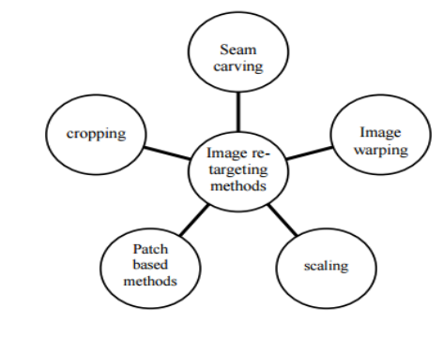

Fig 1.:Image Re-targeting Methods

**• CONTENT-AWARE CROPPING**

Cropping can be defined as manually choosing a window of the target size from the source image to maximize the salient information. Important factor is to find the region of interest (ROI) to determine the optimal sub-image to maintain.

* Advantages and Disadvantages:-

For images containing with small region and having more salient content, cropping method retargets a good quality image. But, for images where all regions contain meaningful information, it retargets images with bad quality.

* **CONTENT-AWARE SCALING**

Scaling is a simple method for retargeting images. Scaling images in horizontal or vertical direction can be performed in real-time using interpolation and will preserve the global visual effects and retarget images with medium perceptual quality

* Advantages and Disadvantages

If the aspect ratio between the input and output is different, scaling will cause large distortions. Image scaling isn’t sufficient as it is oblivious to image content and typically can be applied only uniformly. Also, scaling will introduce some shape deformation into the retargeted image.

**• WARPING**

The warping method can be defined by the warping function, which maps positions in a source image to positions in a target image. The warping function is nonlinear and shows different magnifications in different parts of the image. The warping resizing method emphasizes the ROI and does not discard other parts of the image completely.

* Advantages and Disadvantages

This method could maintain required details and necessary contexts, but it conceives only a single ROI.Because this method locates the focus areas clearly, it could not solve images without obvious focus areas.These methods attempts to keep prominent regions as they are while distorting only homogeneous regions.

**• SEAM CARVING**

Seam carving technique is a popular Image Retargeting method. The general idea of seam carving is to decrease image width or height one pixel at a time, by removing seam of minimal importance. A seam is 8- connected path of pixels (from top to bottom or from right to left, depending on which dimension is to be reduced) that contains only one pixel per row or per column. Seam carving was invented, not only for effective resizing of images with geometric constraints, but also to consider the image content as well. Seam carving supports content-aware image resizing for both reduction and expansion. It works by finding the lowest-energy connected path of pixels from either left to right (horizontal seam) or top to bottom (vertical seam), removing those pixels, and repeating the process. To maintain the rectangular structure of an image, each path of pixels include exactly one pixel per column for horizontal seams

* Advantages and disadvantages

Seam Carving is a popular approach for content aware image resizing. It supports various visual saliency measures for defining the energy of an image, and can also include user input to guide the process. By storing the order of seams in an image, we create multi-size images, that are able to continuously change in real time to fit a given size. However, seam carving method has some drawbacks as with simple row/column removal, it can excessively carve less important parts of an image and result in unwanted visual distortions. Also, the seam method does not consider any approaches to preserve the object shape. Therefore, alone it can exhibit bad perceptual quality, especially for images containing salient objects.

.

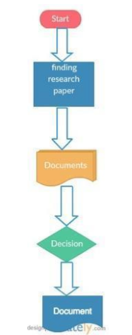

Fig 1.:Filtering of Research papers

**3. Analysis, Design & Modeling**

**3.1 Requirements Specifications**

* Windows Environment
* Ram: 4GB for complete OS Environment
* Processor: 2Ghz Dual Core
* Matlab Software (development stage)

**3.2 Functional Requirement and Non Function Requirement**

**Functional Requirement**

Functional requirements define a function of a [software system](http://en.wikipedia.org/wiki/Software_system" \o "Software system) or its component. Some of

the functional Requirements are:

* Input
* The Training set(Images)
* Select the required attributes
* Applying the desired algorithm
* Output
* The system should be able to apply the algorithm and yield the resulting Image.
* The system should give the desired accuracy.
* Data file(containing Images) should be uploaded/attached correctly.

**Non Functional Requirement**

Non-functional requirements are the [requirement](https://en.wikipedia.org/wiki/Requirement" \o "Requirement)s that specifies criteria that can be used to judge the operation of a system, rather than specific behaviors. Some of the non-functional requirements are:

* Dataset(Images) should be as diverse as possible with as many unique instances to give more accuracy.
* Ability to deal with noisy data(Distorted/high pixel Images).
* The solution must provide reliability to the user such that the system will run with all the features mentioned in this document are available and executing perfectly.
* The application must run on a desktop having MATLAB installed.

**3.3 Overall architecture with component description and dependency details**

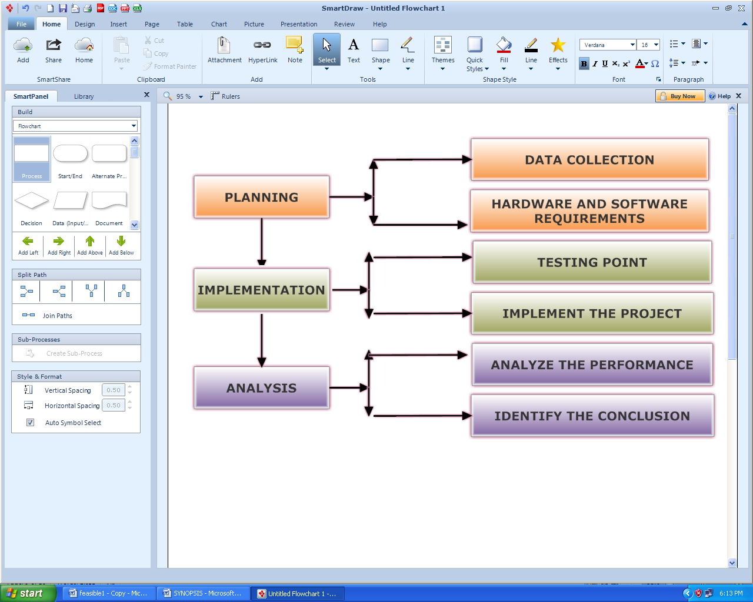

Fig 2.:Architecture Implementation Plan

The Flow of Dataset(Images) is depicted in the below Image where the system(MATLAB) acquires the Image to apply the algorithm.

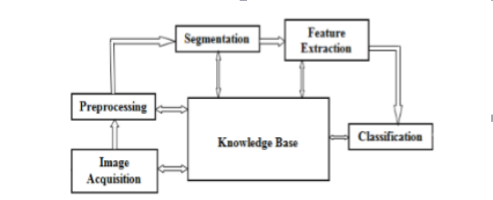

Fig 3.Fundamental steps in Digital Image Processing

* Image Read command: It aims to read/attach/load Images.
* Show command: It aims to display Images..
* Performance Analyzer: Here the user can analyze the performance of Objects in an Image.
* Improvement Command: Here the user can improve Image Contrast.

**3.3 Design Documentation**

**3.4.1 Use Case Diagram**

**UseCase (1)**

**3.4.2 Control Flow Diagram**

The below flow chart shows the flow of implementation process.

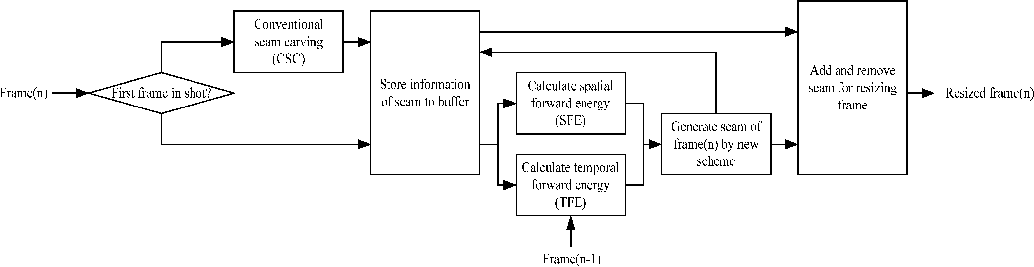

**3.4.3 Sequence Diagram**

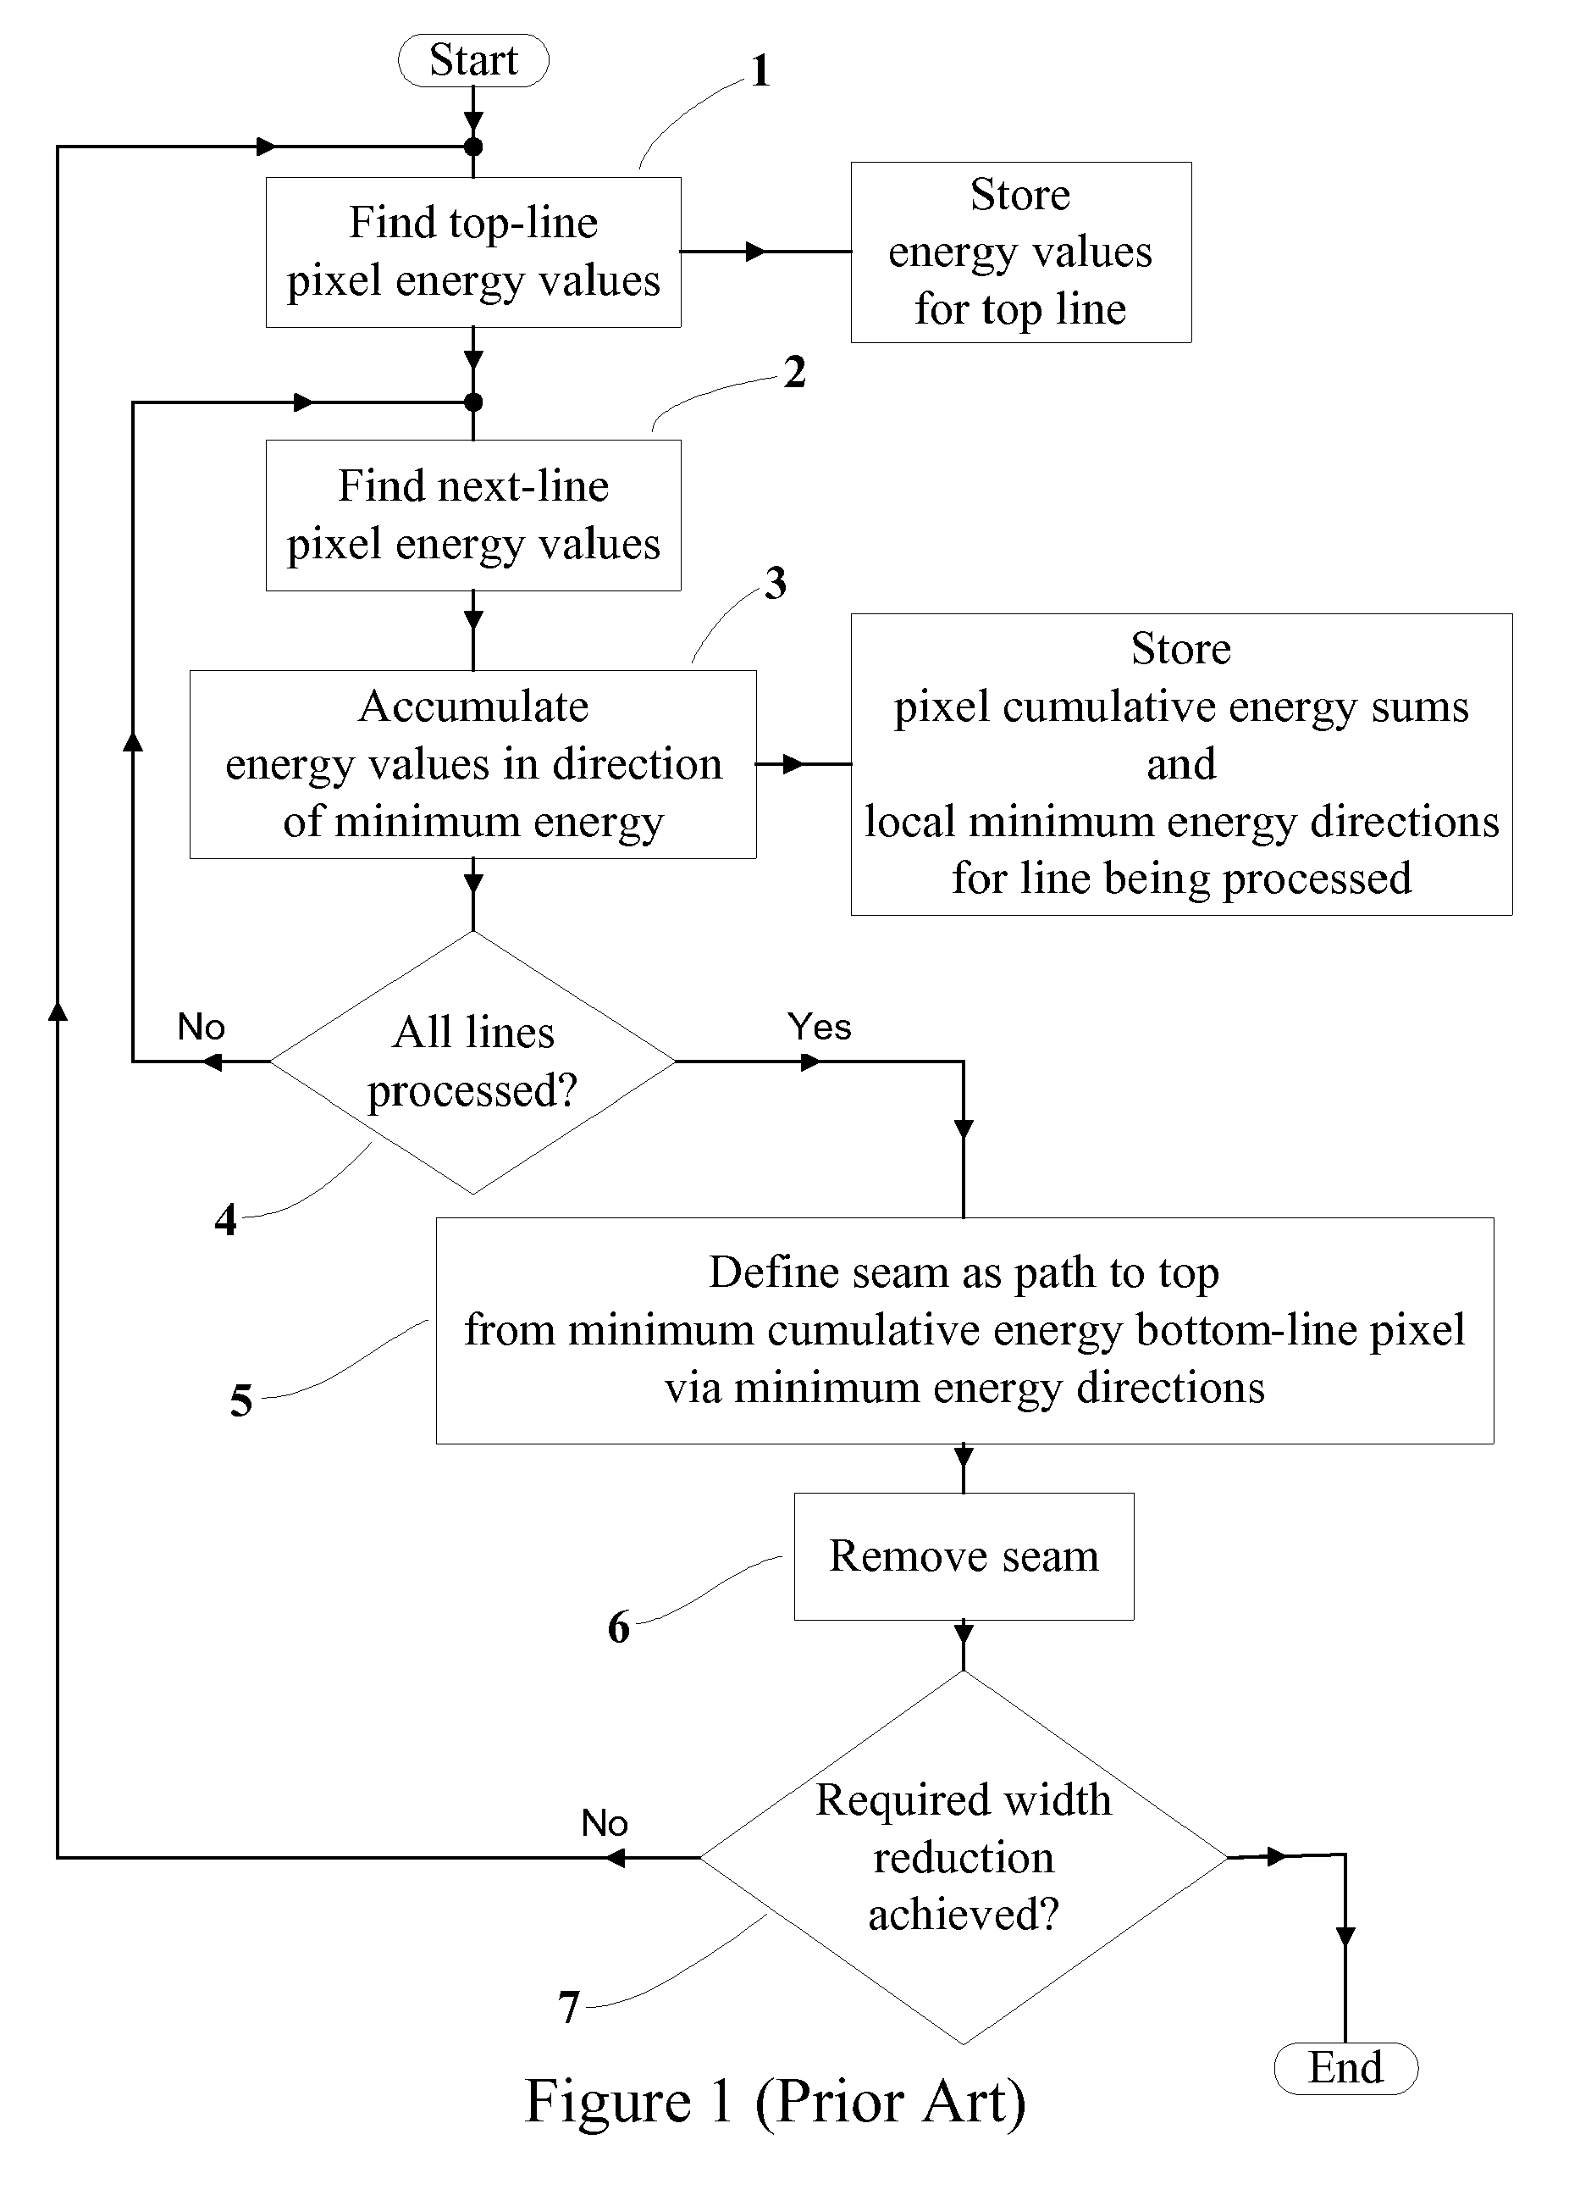

**3.4.4 Proposed Algorithm**

A seam is a connected path of low energy pixels crossing the image from top to bottom, or from left to right. By successively removing or inserting seams we can reduce, as well as enlarge, the size of an image in both directions . Seam carving can support several types of energy functions such as gradient magnitude, entropy, visual saliency, eye-gaze movement, and more. The removal or insertion processes are parameter free however, to allow interactive control, we also provide a scribble based user interface for adding weights to the energy of an image and guide the desired results. The idea behind seam carving is to remove regions of an image who's removal is the least noticeable. Areas that are least noticeable when removed tend to be similar to their surroundings, the pixels in this area are considered to be low energy. A pixels energy is high if its color value is very different from its neighbors.

**ENERGY FUNCTION**

There are different energy functions that can be used to measure this. I describe a methodthat uses the surrounding pixels to measure how different the middle pixel is in comparison.

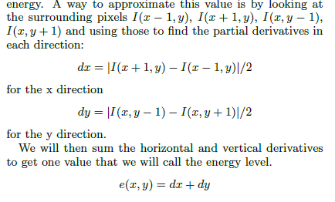

**Fig. 7**

(Ref.Image re-sizing using Seam carving )

To maintain a rectangular image you must remove an equal number of pixels from each row (or column). However just removing the lowest energy pixel from each row over and over will break up the pieces of the image. This leads us to seams. A seam is simply a path that is

one pixel wide and runs from the bottom to the top of an image.



**Fig. 8:** Seam selection function

Here s signifies the seam which will start at the bottom of the image (when i = 1) and traverse up to the top (when i = n). The `for all i' condition states that when you move up you can be at most one pixel to the left or the right of position below you. This insures that the seam stays connected. This same definition holds for horizontal seams where you swap all occurrences of x for y and all occurrences of n for m. Then when a seam is removed all the pixels will shift left (or up) to fill in the missing

The Algorithm will be implemented and would be optimized to yield optimized and more efficient results.

# 3.5 Risk Analysis and Mitigation Plan

**Risk Analysis & Mitigation Plan**

|  |  |  |  |  |  |  |  |
| --- | --- | --- | --- | --- | --- | --- | --- |
| **Risk** | **Description of Risk** | **Risk Area** | **Probability** | **Impact(I)** | **Re(P*I)** | **Mitigation (Y/N)** | **Mitigation Plan** |
| 1. | System not trained | Implementation | 4 | 5 | 15 | Y | Train the system with proper dataset(Image Format). |
| 2. | Object not detected due to distorted Image | Resource | 5 | 4 | 20 | Y | Upload/Attach file with proper dimensions and quality. |
| 3. | When the tool chosen is not installed with required packages. | Performance, time. | 3 | 3 | 9 | Y | Install the tool with required packages. |
| 4. | Photo is of high quality and high pixel distrib., large to be analyzed by the tool. | Performance | 4 | 5 | 20 | Y | Select a portion of data and the try the tool. |

**Rating/Impact**

|  |  |
| --- | --- |
| **Rating** | **Impact** |
| High | 5 |
| Medium | 4 |
| Low | 3 |

**Implementation and Testing**

**4.1 Implementation details and issues**

We would be implementing the algorithms studied under the research papers and after analyzing we would be optimizing the techniques to present a more efficient solution.

The proposed expert system will be made up of two main components

Implementation Phase

We would be implementing the technique used in the Research paper and treat it to the Data-set prepared for all possible outcomes.

Step wise implementation of my research is as follows:

1. Download and install MATLAB _R2009a(7.8.0.347)

2. Create new File or open the already created .m in MATLAB.

3. Execute the code and keep on attaching the Images and tools to be used with the help of commands and toolbox.

4. One can start with an image.

5. We then calculate the weight/density/energy of each pixel. This can be done by various algorithms: gradient magnitude, entropy, visual saliency, eye-gaze movement.

6. After we have the energy of the image, we generate a list of seams. Seams are ranked by energy, with low energy seams being of least importance to the content of the image. We can choose to calculate seams via the dynamic programming approach.

7. We then remove the seams from the image, reducing the size of the image as a result

Screen-shots of the Implementation

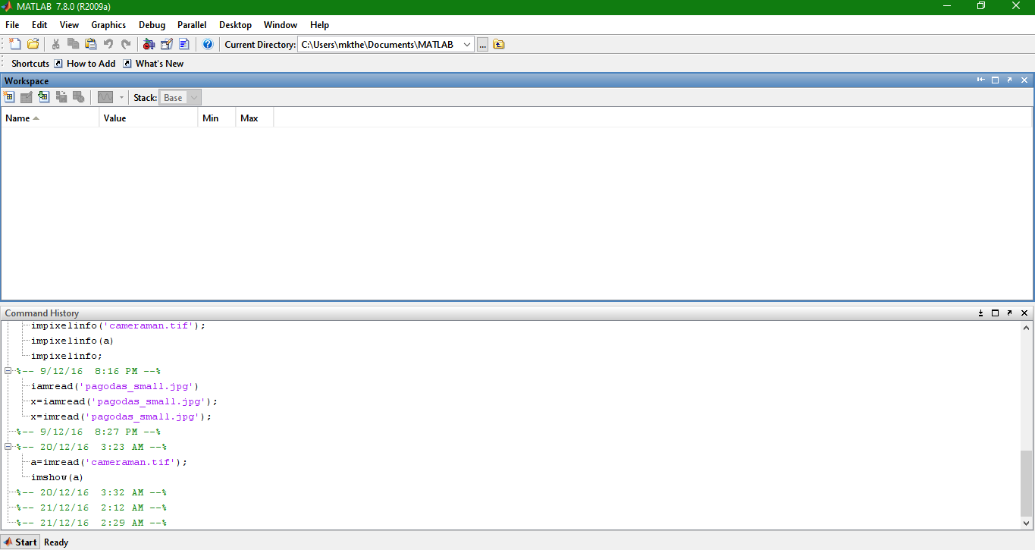

Screenshot1.:Matlab Interface

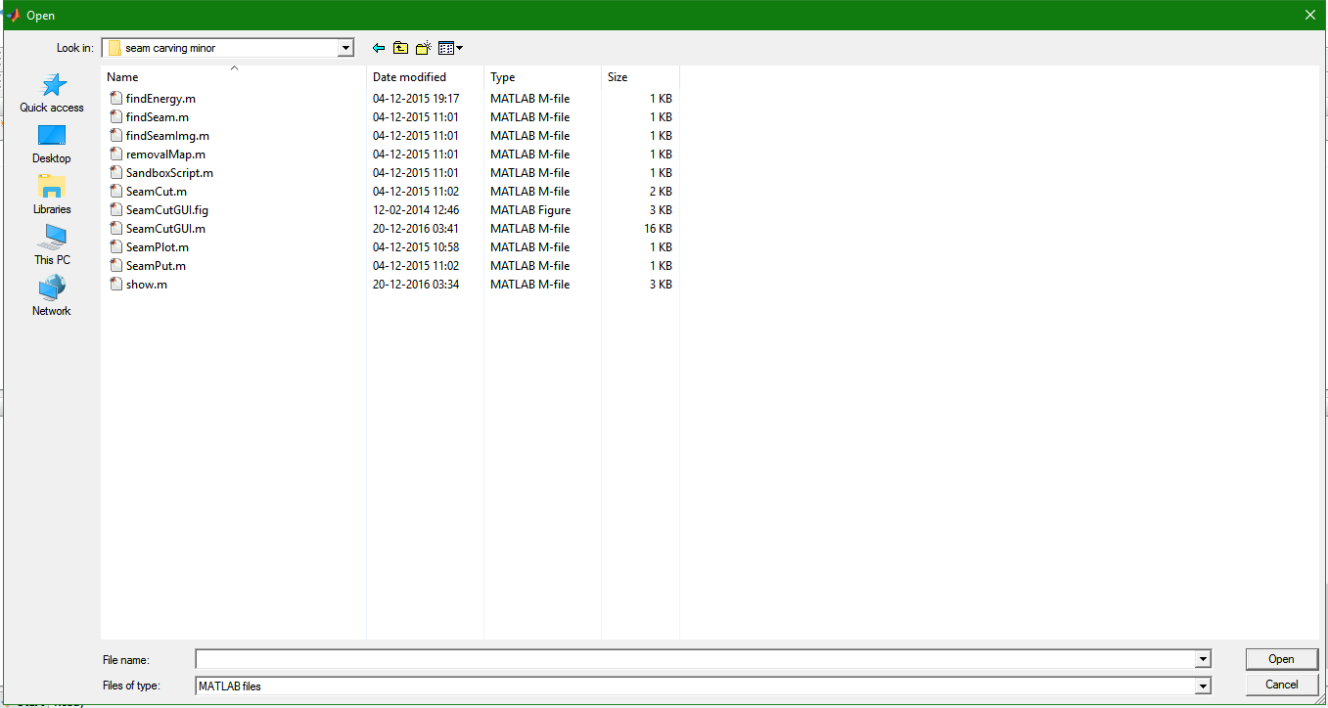

Screenshot2.:All the coded files used to implement Seam Carving Technique

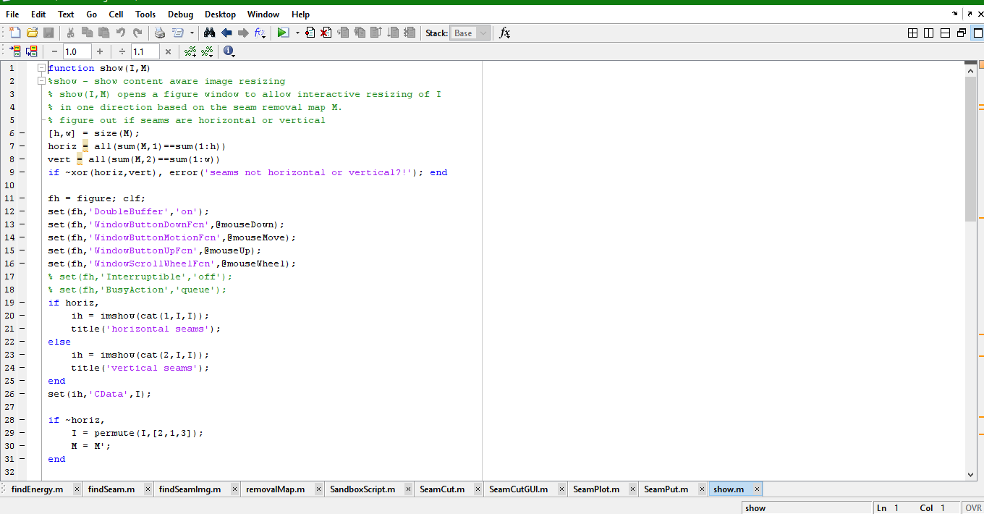

Screenshot3.:All files in Matlab Interface

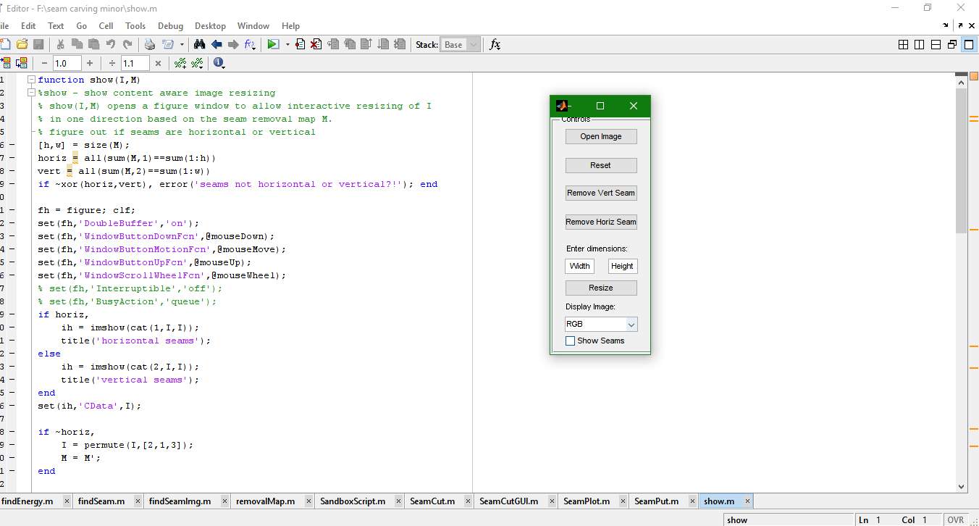

Screenshot4.:SeamCutGUI.m files calls the UI for user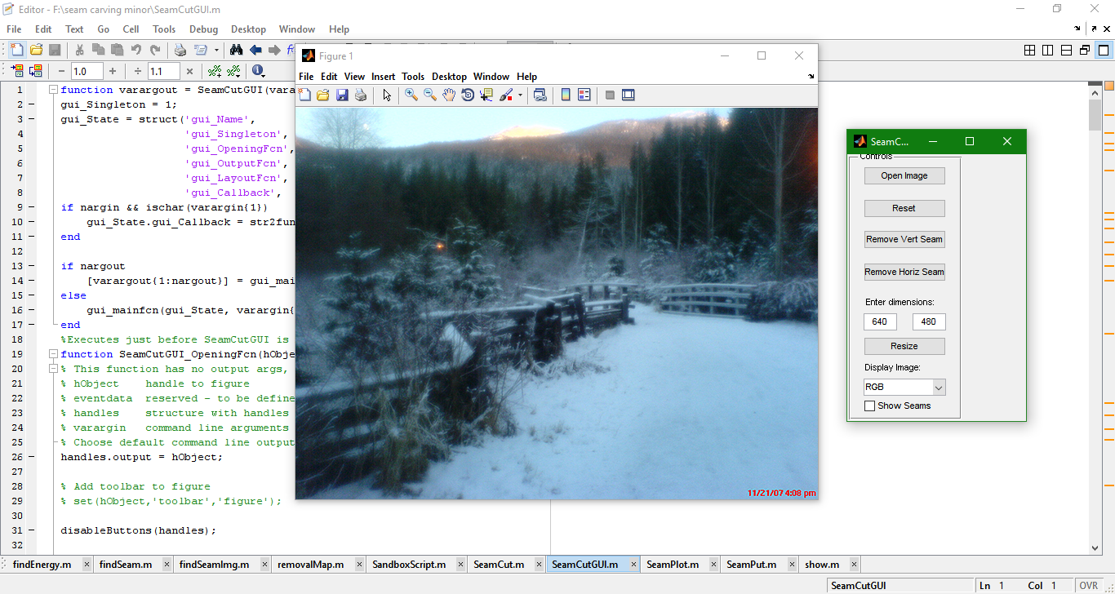

Screenshot5.:Selecting Open Image in UI opens up the selected Image

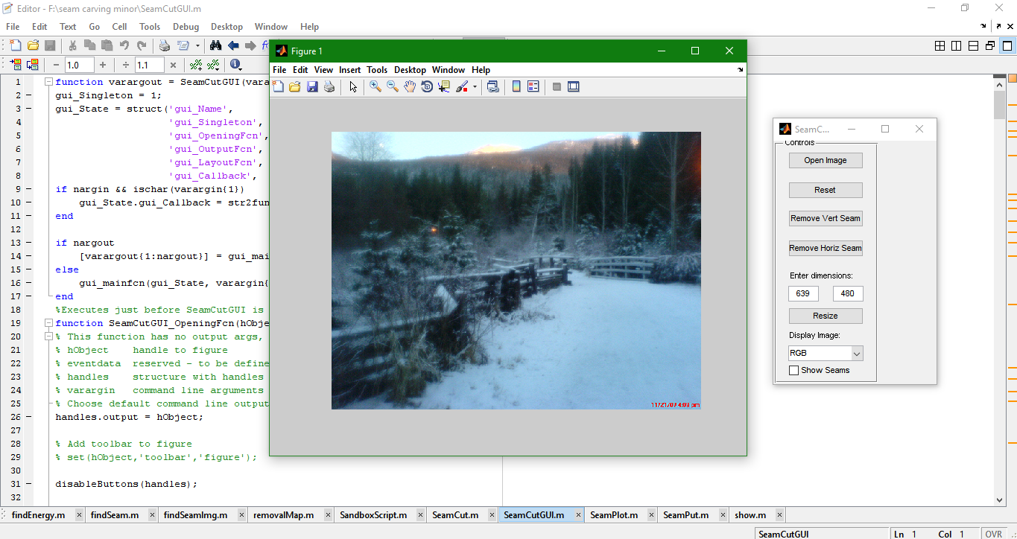

Screenshot6.:Removal of vertical Seam(results in change in Dimensions of Image)

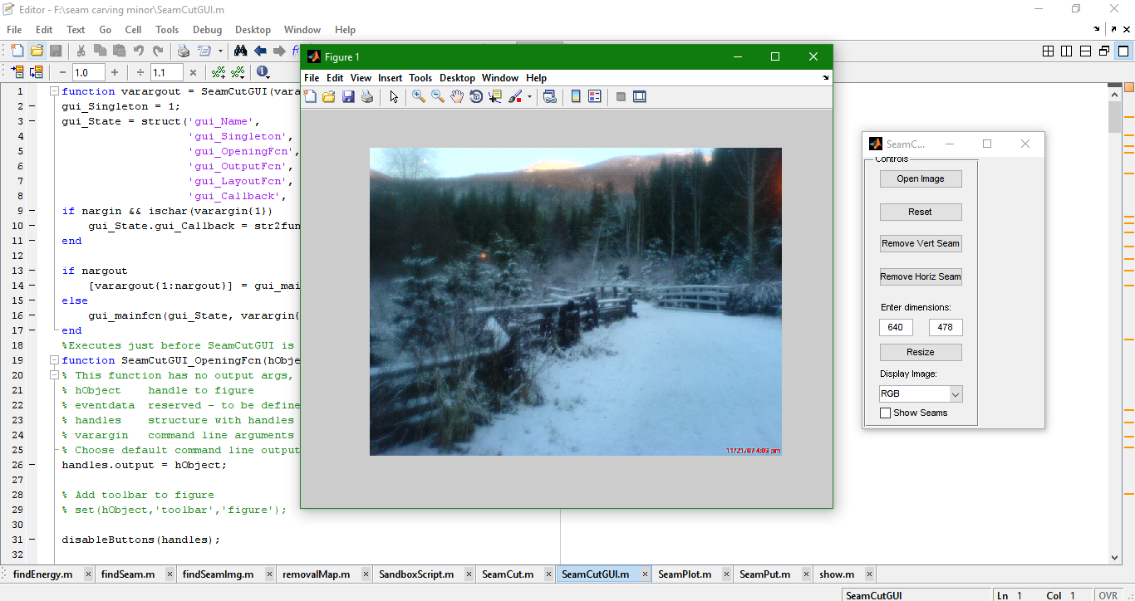

Screenshot7.:Removal of Horizontal Seam(results in Change in Horizontal dimensions)

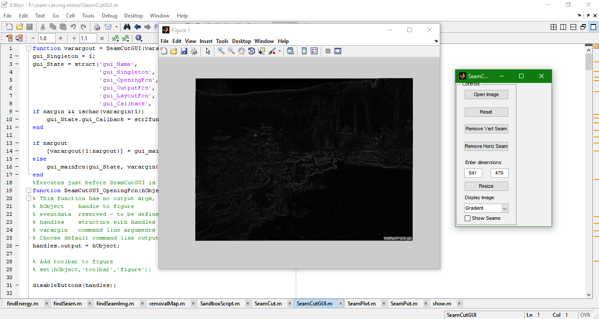

Screenshot8.:Changing the Display Type to Gradient

**4.2 Testing**

**4.2.1 Testing Plan**

**Table 6. Test Plan**

|  |  |  |  |
| --- | --- | --- | --- |
| **Type of test** | **Will test be performed** | **Comment/Explanation** | **Component** |
| Requirement | Yes | Requirements specification must contain  all the requirements that are to be solved  by our system. | Dataset(Photos) and MATLAB |
| Performance | Yes | Redundancy and fail-over options should be considered. | Compare the training photos with test photos ,and compare the accuracy. |

**TEST TEAM DETAILS**

|  |  |  |  |  |
| --- | --- | --- | --- | --- |
| S.No | ROLE | NAME | SPECIFIC RESPONSIBILITIES | Comments |
| 1 | Tester | Mohit Kumra | Testing of tits and bits of the project done | Enthusiastically done |
| 2 | Tester | Sarthak Bhutani | Testing of tits and bits of the project  done | Enthusiastically done |
| 3 | Tester | Rohit Kumar | Testing of tits and bits of the project  done | Enthusiastically done |

Table 3. Test Team Details

**TEST SCHEDULE**

|  |  |  |  |  |
| --- | --- | --- | --- | --- |
| **Activity** | **Start**  **Date** | **Completion**  **Date** | **Hours/day** | **Comments** |
| Data Set Acquistion | 15th September 2016 | 20th October 2016 | 1/2 | Data Sets contain  required data |
| Coding Phase | 25th September 2016 | 8th December 2016 | 1 | Modules were coded |
| Compilation Phase | 20th November 2016 | 8th December 2016 | 3 | Coded Modules were tested against the Data set |
| Testing Phase | 21th November 2016 | 8th December 2016 | 1 | Testing of various types of images was done |

Table 4. Test Schedule

**TEST ENVIRONMENT**

|  |
| --- |
| **SOFTWARE ITEMS** |
| Windows 7 and above.  Matlab R2009a  Image Processing Tool in MatLab |
| **HARDWARE ITEMS** |
| Intel core i3 processor and above  Minimum of 4 GB RAM  Laptop or a Desktop |

Table 5. Test Environment

**4.2.2 Component decomposition and type of testing required**

|  |  |  |  |
| --- | --- | --- | --- |
| S.No | List of Various | Type of Testing Required | Technique for writing test |
|  | Components |  | cases |
|  | (modules) that require |  |  |
|  | testing |  |  |
| 1 | Acquisition/Image Import | All the test techniques shown in testing plan table where done for these each module & quality was insured. | All the test was done manually due to lack of knowledge in automation testing. |
| 2 | Image Type |
| 3 | Seam Selection |
| 4 | Seam enhancement and reduction |
| 5 | Reconstruct Image |
| 6 | Output of the Image |

**4.2.3 Limitations of the solution**

1. With simple row/column removal, it can excessively carve less important parts of an image and result in unwanted visual distortions.

1. Also, the seam method does not consider any approaches to preserve the object shape.

3. The MatLab software tends to slow down on making large changes

**5 Findings & Conclusion**

**5.1 Findings**

The Image resizing has been one of most important research topics in recent years.Information loss is inevitable in the process of image resizing. The key problem is to preserve the most attractive regions and useful information, minimize visual distortion, achieve real-time resizing, and satisfy user preferences under the constraint of topological relations and the global context.

Seam carving technique is most efficient as it overcomes the drawbacks of Warping,Content-aware cropping,Content-aware scaling and additionally include user guide to carry out the process(constraint dependent re-sizing in real time) and can create multi-sized images.

**5.2 Conclusion**

We presented an operator for content-aware resizing of images using seam carving. Seams are computed as the optimal paths on a single image and are either removed or inserted from an image. This operator can be used for a variety of image manipulations including: aspect ratio change, image retargeting, content amplification and object removal. The operator can be easily integrated with various saliency measures, as well as user input, to guide the resizing process. In addition, we define a data structure for multi-size images that support continuous resizing ability in real time.

**5.3 Future Work**

We can Optimize the Seam Carving for Content-Aware Image Resizing technique.We can evolve this by modifying the energy function and check which value does a better job with different type of images and could do the following tasks:

* The seam method can consider any approaches to preserve the object shape.
* It can efficiently carve less important parts of an image and should not result in unwanted visual distortions.
* Different scaled and bit depth image can be implemented.

**REFERENCES:**

**Research Papers:**

1.  **MATLAB based Image Editing and Color Detection::**

<http://www.ijsrp.org/research-paper-0114/ijsrp-p25106.pdf>

2. **Seam Carving for Content-Aware Image Resizing :**

<http://graphics.cs.cmu.edu/courses/15-463/2007_fall/hw/proj2/imret.pdf>#

3. **Image Resizing using Seam Carving :** <http://digitalcommons.morris.umn.edu/cgi/viewcontent.cgi?article=1034&context=horizon>

4. **Optimized Scale-and-Stretch for Image Resizing:** <http://graphics.csie.ncku.edu.tw/Image_Resizing/data/ImageResizing08.pdf>

5. **Refactoring: Current Research and Future Trends:**

<http://ac.els-cdn.com/S1571066105826246/1-s2.0-S1571066105826246-main.pdf?_tid=7c62be90-9644-11e6-9ce1-00000aab0f02&acdnat=1476913337_7a0b31471ade54c51c2c809306308dcc>

6. L**earning the Change for Automatic Image Cropping:**

<http://research.microsoft.com/en-us/UM/people/stevelin/papers/cvpr13yan.pdf>

7. **IMAGE PROCESSING IN FREQUENCY DOMAIN USING MATLAB**

<https://hal.archivesouvertes.fr/file/index/docid/321613/filename/IMAGE_PROCESSING_IN_FREQUENCY_DOMAIN_USING_MATLAB_A_STUDY_FOR_BEGINNERS.pdf>

8. **Automated Defect Recognition Method by Using Digital Image Processing**

<http://ascpro.ascweb.org/chair/paper/CPRT120002010.pdf>

9. **Security using image processing**

<http://airccse.org/journal/ijmit/papers/5213ijmit02.pdf>

10. **Pattern Recognition and Image** **Processing** <https://www.computer.org/csdl/trans/tc/1976/12/01674602.pdf>

11. **Survey on Image Resizing Techniques**

<https://www.ijsr.net/archive/v3i12/U1VCMTQ3MjI%3D.pdf>

12. **Genetic Algorithm for Parameter Optimization of Image Segmentation Algorithm**

<http://users.nik.uni-obuda.hu/sanyo/gpgpu/cinti2013_submission_111.pdf>

13. **Attention Based Auto Image Cropping**

<http://www.ee.ucl.ac.uk/~fstentif/WCAA2007.pdf>

14.**An Overview on Image Processing Techniques**

<http://www.rroij.com/open-access/an-overview-on-image-processing-techniques.php?aid=47175>

**Mohit Kumra**

Bachelor of Engineering, Department of Computer Science and Technology

Jaypee Institute of Information Technology,

[mohitkumra95@gmail.com](mailto:mohitkumra95@gmail.com), +91-8700903421

____________________________________________________________________

**Carrier Objective**: To apply the gained knowledge in real life applications to help mankind grow faster.

**ACADEMIC QUALIFICATIONS**

|  |  |  |  |
| --- | --- | --- | --- |
| **Examination** | **Year** | **Board/University** | **Percentage%** |
| **B.E.(Information Technology)** | 2013-Present | Jaypee Institute of Information Technology, Sector-128, Noida | 8.00(CGPA) |
| Class XII | 2013 | CBSE (AISSE)– Gyan Bharati School | 87.40 |
| Class X | 2011 | CBSE (CGPA Basis)– Gyan Bharati School | 8.4(CGPA) |

**ACHIEVEMENTS AND PARTICIPATION**

* Ranked: **409** on Hackerearth, Ranked: **1200** on Codeforces
* Ranked: **3930** on Codechef, **6000** hackos on hacker rank
* Ranked **993** in the **ACM ICPC 2015** First Round.
* Qualified **Google Code-Jam 2016 1st round**. Active participant on online coding competitions.
* Shortlisted for CISCO(USA) 2016 student exchange program.
* Won **2nd prize** in an event in **Mathemania**: Design and Model space effective building.
* Won **2nd prize** and various other consolation prizes at poetry recitation competition held at School level.

**TECHNICAL SKILLS**

Operating System: Windows, Linux(Ubuntu)

Frameworks: Android Developments Tools, Apache Struts

DBMS Packages: MySQL,Oracle.

Web-Development: HTML, CSS, JavaScript, PHP, XML, JSP.

|  |  |  |
| --- | --- | --- |
| **SKILL LEVEL** | **LANGUAGE** | **IDES/COMPILERS** |
| **PROFICIENT** | C, C++,Java | GCC 4.1.1, Dev C++, Vim |
| **INTERMEDIATE** | HTML, Java Script, AJAX ,CSS,PHP, SQL,Python | Eclipse, MySQL 6.0 Adobe Dreamweaver CS4, Adobe Photoshop CS6,Python(3.0) |
| **WORKING KNOWLEDGE** | Assembly Language, Matlab, Shell Script | Matlab 7.2, Intellij,keil uvision |

**PROJECTS**

**‘Suraksha’- Android Application** (February 2016-May 2016)

Objective: To build an Android Application which allows women to send notifications to individuals and get nearby help centers if they find some troublesome activity being practiced against them.

Description: Our focus was to provide an Android Application that could help women travel safe.Provision of help to women in troublesome situations was our prime concern. Be fearless was the motto of our Application.

My Role: Worked on developing the UI and other functionalists that includes integration of Google Maps.

**Developed a website named Being Limitless** (September 2015-December 2015)

Objective: To build an Interest based website that would allow the user to share and interact with other users sharing the same interests.

Description: Our focus was to develop a website that would allow user to get the updates regarding the interest areas of the used.The used can also share articles and connect with people nearby with the same interest background.

My Role: Worked on front-end developing the Home-Page, and subsequent pages for the website using the concept of HTML, CSS, JavaScript and JQuery. To make it compatible with mobiles as well we have used the concept of bootstrap, though all the other classes are overridden in CSS.

**BookMyShow** (October 2014-December 2014)

Objective: To develop the BookMyShow with the help of **with concepts of OOPS & RDBMS.**The BookMyShow focused only on one domain which involves Movies.

Description**:** The project aimed at developing the BookMyShow application in Java with enhanced functionality and better Graphical UI.

My Role**:** Worked on the backend. My work includes the Database management and its connection with the frontend.

**Developed the College web-kiosk (an Online portal) in C language.** (February 2014 - April 2014)

Objective: To build the college web-kiosk portal with the implementation of C language including most of the functionality of the portal.

Description**:** The user was made to enter the credentials followed by verification a valid user was authorized to browse and check updates regarding Personal details,Academics,Exam Info.

My Role**:** Worked on Dynamic Storage of data using the concept of Linked List. I also worked on file system used for storage of data content for Attendance, Grades, Time-Table and Personal details.

**INTERNSHIP AND TRAINING**

**Completed certification course on Java** (June 2015-July 2015)

Description: Course undertaken with the aim to gain knowledge and skills of Java from Maestro in Software design, Development and Management using Java, Kyrion Technologies.

**Research Intern at IIT-DELHI** (June 2016-Present)

Description: Working on a Project that involves implementation of Machine Learning,Pattern Searching and Website Scraping Tools to fetch Information and treat the application developed onto the information to answer the questions raised by the User.

**INTERESTS**

* I am Passionate about solving Problems related to Programming, Data Structures, Algorithms. I practice solving programming problems on HackerRank, Hacker Earth, Codechef, Codeforces.
* Playing Cricket, Gaming, Testing new Applications and exploring about new Gadgets are my areas of interest.