**Restaurant Recommendation System**

**Objective:**

The objective of this project is to develop an intelligent and user-friendly restaurant recommendation system that leverages data science and machine learning techniques to provide personalized restaurant recommendations to users based on their preferences and location. The system aims to enhance the dining experience for users by offering them tailored restaurant choices, ultimately leading to higher user satisfaction and engagement.

**Methodology:**

1. **Start**
2. **Data Collection**: Gather restaurant data from various sources (e.g., websites, APIs).
3. **Data Pre-processing**: Clean and format the collected data. Handle missing data, duplicates, and inconsistencies.
4. **Content-Based Filtering**: Create user profiles based on user preferences. Match user profiles with restaurant attributes.
5. **Machine Learning Models:** Train models to predict user preferences and ratings.
6. **End**

**Flowchart:**

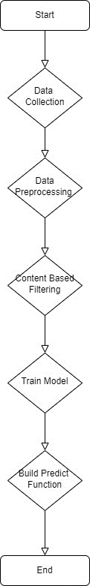

**Gantt Chart**

**Features:**

1. **Personalized Recommendations:** Provide personalized restaurant recommendations based on user preferences, location, and past dining history. Implement collaborative filtering and content-based filtering for recommendation accuracy.
2. **User Feedback System:** Enable users to rate and review recommended restaurants. Use feedback to continuously improve recommendations.
3. **Search and Filtering Options (optional)**: Allow users to search for restaurants by various criteria (cuisine, location, price, rating, etc.). Implement advanced filtering options to refine search results.
4. **Feedback and Rating Display**: Display user reviews and ratings for each restaurant.

**Limitations:**

1. **Limited Offline Access:** Users may encounter difficulties accessing recommendations without an internet connection, especially in mobile apps.
2. **Diversity of Recommendations**: The system may struggle to provide diverse recommendations for users with unique tastes, potentially leading to filter bubbles.
3. **Scalability**: As the user base and restaurant database grow, the system's performance and response time may become a concern.
4. **Geographic Coverage**: The system may be less effective in areas with limited restaurant data or in rural regions.

**Unique Features:**

1. **Music and Playlist Recommendations**: Suggest music or playlists that match the ambiance of the selected restaurant, creating a well-rounded dining experience.