ROUND-ROBIN CPU SCHEDULER
A Project Based Learning Report Submitted in partial fulfilment of the requirements for
the award of the degree
Bachelor of Technology
in the Department of Computer Science and Engineering
Operating Systems & System Programming (OS & SP)
Course Code: 25CS2104E

Submitted by
Srianish Saravan : 2510030417
Vinay Goud : 2510030339
Mohit : 2510030336
Numairuddin : 2510030353

Under the guidance of
Dr. A. Seenu


Computer Science and Engineering
Koneru Lakshmaiah Education Foundation (KLH University)
Aziz Nagar
Semester 4 | Academic Year 2026–2027

ABSTRACT
This project implements a Round-Robin CPU scheduling simulator in the C programming language. Round-Robin is a preemptive, time-shared scheduling method in which runnable processes receive CPU time in FIFO ready-queue order for at most a fixed time quantum. If a process does not finish in its allocated slice, it is placed at the rear of the queue; if it finishes, its completion time is recorded. The program accepts the number of processes, each process's arrival and burst times, and a positive time quantum. It prints a Gantt-style execution sequence and calculates completion time (CT), turnaround time (TAT), waiting time (WT), and their averages. The implementation was compiled with GCC in a Linux/WSL terminal. In the recorded run, four processes with burst times 4, 3, 5, and 7 time units arrived at time 0, and the time quantum was 2. The program reported completion times of 10, 11, 16, and 19; an average turnaround time of 14.00 time units; and an average waiting time of 9.25 time units. These results show how time slicing rotates CPU access among processes and provides measurable scheduling metrics.

LIST OF FIGURES
- Figure 1. Round-Robin scheduler flowchart
- Figure 2. Gantt chart for the recorded four-process run

LIST OF TABLES
- Table 1. Software and implementation requirements
- Table 2. Scheduling formulas
- Table 3. Actual process results
- Table 4. Project specification test cases

TABLE OF CONTENTS
1. INTRODUCTION
Problem statement; objectives; scope
2. METHODOLOGY
Requirements; data model; algorithm; formulas
3. EXPERIMENTS
Implementation; compilation; test cases
4. RESULTS
Recorded execution; Gantt chart; metrics and discussion
5. CONCLUSION AND FUTURE WORK
Conclusion; limitations; future work
REFERENCES
APPENDIX A — SOURCE CODE

ROUND-ROBIN CPU SCHEDULER

1. INTRODUCTION
An operating system manages hardware resources and provides services that allow programs to execute. One of its central responsibilities is CPU scheduling: deciding which ready process should use the processor next. On a multitasking system, several processes may be ready at the same time, while a CPU core can execute only one process at a time. A scheduling policy therefore affects responsiveness, fairness, waiting time, turnaround time, and the frequency of context switches.
First-Come, First-Served (FCFS) executes processes in arrival order and is simple to implement, but a long process at the front can delay shorter jobs. Round-Robin (RR) addresses this issue by giving each ready process a limited time slice, called the time quantum. The scheduler selects the process at the front of a first-in, first-out (FIFO) ready queue and executes it for the smaller of the quantum and its remaining CPU burst. A process that finishes leaves the queue; an unfinished process is added to the rear after the scheduler accounts for processes that arrived during the time slice.
Round-Robin is preemptive because a running process can be interrupted when its quantum expires, even if it has not completed. This rotation provides each continuously ready process with opportunities to execute and helps avoid indefinite postponement under the basic algorithm. The quantum is a key design parameter. A small quantum can improve responsiveness but increases scheduling and context-switch overhead; a large quantum reduces rotations and may make the behavior resemble FCFS when bursts fit within one slice.
This project develops a C program that simulates the Round-Robin policy for processes with arrival times and CPU burst times. It maintains remaining execution time, tracks which processes have entered the ready queue, advances a logical clock, records completion times, and computes turnaround and waiting times. The program also represents CPU idle intervals when no process is ready and the next process has not yet arrived.
The project scope is a user-space simulation of scheduling logic rather than a replacement for the operating system's kernel scheduler. It demonstrates queue management and scheduling calculations using standard C and GCC. The provided terminal run is used as the main experimental result, while the three required cases from the project specification are described as validation scenarios. The report distinguishes the actual recorded run from those specified test cases so that expected examples are not misrepresented as measured output.

1.1 Problem Statement
Design and implement a C-based Round-Robin CPU scheduler that handles process arrival times and burst times, applies a configurable positive time quantum, maintains a FIFO ready queue, produces an execution timeline, and calculates completion, turnaround, waiting, and average scheduling times.

1.2 Objectives
- Implement preemptive, time-sliced CPU scheduling using a FIFO ready queue.
- Handle process arrival times, remaining burst times, and CPU idle intervals.
- Re-enqueue unfinished processes at the rear of the ready queue.
- Record completion time and calculate turnaround time and waiting time.
- Validate behavior with the project specification's three test cases and the recorded four-process run.

1.3 Scope
- The program simulates one CPU and assumes each process has a single CPU burst.
- Arrival time and burst time are integer time units entered by the user.
- The time quantum must be greater than zero.
- The implementation uses standard C input/output and a simple integer array as a queue.
- The program reports scheduling metrics; it does not create or schedule real OS processes.

2. METHODOLOGY
The implementation follows a queue-based simulation. Each process is represented by its process number, arrival time, original burst time, remaining burst time, completion time, turnaround time, waiting time, and a flag indicating whether it has already been inserted into the ready queue. The logical clock advances by the actual duration of each CPU slice.

2.1 Tools and Requirements
Item | Description
Operating environment | Linux or WSL2 terminal (the supplied output shows a Linux/WSL-style shell).
Compiler | GCC (GNU Compiler Collection).
Language | C.
Header file in supplied code | <stdio.h>. The project sheet additionally lists <stdlib.h> and <stdbool.h>; they are not needed by the pasted implementation.
Input | Number of processes, arrival time, burst time for each process, and time quantum.
Output | Gantt-style execution sequence, CT, TAT, WT, average TAT, and average WT.

2.2 Scheduling Data and Queue
The ready queue is FIFO. Processes whose arrival time is less than or equal to the current clock are inserted once, in the order in which the program scans the input list. At dispatch, the front process is removed. The CPU executes min(remaining time, quantum). New arrivals observed at the end of the slice are inserted before the unfinished running process is re-enqueued, matching the order implemented in the supplied code.
If no process is ready, the program searches for the next not-yet-added process with remaining work. When that arrival lies in the future, it prints an IDLE interval and advances the logical clock. This supports gaps between process arrivals.

2.3 Algorithm
- Read the number of processes, then read arrival time and burst time for every process.
- Initialize remaining[i] to burst[i], completion[i] to zero, and added[i] to false/zero.
- Read the time quantum and reject it if it is less than or equal to zero.
- At the current logical time, add each not-yet-added process whose arrival time is less than or equal to the clock and whose remaining time is positive.
- If the queue is empty, find the next unadded process with remaining work and advance the clock to its arrival time; display the idle interval.
- Remove the process at the front of the queue and execute it for min(remaining time, quantum).
- Advance the clock and subtract the executed duration from the process's remaining time.
- Add any processes that arrived during that slice to the queue. If the current process has finished, record its completion time; otherwise, enqueue it at the rear.
- Repeat until all processes complete. Calculate TAT = CT − AT and WT = TAT − BT, then compute the averages.

2.4 Flowchart
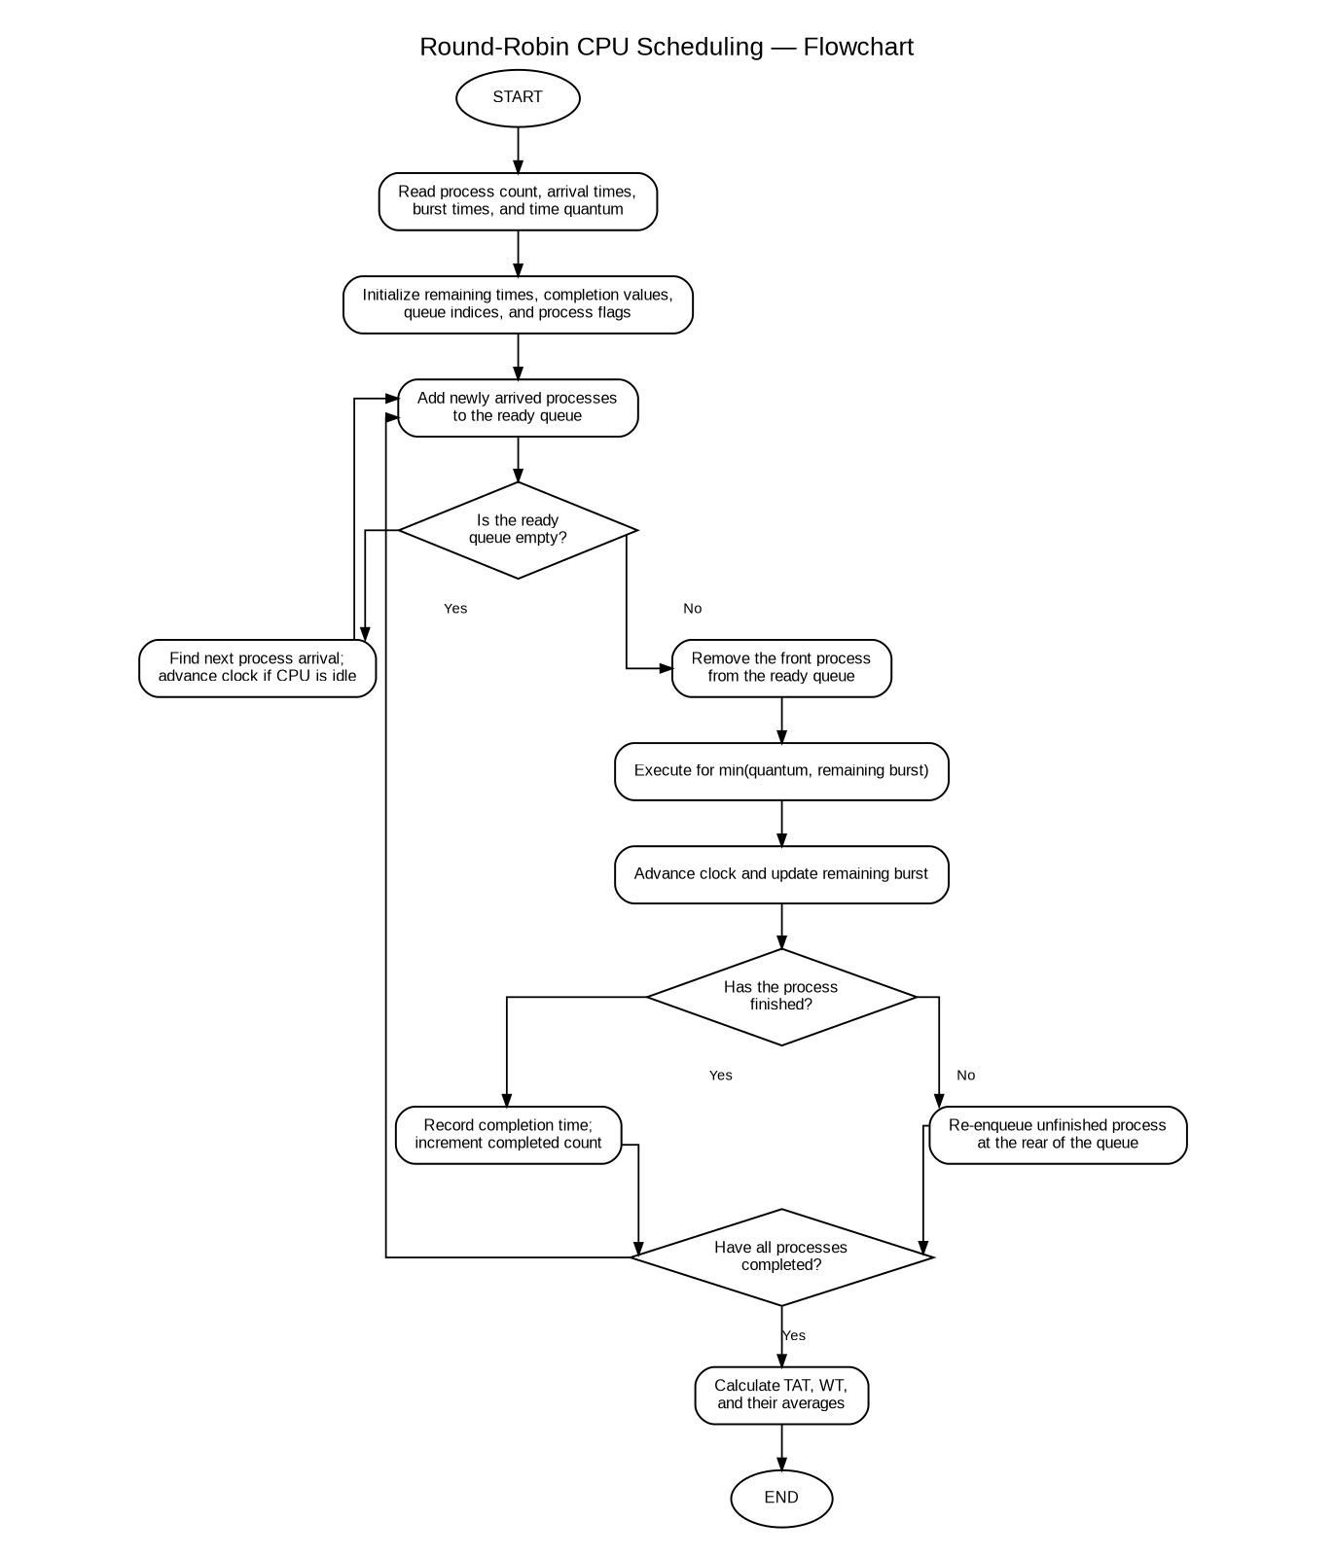
Figure 1. Flowchart of the Round-Robin scheduling logic.

2.5 Scheduling Formulas
Metric | Definition
Completion Time (CT) | Clock time at which a process finishes its final CPU slice.
Turnaround Time (TAT) | TAT = CT − AT
Waiting Time (WT) | WT = TAT − BT
Average Turnaround Time | Sum of all TAT values ÷ number of processes.
Average Waiting Time | Sum of all WT values ÷ number of processes.

3. EXPERIMENTS
The implementation was compiled and run in a Linux/WSL-style terminal using GCC. The command recorded by the team was:
gcc round_robin.c -o round_robin
./round_robin
The recorded experiment used four processes, all arriving at time 0. Their burst times were 4, 3, 5, and 7 time units, and the time quantum was 2.
Process | Arrival Time | Burst Time
P1 | 0 | 4
P2 | 0 | 3
P3 | 0 | 5
P4 | 0 | 7
Time quantum | — | 2

3.1 Test Cases from the Course Specification

Specification test 1
Input: P1 burst = 5, P2 burst = 3, quantum = 2; both arrive at 0 for the illustrated sequence.
Expected sequence: P1(2) → P2(2) → P1(2) → P2(1) → P1(1).
Purpose: Shows repeated time slices and re-enqueueing. This is a specification case, not part of the supplied terminal transcript.

Specification test 2
Input: P1 burst = 2, P2 burst = 2, quantum = 4; both arrive at 0.
Expected sequence: P1(2) → P2(2).
Purpose: Each process finishes in one slice; the order is equivalent to FCFS for these arrivals.

Specification test 3
Input: P1 burst = 10, quantum = 3; arrival time = 0.
Expected sequence: P1(3) → P1(3) → P1(3) → P1(1).
Purpose: The process finishes in four iterations.

Recorded implementation run
Input: P1(AT=0,BT=4), P2(AT=0,BT=3), P3(AT=0,BT=5), P4(AT=0,BT=7), quantum = 2.
Expected sequence: P1 → P2 → P3 → P4 → P1 → P2 → P3 → P4 → P3 → P4 → P4.
Purpose: Actual output supplied by the team; detailed timings and metrics are shown in the Results section.
The three specification cases above are documented as required validation scenarios. The only run for which a full terminal transcript was supplied is the four-process run described in Section 4.

4. RESULTS

4.1 Actual Gantt Chart
The following chart is reconstructed from the execution sequence in the supplied terminal output.
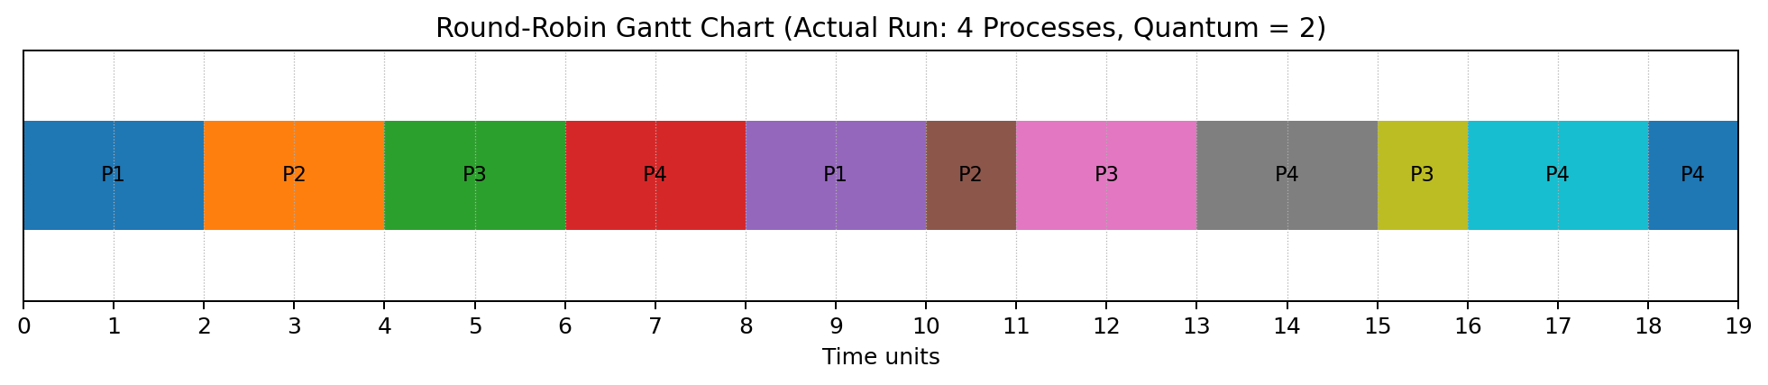
Figure 2. Gantt chart for the recorded run (time quantum = 2).
Execution intervals: 0 | P1 | 2 | P2 | 4 | P3 | 6 | P4 | 8 | P1 | 10 | P2 | 11 | P3 | 13 | P4 | 15 | P3 | 16 | P4 | 18 | P4 | 19

4.2 Process-wise Results
Process | AT | BT | CT | TAT = CT−AT | WT = TAT−BT
P1 | 0 | 4 | 10 | 10 | 6
P2 | 0 | 3 | 11 | 11 | 8
P3 | 0 | 5 | 16 | 16 | 11
P4 | 0 | 7 | 19 | 19 | 12

4.3 Average Metrics
Metric | Calculation | Result
Average turnaround time | (10 + 11 + 16 + 19) / 4 | 14.00 time units
Average waiting time | (6 + 8 + 11 + 12) / 4 | 9.25 time units

In the recorded run, all four processes arrive at time zero. The scheduler initially places them in process order in the ready queue. With a quantum of 2, P1, P2, P3, and P4 each receive a first slice. P1 then completes on its second slice at time 10; P2 completes at time 11; P3 completes at time 16; and P4 completes at time 19.
Turnaround time is the total elapsed time from arrival to completion. Because all four processes arrive at time zero, each turnaround time equals its completion time. Waiting time is turnaround time minus the original CPU burst. The sum of turnaround times is 56, producing an average of 14.00 time units. The sum of waiting times is 37, producing an average of 9.25 time units. These values match the terminal output supplied for this report.
The Gantt chart represents the actual sequence and timing printed by the program. It demonstrates that the scheduler alternates among unfinished processes and shortens the final slice when the remaining burst is less than the quantum. The final two P4 slices appear consecutively because P4 is the only unfinished process left at that point; the scheduler still applies the quantum rule.

4.4 Interpretation
- The result shows that each process receives CPU time in slices of at most two units while multiple processes remain ready.
- P1 and P2 complete earlier than P3 and P4 because their required CPU bursts are shorter, although exact completion order also depends on queue rotation.
- When only P4 remains, it is scheduled repeatedly until its remaining burst is zero. The final slice uses one unit, which is less than the quantum.
- The calculated metrics are based on the provided output and the standard definitions CT, TAT, and WT; they are not hardware performance measurements.

5. CONCLUSION AND FUTURE WORK

5.1 Conclusion
The project demonstrates a Round-Robin CPU scheduling simulator implemented in C and compiled with GCC. The program accepts arrival and burst times, applies a configurable positive time quantum, maintains a ready queue, displays the execution order, and calculates completion, turnaround, and waiting times. For the supplied run of four processes with quantum 2, the reported average turnaround time is 14.00 time units and average waiting time is 9.25 time units. The output provides a concrete illustration of time-sliced scheduling and queue rotation.

5.2 Limitations
- The queue is declared as queue[n * 10]. Since rear is a cumulative insertion index and is not wrapped around or reused, a sufficiently long workload or very small quantum can exceed this fixed capacity. A dynamically sized circular queue would be more robust.
- The pasted program validates that the time quantum is positive but does not validate that n is positive, burst times are positive, arrival times are non-negative, or scanf succeeded. Input validation should be added before using variable-length arrays and dividing by n.
- The implementation uses a variable-length array for queue and process data, which is supported by many C compilers in C99 mode but is not supported by every C implementation.
- The program is a simulator. Its reported times are logical CPU time units, not measured wall-clock performance or real kernel context-switch latency.

5.3 Future Work
- Replace the fixed queue with a circular queue or dynamically allocated queue that can safely reuse storage.
- Validate process count, arrival times, burst times, quantum, and input conversion results.
- Add automated test scripts for the three official cases, idle CPU intervals, simultaneous arrivals, and processes arriving during an active slice.
- Display per-slice start and end times in a more structured Gantt chart and optionally export results to a file.
- Compare average waiting and turnaround times for different quanta, and add FCFS as a baseline for educational comparison.

REFERENCES
[1] Silberschatz, A., Galvin, P. B., and Gagne, G., Operating System Concepts, Wiley. (Use the edition prescribed by the course, if specified.)
[2] Stallings, W., Operating Systems: Internals and Design Principles, Pearson. (Use the edition prescribed by the course, if specified.)
[3] GNU Project, GCC, the GNU Compiler Collection: https://gcc.gnu.org/.

APPENDIX A — SOURCE CODE
The following section presents the C source code developed by our team for the Round-Robin CPU Scheduling project. The program implements time-sliced CPU scheduling using a ready queue and calculates the completion time, turnaround time, and waiting time of each process. The source code is included to explain our implementation and support the results presented in this report.
#include <stdio.h>
int main() {
int n, quantum;

printf("========================================\n");
printf(" ROUND ROBIN CPU SCHEDULING\n");
printf("========================================\n\n");

printf("Enter number of processes: ");
scanf("%d", &n);

int arrival[n];
int burst[n];
int remaining[n];
int completion[n];
int turnaround[n];
int waiting[n];
int added[n];

for (int i = 0; i < n; i++) {
printf("Enter Arrival Time and Burst Time for P%d: ", i + 1);
scanf("%d %d", &arrival[i], &burst[i]);
remaining[i] = burst[i];
completion[i] = 0;
added[i] = 0;
}

printf("Enter Time Quantum: ");
scanf("%d", &quantum);

if (quantum <= 0) {
printf("Time Quantum must be greater than 0.\n");
return 1;
}

int queue[n * 10];
int front = 0, rear = 0;
int time = 0, completed = 0;

printf("\n========================================\n");
printf(" GANTT CHART\n");
printf("========================================\n");
printf("0");

while (completed < n) {
for (int i = 0; i < n; i++) {
if (arrival[i] <= time && remaining[i] > 0 && added[i] == 0) {
queue[rear++] = i;
added[i] = 1;
}
}

if (front == rear) {
int nextArrival = -1;
for (int i = 0; i < n; i++) {
if (remaining[i] > 0 && added[i] == 0) {
if (nextArrival == -1 || arrival[i] < nextArrival)
nextArrival = arrival[i];
}
}
if (nextArrival > time) {
printf(" -- IDLE -- %d", nextArrival);
time = nextArrival;
}
continue;
}

int current = queue[front++];
int executionTime = (remaining[current] > quantum)
? quantum : remaining[current];

printf(" -- P%d -- ", current + 1);
time += executionTime;
remaining[current] -= executionTime;
printf("%d", time);

for (int i = 0; i < n; i++) {
if (arrival[i] <= time && remaining[i] > 0 && added[i] == 0) {
queue[rear++] = i;
added[i] = 1;
}
}

if (remaining[current] == 0) {
completion[current] = time;
completed++;
} else {
queue[rear++] = current;
}
}

float totalTurnaround = 0, totalWaiting = 0;

printf("\n\n========================================\n");
printf(" PROCESS RESULTS\n");
printf("========================================\n\n");
printf("%-10s %-8s %-8s %-8s %-8s %-8s\n",
"Process", "AT", "BT", "CT", "TAT", "WT");
printf("----------------------------------------------------------\n");

for (int i = 0; i < n; i++) {
turnaround[i] = completion[i] - arrival[i];
waiting[i] = turnaround[i] - burst[i];
totalTurnaround += turnaround[i];
totalWaiting += waiting[i];
printf("P%-9d %-8d %-8d %-8d %-8d %-8d\n",
i + 1, arrival[i], burst[i], completion[i],
turnaround[i], waiting[i]);
}

printf("\n========================================\n");
printf(" FINAL RESULTS\n");
printf("========================================\n");
printf("Average Turnaround Time = %.2f\n", totalTurnaround / n);
printf("Average Waiting Time = %.2f\n", totalWaiting / n);
printf("========================================\n");
return 0;
}

